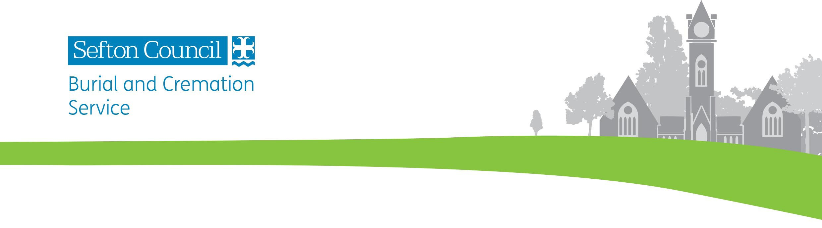

PURCHASING A GRAVE

Graves are available for purchase in the four cemeteries operated by Sefton Council:

Bootle Cemetery, Linacre Lane, Bootle, Merseyside L20 6ET
- Full-sized graves for up to three full burials and also for ashes burials
- A separate area for baby burials, with a memorial.

Thornton Garden of Rest, Lydiate Lane, Thornton, Liverpool L23 1TP
- Full-sized graves for up to three full burials and also for ashes burials
- Smaller graves for the burial of ashes only
- A separate area for baby burials.

For any enquiries relating to Bootle Cemetery or Thornton Garden of Rest, contact or visit Thornton Garden of Rest at Lydiate Lane, Thornton, Liverpool L23 1TP; phone: 0151 924 5143; email: thornton.gardenofrest@sefton.gov.uk

Duke Street Cemetery, Duke Street, Southport PR8 5EL
Full-sized graves for up to four full burials and also for ashes burials
- A separate area for Jewish burials, with chapel and washroom
- A separate area for baby burials, with a memorial.

Liverpool Road Cemetery, Liverpool Road, Birkdale, Southport PR8 3BD
- Full-sized graves for up to four full burials and also for ashes burials
- Smaller graves for the burial of ashes only
- A separate area for Muslim burials.

For any enquiries relating to Duke Street or Liverpool Road Cemeteries, contact or visit Southport Crematorium at Southport Road, Scarisbrick, Southport PR8 5JQ; tel 01704 533443; email southport.crematorium@sefton.gov.uk

In order to purchase a burial plot, the grave owner would need to complete a purchase form and return it to the relevant office along with the full fee. Fees are as follows (valid until 31st March 2020):

For a full-sized plot without a headstone foundation (available at Bootle, Thornton, Duke Street and Liverpool Road):
Owner is a resident of Sefton £1,110.00
Owner is not a resident of Sefton £2,060.00

For a full-sized plot with a headstone foundation (available at Bootle and Thornton):
Owner is a resident of Sefton £1,157.00
Owner is not a resident of Sefton £2,107.00

For an ashes only plot (including headstone foundation):
Owner is a resident of Sefton £892.00
Owner is not a resident of Sefton £1,737.00

Note that there is an additional fee for opening the grave for a burial.

Once a grave has been allocated, the Deed of ownership will be sent to the grave owner.

All burials should be done by appointment. Appointments are available Monday to Friday (not including bank holidays) and should be arranged with the relevant office. All burials and headstone work need to be authorised, in writing, by the registered grave owner.

A headstone or memorial may be added to the grave, subject to certain restrictions. Your stonemason will arrange the necessary permit with the cemetery office.

After a grave owner passes away, the ownership would need to be transferred into someone else’s name before any further burials could take place within the grave.

PURCHASE FORM FOR A PRIVATE GRAVE

THIS SECTION TO BE COMPLETED AND SIGNED BY THE NEW DEED HOLDER
(in block letters please)

I wish to apply to reserve the right of burial in:

Name of cemetery………………………………………………………………………..........

Preferred section/denomination …………………………….……………………………….

*a full-sized grave for coffin burials / *a grave for ashes burials only * delete as applicable

For full-sized graves only: To accommodate…………full burials
Note: Reduced-sized graves for the burial of ashes are available at Thornton Garden of Rest and Liverpool Road Cemetery only. These accommodate up to 6 interments, and include a headstone foundation

Name of Owner Mr/Mrs/Ms/Miss/other ………………………………………………………

Address …………………………………………………………………………………………

………………………………………………………………………………………….

………………………………………………… Postcode …………….………….

Contact Number ...............................................................................................................

Signature of Owner ………………………………………………. Date ……………………

PLEASE RETURN THE COMPLETED FORM, TOGETHER WITH THE APPROPRIATE FEE (payable to Sefton M.B.C.) TO THE RELEVANT OFFICE

The grave deed will be forwarded to you in due course
If you have any questions please do not hesitate to contact the relevant cemetery office

FOR OFFICE USE ONLY

Cemetery _____________________________________________________________

Section __________________________ Denomination __________________

Grave No __________________________ Grant _________________________

Amount £_________________________ Receipt ______________________

FOR OFFICE USE ONLY

Cemetery _____________________________________________________________

Section __________________________ Denomination __________________

Grave No __________________________ Grant _________________________

Amount £_________________________ Receipt ______________________

FOR OFFICE USE ONLY

Cemetery _____________________________________________________________

Section __________________________ Denomination __________________

Grave No __________________________ Grant _________________________

Amount £_________________________ Receipt ______________________

