Annual Canvass FAQ’s

What do I need to do?
The instructions in the letter or on the guidance leaflet will explain what you need to do.
The information you provide about the residents of your household is the first step in the process and those who are not registered to vote will need to register themselves either online at main Gov website or we will send them a form.
● Registering online will only takes a couple of minutes
● You will need your National Insurance Number

Do I list everyone who lives in the property?
You need to include the name and nationality of everyone aged 16 or over who is resident and eligible to register to vote. If there are no eligible residents, you should tell us why.

How do I know who is eligible to vote?
Your name should be included on this form:
● if you are British, Irish, a European Union or a Commonwealth citizen who has leave to remain in the UK or does not require leave to remain in the UK
● if you are aged 16 and over (however you will not be able to vote until you are 18)

My son/daughter is living away at university, should I register them here or at home?
Your son/daughter can register at their home address as well as their university address.
This means they can vote in local elections at both addresses as long as they are in different local government areas but cannot vote at both addresses in a Parliamentary election.

Voting by Post
If you don’t already vote by post, you can request an application form when registering to vote or request an application at anytime by contacting Sefton Council Electoral Services.
You can apply any time up to 11 working days before the date of an election.
Your postal vote(s) will be posted to you around 8 working days before the date of an election.
The ballot papers will arrive in an envelope like this (follow the instructions and return the completed pack in the envelope provided by 10pm on election day):
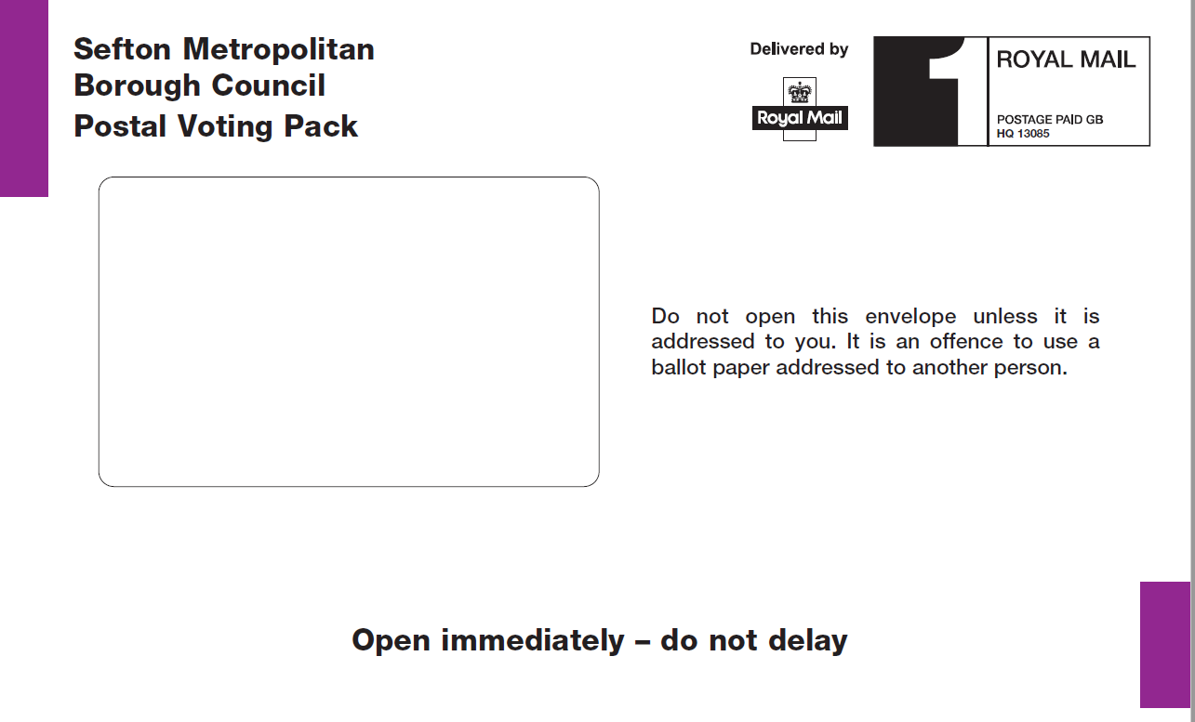

Contact details
For general queries about electoral registration or elections, please contact the Electoral Services Office on 0345 140 0845 or email: electors@sefton.gov.uk

Examples provided by the Cabinet Office

