Date: 13th August 2021

Dear Care and Community Support Provider,

As always, we want to thank you for everything you are doing to continue to keep our vulnerable residents safe and well. Please continue to follow all Infection Control and visiting guidance. Please contact the Community Infection Control Team on 0151 295 3036 for advice and guidance.

**Care Homes – Musical Interaction offer**

We would like to start with a message from Holistic Harmonies Community Interest Company who use music to connect communities through Singing Mamas Choirs, Family Social Events and Intergenerational Music & Movement Programmes.

We have just received a grant from the National Lottery which will allow us to deliver our 6 week Music & Movement Programme in 4 care homes across Liverpool, Knowsley and Sefton, starting in January 2022 (guidelines permitting).

We're also putting together our Travelling Carol Singing Trio project again which will tour around organisations this December.

Would your care home benefit from regular musical interactions?

Benefits include:

* Improved mobility
* Improved mood
* Improved staff morale
* Falls prevention

Please read a copy of our published report: <https://www.shortwork.org.uk/projects/holistic-harmonies>

Please contact Rachel at: [rachel@holistic-harmonies.com](mailto:rachel@holistic-harmonies.com) or telephone 07747446048.

Start to build a relationship with Holistic Harmonies to see how you can embed music and movement into the lives of your staff and residents.

**Mental Health at Work eLearning**

Sefton Council is offering a FREE eLearning Mental Health at Work eLearning course to all Care Providers and Community Services operating in Sefton.

The course will provide you with a wide understanding of mental health issues and the signs to look out for, for yourself and your colleagues. The aim is to support the promotion of a safe and respectful workplace culture, to equip staff and teams to better manage concerns that arise around mental health and being able to actively support each other. The course recognises by creating an environment that promotes wellbeing, staff feel supported and valued.

Click on the following link to access the course: https://seftonclc.melearning.university/course_centre/course_details/134

If you have any questions or queries email training.services@sefton.gov.uk or call 0151 934 2872.

**Guidance updates this week**

Bereavement resources

<https://www.gov.uk/government/publications/steps-to-take-following-the-death-of-a-person-who-worked-in-adult-social-care-in-england/bereavement-resources-for-the-social-care-workforce>

Updated How to work safely in domiciliary care

<https://www.gov.uk/government/publications/covid-19-how-to-work-safely-in-domiciliary-care?utm_medium=email&utm_campaign=govuk-notifications&utm_source=25fcbeeb-6e5a-46b5-8ae6-f9488a1b82ab&utm_content=daily>

**Infection Control Fund**

Just a reminder Interim returns have been sent out for return on 20th August. If they have any issues please contact ascfinance@sefton.gov.uk

**CQC resource and Q and A session on Mandatory Vaccinations**

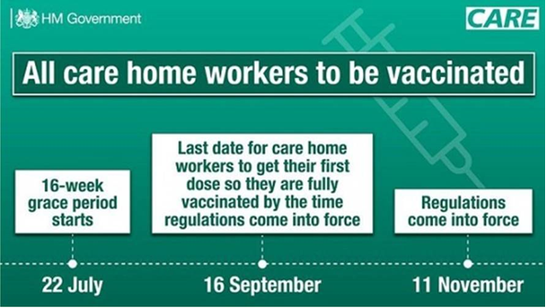

Please see below the link to new guidance and resources for ‘vaccines as a condition of deployment’ in care homes including the details of a webinar scheduled for the 17th August 2021.

[Sent by CQC on behalf of DHSC Adult Social Care update (govdelivery.com)](https://content.govdelivery.com/bulletins/gd/UKCQC-2eb6ce7?wgt_ref=UKCQC_WIDGET_3)

From us, all the Health and Care partners and Councillor Paul Cummins, Cabinet Member for Adult Social Care, we would like to thank you and your staff once again for all your hard work and everything you are doing at this time.

Yours sincerely

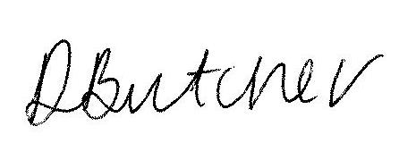

Deborah Butcher

Executive Director for Adult Social Care and Health

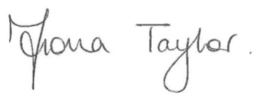

Fiona Taylor

Chief Officer, NHS South Sefton and NHS Southport and Formby CCGs