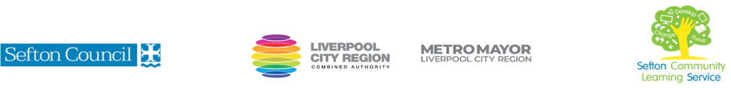
DRAWING FOR BEGINNERS
(Courses are offered subject to viable numbers.)
This course is for: | Adult learners who have non or very little previous experience of drawing.  Also suitable as a ‘refresher’ course for learners who have done some drawing and need motivation to continue on their own.
What will I learn: | Course content below is subject to change based on prior knowledge and skills of each cohort.  Week 1  Induction  Initial and diagnostic assessment and setting of personal targets  Introduction to drawing using pencil, basic exercises, experimental drawing workshop, working in line improving understanding of the medium.  Week 2  Pencil Workshop using tonal value, tonal ladders, variety of pencil grades.  Observational drawing, sight- size measurement, create 3D impression.  Week 3  Pen and Ink Workshop, develop understanding of mark making, using observational drawing to explore and develop mark making techniques. Copy a Van Gogh drawing to further develop your pen and ink skills  Week 4  Charcoal workshop developing medium techniques. Working from observation, understanding tonal value and how to create 3D effects. Develop skills by working from a black and white image  Week 5  Tonal Pastel workshop. Continue to develop understanding of drawing using a variety of tonal values, working on pastel paper, building up, blending and creating an image with shape, form, and 3D.  You will have the opportunity to discuss and set your individual learning targets with your tutor and discuss the support you might need to ensure you have an enjoyable and meaningful learning experience
Knowledge and skills needed: | On this course you will need to:  - follow verbal and written instructions and work through them at your own pace  - listen and join in group discussions  - jot down notes to record relevant information  - keep your work organised in a file  - use a PC/laptop or tablet for research or to present your work and to access our learning platform  - have some dexterity using your hands
Materials needed: | At enrolment, you will need your NI number and proof of benefits (if applicable).  Your tutor will provide many of the learning resources, but you will need to come prepared to the lessons with an A4 pad; pen and folder or file to keep your work organised. Tutor to advise about possible sketch book to buy plus pencils etc as course progresses.  It will be an advantage, but not essential, if you have access to the internet at home to extend your learning.
How will I learn: | Each session will consist of a dynamic tutor presentation followed by a range of interactive activities.  There will be plenty of revision and consolidation and learning will build on previous learning.  Your progress will be monitored by informal assessment tasks, and you will receive verbal and written feedback from the tutor to help you make good progress.
Progression routes: | On completion of this course, you can progress to another Art course through S.C.L.S, enrol on ‘CLUBS’( tutor to give advice) or work towards a higher Art qualification at a local College, Southport or Hugh Baird  Ask your tutor for advice and a copy of the progression ladder.  SCLS offers a range of Functional Skills courses from Entry 1 up to Level 2 if you need to brush up your maths and English skills or require a qualification to support you with your career path.  Sefton @ Work will be able to provide independent information, advice, and guidance to support you making informed choices for progression into further education, volunteering, or employment.

V- July22

