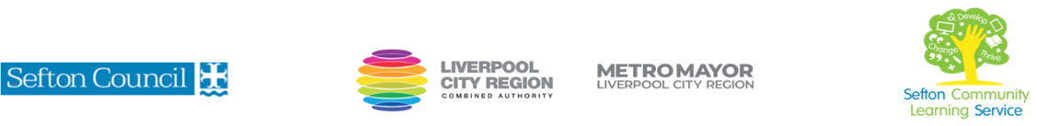
Introduction to Feminism from the 20th Century
(Courses are offered subject to viable numbers.)
This course is for: | Adult learners who have little or no prior knowledge about the development of the feminist movement, its history and/or the role it plays in modern society.
What will I learn: | The course content below is subject to change based on each cohort's prior knowledge and skills.  Week 1  - Induction onto the course; aims and goal setting.  - An introduction to the development of the term feminism and the historical events which lead to the first wave of feminism in Britain i.e., late 19th to early 20th century.  Week 2  - The second wave of feminism i.e., post world wars, the 1960s until the 1980s  - An outline of some of the feminist theories e.g. Marxist/socialist feminism, radical, liberalism, postmodern and multi-racial feminism  Week 3  - The development of the third wave (modern) feminism i.e. 21st century  - Recognising how gender intersects with race, class, nationality, ethnicity, age, and sexual orientation.  Week 4  - Key figures in the history of feminism and current influencers  - Gender in the media and the impact on body image, violence towards and control of women.  Week 5  - The representation of feminism/gender in art, movies, and literature  - Group work- preparing for mini-presentation  Week 6  - End of course review  - Group mini-presentations  You will have the opportunity to discuss and set your individual learning targets with your tutor and discuss the support you might need to ensure you have an enjoyable and meaningful learning experience.
Knowledge and skills needed: | This is a course for complete beginners and no prior subject knowledge or skills are required. A basic level of literacy needed (L1)  On this course, you will need to:  - follow verbal and written instructions and work through them at your own pace  - listen and join in group discussions  - work in a small group  - jot down notes to record relevant information  - keep your work organised in a file  - use a PC/laptop or tablet for research or to present your work
Materials needed: | At enrolment, you will need your NI number and proof of benefits (if applicable).  Your tutor will provide many of the learning resources, but you will need to come prepared to the lessons with an A4 pad; pen and folder or file to keep your work organised.  It will be an advantage, but not essential, if you have access to the internet at home to extend your learning. If needed, your tutor will be able to support you with IT skills required for your course.
How will I learn: | Each session will consist of a dynamic tutor presentation followed by a range of interactive activities.  There will be plenty of revision and consolidation and learning will build on previous learning.  Your progress will be monitored by informal assessment tasks, and you will receive verbal and written feedback from the tutor to help you make good progress.
Progression routes: | On completion of this course, you can progress to;  - further online courses  - pursuing some of the movies, books, poetry, and art recommended on the course.  - Self-study with the recommended reading list  - Further courses in Gender studies  Ask your tutor for advice and a copy of the progression ladder.  SCLS offers a range of Functional Skills courses from Entry 1 to Level 2 if you need to brush up on your maths and English skills or require a qualification to support your career path.  Sefton @ Work will be able to provide independent information, advice, and guidance to support you in making informed choices for progression into further education, volunteering, or employment.

