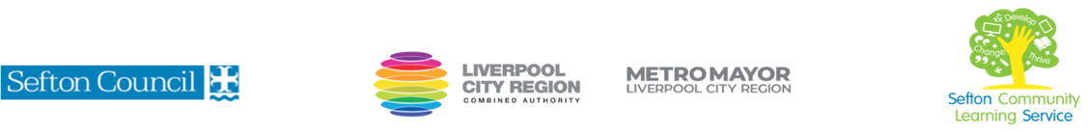
HEALTHY EATING ON A BUDGET

(Courses are offered subject to viable numbers.)
This course is for: | Adult learners who would like to cook a variety of tasty, healthy and economical dishes and learn ways to cut their household food bill
What will I learn: | Course content below is subject to change based on prior knowledge and skills of each cohort.  Week 1  - Induction  - Initial assessment: what do you usually cook? What limits the way you eat?  - Setting of personal targets  - Safety in the kitchen  - Hands on: learn to prepare a quick and healthy dip  Week 2  - Keeping in balance: making sure you get all the food groups you need.  - Recipe: chicken and vegetable soup. You will learn to prepare a simple, delicious meal in a bowl.  - Discussion: using online tools to measure nutrition  Week 3  - Pulses for protein. Tasty alternatives to meat for your everyday meals  - Recipe: lentil bolognese. Learn how to prepare a delicious sauce to serve with pasta, with variations to serve in other ways.  - Discussion: setting your household budget  Week 4  - Keeping the costs down  - Recipe: Quick and simple stir fry  - Discussion: energy saving and other tips for cutting costs  Week 5  - Look after your leftovers. Creative ways to avoid waste  - Recipe: Spanish omelette. Using leftover and fresh vegetables to prepare a Spanish omelette to eat hot or cold.  - Discussion: other ways to reduce food waste  Week 6  - Healthy eating doesn’t mean no treats! Bakes that won’t break the bank  - Recipe: flapjacks full of goodness. Use nuts, fruit and spices to add flavour and goodness to a simple home bake.  - Discussion: what other simple, healthy snacks can you offer?  - Course review and next steps discussion  You will have the opportunity to discuss and set your individual learning targets with your tutor and discuss the support you might need to ensure you have an enjoyable and meaningful learning experience
Knowledge and skills needed: | This is a course for complete beginners and no prior subject knowledge or skills are required.  However, on this course you will need to:  - follow verbal and written instructions and work through them at your own pace  - listen and join in group discussions  - jot down notes to record relevant information  - keep your notes and handouts organised in a file  - safely use a variety of kitchen implements including knives, hot pans and oven equipment  - measure and prepare ingredients  - make shopping lists  - use a calculator to work out food costs and nutrition content
Materials needed: | At enrolment, you will need your NI number and proof of benefits (if applicable).  Your tutor will provide many of the learning resources and specialist ingredients, but you will need to come prepared to the lessons with an A4 pad, pen and folder or file to keep your work organised. All kitchen equipment will be provided.  You will need your own apron and a Tupperware box or similar to take home your prepared dishes. You will also need to shop for main ingredients (max £2 per session) and may be asked to contribute towards other ingredients provided (max £2 for the course)  It will be an advantage, but not essential, if you have access to the internet at home to extend your learning and access online resources. If needed, your tutor will be able to support you with IT skills required for your course.
How will I learn: | Each session will consist of a dynamic tutor presentation followed by a range of interactive activities.  There will be plenty of revision and consolidation and learning will build on previous learning.  Your progress will be monitored by informal assessment tasks, and you will receive verbal and written feedback from the tutor to help you make good progress.
Progression routes: | On completion of this course, you can progress to further courses here at SCLS to help you expand your knowledge and love of cookery. If you are thinking of catering as a career, we can advise you about hospitality courses or help you find out about apprenticeships or employment opportunities.  Ask your tutor for advice and a copy of the progression ladder.  SCLS offers a range of Functional Skills courses from Entry 1 up to Level 2 if you need to brush up your maths and English skills or require a qualification to support you with your career path.  Sefton @ Work will be able to provide independent information, advice, and guidance to support you making informed choices for progression into further education, volunteering, or employment.
V- July22 (2)

