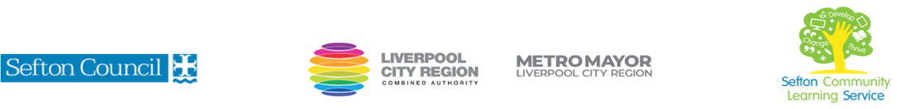
An introduction to Mindfulness and Meditation

(Courses are offered subject to viable numbers.)
This course is for: | Adult learners who are interested in Mindfulness and the practice of Meditation. You don’t need to have any prior knowledge of the subject.  This fascinating course will help develop your knowledge of the history of mindfulness and the practice of meditation, exploring the importance of both the physical and psychological aspects of mindfulness.
What will I learn: | Course content below is subject to change based on prior knowledge and skills of each cohort.  Week 1  - Induction  - Initial and diagnostic assessment and setting of personal targets  - Introduction to the subject, looking at what mindfulness is and its origins.  - Mindfulness exercise incorporating meditation.  Week 2  - The science behind mindfulness, how it affects our brain and body.  - Mindfulness exercise incorporating meditation.  Week 3  - Looking at the benefits of mindfulness.  - Mindfulness exercise incorporating meditation.  Week 4  - Looking at how the mind works and why focussing on the present is positive.  - Mindfulness exercise incorporating meditation.  (Homework, research different types of meditation to utilise over the next two weeks)  Week 5  - Looking at different types of meditation including metta and shambala.  - Mindfulness exercise incorporating meditation.  Week 6  - What medication would you like to try within your exercise.  - Have you met your personal targets?  Throughout the course, you will take part in several mindfulness exercises.  You will have the opportunity to discuss and set your individual learning targets with your tutor and discuss the support you might need to ensure you have an enjoyable and meaningful learning experience.
Knowledge and skills needed: | On this course you will need to:  - Be able to follow verbal and written instructions  - Be able to listen and join in group discussions  - Be able to make notes and record relevant information  - Be able to keep your work organised in a portfolio  - Be able to use a PC/laptop/tablet for research and to access websites for information
Materials needed: | At enrolment, you will need your NI number and proof of benefits (if applicable).  Your tutor will provide many of the learning resources, but you will need to come prepared to the lessons with an A4 pad; pen and folder or file to keep your work organised.  There are no formal entry requirements. The course is suitable for all levels of ability.  It will be an advantage, but not essential, if you have access to the internet at home to extend your learning. If needed, your tutor, will be able to support you with IT skills required for your course.
How will I learn: | Each session will consist of a dynamic tutor presentation followed by a range of interactive activities.  There will be plenty of revision and consolidation and learning will build on previous learning.  Your progress will be monitored by informal assessment tasks, and you will receive verbal and written feedback from the tutor to help you make good progress which will enable you to build a portfolio of evidence.
Progression routes: | On completion of this course, you can progress to further courses within Cambridge Road Learning Services or an IT course which will promote your research abilities to aid with your passion for mindfulness and meditation.  Ask your tutor for advice and a copy of the progression ladder.  SCLS offers a range of Functional Skills courses from Entry 1 up to Level 2 if you need to brush up your maths and English skills or require a qualification to support you with your career path.  Sefton @ Work will be able to provide independent information, advice, and guidance to support you making informed choices for progression into further education, volunteering, or employment.

V- July22 (2)

