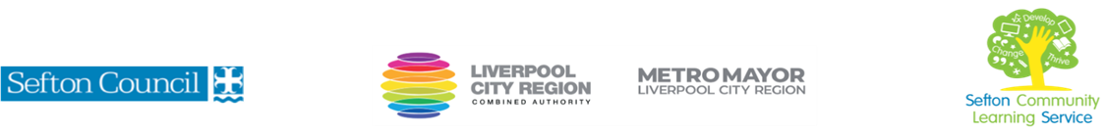

|  |  |
| --- | --- |
| **Family Learning Spooky Crafts**  (Courses are offered subject to viable numbers.) | |
| This course is for: | Parents/guardians with their children to learn simple craft techniques. **2 children per adult. Recommended age range 4-11 years old** |
| What will I learn: | Learners will develop & improve skills in drawing, using paint, using basic literacy and numeracy skills in creating a craft items with a “spooky” theme. |
| Knowledge and skills needed: | No prior knowledge or skills required  You should be able to follow health and safety guidelines.  You will also need to follow written and verbal instructions, take part in discussion and keep a record of achievement.  **Note: Parents/guardians must attend with their child. All children must be supervised by their parent/guardian.** |
| Materials needed: | Please come prepared to complete enrolment with your NI number and proof of benefit (if applicable). You will also need to bring pen & paper to your first session.  All learning materials are provided |
| How will I learn: | Set in an informal relaxed and friendly atmosphere, you will be working together as a family group with your tutor providing support, guidance and encouragement as required. |
| Progression routes: | We offer a range of family learning and wider family learning courses you can progress to, including: Creative Crafts, Half Term Family Crafts, Baby Massage, Help your children with Numeracy and Create and use Story Sacks to support your child’s development.  SCLS offers a range of Functional Skills courses from Entry 1 up to Level 2 if you need to brush up your maths and English skills or require a qualification to support you with your career path.    Sefton @ Work will be able to provide independent information, advice and guidance to support you making informed choices for progression into further education, volunteering or employment. |