Sefton Council

Review of Polling Districts, Polling Places and Polling Stations 2025

Returning Officer's Representations

Definitions
Polling District
A polling district is a geographical area created by the sub-division of an electoral area, i.e., a ward or parliamentary constituency, into smaller parts. A polling district will not breach ward boundaries.
Polling Place
A polling place is a building (e.g., a school or community centre) or area in which a polling station is located.
Polling Station
A polling station is the physical location (i.e., the room) where the process of voting takes place.

This document

This document provides an overview of the current ward, polling district and polling station, along with the current electorate. Polling Districts which cover parish council areas and wards are shown in the Returning Officer’s comments.

The maps provided are shown on the current boundaries of the existing wards, not the new wards introduced by the Sefton (Electoral Changes) Order 2024.

Review of Polling Districts, Polling Places and Polling Stations 2025
Returning Officer's Representations
Existing Ward Name | Meols |  | New Ward Name |  | Meols
Number of Polling Places | 3 |  | No. of Polling Stations | 6
Constituency | Southport

Polling District  Code | Current Polling Place/ Station | Proposal |  |  | Returning Officer's Comments
 |  | Electorate | Polling District Boundary | Polling Place
Y1 | Crossens Community Centre,  The Recreation Ground,  Rufford Road, PR9 8HT | 1918 | Change/  No Change | Change/  No Change
Y2 | Crossens Community Centre,  The Recreation Ground,  Rufford Road, PR9 8HT | 1441 | Change/  No Change | Change/  No Change
Y3 | Crossens Community Centre,  The Recreation Ground,  Rufford Road, PR9 8HT | 1767 | Change/  No Change | Change/  No Change
Y4 | Marshside Temperance Hall,  63a Shellfield Road, PR9 9UL | 1643 | Change/  No Change | Change/  No Change
Y5 | Cornerstone Methodist Church,  1 Marshside Road, PR9 9TL | 1679 | Change/  No Change | Change/  No Change
Y6 | Cornerstone Methodist Church,  1 Marshside Road, PR9 9TL | 1596 | Change/  No Change | Change/  No Change

Meols Ward Local Government Boundary Commission Comments
New Ward Name Meols
The Southport Liberal Democrats requested minor adjustments to the boundary between our proposed Cambridge and Meols wards. Specifically, they proposed that Seaton Way and Northam Close, currently split between the two wards, be fully incorporated into Cambridge ward. Additionally, they requested that a few properties on Fairhaven Road be transferred to Meols ward. We concur that these two modifications will create a clearer and more identifiable ward boundary. We also note the minor improvement in electoral equality. We have thus included both changes in our final recommendations.

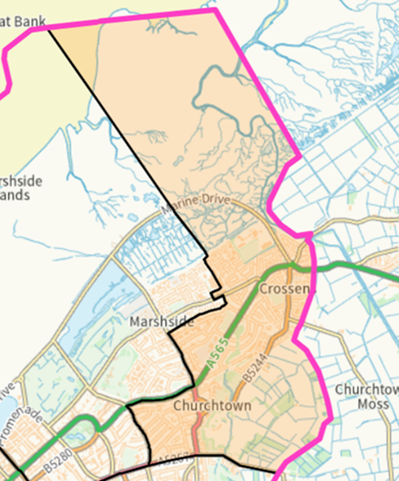 | 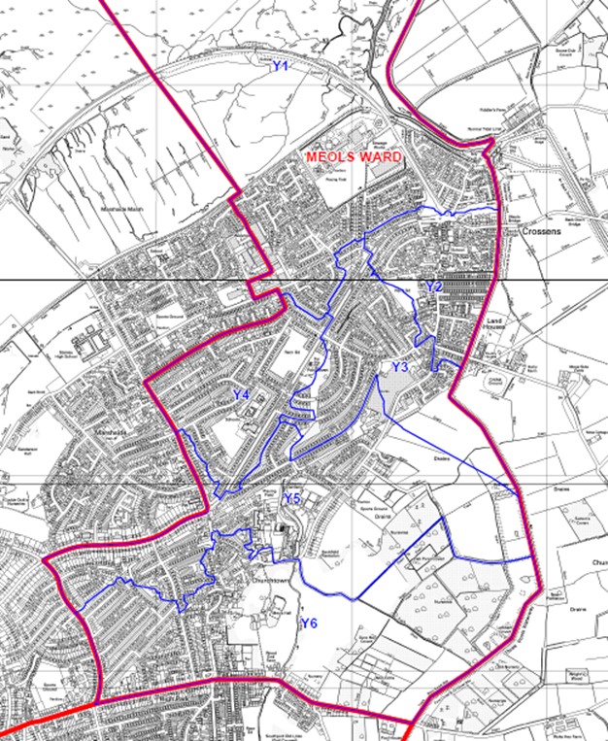

Meols Ward

Review of Polling Districts, Polling Places and Polling Stations 2025
Returning Officer's Representations
Existing Ward Name | Cambridge |  | New Ward Name |  | Cambridge
Number of Polling Places | 4 |  | No. of Polling Stations | 6
Constituency | Southport

Polling District  Code | Current Polling Place/ Station | Proposal |  |  | Returning Officer's Comments
 |  | Electorate | Polling District Boundary | Polling Place
X1 | Fleetwood Hesketh Sports & Social Club, Fylde Road, PR9 9XH | 1689 | Change/  No Change | Change/  No Change
X2 | Emmanuel Church Hall, Cambridge Road, PR9 9PR | 1412 | Change/  No Change | Change/  No Change
X3 | Emmanuel Church Hall, Cambridge Road, PR9 9PR | 1752 | Change/  No Change | Change/  No Change
X4 | All Saints Parish Hall, Park Road, PR9 9JB | 1528 | Change/  No Change | Change/  No Change
X5 | Southport Quaker Meeting House, 16 Court Road, PR9 9ER | 1567 | Change/  No Change | Change/  No Change
X6 | Southport Quaker Meeting House, 16 Court Road, PR9 9ER | 1733 | Change/  No Change | Change/  No Change

Cambridge Ward Local Government Boundary Commission Comments
New Ward Name Cambridge
The Southport Liberal Democrats requested minor adjustments to the boundary between our proposed Cambridge and Meols wards. Specifically, they proposed that Seaton Way and Northam Close, currently split between the two wards, be fully incorporated into Cambridge ward. Additionally, they requested that a few properties on Fairhaven Road be transferred to Meols ward. We concur that these two modifications will create a clearer and more identifiable ward boundary. We also note the minor improvement in electoral equality. We have thus included both changes in our final recommendations.
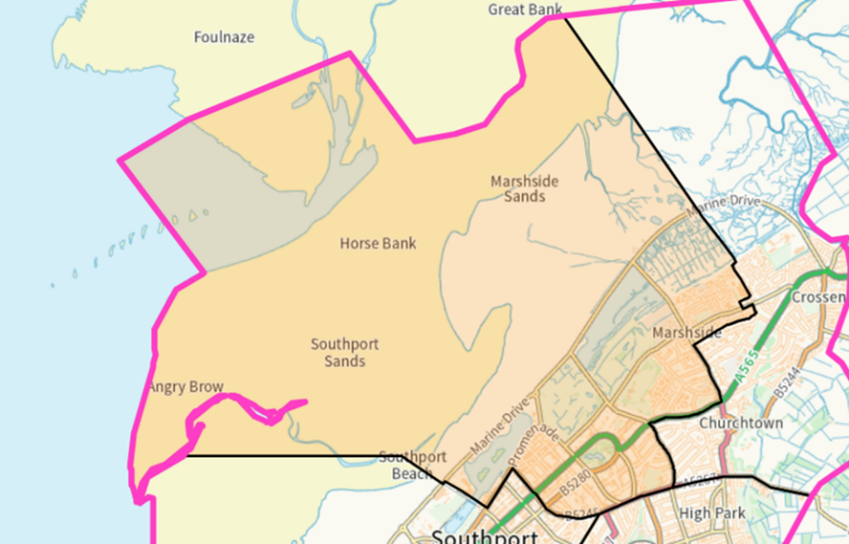 | 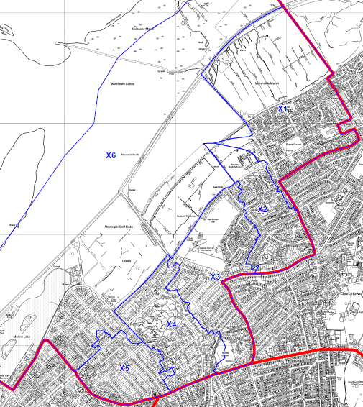

Cambridge Ward
Review of Polling Districts, Polling Places and Polling Stations 2025
Returning Officer's Representations
Existing Ward Name | Dukes |  | New Ward Name |  | Dukes
Number of Polling Places | 4 |  | No. of Polling Stations | 6
Constituency | Southport

Polling District  Code | Current Polling Place/ Station | Proposal |  |  | Returning Officer's Comments
 |  | Electorate | Polling District Boundary | Polling Place
W1 | Holy Trinity Church Hall, Hoghton Street, PR9 0TF | 1634 | Change/  No Change | Change/  No Change
W2 | Holy Trinity Church Hall, Hoghton Street, PR9 0TF | 1494 | Change/  No Change | Change/  No Change
W3 | Southport Market, King Street,  PR8 1LA | 1780 | Change/  No Change | Change/  No Change
W4 | St. James C.E. Church Hall, Memorial Hall, Lulworth Road,  PR8 2BQ | 1729 | Change/  No Change | Change/  No Change
W5 | Birkdale United Reformed Church Hall, Grosvenor Road, PR8 2ET | 1917 | Change/  No Change | Change/  No Change
W6 | Birkdale United Reformed Church Hall, Grosvenor Road, PR8 2ET | 1939 | Change/  No Change | Change/  No Change

Dukes Ward Local Government Boundary Commission Comments
New Ward Name Dukes
A vast majority of Hall Street is currently within Duke’s ward. However, a small portion of the eastern side of the road falls within Norwood ward. The Southport Liberal Democrats requested that all of Hall Street be included in Duke’s ward. We have adopted this minor modification as we consider it to provide for a more clearly identifiable ward boundary.
A local resident stated that our proposed Duke’s ward was particularly ‘odd’ because it combined the most deprived and least deprived areas in Southport. They argued that this would make it difficult for any political party to effectively represent the interests of this ward. We have no view of or regard for which political party may more effectively represent certain types of communities. Furthermore, we do not make the automatic presumption that, because two areas have different social-economic profiles, they should go into different wards. Having considered the evidence received, we have decided to make no changes to the boundaries of this ward, except for the small amendment outlined in the previous paragraph.
Another local resident expressed concerns about the allocation of resources in the Duke’s ward. However, this review is focused exclusively on the electoral arrangements within the borough. Our role does not extend to resource allocation across individual wards.

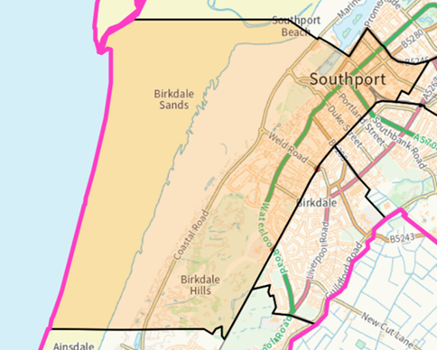 | 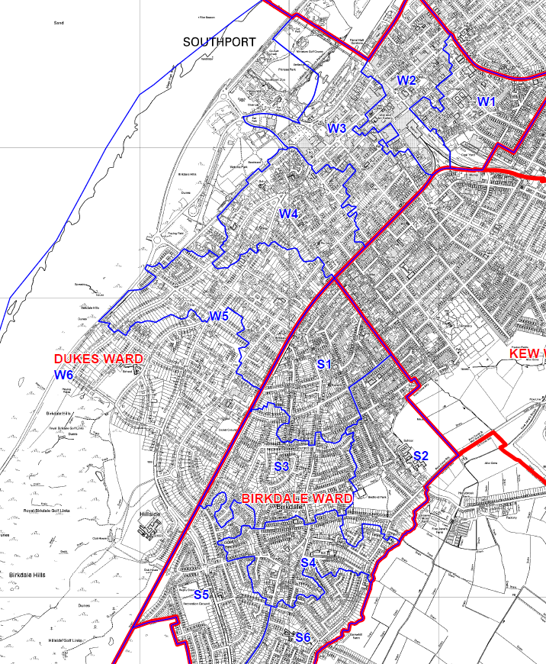

Dukes Ward

Review of Polling Districts, Polling Places and Polling Stations 2025
Returning Officer's Representations
Existing Ward Name | Norwood |  | New Ward Name |  | Norwood
Number of Polling Places | 4 |  | No. of Polling Stations | 6
Constituency | Southport

Polling District  Code | Current Polling Place/ Station | Proposal |  |  | Returning Officer's Comments
 |  | Electorate | Polling District Boundary | Polling Place
V1 | St. Luke`s Church Hall, St. Luke's Road, PR9 0SH | 2007 | Change/  No Change | Change/  No Change
V2 | Southport Community Centre, Norwood Road, PR8 6HQ | 2155 | Change/  No Change | Change/  No Change
V3 | Canning Road Evangelical Church Hall, Canning Road, PR9 7SS | 1576 | Change/  No Change | Change/  No Change
V4 | Canning Road Evangelical Church Hall, Canning Road, PR9 7SS | 1565 | Change/  No Change | Change/  No Change
V5 | St. Simon and St. Jude New Church Hall, Old Park Lane, PR9 7BQ | 1552 | Change/  No Change | Change/  No Change
V6 | St. Simon and St. Jude New Church Hall, Old Park Lane, PR9 7BQ | 1442 | Change/  No Change | Change/  No Change

Norwood Ward Local Government Boundary Commission Comments
New Ward Name Norwood
A local resident stated that the boundary between the areas of Kew and Blowick cuts through the middle of a community, following the route of a former railway line instead of the present railway line. They argued that this creates a disconnect between different areas in Norwood ward. The resident re-emphasised a preference for a Blowick ward, which they had put forward during the previous consultation. However, it was not clear from the local resident’s submissions how a potential Blowick ward would be configured. Therefore, we have decided not to make any changes to our Norwood ward based on these submissions.
The local resident also suggested that we could rename Norwood ward to High Park. We decided not to adopt this proposal as we were not persuaded that this name is any more reflective of the communities in this ward than the current name of Norwood.

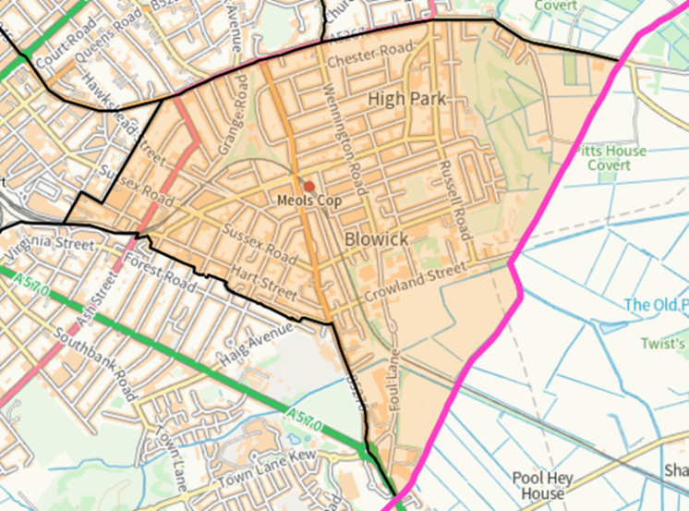 | 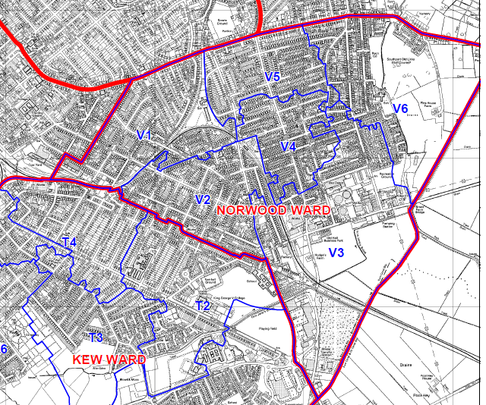

Norwood Ward
Review of Polling Districts, Polling Places and Polling Stations 2025
Returning Officer's Representations
Existing Ward Name | Kew |  | New Ward Name |  | Kew
Number of Polling Places | 5 |  | No. of Polling Stations | 6
Constituency | Southport

Polling District  Code | Current Polling Place/ Station | Proposal |  |  | Returning Officer's Comments
 |  | Electorate | Polling District Boundary | Polling Place
T1 | Church of St Francis of Assisi, 68 Folkestone Road, PR8 5PH | 2992 | Change/  No Change | Change/  No Change
T2 | Southport Football Club, Haig Avenue, PR8 6JZ | 1485 | Change/  No Change | Change/  No Change
T3 | The Family Life Centre, Ash Street, PR8 6JH | 1675 | Change/  No Change | Change/  No Change
T4 | St. Philip & St. Paul with Wesley Church, Hampton Road, PR8 6QF | 1750 | Change/  No Change | Change/  No Change
T5 | Fernley Road Christian Church, 1A Fernley Road, PR8 5AU | 1532 | Change/  No Change | Change/  No Change
T6 | Fernley Road Christian Church, 1A Fernley Road, PR8 5AU | 1510 | Change/  No Change | Change/  No Change

Kew Ward Local Government Boundary Commission Comments
New Ward Name Kew
The Southport Liberal Democrats proposed adjusting the boundary so that all of Haig Avenue falls within Kew ward. Currently, most of Haig Avenue is in Kew ward, but a small section on the odd-numbered side of the road is in Norwood ward. Similarly, a relatively new development at Princes Gardens is currently situated in the Norwood ward. However, it is only accessible from Kew ward. The Southport Liberal Democrats suggested moving the boundary so that Princes Gardens is included in Kew ward. We agree that these two changes will result in clearer ward boundaries and better reflect road access routes in the area. As a result, we have incorporated these boundary adjustments into our final recommendations.

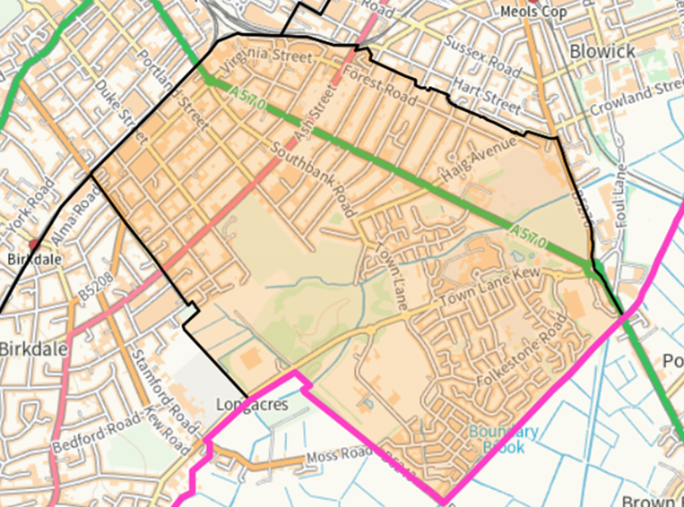 | 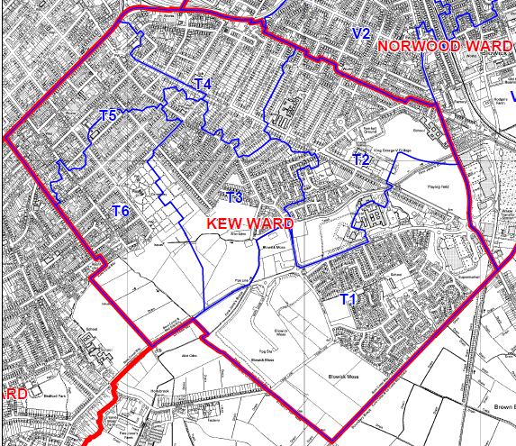

Kew Ward
Review of Polling Districts, Polling Places and Polling Stations 2025
Returning Officer's Representations
Existing Ward Name | Birkdale |  | New Ward Name |  | Birkdale
Number of Polling Places | 3 |  | No. of Polling Stations | 6
Constituency | Southport

Polling District  Code | Current Polling Place/ Station | Proposal |  |  | Returning Officer's Comments
 |  | Electorate | Polling District Boundary | Polling Place
S1 | St. Peter`s Parish Centre, St. Peter`s Road, PR8 4BY | 1954 | Change/  No Change | Change/  No Change
S2 | St. Peter`s Parish Centre, St. Peter`s Road, PR8 4BY | 1656 | Change/  No Change | Change/  No Change
S3 | St. John`s Hall, St. John`s Road, PR8 4JP | 1743 | Change/  No Change | Change/  No Change
S4 | Liverpool Road Methodist Church Hall, Liverpool Road, PR8 4PD | 1589 | Change/  No Change | Change/  No Change
S5 | Liverpool Road Methodist Church Hall, Liverpool Road, PR8 4PD | 1708 | Change/  No Change | Change/  No Change
S6 | Liverpool Road Methodist Church Hall, Liverpool Road, PR8 4PD | 1483 | Change/  No Change | Change/  No Change

Birkdale Ward Local Government Boundary Commission Comments
New Ward Name Birkdale
During the previous consultation, the Sefton Labour Group proposed moving several roads connected to Upper Aughton Road from Kew ward to Birkdale ward, to improve electoral equality in Kew ward. We were initially not persuaded to make this amendment, as we determined that Upper Aughton Road represented a strong and recognisable boundary. However, the Southport Liberal Democrats supported this aspect of the Labour Group’s submission, suggesting that we place the boundary on, or near, Boundary Street. They stated that this change would promote electoral equality but also restore the historical boundary between areas of Kew and Birkdale. They further emphasised that local residents in this area identify themselves as part of Birkdale. We have decided to adopt this proposal as it is clear that there is cross-party support for such change. There is clear evidence provided across both rounds of consultation that this adjustment would better reflect our statutory criteria and, in particular, the local community identities of residents in this area.
A local resident stated that the area incorporated into the Birkdale ward from the Kew ward has traditionally been viewed as part of Kew. However, the specific area transferred into the Kew ward consists of new residential development near the Garden Centre. As outlined in the draft recommendations, this adjustment was made to prevent the development from being divided across wards. The Southport Liberal Democrats have endorsed this decision. We consider that this particular part of the boundary between the Birkdale and Kew wards is clear and identifiable, and we retained it in our final recommendations.
Another local resident noted that it was ‘odd’ that our draft Kew ward had ‘hardly changed’, given the anticipated development within the ward. However, the aforementioned changes will bring the electoral variance of Kew ward closer to the average for the borough, resulting in a better level of electoral equality

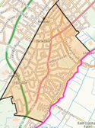 | 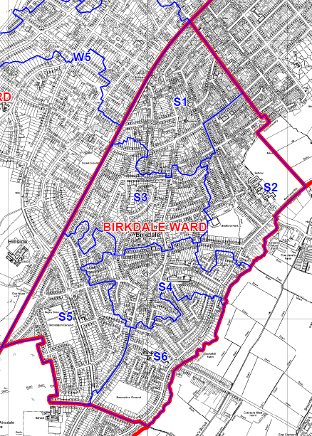

Birkdale Ward
Review of Polling Districts, Polling Places and Polling Stations 2025
Returning Officer's Representations
Existing Ward Name | Ainsdale |  | New Ward Name |  | Ainsdale
Number of Polling Places | 5 |  | No. of Polling Stations | 6
Constituency | Sefton Central

Polling District  Code | Current Polling Place/ Station | Proposal |  |  | Returning Officer's Comments
 |  | Electorate | Polling District Boundary | Polling Place
R1 | Sacred Heart Catholic Church Hall, Liverpool Road, PR8 3BP | 1835 | Change/  No Change | Change/  No Change
R2 | Ainsdale Methodist Church Hall, Liverpool Road, PR8 3NQ | 1507 | Change/  No Change | Change/  No Change
R3 | Shoreside Primary School, Westminster Drive, PR8 2QZ | 2194 | Change/  No Change | Change/  No Change
R4 | Ainsdale Methodist Church Hall, Liverpool Road, PR8 3NQ | 1530 | Change/  No Change | Change/  No Change
R5 | Pinfold Hall, Pinfold Lane, PR8 3QH | 1557 | Change/  No Change | Change/  No Change
R6 | Woodvale Community Centre, Meadow Lane, PR8 3RS | 1545 | Change/  No Change | Change/  No Change

Ainsdale Ward Local Government Boundary Commission Comments
New Ward Name Ainsdale
We received no submissions that related directly to our proposed Ainsdale ward. We have therefore decided to confirm the ward as final.
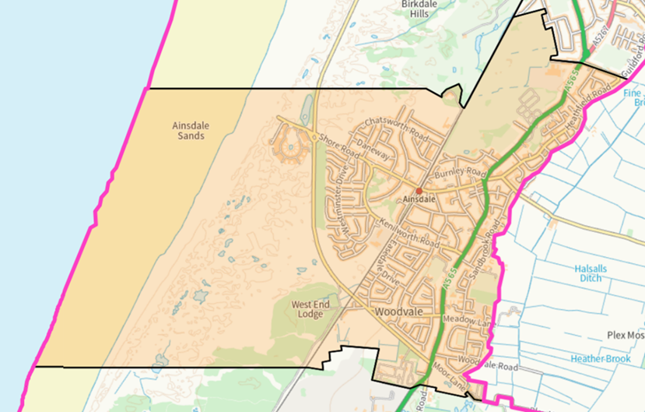 | 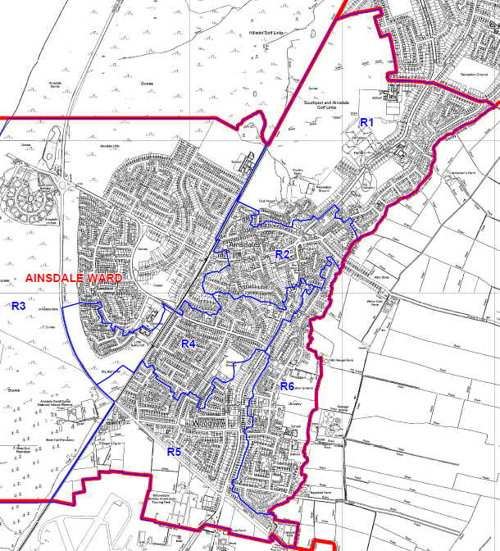

Ainsdale Ward
Review of Polling Districts, Polling Places and Polling Stations 2025
Returning Officer's Representations
Existing Ward Name | Harington |  | New Ward Name |  | Formby West
Number of Polling Places | 5 |  | No. of Polling Stations | 6
Constituency | Sefton Central

Polling District  Code | Current Polling Place/ Station | Proposal |  |  | Returning Officer's Comments
 |  | Electorate | Polling District Boundary | Polling Place
Q1 | Victoria Hall, 8 Timms Lane,  L37 7DN | 1227 | Change/  No Change | Change/  No Change | Formby Parish (Harington Ward)
Q2 | Freshfield Bowling Club,  16 Timms Lane, L37 7DN | 1349 | Change/  No Change | Change/  No Change | Formby Parish (Harington Ward)
Q3 | The Pinewoods Pub, Wicks Green, L37 1PR | 2229 | Change/  No Change | Change/  No Change | Formby Parish (Harington Ward)
Q4 | St. Lukes Church Meeting Room, St Lukes Church Road, L37 2DF | 1410 | Change/  No Change | Change/  No Change | Formby Parish (Harington Ward)
Q5 | St. Lukes Church Meeting Room, St Lukes Church Road, L37 2DF | 1279 | Change/  No Change | Change/  No Change | Formby Parish (Harington Ward)
Q6 | Holy Trinity Church Hall, Rosemary Lane, L37 3HA | 2320 | Change/  No Change | Change/  No Change | Formby Parish (Harington Ward)

Harington Ward Local Government Boundary Commission Comments
New Ward Name Formby West
A local resident proposed a significantly different warding pattern for the Formby area. This pattern comprised a Formby Freshfield ward and a Formby Ravenmeols ward, with Formby divided along a north–south axis. We carefully considered this proposal, given that we had previously sought feedback on whether such an arrangement would be preferable. However, we have ultimately decided not to adopt these wards in our final recommendations. We determined that the community evidence provided did not sufficiently justify why a north–south divide of Formby would be preferable and how it would better reflect community identities and interests. We consider that without a strong level of community-based evidence to support these proposals, a significant alteration of the boundaries outlined in our draft recommendations is not appropriate.
However, the local resident did provide evidence that the current ward names of Harington and Ravenmeols were no longer suitable. They indicated that the name ‘Ravenmeols’ was particularly unsuitable, given that the Raven Meols Hills are not within the ward. Another local resident submitted a proposal that Harington and Ravenmeols wards be renamed Formby West and Formby East, respectively. We have decided to adopt these ward names, as we agree with this local resident that they will be more identifiable to local electors.
Two local residents opposed splitting Formby between wards. However, as outlined in the draft recommendations, a ward encompassing the entirety of Formby and Little Altcar parishes would require six councillors to achieve good electoral equality. Therefore, both parishes must be divided across two three-councillor wards to ensure adherence to the presumption in legislation that the borough be represented by a uniform pattern of three-councillor wards, and to achieve good electoral equality.
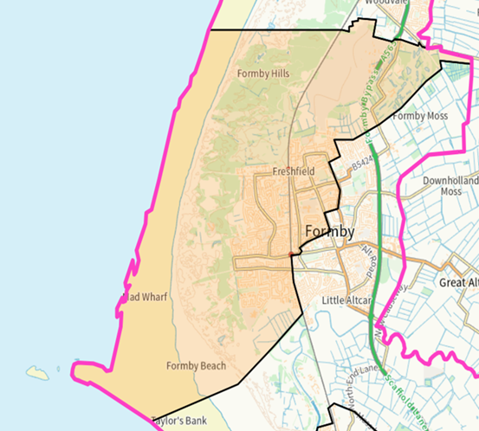 | 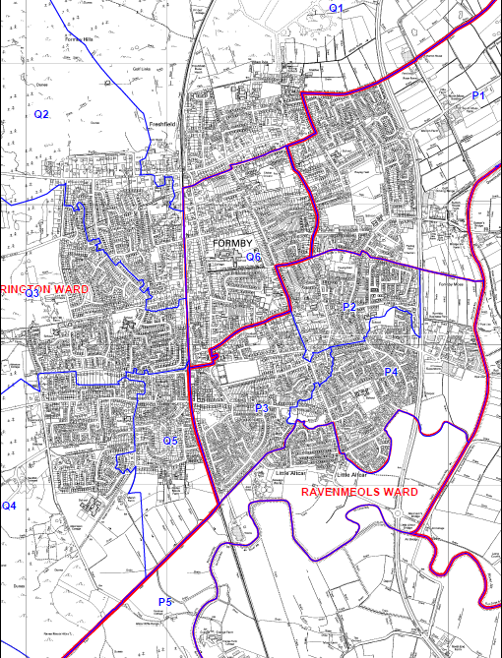

Review of Polling Districts, Polling Places and Polling Stations 2025
Returning Officer's Representations
Existing Ward Name | Ravenmeols |  | New Ward Name |  | Formby East
Number of Polling Places | 3 |  | No. of Polling Stations | 6
Constituency | Sefton Central

Polling District  Code | Current Polling Place/ Station | Proposal |  |  | Returning Officer's Comments
 |  | Electorate | Polling District Boundary | Polling Place
P1 | Lighthouse Church,  93 Church Road, L37 3NB | 2369 | Change/  No Change | Change/  No Change | Formby Parish (Ravenmeols Ward)
P2 | Lighthouse Church,  93 Church Road, L37 3NB | 1571 | Change/  No Change | Change/  No Change | Formby Parish (Ravenmeols Ward)
P3 | Ravenmeols Community Centre, 225 Park Road, L37 6EW | 2322 | Change/  No Change | Change/  No Change | Formby Parish (Ravenmeols Ward)
P4 | Ravenmeols Community Centre, 225 Park Road, L37 6EW | 2228 | Change/  No Change | Change/  No Change | Formby Parish (Ravenmeols Ward)
P5 | Ravenmeols Community Centre, 225 Park Road, L37 6EW | 1145 | Change/  No Change | Change/  No Change | Little Altcar Parish
P6 | Ince Blundell Village Hall, 1 Victoria Road, Ince Blundell, L38 6JE | 395 | Change/  No Change | Change/  No Change | Ince Blundell Parish

Ravenmeols Ward Local Government Boundary Commission Comments
New Ward Name Formby East
A local resident proposed a significantly different warding pattern for the Formby area. This pattern comprised a Formby Freshfield ward and a Formby Ravenmeols ward, with Formby divided along a north–south axis. We carefully considered this proposal, given that we had previously sought feedback on whether such an arrangement would be preferable. However, we have ultimately decided not to adopt these wards in our final recommendations. We determined that the community evidence provided did not sufficiently justify why a north–south divide of Formby would be preferable and how it would better reflect community identities and interests. We consider that without a strong level of community-based evidence to support these proposals, a significant alteration of the boundaries outlined in our draft recommendations is not appropriate.
However, the local resident did provide evidence that the current ward names of Harington and Ravenmeols were no longer suitable. They indicated that the name ‘Ravenmeols’ was particularly unsuitable, given that the Raven Meols Hills are not within the ward. Another local resident submitted a proposal that Harington and Ravenmeols wards be renamed Formby West and Formby East, respectively. We have decided to adopt these ward names, as we agree with this local resident that they will be more identifiable to local electors.
Two local residents opposed splitting Formby between wards. However, as outlined in the draft recommendations, a ward encompassing the entirety of Formby and Little Altcar parishes would require six councillors to achieve good electoral equality. Therefore, both parishes must be divided across two three-councillor wards to ensure adherence to the presumption in legislation that the borough be represented by a uniform pattern of three-councillor wards, and to achieve good electoral equality.
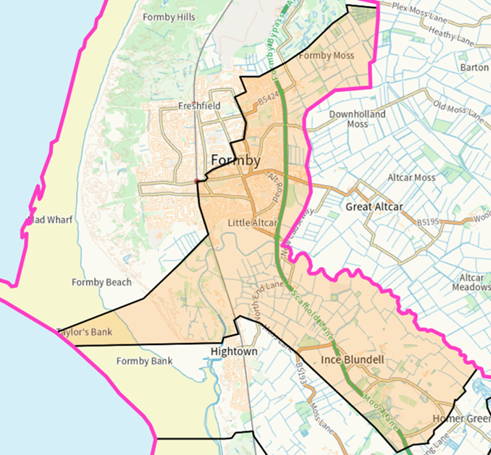 | 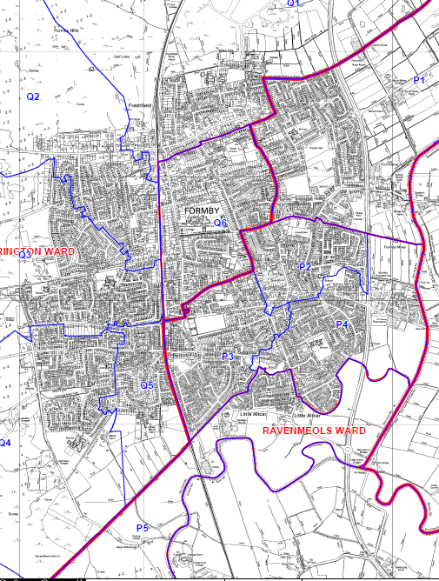

Review of Polling Districts, Polling Places and Polling Stations 2025
Returning Officer's Representations
Existing Ward Name | Manor |  | New Ward Name |  | Thornton & Hightown
Number of Polling Places | 4 |  | No. of Polling Stations | 6
Constituency | Sefton Central

Polling District  Code | Current Polling Place/ Station | Proposal |  |  | Returning Officer's Comments
 |  | Electorate | Polling District Boundary | Polling Place
N1 | St. Stephen`s Church Hall, St Stephen`s Road, Hightown, L38 0BL | 1738 | Change/  No Change | Change/  No Change | Hightown Parish
N2 | St. Helen's Catholic Church, 112 Alexandra Road, L23 7TQ | 1551 | Change/  No Change | Change/  No Change
N3 | All Saints with St Frideswyde, 93 Forefield Lane, L23 9TJ | 2479 | Change/  No Change | Change/  No Change
N4 | The King`s Church,  Drummond Road, L23 9YP | 1890 | Change/  No Change | Change/  No Change
N5 | The King`s Church,  Drummond Road, L23 9YP | 1811 | Change/  No Change | Change/  No Change | Thornton Parish
N6 | The King`s Church,  Drummond Road, L23 9YP | 482 | Change/  No Change | Change/  No Change | Sefton & Lunt Parish (South Ward)

Manor Ward Local Government Boundary Commission Comments
New Ward Name Thornton & Hightown
We received a submission from a local resident proposing that the parish of Ince Blundell be incorporated into a Manor ward which would be renamed Thornton & Little Crosby. The argument put forth was that, as a rural parish, the community identities and interests of Ince Blundell would be better represented in a ward alongside other rural parishes.
After careful consideration, we have decided not to adopt this change as part of our final recommendations. We acknowledge that the local resident provided some community evidence to support the transfer of Ince Blundell parish to a different ward. However, on balance, we were not persuaded we had received sufficient evidence to justify such a notable change to our draft recommendations.
We have nonetheless been persuaded that a ward name change is appropriate. However, we consider the name Thornton & Hightown, as suggested by another local resident, to be most appropriate. Given that the Thornton and Hightown areas are the two more populous communities in the ward, we consider it to be the most suitable ward name.
Two local residents requested that the area of Homer Green be included either as part of Ince Blundell or Sefton parishes, rather than in Thornton parish, due to its geographical location and more rural concerns. However, we cannot recommend any changes to external parish boundaries as part of this electoral review; this responsibility lies with the Borough Council through a Community Governance Review.
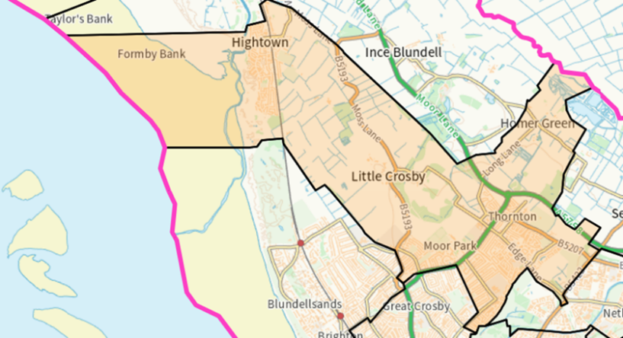
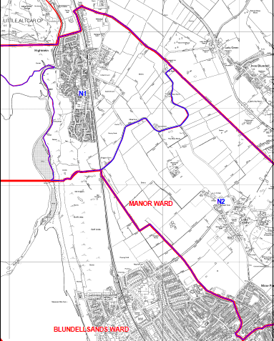 | 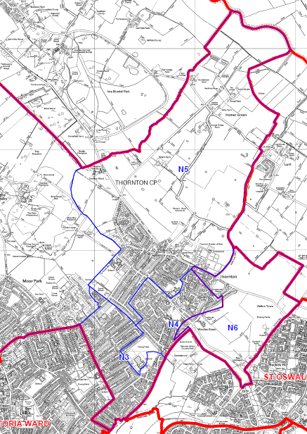

Review of Polling Districts, Polling Places and Polling Stations 2025
Returning Officer's Representations
Existing Ward Name | Blundellsands |  | New Ward Name |  | Blundellsands
Number of Polling Places | 6 |  | No. of Polling Stations | 6
Constituency | Sefton Central

Polling District  Code | Current Polling Place/ Station | Proposal |  |  | Returning Officer's Comments
 |  | Electorate | Polling District Boundary | Polling Place
M1 | Blundellsands Lawn Tennis Club, Warren Road, L23 6UF | 1341 | Change/  No Change | Change/  No Change
M2 | St. Michael`s Church Hall,  Dowhills Road, L23 8SP | 1742 | Change/  No Change | Change/  No Change
M3 | St. Helen's Catholic Church,  112 Alexandra Road, L23 7TQ | 1540 | Change/  No Change | Change/  No Change
M4 | St. Luke's Church,  71 Liverpool Road, L23 5SE | 1379 | Change/  No Change | Change/  No Change
M5 | Blundellsands & Crosby United Reformed Church Hall, Eshe Road, L23 3AR | 1382 | Change/  No Change | Change/  No Change
M6 | St. Nicholas Church Hall, Harlech Road, L23 6XA | 1865 | Change/  No Change | Change/  No Change

Blundellsands Ward Local Government Boundary Commission Comments
New Ward Name Blundellsands
During the consultation on our draft recommendations, we received several submissions that related to our Blundellsands and Victoria wards. One local resident requested that we refrain from making any changes to the current Victoria ward, expressing satisfaction with the existing boundary arrangement. However, three other local residents supported a change in boundaries, with two of them proposing specific modifications.
One of the local residents suggested shifting the more urbanised parts of our draft Manor ward and incorporating them into a renamed Great Crosby ward. Additionally, they proposed transferring portions of our draft Victoria ward into reconfigured Blundellsands and Waterloo wards. This adjustment would align the boundary with College Road while dividing the latter two wards along Brooke Road East and Brooke Road West. Another local resident, who supported the latter boundary change, also stated that we could address the forecast over-representation of Victoria ward by removing the area opposite Merchant Taylors’ School (up to and including Brownmoor Lane) by placing it in Manor ward.
We carefully considered these proposals. However, we have decided not to adopt any changes to the boundaries of our proposed Blundellsands and Victoria wards in our final recommendations. We consider that the community evidence provided was not strong enough to justify a significant variation in the boundaries defined in our draft recommendations. However, we have been persuaded that a name change for Victoria ward is appropriate and that the name Great Crosby provides a better reflection of the ward’s constituent communities. We have thus renamed our proposed Victoria ward Great Crosby in our final recommendations.
A local resident requested that the Carnegie Library building be moved from Blundellsands ward to Victoria ward. They argued that the building has no historical connection to Blundellsands and was instead part of the College Road community. The suggestion was to adjust the boundary between the two wards to follow Coronation Road. After careful consideration, we have adopted this small adjustment and placed the library in our proposed Great Crosby ward. We believe this change better reflects community identities and represents a minor adjustment that does not affect any electors.
A local resident requested that Forefield Lane be incorporated into a single ward. The road is currently divided between wards and parliamentary constituencies. However, no alternative ward boundary proposal was suggested. As a result, we have decided to retain this boundary in our final recommendations
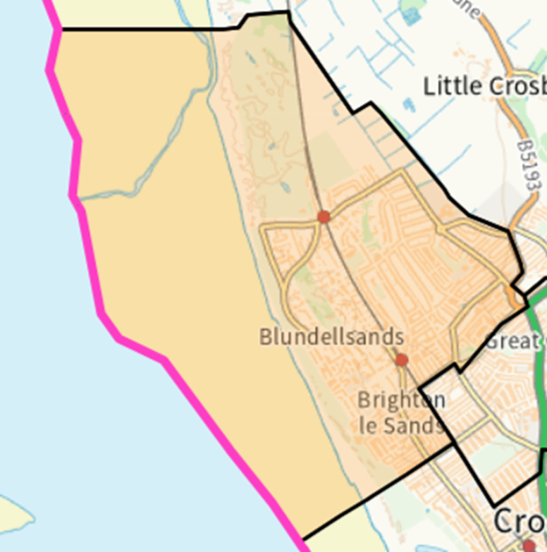 | 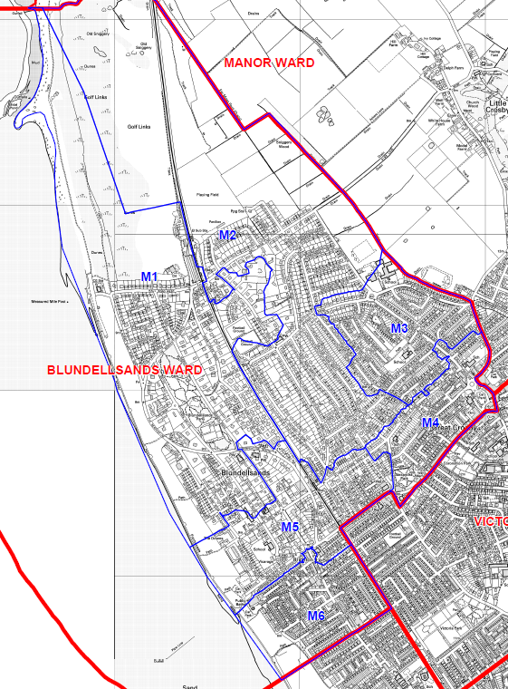
Blundellsands Ward
Review of Polling Districts, Polling Places and Polling Stations 2025
Returning Officer's Representations
Existing Ward Name | Sudell |  | New Ward Name |  | Maghull East
Number of Polling Places | 6 |  | No. of Polling Stations | 6
Constituency | Sefton Central

Polling District  Code | Current Polling Place/ Station | Proposal |  |  | Returning Officer's Comments
 |  | Electorate | Polling District Boundary | Polling Place
A1 | St. Peter`s Church,  Moorhey Road, L31 5LW | 1430 | Change/  No Change | Change/  No Change | Maghull Town Council (East Ward)
A2 | Maghull Cricket Club, Tommy Gent Way, Hall Lane, L31 3DY | 1628 | Change/  No Change | Change/  No Change | Maghull Town Council (East Ward)
A3 | The Pavilion, Glenn Park, off Haymans Green, L31 6DA | 2230 | Change/  No Change | Change/  No Change | Maghull Town Council (East Ward)
A4 | St. Gregory's Parish Centre, Liverpool Road, L31 2NA | 1096 | Change/  No Change | Change/  No Change | Maghull Town Council (North Ward)
A5 | Maghull Chapel,  85 Foxhouse Lane, L31 6EE | 2015 | Change/  No Change | Change/  No Change | Maghull Town Council (North Ward)
A6 | Moss Side Maghull Cricket Club,  400 Park Lane, L31 1HQ | 2176 | Change/  No Change | Change/  No Change | Maghull Town Council (North Ward)

Sudell Ward Local Government Boundary Commission Comments
New Ward Name Maghull East
We received four submissions that related to the names of our proposed Molyneux, Park and Sudell wards. Lydiate Parish Council requested that our draft Park ward be renamed Lydiate & Maghull West. This ward name was suggested by the Southport Liberal Democrats during the previous consultation, and we had invited comments on this proposal. Lydiate Parish Council stated that this revised ward name would assist electors in Lydiate parish to ‘better identify with their ward and strengthen the public’s knowledge on where Lydiate sits in Sefton.’ Three local residents also expressed support for this name change. We are therefore changing the name of Park ward to Lydiate & Maghull West as part of our final recommendations.
In our draft recommendations, we considered whether it was similarly appropriate to rename Sudell ward to Maghull East. Three local residents supported this ward name change. Consequently, we have therefore adopted this ward name change as part of our final recommendations.
To maintain consistency for ward names across the broader Maghull area, we have decided to rename Molyneux ward to Aintree & Maghull South. We consider that this revised ward name provides a clearer description of the ward’s constituent communities. This revised ward name was supported by two local residents.
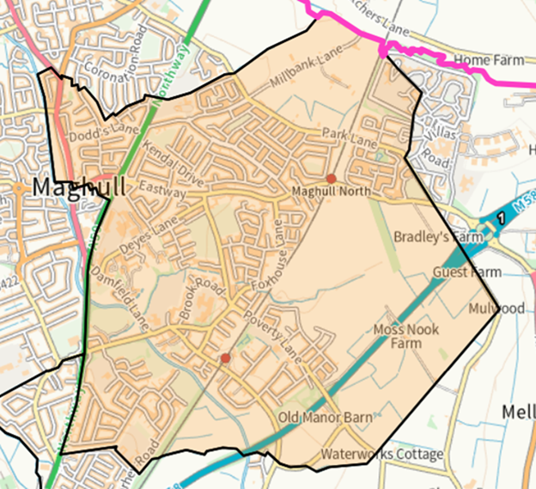 | 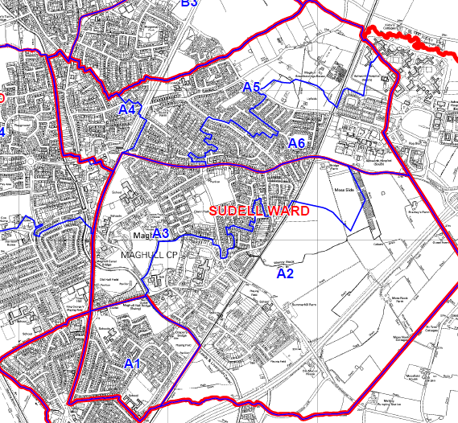

Review of Polling Districts, Polling Places and Polling Stations 2025
Returning Officer's Representations
Existing Ward Name | Park |  | New Ward Name |  | Lydiate & Maghull West
Number of Polling Places | 5 |  | No. of Polling Stations | 6
Constituency | Sefton Central

Polling District  Code | Current Polling Place/ Station | Proposal |  |  | Returning Officer's Comments
 |  | Electorate | Polling District Boundary | Polling Place
B1 | Lydiate Parish Hall,  288 Southport Road, L31 4EQ | 1040 | Change/  No Change | Change/  No Change | Lydiate Parish (North Ward)
B2 | Lydiate Village Centre,  Lambshear Lane, L31 2LA | 2284 | Change/  No Change | Change/  No Change | Lydiate Parish (West Ward)
B3 | St. Gregory's Parish Centre, Liverpool Road, L31 2NA | 1799 | Change/  No Change | Change/  No Change | Lydiate Parish (South Ward)
B4 | St. James Church Hall,  Green Lane, L31 8BW | 2465 | Change/  No Change | Change/  No Change | Maghull Town Council (West Ward)
B5 | Maghull Town Hall,  Hall Lane, L31 7BB | 1826 | Change/  No Change | Change/  No Change | Maghull Town Council (West Ward)
B6 | Maghull Town Hall,  Hall Lane, L31 7BB | 343 | Change/  No Change | Change/  No Change | Sefton & Lunt Parish (North Ward)

Park Ward Local Government Boundary Commission Comments
New Ward Name Lydiate & Maghull West
We received four submissions that related to the names of our proposed Molyneux, Park and Sudell wards. Lydiate Parish Council requested that our draft Park ward be renamed Lydiate & Maghull West. This ward name was suggested by the Southport Liberal Democrats during the previous consultation, and we had invited comments on this proposal. Lydiate Parish Council stated that this revised ward name would assist electors in Lydiate parish to ‘better identify with their ward and strengthen the public’s knowledge on where Lydiate sits in Sefton.’ Three local residents also expressed support for this name change. We are therefore changing the name of Park ward to Lydiate & Maghull West as part of our final recommendations.
In our draft recommendations, we considered whether it was similarly appropriate to rename Sudell ward to Maghull East. Three local residents supported this ward name change. Consequently, we have therefore adopted this ward name change as part of our final recommendations.
To maintain consistency for ward names across the broader Maghull area, we have decided to rename Molyneux ward to Aintree & Maghull South. We consider that this revised ward name provides a clearer description of the ward’s constituent communities. This revised ward name was supported by two local residents.

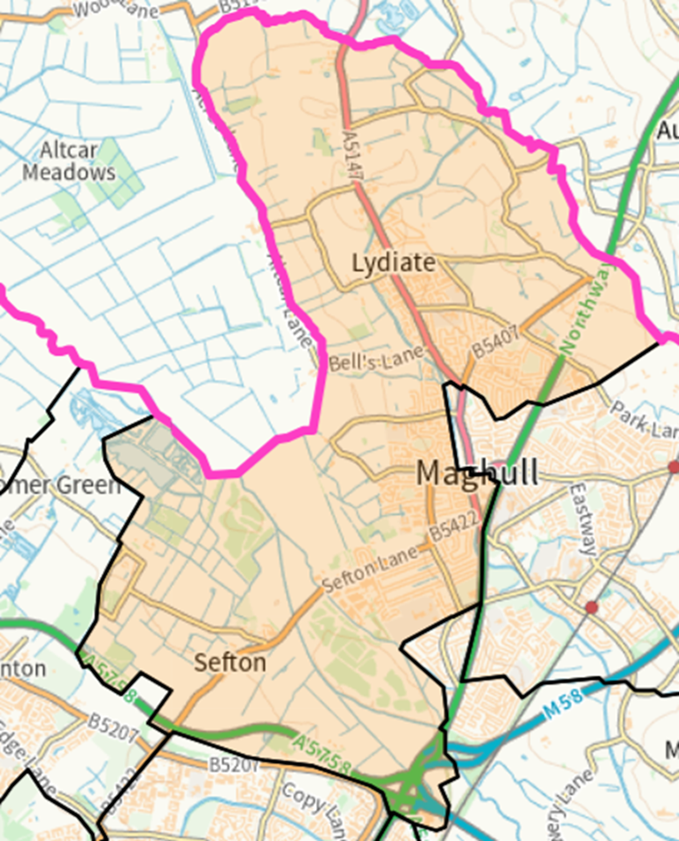 | 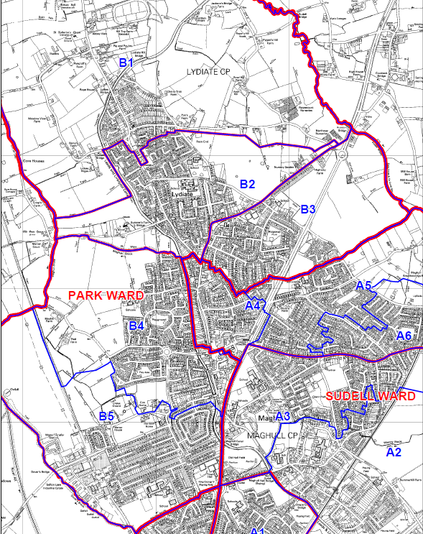

Review of Polling Districts, Polling Places and Polling Stations 2025
Returning Officer's Representations
Existing Ward Name | Molyneux |  | New Ward Name |  | Aintree & Maghull South
Number of Polling Places | 4 |  | No. of Polling Stations | 6
Constituency | Sefton Central (C1,C2,C3) and Liverpool Walton (C4,C5,C6)

Polling District  Code | Current Polling Place/ Station | Proposal |  |  | Returning Officer's Comments
 |  | Electorate | Polling District Boundary | Polling Place
C1 | Scout Hall, 146 Waddicar Lane, Melling, L31 1DZ | 319 | Change/  No Change | Change/  No Change | Melling Parish
C2 | Scout Hall, 146 Waddicar Lane, Melling, L31 1DZ | 2433 | Change/  No Change | Change/  No Change | Melling Parish
C3 | St. George's United Reformed Church Hall, Northway, L31 7BG | 2098 | Change/  No Change | Change/  No Change | Maghull Town Council (South Ward)
C4 | Aintree Community Centre, Oriel Drive, Aintree, L10 6NJ | 2028 | Change/  No Change | Change/  No Change | Aintree Village Parish (North Ward)
C5 | St. Giles Church, Aintree Lane, Aintree, L10 8LE | 1522 | Change/  No Change | Change/  No Change | Aintree Village Parish (South Ward)
C6 | St. Giles Church, Aintree Lane, Aintree, L10 8LE | 1922 | Change/  No Change | Change/  No Change | Aintree Village Parish (South Ward)

Molyneux Ward Local Government Boundary Commission Comments
New Ward Name Aintree & Maghull South
We received four submissions that related to the names of our proposed Molyneux, Park and Sudell wards. Lydiate Parish Council requested that our draft Park ward be renamed Lydiate & Maghull West. This ward name was suggested by the Southport Liberal Democrats during the previous consultation, and we had invited comments on this proposal. Lydiate Parish Council stated that this revised ward name would assist electors in Lydiate parish to ‘better identify with their ward and strengthen the public’s knowledge on where Lydiate sits in Sefton.’ Three local residents also expressed support for this name change. We are therefore changing the name of Park ward to Lydiate & Maghull West as part of our final recommendations.
In our draft recommendations, we considered whether it was similarly appropriate to rename Sudell ward to Maghull East. Three local residents supported this ward name change. Consequently, we have therefore adopted this ward name change as part of our final recommendations.
To maintain consistency for ward names across the broader Maghull area, we have decided to rename Molyneux ward to Aintree & Maghull South. We consider that this revised ward name provides a clearer description of the ward’s constituent communities. This revised ward name was supported by two local residents.
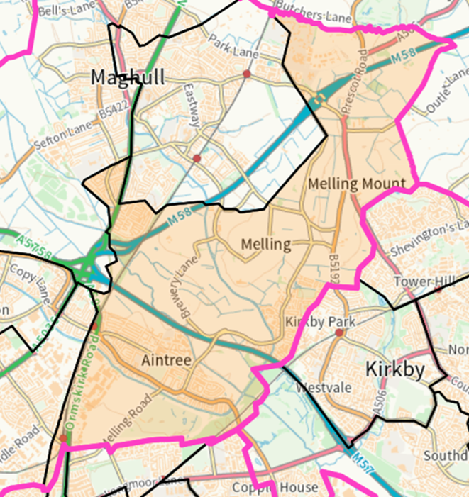 | 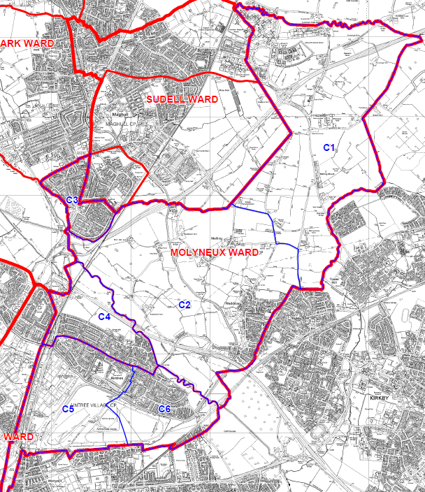

Review of Polling Districts, Polling Places and Polling Stations 2025
Returning Officer's Representations
Existing Ward Name | Victoria |  | New Ward Name |  | Great Crosby
Number of Polling Places | 6 |  | No. of Polling Stations | 6
Constituency | Bootle

Polling District  Code | Current Polling Place/ Station | Proposal |  |  | Returning Officer's Comments
 |  | Electorate | Polling District Boundary | Polling Place
L1 | Marine Football Club, Rosset Park Stadium, College Road, L23 3AS | 1576 | Change/  No Change | Change/  No Change
L2 | Waterloo Methodist Church, Birchdale Road, L22 9QX | 1654 | Change/  No Change | Change/  No Change
L3 | Crosby Comrades Club,  96 Liverpool Road, L23 5TG | 1992 | Change/  No Change | Change/  No Change
L4 | Crosby ATC & ACF Cadet Centre, Endbutt Lane, L23 0TT | 1968 | Change/  No Change | Change/  No Change
L5 | Queensway Allotments Meeting Room, Queensway, L22 4RA | 1469 | Change/  No Change | Change/  No Change
L6 | All Saints with St Frideswyde, 93 Forefield Lane, L23 9TJ | 1965 | Change/  No Change | Change/  No Change

Victoria Ward Local Government Boundary Commission Comments
New Ward Name Great Crosby
During the consultation on our draft recommendations, we received several submissions that related to our Blundellsands and Victoria wards. One local resident requested that we refrain from making any changes to the current Victoria ward, expressing satisfaction with the existing boundary arrangement. However, three other local residents supported a change in boundaries, with two of them proposing specific modifications.
One of the local residents suggested shifting the more urbanised parts of our draft Manor ward and incorporating them into a renamed Great Crosby ward. Additionally, they proposed transferring portions of our draft Victoria ward into reconfigured Blundellsands and Waterloo wards. This adjustment would align the boundary with College Road while dividing the latter two wards along Brooke Road East and Brooke Road West. Another local resident, who supported the latter boundary change, also stated that we could address the forecast over-representation of Victoria ward by removing the area opposite Merchant Taylors’ School (up to and including Brownmoor Lane) by placing it in Manor ward.
We carefully considered these proposals. However, we have decided not to adopt any changes to the boundaries of our proposed Blundellsands and Victoria wards in our final recommendations. We consider that the community evidence provided was not strong enough to justify a significant variation in the boundaries defined in our draft recommendations. However, we have been persuaded that a name change for Victoria ward is appropriate and that the name Great Crosby provides a better reflection of the ward’s constituent communities. We have thus renamed our proposed Victoria ward Great Crosby in our final recommendations.
A local resident requested that the Carnegie Library building be moved from Blundellsands ward to Victoria ward. They argued that the building has no historical connection to Blundellsands and was instead part of the College Road community. The suggestion was to adjust the boundary between the two wards to follow Coronation Road. After careful consideration, we have adopted this small adjustment and placed the library in our proposed Great Crosby ward. We believe this change better reflects community identities and represents a minor adjustment that does not affect any electors.
A local resident requested that Forefield Lane be incorporated into a single ward. The road is currently divided between wards and parliamentary constituencies. However, no alternative ward boundary proposal was suggested. As a result, we have decided to retain this boundary in our final recommendations
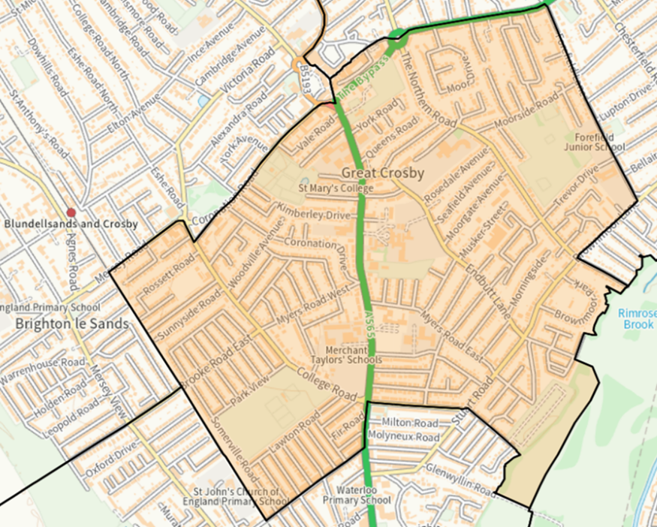 | 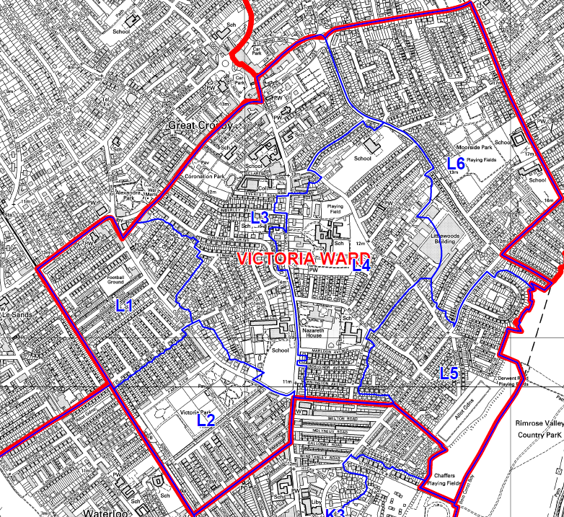

Review of Polling Districts, Polling Places and Polling Stations 2025
Returning Officer's Representations
Existing Ward Name | Church |  | New Ward Name |  | Waterloo
Number of Polling Places | 5 |  | No. of Polling Stations | 6
Constituency | Bootle

Polling District  Code | Current Polling Place/ Station | Proposal |  |  | Returning Officer's Comments
 |  | Electorate | Polling District Boundary | Polling Place
K1 | St. Edmund of Canterbury Parish Centre, 62 Oxford Road, L22 8QF | 1682 | Change/  No Change | Change/  No Change
K2 | Kingsway Christian Centre,  Church Road, L22 5NA | 1766 | Change/  No Change | Change/  No Change
K3 | Crosby Central Library,  Crosby Road North, L22 0LQ | 2280 | Change/  No Change | Change/  No Change
K4 | SING Plus Centre,  53 Cambridge Road, L21 1EZ | 1134 | Change/  No Change | Change/  No Change
K5 | SING Plus Centre,  53 Cambridge Road, L21 1EZ | 1226 | Change/  No Change | Change/  No Change
K6 | Rimrose Hope Primary School, Sandy Road, L21 1AD | 1115 | Change/  No Change | Change/  No Change

Church Ward Local Government Boundary Commission Comments
New Ward Name Waterloo
We received four submissions from local residents regarding our draft Church ward. All of these submissions expressed a preference for a different ward name, with each submission arguing that the Church name did not accurately describe the ward’s constituent communities. The alternative names suggested were Waterloo, Waterloo Station and Waterloo & Seaforth. After careful consideration, we consider that the name of Waterloo to be the most suitable, given it forms the predominant community in the proposed ward. We propose no changes to the boundaries of this ward as part of our final recommendations.
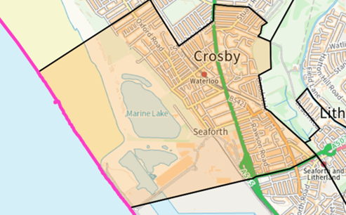 | 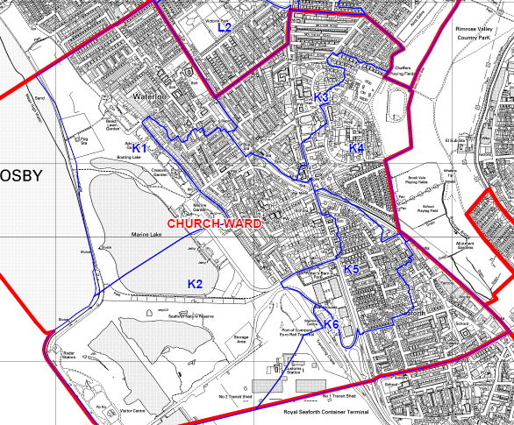

Review of Polling Districts, Polling Places and Polling Stations 2025
Returning Officer's Representations
Existing Ward Name | Linacre |  | New Ward Name |  | Bootle West
Number of Polling Places | 5 |  | No. of Polling Stations | 6
Constituency | Bootle

Polling District  Code | Current Polling Place/ Station | Proposal |  |  | Returning Officer's Comments
 |  | Electorate | Polling District Boundary | Polling Place
J1 | Bowersdale Resource Centre, Crescent Road, L21 4LJ | 1599 | Change/  No Change | Change/  No Change
J2 | St. Leonard`s Church,  60 Peel Road, L20 4RW | 1410 | Change/  No Change | Change/  No Change
J3 | St. Leonard`s Church,  60 Peel Road, L20 4RW | 1608 | Change/  No Change | Change/  No Change
J4 | Brunswick Youth & Community Centre, 104 Marsh Lane, L20 4JQ | 1488 | Change/  No Change | Change/  No Change
J5 | Bootle Main Library,  220 Stanley Road, L20 3EN | 1435 | Change/  No Change | Change/  No Change
J6 | Community by Nature,  40/42 Hertford Road, L20 7DH | 1594 | Change/  No Change | Change/  No Change

Linacre Ward Local Government Boundary Commission Comments
New Ward Name Bootle West
A local resident proposed that our recommended Derby and Linacre wards be renamed Bootle West and Bootle East, respectively. We have decided to adopt these names as we agree with the local resident that they are more relevant and reflective of local communities and will provide electors in Bootle with a clearer understanding of the area that each ward covers.
Another local resident opposed our decision to move the boundary between the current Linacre and Church wards from the A5036 road. While we note that this road would serve as an identifiable boundary, it would result in our proposed Bootle West ward having a forecast electoral variance of -13% by 2029. We are not persuaded that sufficient evidence has been put forward to support such a variance and have therefore decided to confirm our draft recommendations as final in this respect.
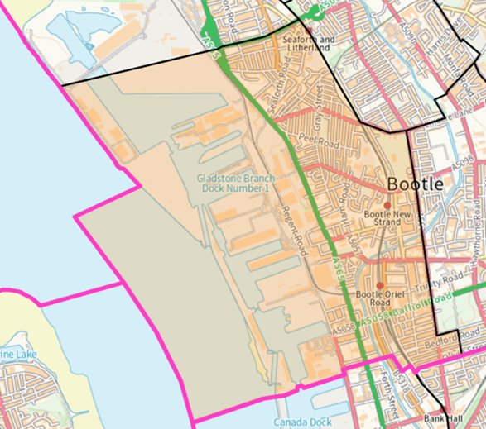 | 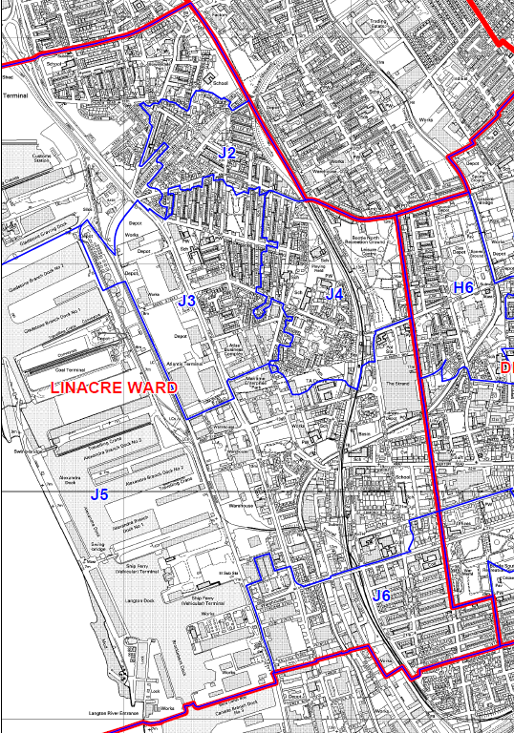

Review of Polling Districts, Polling Places and Polling Stations 2025
Returning Officer's Representations
Existing Ward Name | Derby |  | New Ward Name |  | Bootle East
Number of Polling Places | 6 |  | No. of Polling Stations | 6
Constituency | Bootle

Polling District  Code | Current Polling Place/ Station | Proposal |  |  | Returning Officer's Comments
 |  | Electorate | Polling District Boundary | Polling Place
H1 | Bootle Cricket Club,  Wadham Road, L20 2DD | 1565 | Change/  No Change | Change/  No Change
H2 | Bootle Provincial Church Hall,  4-6 University Road, L20 3NF | 1175 | Change/  No Change | Change/  No Change
H3 | Christ Church Parish Hall,  Oxford Road, L20 9HW | 1472 | Change/  No Change | Change/  No Change
H4 | St. Monica`s Parish Centre,  Stewart Avenue, L20 9JD | 2591 | Change/  No Change | Change/  No Change
H5 | YKids, (Former Orrell Library),  98A Linacre Lane, L20 6ES | 1033 | Change/  No Change | Change/  No Change
H6 | St. Matthew's and St. Mary's Church, 410 Stanley Road, L20 5AE | 1281 | Change/  No Change | Change/  No Change

Derby Ward Local Government Boundary Commission Comments
New Ward Name Bootle East
A local resident proposed that our recommended Derby and Linacre wards be renamed Bootle West and Bootle East, respectively. We have decided to adopt these names as we agree with the local resident that they are more relevant and reflective of local communities and will provide electors in Bootle with a clearer understanding of the area that each ward covers.
Another local resident opposed our decision to move the boundary between the current Linacre and Church wards from the A5036 road. While we note that this road would serve as an identifiable boundary, it would result in our proposed Bootle West ward having a forecast electoral variance of -13% by 2029. We are not persuaded that sufficient evidence has been put forward to support such a variance and have therefore decided to confirm our draft recommendations as final in this respect.
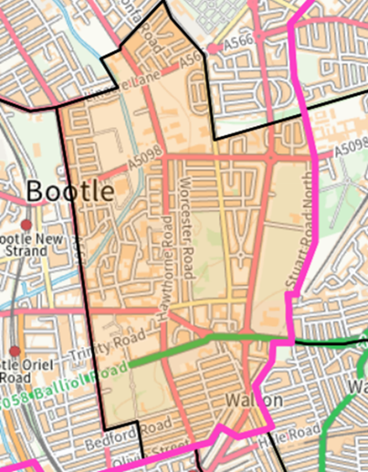 | 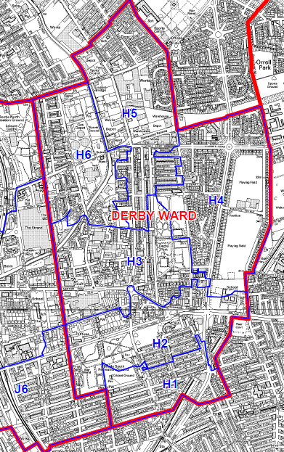

Review of Polling Districts, Polling Places and Polling Stations 2025
Returning Officer's Representations
Existing Ward Name | Litherland |  | New Ward Name |  | Litherland
Number of Polling Places | 5 |  | No. of Polling Stations | 6
Constituency | Bootle

Polling District  Code | Current Polling Place/ Station | Proposal |  |  | Returning Officer's Comments
 |  | Electorate | Polling District Boundary | Polling Place
G1 | Swan Womens Centre,  Linacre Road, L21 6NR | 1857 | Change/  No Change | Change/  No Change
G2 | Linacre Bridge Community Hub,  546 Stanley Road, L20 5DW | 1509 | Change/  No Change | Change/  No Change
G3 | Linacre Bridge Community Hub,  546 Stanley Road, L20 5DW | 1689 | Change/  No Change | Change/  No Change
G4 | Mel Inn Social Club,  513 Hawthorne Road, L20 6JJ | 728 | Change/  No Change | Change/  No Change
G5 | British Legion Club,  2-4 Orrell Road, L21 8NU | 1605 | Change/  No Change | Change/  No Change
G6 | Netherton Park Estate Social Club Pavilion, 1 Arnside, L21 5JH | 1856 | Change/  No Change | Change/  No Change

Litherland Ward Local Government Boundary Commission Comments
New Ward Name Litherland
No submissions received that related directly to our proposed Litherland ward. We have therefore decided to confirm the ward as final.
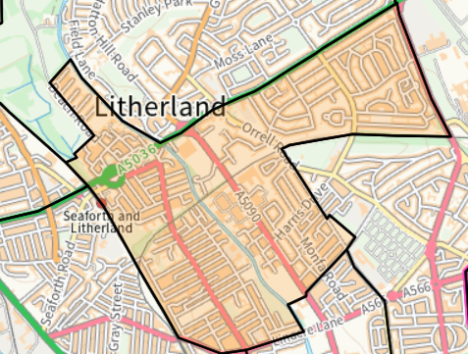 | 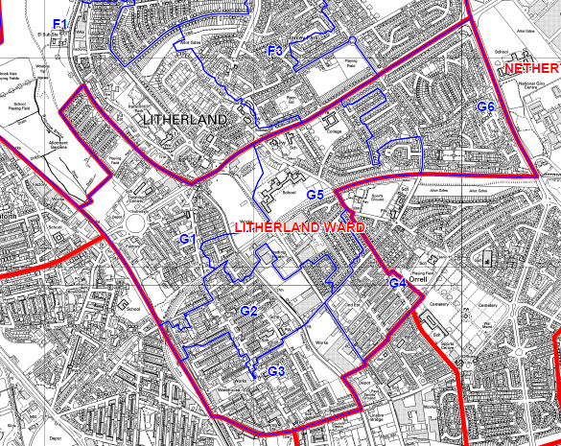

Review of Polling Districts, Polling Places and Polling Stations 2025
Returning Officer's Representations
Existing Ward Name | Ford |  | New Ward Name |  | Ford
Number of Polling Places | 4 |  | No. of Polling Stations | 6
Constituency | Bootle

Polling District  Code | Current Polling Place/ Station | Proposal |  |  | Returning Officer's Comments
 |  | Electorate | Polling District Boundary | Polling Place
F1 | English Martyrs Parish Hall,  School Lane, L21 7LX | 1781 | Change/  No Change | Change/  No Change
F2 | Ford Lane Community Centre,  Ford Lane, L21 9NF | 1650 | Change/  No Change | Change/  No Change
F3 | English Martyrs Parish Hall,  School Lane, L21 7LX | 1768 | Change/  No Change | Change/  No Change
F4 | Litherland Family Wellbeing Centre, off Boundary Road, L21 7LA | 1229 | Change/  No Change | Change/  No Change
F5 | Marjorie McKay Centre,  Carr Meadow Hey, L30 2NY | 1324 | Change/  No Change | Change/  No Change
F6 | Ford Lane Community Centre,  Ford Lane, L21 9NF | 1547 | Change/  No Change | Change/  No Change

Ford Ward Local Government Boundary Commission Comments
New Ward Name Ford
No submissions received that related directly to this ward. We have therefore decided to confirm our draft recommendations for Ford ward as final.
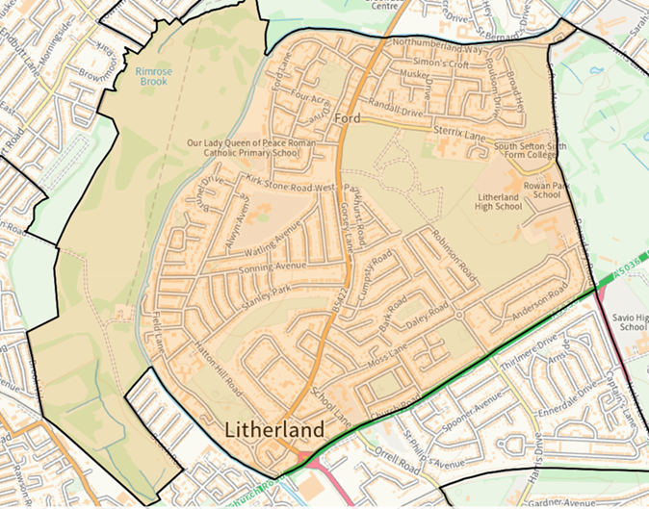 | 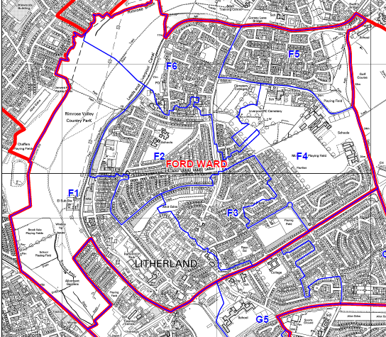

Review of Polling Districts, Polling Places and Polling Stations 2025
Returning Officer's Representations
Existing Ward Name | St Oswald |  | New Ward Name |  | Netherton North
Number of Polling Places | 4 |  | No. of Polling Stations | 6
Constituency | Bootle

Polling District  Code | Current Polling Place/ Station | Proposal |  |  | Returning Officer's Comments
 |  | Electorate | Polling District Boundary | Polling Place
E1 | St. Mark's Church,  Gorsey Lane, L30 2QN | 994 | Change/  No Change | Change/  No Change
E2 | Feelgood Factory,  Glovers Lane, L30 5QW | 1608 | Change/  No Change | Change/  No Change
E3 | Netherton Activity Centre,  Glovers Lane, L30 3TL | 1436 | Change/  No Change | Change/  No Change
E4 | Netherton Activity Centre,  Glovers Lane, L30 3TL | 1147 | Change/  No Change | Change/  No Change
E5 | Feelgood Factory,  Glovers Lane, L30 5QW | 1648 | Change/  No Change | Change/  No Change
E6 | St. Oswald`s Church & Community Centre,  Ronald Ross Avenue, L30 5RD | 1315 | Change/  No Change | Change/  No Change

St Oswald Ward Local Government Boundary Commission Comments
New Ward Name Netherton North
We received two submissions concerning the names of Netherton & Orrell and St Oswald wards. One local resident suggested renaming these wards Netherton East & Orrell and Netherton St Oswald, while another proposed renaming them Netherton South & Orrell and Netherton North.
We agree that these ward names should be amended to better reflect the communities they represent. After consideration, we find the names Netherton South & Orrell and Netherton North to be more suitable as we consider them to be more geographically accurate and have adopted them as part of our final recommendations
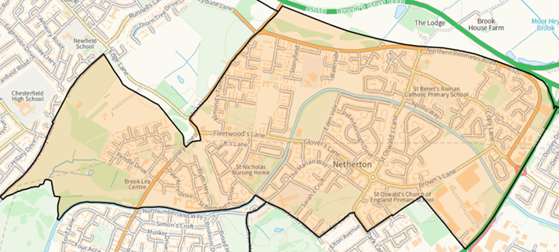 | 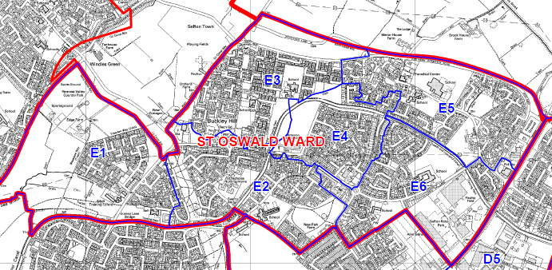

Review of Polling Districts, Polling Places and Polling Stations 2025
Returning Officer's Representations
Existing Ward Name | Netherton & Orrell |  | New Ward Name |  | Netherton South & Orrell
Number of Polling Places | 5 |  | No. of Polling Stations | 6
Constituency | Bootle

Polling District  Code | Current Polling Place/ Station | Proposal |  |  | Returning Officer's Comments
 |  | Electorate | Polling District Boundary | Polling Place
D1 | YKids, (Former Orrell Library),  98A Linacre Lane, L20 6ES | 1512 | Change/  No Change | Change/  No Change
D2 | St. John & St. James Church and Community Centre,  71 Bailey Drive, L20 6EX | 1504 | Change/  No Change | Change/  No Change
D3 | St. John & St. James Church and Community Centre,  71 Bailey Drive, L20 6EX | 1750 | Change/  No Change | Change/  No Change
D4 | Netherton Park Neighbourhood Centre, Chester Avenue, L30 1QW | 2044 | Change/  No Change | Change/  No Change
D5 | The Oldy Club,  Ormskirk Road, L30 8RA | 1992 | Change/  No Change | Change/  No Change
D6 | St. Oswald`s Church & Community Centre,  Ronald Ross Avenue, L30 5RD | 946 | Change/  No Change | Change/  No Change

Netherton & Orrell Ward Local Government Boundary Commission Comments
New Ward Name Netherton South & Orrell
We received two submissions concerning the names of Netherton & Orrell and St Oswald wards. One local resident suggested renaming these wards Netherton East & Orrell and Netherton St Oswald, while another proposed renaming them Netherton South & Orrell and Netherton North.
We agree that these ward names should be amended to better reflect the communities they represent. After consideration, we find the names Netherton South & Orrell and Netherton North to be more suitable as we consider them to be more geographically accurate and have adopted them as part of our final recommendations
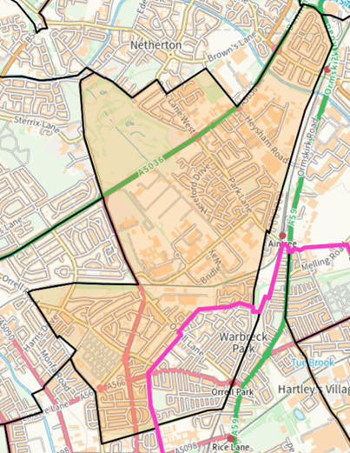 | 