

STATEMENT
OF ACCOUNTS

2022/2023

Final audited version approved by
the Chair of Audit and Governance Committee – 9th December 2024

Contents

Section Page

- Narrative Report 1

- Statement of Responsibilities for the Statement of Accounts 25

- Comprehensive Income and Expenditure Statement 27

- Movement in Reserves Statement 29

- Balance Sheet 31

- Cash Flow Statement 33

- Notes to the Financial Statements - Expenditure and Funding 35 Analysis

- Other Notes to the Financial Statements 37

- Collection Fund 111

- Group Accounts 115

- Annual Governance Statement 129

- Independent Auditors’ Report to the Members of Sefton 143
Council

- Glossary 147

- Abbreviations 155

- Useful Addresses 157

Sefton MBC Statement of Accounts 2022/23

1 NARRATIVE REPORT

Introduction

Sefton is a Metropolitan Borough Council, providing the full range of local authority services to the residents of Sefton. These services include planning, licensing, street cleansing, highways maintenance, and refuse collection, as well as safeguarding vulnerable children and helping older people retain their independence.

Located on the west coast of England between Liverpool in the south and Lancashire in the north / northwest, the Council covers the area of around 15,000 hectares, stretching from Bootle in the South, through Seaforth, Waterloo, Crosby, Thornton, Altcar, Ince Blundell, Lunt, Freshfield and Formby, up to and including Birkdale, Ainsdale, Southport and Crossens in the North. It also includes the areas of Maghull, Lydiate and parts of Melling and Aintree. It is responsible for providing services to approximately 279,000 residents, local businesses and industry.

As a local authority, Sefton is accountable to Central Government and the electorate. It is responsible for continuously looking to improve its services to ensure that it meets the needs of the local community. Each service must ensure that the local taxpayers are receiving "value for money" by delivering high quality outcomes.

The Council has continued to face significant financial challenges in 2022/2023. As a result of the
Government’s previous austerity program, the Council’s core grant funding was reduced every year over a ten-year period between 2010/2011 and 2019/20. By 2019/2020 core Government grant funding had reduced by more than 50%. As a result of the cuts in grant funding, local authorities are now more reliant on local sources of income such as Council Tax and Business Rates. During this period the Council has also seen a rise in demand for statutory services, most notably social care services provided to vulnerable adults and children.

For 2022/23, the Government announced a £14.5 million (13.4%) increase in the Sefton Council’s core grant funding, which equated to a 7.7% increase in total core funding when council tax income was taken into account. The grant increase included £1.0 million from the Market Sustainability and Fair Cost of Care Fund which comes with new responsibilities and a one-off services grant of £4.5 million which included compensation for the additional cost of employer’s national insurance contributions as a result of the health and social care levy. This is only the third year in which funding has increased since 2010/11 and core grant funding remains lower than it was in 2014/15 in cash terms.

As a result of the previous funding cuts and the increase in demand for statutory services, the Council needed to identify and agree savings of £233 million within its financial plans between 2010/11 and 2019/20. The impact of these savings required a radical change to the way that the Council operates and provides services. To facilitate this change, the Council undertook a major consultation exercise in 2016 to identify the areas that local residents thought the Council should prioritise for use of its resources (Sefton 2030 Vision and Council Core Purpose). The outcome of this consultation is summarised later in this document. The Council also invited the LGA to undertake a peer group review which was undertaken in September 2018, the recommendations of this review have been implemented over the following years. The LGA were due to follow up the initial review with a visit in 2020, however, this was postponed because of the coronavirus pandemic. The LGA have since revisited the Council in April 2022 to assess progress against their recommendations.

In order to facilitate the changes required to meet the Council’s future priorities, we developed a Framework for Change program. This program covers three main strands, Economic Growth and Strategic Investment, Council of 2023 and Demand Management. The Council has also developed a Climate Change Emergency Plan that represents its commitment to reducing carbon emissions.

The challenges faced by the Council have been compounded over the past year as a result of the ongoing impact of Covid-19, the invasion of Ukraine, the cost-of-living crisis, increasing demand for services (particularly children’s social care), interest rate increases (higher cost of borrowing), and the recent sharp rise in inflation (higher energy costs). The annual increase in the Consumer Price Index peaked at 11.1% in October 2022 which is significantly higher than the increase total core funding of 7.7%. The impact of these pressures has meant the Council needed to introduce further cost saving measures in 2022/23 and has reported a deficit of £2.8 million for the year, which has reduced the Council’s general balances by £5.7 million more than was budgeted for. Despite this the Council has been able to set a balanced budget for 2023/24 and agree a Medium-Term Financial Plan for the period up to 2025/26 setting out its approach to funding service provision over the next three years.

An overview of Sefton Council

Sefton Councillors in 2022/2023

The Council is composed of 66 councillors (three for each of the Borough's 22 wards), with one-third elected three years in every four. The political analysis of the councillors as at 31 March 2023 is identified below:

Labour | 46
Liberal Democrat and Progressive Alliance Group | 8
Conservative | 5
Lydiate, Maghull, Aintree & Lunt Community Independents | 3
Independents Group | 2
Southport Councillors Group | 2
Total | 66

Councillors are democratically accountable to residents of their ward. The overriding duty of councillors is to the whole community, but they have a special duty to their constituents, including those who did not vote for them.

Councillors have to agree to follow a Code of Conduct to ensure high standards in the way they undertake their duties. The Audit and Governance Committee trains and advises them on the Code of Conduct which is set out in Chapter 2 of the Council’s Constitution.

Management Structure

Councillors

Along with many other authorities, a Leader and Cabinet management structure has been adopted. The Council appoints the Leader of the Council, approves those matters which are part of the Council's policy framework and provides an opportunity through questioning and debate for the Cabinet to be held to account.

The Cabinet has to make decisions which are in line with the Council's overall policies and budget. If it wishes to make a decision which is outside the budget or policy framework, this must be referred to the Council as a whole to decide.

Individual Members of the Cabinet make decisions on service issues within their area of responsibility (portfolio) under delegated powers set out in Chapter 5 of the Constitution.

There are four Overview and Scrutiny Committees which support the work of the Cabinet and the Council as a whole. They allow citizens to have a greater say in Council matters by holding public inquiries into matters of local concern:

•Overview and Scrutiny Committee (Adult Social Care and Health)
•Overview and Scrutiny Committee (Children’s Services and Safeguarding)
•Overview and Scrutiny Committee (Regeneration and Skills)
•Overview and Scrutiny Committee (Regulatory, Compliance and Corporate Services)

These lead to reports and recommendations which advise the Cabinet and the Council as a whole on its policies, budget and service delivery. The Committees also monitor the decisions of the Cabinet.

There is also the opportunity for the public to ask questions or submit petitions directly to the Council.

The Leader of the Labour Group, Councillor Ian Maher, is the Leader of the Council.

Strategic Management

The senior management structure aims to reflect the need for departments to collaboratively work together as ‘One Council’ and thereby maximise capacity and avoid duplication. In support of the politicians, the senior management structure is identified below.

The posts shown below formed the Strategic Leadership Board in March 2023.

Assistant Directors /
Head
s

of Service

Chief Executive

Executive Director
s

Executive Directors: (1) Adult Social Care and Health, (2) Children’s Social Care and Education, (3) Corporate Resources and Customer Services, (4) People, (5) Place.

Assistant Directors / Heads of Service: (1) Adult Social Care, (2) Children’s Safeguarding and Quality Assurance (3) Children’s Social Care, (4) Commercial Development, (4) Communities, (6) Economic Growth and Housing, (7) Education, (8) Help and Protection, (9) Highways and Public Protection, (10) Legal and Democratic Officer / Monitoring Officer, (11) Life Course Commissioning, (12) Operational In-House Services, (13) Public Health & Wellbeing, and (14) Strategic Support.

The changes to the Strategic Leadership Board in recent years have reduced the number of heads of service reporting directly to the Chief Executive. The changes are intended to provide for clearer reporting lines (with appropriate span of control) and concentration on key strategic areas.

Other Employees

At the end of 2022/2023 the Council employed approximately 2,800 people (full time equivalents, excluding school-based employees). As part of the process to reduce costs to ensure a balanced budget, roles and responsibilities have changed and the number of employees has reduced considerably over recent years. Since 2010, when the austerity measures were imposed, the Council has reduced the number of full-time equivalent staff by 24%.

Sefton 2030 Vision and Council Core Purpose

In November 2016, the Council approved the Sefton 2030 Vision and the Council Core purpose. This was developed following an extensive consultation with residents, businesses and many visitors to the borough. In their thousands, these groups told the Council they want to be involved in planning the future, what matters to them and how all stakeholders need to work together to make the vision happen. The Vision will enable the Council and partners to demonstrate the connected thinking and action. It will also enable the Council to bring about meaningful and measurable plans with targets, timescales and a performance management framework.

In supporting the delivery of the Vision, the Council approved the following refined Core Purpose to articulate its role in delivering the 2030 vision.
o Protect the most vulnerable: i.e. those people who have complex care needs with no capacity to care for themselves and no other networks to support them. For those who are the most vulnerable we will have a helping role to play, we will challenge others to ensure we all protect the most vulnerable and where we need to, we will intervene to help improve lives.
- Facilitate confident and resilient communities: The Council will be less about doing things to and for residents and communities and more about creating the capacity and motivation for people to get involved, do it for themselves and help one another. We will create an environment in which residents are less reliant on public sector support and which have well developed and effective social support.
- Commission, broker and provide core services: The Council will directly deliver fewer services but will act as a broker and commissioner of services which meet the defined needs of communities, are person-centred and localised where possible. We will deliver services which can’t be duplicated elsewhere or where we add value.
- Place-leadership and influencer: Making sure what we and what others do are in the best interests of Sefton and its residents and has a contributing role to the 2030 vision of the borough.
This includes strong leadership and influencing partner organisations to work towards common goals and building pride in the borough.
- Drivers of change and reform: The Council will play a key role in leading change and reform to improve outcomes for Sefton residents and continuously improve the borough.
- Facilitate sustainable economic prosperity: That is, people having the level of money they need to take care of themselves and their family; creating the conditions where relatively low unemployment and high income prevail, leading to high purchasing power; and having enough money to invest in infrastructure.
- Generate income for social reinvestment: The Council will develop a commercial nature and look to what it can do either by itself or with others to generate income and profit that can be reinvested into delivering social purpose.
- Cleaner and Greener: The Council will work with others to maintain Sefton’s natural beauty and ensure that its many assets provide a contribution to Sefton’s economy, peoples wellbeing and the achievement of the 2030 Vision.

The Council is due to start to review its Vision and the Council Core purpose again in 2023, building upon the work previously undertaken, assessing the impact of Vision 2030 and developing Vision 2035.

Governance / VFM / Risk

The Council is required to review its governance arrangements on an annual basis, along with its arrangements for achieving economy, efficiency and effectiveness, and ensuring it is identifying and managing risk effectively.

The annual review has been undertaken and the outcome of that review is reported in the annual governance statement (AGS) which is published as part of the statement of accounts. A copy of the AGS can be found in section 11 of this document.

LGA Peer Group Review

In September 2018, a six-strong team of expert local government officers and councillors were invited in by the council and spent four days talking to over 140 staff, councillors of all parties, and public and private partners.

The peer review team considered five core themes; understanding local context and priority setting, leadership of place, financial planning and viability, organisational leadership and governance and capacity to deliver.

Throughout the review, they commented on how impressed they were by the energy, commitment and appetite for change held by the workforce which they felt put the council in a strong position to continue its transformation journey and effectively play its role in achieving the Sefton 2030 vision.

Their independent findings also praised the council for listening to and serving its communities well through a challenging period of austerity and highlighted the council’s knowledge of Sefton.

They recognised Sefton's combined strong political and managerial leadership as a key driver of success in managing a 51% reduction in grant funding through effective budget planning.

In a full feedback report, the peer review team suggested some areas of improvement for the council to consider going forward, including prioritising the refresh of the core purpose, accelerating work on a local economic growth strategy and clearer parameters around commercialisation.

The Council’s Cabinet agreed that their recommendations be accepted, and authorised officers to develop an associated action plan; this plan was agreed by Cabinet in January 2019. Since then, a progress report and updated action plan has been considered and approved by Cabinet in March 2020.

The LGA have since revisited the Council in April 2022 to assess progress against their recommendations. A report was presented to Cabinet on 28 June 2022, which concluded that the Council had worked purposefully and had seen an improved approach across all the areas. Following this a further progress review has taken place remotely on 18 January 2023.

Framework for Change 2020 programme

In March 2021, the Council approved the continuation of the Framework for Change 2020 Programme as part of its budget setting process along with the commencement of all appropriate activity required to deliver the programme as it develops.

This is a comprehensive and ambitious programme that seeks to support the delivery of the Council’s core purpose and vision for 2030. The programme is complex and spans a number of financial years. It aims to develop new ways of working that will improve efficiency and deliver a balanced and sustainable budget.

The Framework for Change 2020 programme is focussed on the following themes:

Theme | Workstreams
Council of 2023 | - Service inputs and new operating models  - New Ways of Working and Taking Advantage of Technology  - Workforce Development  - Organisation design across the Council
Demand Management | - Localities - further embedding early intervention and prevention  - Children’s Social Care – Delivering the Children’s Plan  - Adults’ Social Care  - Streetscene  - Education Excellence  - Special Educational Needs and Disability (SEND)
Economic Growth and Strategic Investment | Town Centre Regeneration, Large Employment Sites, Strategic Transport Schemes, Coast Access Gateways, Industry sector development, Housing, Employment and Skills, and Investment.

The framework for change programme is being updated and will be replaced by a new Corporate Plan in 2023 that builds on our achievements and sets out the Council’s priorities for the next three years.

Climate Change Emergency

As a coastal borough, Sefton feels the effects of climate change more keenly than other parts of the UK. Extreme weather will impact negatively on our communities and businesses, and we must do all in our power to reduce the likelihood of an extreme weather event.

On 18th July 2019, Sefton joined 60% of UK local authorities in declaring a climate emergency in response to the growing consensus worldwide that urgent action. The Council has since developed a Climate Emergency Strategy and a Climate Change Emergency Action Plan in response to the declaration.

Sefton Council will focus its efforts on energy use reduction as well as exploring the potential for green infrastructure and offsetting. This work will be aligned to the delivery of the Sefton 2030 Vision and the Council’s Core Purpose with the aim of making Sefton a better place to live and work. The Council’s aim is to achieve 100% clean energy by 2030 and reduce demand across our organisation to work towards becoming net carbon zero by 2030.

Achieving these aims will require investment in developing renewable energy generation, use of biogas produced through waste streams and agricultural waste stock, carbon offsetting, and moving to low carbon fleet vehicles as well as adapting the way we deliver services to reduce energy usage.

Progress towards the Council’s clean energy targets is being regularly monitored with a report to Council in April 2023 highlighting the significant work that has been undertaken in the first phase, including mapping out a route to net zero by 2030 and identifying the work required and costs involved. An effective governance structure has been established, community engagement has been undertaken, and work to deliver the plan has started. Work undertaken so far includes the roll out of an LED street lighting replacement programme, improving insulation and glazing at Southport and Bootle Town halls, and encouraging the continuation of agile working. This has resulted in a reduction in the Council’s Carbon footprint of 13% being achieved by the end of 2021/22 (the 2022/23 figures are being finalised), which is expected to rise to 28% the projects started in phase 1 are complete.

Age Profile of Sefton Residents

The age profile of residents is important to local authorities as it influences where / what services are provided. Census 2021 results indicated that Sefton’s total population was 279,239. The figures also showed that 23% of Sefton’s residents are aged 65 and over; this is above the Liverpool City Region
– LCR (19%), North West (19%) and England (18%) averages. Sefton is ranked 80th highest out of 309 local authorities for the rate of residents aged 65 or over. The high proportion of older residents has an impact on the level of resources that the Authority requires for elderly care provision. Sefton is in the highest 30% of Local Authorities for the proportions of elderly residents across the country.

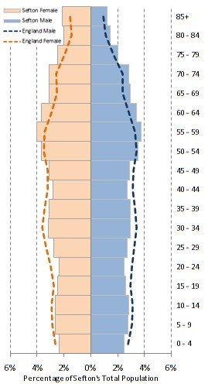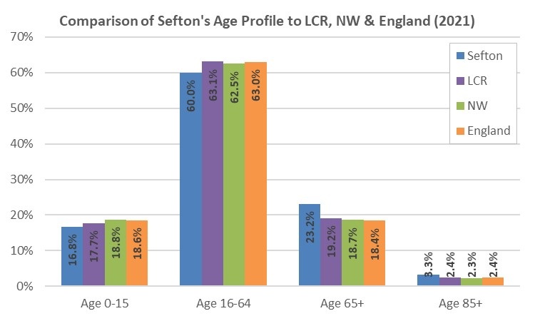

At 23%, Sefton has the 7th highest proportion of over 65’s across the 39 North West local authorities and is highest of the six Liverpool City Region (LCR) authorities.

Sefton is the 52nd highest LA for the proportion of residents aged 85 and over throughout England and is the 4th highest in the North West, at 3.3% of the overall population, Sefton is again higher than the LCR (2.4%), North West (2.3%) and national (2.4%) proportions. The Borough is again the highest of the six LCR authorities.

The number of residents over 65 is projected to increase steadily between 2018 and 2043. For males, the increase is projected to be 36% (28,132 to 38,260) and an increase for females of 31% (35,900 to 46,938). This means an overall 65+ population increase of 33% rising from 64,032 in 2018 to 85,198 by 2043.

Greatest increases are amongst those aged 85 and above with and overall increase of 73% (9,309 to 16,134). The male over 85 population rising by 104% (3,146 to 6,418) between 2018 and 2043. For females, the increase is projected to be 58% (6.163 to 9,716).

The rate of increase in the over 65 population of 33% compared to overall population increases of just 6% means that by 2043 approximately one in three Sefton residents will be age 65 or over.

Projected reductions in working age population (16 to 65-year olds) of 3% compared to increases in the over 65 population will mean the proportion of the adult population of the borough that is of pensionable age will be 29% by 2043, compared to 23% in 2018.

[Source: Census 2021 – TS009 Sex by Single Year of Age / Population Projections 2018]

Performance information

Core Funding

Business Rates: There was no change in the standard business rate multiplier in 2022/23. The Council billed £68.219m of business rates charges in 2022/23 (excludes prior year adjustments), this was £9.995m higher than the net amount billed in 2021/22. The increase in business rates charges was largely due to a reduction in Retail, Leisure & Hospitality discounts from 1 April 2022, as the Government wound down the level of support provided to businesses following the removal of Coronavirus restrictions. The council collected 99.4% of the amount billed in the year, up from 97.3% in 2021/22. A surplus of £22.761m is reported in the Collection Fund for 2022/23 (excluding contributions to the previous year’s estimated deficit) of which Sefton Council’s retained share is £22.533m (99.0%). A large proportion of this surplus is due to a reduction in the provision for appeals following the end of the 2017 Rating List and the settlement of 2010 Rating List appeals. The surplus on the Collection Fund will be distributed over the next two years (2023/24 and 2024/25).

Council Tax: The Council increased its council tax band D charge by £51.26 (2.99%) in 2022/23. This included a social care precept of 1.0%. The Council billed £186.972m of council tax charges in 2022/23 (including precepts) of which 95.0% was collected in the year, up from 94.8% in 2021/22. A surplus of £3.512m is reported in the Collection Fund in 2022/23 (excluding contributions to previous years estimated surplus) of which Sefton Council’s share is £2.950m (84.0%). The surplus is largely due to housing growth and a reduction in council tax support claimants (compared to the number estimated). The surplus on the Collection Fund will be distributed over the next two years (2023/24 and 2024/25).

Government Grant Funding: During 2022/2023, Sefton’s core grant funding (including Settlement Funding Assessment, New Homes Bonus, Improved Better Care Fund, Social Care Grant, Market Sustainability and Fair Cost of Care Fund, and 2022/23 Services Grant) increased by £14.5m (13.4%), which included a £3.3 million increase in Social Care Grant & a new £1.0 million Market Sustainability and Fair Cost of Care Fund Grant which comes with additional conditions and responsibilities. It also included a one-off 2022/23 Services Grant of £4.5m which included funding to offset employers’ additional national insurance contributions as a result of the new health and social care levy introduced in April 2022.

Future Funding: In December 2022, the Secretary of State for Levelling Up, Housing and Communities announced a one-year finance settlement for local government which once again included a significant amount of one-off funding which may not continue in future years. The Government had previously announced their intention to introduce a new funding distribution formula using updated population data as well as resetting business rate retention baselines, however, this has now been deferred until after the end of the current parliament. The most recent Spending Review period ends on 31 March 2025 and there will be a General Election before this date. This leaves Sefton’s future funding levels uncertain and makes medium-term financial planning difficult. Also, the long-term impact of the Covid19 pandemic, the impact of Brexit, the cost-of-living crisis, increasing demand for services, and the recent spike in inflation and interest rates has significantly increased the financial pressure on local government. Despite this uncertainty, the Council has prepared and agreed a Medium-Term Financial Plan for the period 2023/24 to 2025/26 setting out its approach to funding service provision over the next three years. This plan will be subject to review and revision as impact of current economic pressures develops and additional information on future funding levels becomes available.

Economy

The Borough has a mixed economy ranging from industry, commerce and tourism. The east bank of the Port of Liverpool is actually in Sefton, not Liverpool. The opening of “Liverpool 2”, the new deepwater container terminal is expected to provide many opportunities to improve the economy further.

Sefton is part of the Liverpool City Region and the embryonic “Northern Powerhouse” which is expected to provide further impetus to the local economy in the future.

Latest available key data on the Sefton economy

- The unemployment benefit claimant rate in Sefton in in February 2023 was 3.8%. Sefton is slightly lower than the rates seen across LCR (4.6%) and the North West (4.2%) yet is marginally higher than the national rate (3.7%). Compared to the previous year the number of unemployed people in Sefton has considerably reduced (approximately 1,390 / 22%), though February 2023 has the third highest number of claimants in the last nine years (with February 2021 having the highest). A similar pattern can be seen across LCR and England.
- The economic activity rate in Sefton is 78.4%, higher than the rates seen across the city region (75.5%) and regionally (76.3%) yet lower than those seen nationally (79.0%) o There are currently 124,800 Sefton residents in employment (75.2% employment rate).
- 60.2% of residents are educated to NVQ Level 3 or above is slightly higher than that of LCR (58.8%) and the North West (53.8%) yet lower than the national average (61.4%). o In 2022, the average full-time earnings for residents of Sefton were £590 per week, or £30,675 per annum, 9% lower than the English average and 2% lower than the North West.
- The National Living Wage increased to £10.20 per hour in April 2023 for over-23s only. o Sefton’s Rank of Average Score in the Indices of Multiple Deprivation (IMD) 2019 was 89th out of 317 local authorities (317 being the least deprived).
- There are 38 Sefton LSOA’s (Lower Super Output Area – used in census collection) in the most deprived 10% of LSOAs across England. Seven of the 38 LSOA’s are in the most deprived 1% of LSOA’s nationally, six are in Linacre Ward; the other is in Derby Ward.
- 50 out of 189 LSOAs have a deprivation score less than in 2015 indicating that deprivation has reduced in the area. Meaning nearly three quarters of the areas have an increased deprivation score, indicating they have become more deprived.
- Sefton is ranked 89th out of 317 local authorities for deprivation affecting Children and 72nd for deprivation affecting Older people in 2019.
- 31 LSOA’s across Sefton fall in to the most deprived 10% areas for children, with 31 being in the most deprived 10% for older people. Five of the 31 fall within the top 1% of deprived areas nationally for children (located in Linacre – 3, Derby -1 and Litherland -1 wards). One LSOA is in the top 1% of deprived areas in England for older people (located in Debry ward).
- 80 of Sefton LSOA’s have seen the child related deprivation score (and therefore the deprivation affecting children) increase from 2015 to 2019, with 97 Sefton LSOA’s seeing increases in older people related deprivation.

[Source: NOMIS Claimant count by sex and age February 2023, NOMIS Labour Market Profile: ONS Annual Population Survey October 2021 to September 2022 / January to December 2021, NOMIS
Labour Market Profile: ONS Annual Survey of Hours and Earnings – Residents Analysis 2022, The National Minimum Wage 2023, IMD 2015/19]

Social Care

Sefton’s Adult Social Care dealt with 23,603 contacts during 22/23, 32% of these related to new clients. Sefton supported 5,455 clients in long term community or residential services during the year, along with providing support to 405 carers.

At the 31st March 2022, there were 2,676 Children in Need, a rate of 494.7 per 10,000 population aged 0 to 17, considerably higher than that of England (334.3), North West (384.3) and Sefton’s Statistical Neighbours average (382.4). At the same time 337 children were subject to a Child Protection Plan which was 62.3 per 10,000 population aged 0 -17, again higher rates than seen by the Borough’s statistical neighbours (42.1), regionally (48.5), and nationally (50.3). With 598 children recorded as Looked After as at 31st March 2022, as with Children in Need and Child Protection Plans, the Children Looked After rate was considerably higher in Sefton (113.0) than England (70.0 per 10,000 children aged 0 - 17), the North West (97) and the Statistical Neighbour group (90.3).

The governing bodies in DLUHC granted national funding for the Supporting Families Programme to continue for a further three years from 1st April 2022 – 31st March 2025. The first year of the current Supporting Families Programme was completed on 31st March 2023. The target of 331 families was achieved with the cohort being ‘turned around’ meaning that the LA could draw down funding from the government of £800 per family. This generated £264 800 worth of funding to support interventions provided by Social Workers to support families. The second year commenced on 1st April 2023 and is due to end on 31st March 2024. The target is to turn 536 families round within the timeframe which will generate a further £428 800 of funding. The third year will commence on 1st April 2024 and is due to end on 31st March 2025. The target is to turn 663 families round within the timeframe which will generate a further £530 400 of funding. Therefore, the cumulative grand total for funding, provided that all targets are achieved, will be £1 224 000.

[Sources: Sefton Adult Social Care, B1 children in need 2013 to 2022, Local Authority Interactive Tool (LAIT) March 2023, Turnaround Families Database]

Tourism

Sefton has over 22 miles of coastline boasting a number of beautiful beaches and stunning natural beauty. Attractions range from Gormley’s “Iron Men” on the beach in Crosby, to the Pinewoods (and red squirrels) in Formby, to the iconic attraction of Southport, with its elegant shopping in classic Victorian surroundings.

Southport has hotels, attractions, restaurants, Southport Beach, and the famous tree lined Lord Street boulevard with its iconic canopies. It is rumoured that Napoleon re-modelled certain parts of Paris based on his knowledge of Southport during his stay in the town back in the mid-19th century. Southport also hosts a superb events programme including the annual Air Show, Fireworks Championship and Flower Show while Sefton is also home of the Grand National.

There are many world class golf courses within Sefton, Royal Birkdale regularly hosts The Open while Hillside Golf club has recently hosted The British Masters. The area’s reputation for golf is known nationwide and is known as “England's Golfing Capital” due to the number and variety of top-quality courses. This attracts visitors from the across the UK and many from the United States, Europe and Japan.

Technology / Systems

The Council is now in the fifth year of a five-year contract with Agilisys Ltd for the provision of IT services to the Council. This agreement has enabled the Council to reduce the annual costs of IT services, and it has also allowed the Council to benefit from the innovation and best practice which Agilisys has implemented for other local authorities. This agreement has been extended for a further year, as per the extension clauses of the contract.

The Council has deployed its Cloud Telephony solution (8x8) across the workforce, supporting Officers to work in an agile way as well as ensuring that the Council is ready for the national decommissioning of analogue telephony.

The Council has completed the migration of most Council systems and data to cloud hosting, ensuring that the authority has a robust and secure ICT platform in place that supports operational service delivery.

The Council has continued to strengthen and enhance its cyber security mechanisms as part of its ongoing commitment to protecting systems and data, including the deployment of new security software.

The Council continues to actively develop its digital solutions to support social care services, with the recent upgrade of its main social care case management system, and the ongoing development of tools and processes within it. Greater use is being made of online portals to enhance service provision to service users and external agencies.

Councillors continue to use new mobile devices and technology which allows them to conduct their duties more efficiently by granting access to key information and electronic communication with citizens whilst on the move. This has resulted in a reduction in the use of paper and printing for Council meeting documentation.

The Council continues to improve and develop its digital offering to customers. The Council website continues to benefit from ongoing improvements following its redesign in 2022 and further improvements will be made as part of the continuing website development programme. The development and deployment of the Council’s digital Customer Experience platform continues, with the initial phase approaching completion.

The Council continues to rationalise its use of systems to leverage use of existing investments, deploy better integration between systems and reduce the overall spend in this area. Continued leverage of the Council's Microsoft software is constantly being explored and progressed; this provides efficiency improvements to the Council and ensures we maximise our financial investment. The Council is also working on further rollout of intelligent automation technology to improve and streamline back-office processes.

The Council continues to explore the design and implementation of Technology-Enabled Care solutions which will allow older and/or vulnerable adults to live independently at home, and to increase independence within care homes. Key outputs include grants to care homes for technology improvements such as interactive tables, VR headsets and voice prompt systems, as well as rollout of a new digital care records management system.

Homes for Ukraine

Since the introduction of the national Homes for Ukraine scheme in March 2022, Sefton residents have helped to provide safe housing for almost 300 Ukrainians fleeing war.

Working in partnership with local voluntary, community and faith (VCF) sector, Sefton CVS, Sefton 4 Good and Sefton Council launched the Sefton Ukraine Welcome Appeal to raise funds to support Ukrainian individuals and families arriving in the borough of Sefton through the Homes for Ukraine initiative. The fund is helping to provide a community response, such as settlement grants for individuals and families; providing social, cultural and community networks and activities, language support, travel cards, clothing, IT and equipment and other needs as they are identified. The Council also produced a welcome pack for Ukrainian refuges settling in Sefton providing details of local services setting out how they could access advice and support.

Financial Overview

Revenue Budget Process / Council Tax

Unlike in previous years, the Council was unable to formulate a multi-year budget plan due to the oneyear Local Government Finance Settlement and the lack of clarity over future settlements. The Council identified a budget shortfall for 2022/2023 of £7.115m. Specific options to contribute to the budget shortfall in 2022/2023 were identified, including a 2.99% increase in Council Tax. Councillors were reminded that the use of one-off resources should only occur in setting a robust financial plan when there is a clear short-term requirement and that these are not used to avoid making budget savings.

The Council experienced significant budget pressures in some service areas, particularly Children’s Social Care, Children with Disabilities, Home to School Transport, Operational In-House Services, Energy Costs and Pay Inflation. However, the Council did identify underspending in other areas as well as implementing significant mitigating actions during the year to ensure the overspend would be met as far as possible, particularly in light of the financial pressures due to Children’s Social Care. These measures enabled the outturn position to be in line with that expected during the year implementing the planned use of balances.

Financial risks up to 2022/2023

The budget reductions identified in the budget for 2022/2023 highlight the growing level of financial risks the Council will be facing over the coming years and the level of risk which it is possible to mitigate. The financial forecasts themselves are only estimates of future political, economic, environmental and demographic forecasts which contain many variables and degrees of uncertainty.

The budget proposals made to date contain some risks, given the extent and the impact of the £233m savings Sefton had faced to March 2020. The Council has been made aware of the consultations conducted since 2011 in determining the equality impact and risks of the reductions and reconfigurations of services. All options require close monitoring of implementation and delivery and any non-achievement reported and corrected in a timely way.

The 2022/2023 budget represented the thirteenth successive year of budget reductions for Sefton Council.

Delivering savings over such a long period has had a significant impact on the delivery of Council services. In developing the approach to delivering the savings it was important to balance the delivery of savings with the protection of those services which contribute the most to the delivery of the Vision and Core Purpose.

Achieving the ambitions of Sefton 2030 also requires the Council to be financially sustainable, to ensure services align with the core purpose and that the Council works with partners to achieve better outcomes.

In order to meet this challenge, the Council has developed a ‘Framework for Change’ which is comprised of the following pillars which will help the Council deliver against its stated objectives including financial sustainability. These are:

- Economic Growth and Strategic Investment;
- Council of 2023;
- Demand Management.

Each of these themes will contribute towards delivering the Sefton 2030 Vision and a financially sustainable Council.

Revenue Financial Performance of the Council 2022/2023

Non-School General Fund Net Expenditure

The General Fund encompasses expenditure relating to the day-to-day running of the Council. Transactions relating to Schools’ delegated budgets are included within the General Fund but because Schools are entitled to retain any year-end balances for future use, the General Fund balances are analysed according to whether or not they belong to Schools.

On 3 March 2022, the Council approved a revenue budget for 2022/2023 of £212.007m, which included £1.382m relating to the expenditure of Parish Councils. At that time, it was anticipated that balances for non-school budgets would total £12.778m at 31 March 2023. As a result of an underspend of £2.023m in 2021/2022 the anticipated year-end balances position was revised to £14.799m. The 2022/2023 Budget assumed an increase in general balances of £2.892m as part of a strategy to increase balances and ensure financial resilience.

Overall, actual expenditure for 2022/2023 on General Fund services (excluding Schools' delegated expenditure) was £5.700m higher than the Base Estimates which has reduced General Fund Balances. This was planned during the year as part of a remedial plan to offset significant in-year financial pressures, particularly around Children’s Social Care, Energy costs and pay inflation.

The Authority's reported Non-School General Fund balances at 31 March 2023 are therefore £11.991m as shown in the following table:

Non-School General Fund Balances | £m
Actual Non-School General Fund Balances at 31 March 2022 | -14.799
Plus Budgeted Contribution to Balances | -2.892
Plus overspend in comparison to the 2022/2023 Base Estimate: | 5.700
Actual Non-School General Fund Balances at 31 March 2023 | -11.991

A comparison of actual expenditure to budgeted expenditure is shown below:

Net Revenue Expenditure |  | Budget | Net  Expenditure  Chargeable to General  Fund  Balances  (per EFA) | Adjustments for Internal  Recharges /  Earmarked  Reserves | Outturn  Expenditure against  Budget for  Monitoring  Purposes | Variance
 |  | £m | £m | £m | £m | £m
Services
Strategic Management |  | 4.038 | 1.160 | 2.914 | 4.074 | 0.036
Adult Social Care |  | 102.929 | 98.971 | 3.735 | 102.706 | -0.223
Children's Social Care |  | 52.876 | 70.684 | 2.572 | 73.256 | 20.380
Communities |  | 18.611 | 14.077 | 2.132 | 16.209 | -2.402
Corporate Resources |  | 5.673 | 31.661 | -26.793 | 4.868 | -0.805
Economic Growth & Housing |  | 6.811 | 4.723 | 1.980 | 6.703 | -0.108
Education Excellence |  | 11.643 | 12.718 | 0.575 | 13.293 | 1.650
Education Excellence - Schools |  | 0 | -2.044 | 2.044 | 0.000 | 0.000
Health and Wellbeing |  | 19.374 | 17.570 | 0.112 | 17.682 | -1.692
Highways & Public Protection |  | 11.508 | 8.425 | 3.167 | 11.592 | 0.084
Operational In-House Services |  | 17.008 | 17.322 | 0.558 | 17.880 | 0.872
Other Services |  | 2.923 | 2.053 | 0.745 | 2.798 | -0.125
Energy Costs |  |  |  | 2.058 | 2.058 | 2.058
Total Service Net Expenditure |  | 253.393 | 277.320 | -4.204 | 273.116 | 19.723
Remedial Action Plan - July |  |  |  | -9.700 | -9.700 | -9.700
Remedial Action Plan September | – |  |  | -4.800 | -4.800 | -4.800
Corporate Items |  | -8.526 | 24.836 | -32.251 | -7.415 | 1.111
Levies |  | 35.222 | 35.222 | - | 35.222 | -
Parish Precepts |  | 1.382 | 1.382 | - | 1.382 | -
Total Net Expenditure |  | 281.471 | 338.760 | -50.955 | 251.419 | 6.334
Financed by:
Council Tax Payers |  | -151.707 | -151.707 | - | -151.707 | -
Business Rates Top-Up |  | -22.151 | -22.151 | - | -22.151 | -
Retained Business Rates |  | -38.149 | -38.149 | - | -38.149 | -
General Government Grants |  | -72.356 | -94.188 | 21.198 | -72.990 | -0.634
Total Financing |  | -284.363 | -306.195 | 21.198 | -254.881 | -0.634
Amount Funded from / contributed to (-) General  Balances |  | -2.892 | 32.565 | -29.757 | 2.808 | 5.700

Note: The total of the figures shown above for Other Services and Corporate Items are categorised differently in the Expenditure & Funding Analysis (total of Corporate Unallocated Costs and Financing and Investment Income & Expenditure)

For clarity, brief definitions some services are noted below to help the reader understand what some of the functions that are provided: -

- Communities – Services include amenities and support for local neighbourhoods, youths, libraries and arts, sports and families.

- Operational In-House Services – The delivery of key services including refuse collection / recycling, street cleansing, burials and cremation, school meals, crossing patrols, parks, coast and countryside.

The main variances relate to six key areas:

Children’s Social Care - Children’s Social Care overspent in 2022/23 by £20.380m, a position that was reported to Cabinet throughout the year.

The service continued to see rising demand and further investigatory work is ongoing with partner agencies with the aim of addressing this. Overall, the overspend was made up of the following key areas: -
  - Due to a significant number of vacancies within the service, especially with regard to Social Workers, the expenditure on agency staff has been £6.5m over the staffing budget. Within this £3.5m relates to managed teams as well as the costs of employing additional social workers to manage the additional casework brought about by the rising demand for services.
  - At the start of the financial year as inflation took hold in the UK, unbudgeted for inflation on accommodation costs has resulted in an overspend of £1.2m; and,
  - A number of additional complex and high-cost placements have had to be entered into which have led to an overspend on this budget of £8.3m. Since the budget was set in March there was an increase in Independent Residential Placements from 69 to 79. In addition, there were more cases requiring high-cost accommodation and support than previously, and the costs of these had also risen significantly. Some new cases were initially costing substantial amounts per week. Within the budget for 2023/24 there was provision for an additional 5 placements therefore this increase from 69 to 79 will result in a budget pressure in the new year.

Communities – The surplus of £2.402m primarily relates to reduced expenditure on sports facilities due to the closure of Splashworld and significant vacancy savings on family wellbeing staffing. There were also other vacancy savings across the service, as well as additional grant funding made available to offset existing costs in the year.

Education Excellence – The net overspend of £1.650m is due to a significant increase in the costs of Home to School Transport. There was an increase in the number of children being transported, especially relating to out of borough placements. In addition, there was an increase in the cost or providing the transport, particularly from September.

Health & Wellbeing – A net surplus of £1.692m arose primarily due to savings on contracts procured during the year, including on substance misuse and health prevention services. In addition, there were also vacancy savings in the service, as well as additional grant funding made available to offset existing costs in the year.

Energy Costs - As reported throughout the year, the global increase in energy prices had a significant impact on the Council’s energy and fuel costs, increasing costs by £2.052m above budget. It should be noted that energy is a national issue and affected all local authorities. However, no additional Government funding was made available for local government, despite representations made both nationally and locally.

Remedial Action Plans – Due to the overall pressures faced during the year, particularly from the increased costs of energy, the pay award and Children’s Social Care, Cabinet approved Remedial Action Plans to fund these pressures. In June they approved one-off savings of £9.7m (plus the use of £2.9m of General Balances) and in September approved further one-off savings of £4.8m (plus the use of £2.8m of General Balances).

Schools

In accordance with the Fair Funding Scheme for Financing Schools, individual schools are able to carry forward any underspend on their budgets. Conversely, an overspend against budgets become the first call on future available resources. Net expenditure on schools, whether incurred directly from delegated budgets or spent against centrally retained budgets by the LEA in support of schools, is funded from the ring-fenced Dedicated Schools Grant (DSG).

The DSG was overspent by £0.286m in 2022/2023. This comprised an overspend of £0.229m across
Individual Schools’ delegated budgets, and a net decrease in the level of DSG school funds held by
the Local Authority during 2022/2023 in respect of the Supply Teachers scheme (£0.046m increase) and the Business Rates scheme (£0.113m decrease). Movements in Schools’ balances during 2022/2023 can be summarised as follows:

Schools’ Balances | £m
Schools’ balances as at 1 April 2022 | -18.289
Overspend on Schools’ Delegated Budgets Schools’ balances at 31 March 2023 | 0.296
 | -17.993

The Council’s Centrally Retained DSG balances are separate to its Maintained Schools’ balances.
These are in respect of Schools’ Central Support services; Early Years (non-schools) provision and High Needs (non-schools) provision. The net opening balance of these reserves, as at 1 April 2022, was a deficit of £11.097m. During 2022/2023, this deficit has grown considerably, mostly due to the significant overspending of High Needs. This has taken the balances into a net deficit position of £17.059m (see below).

Centrally Retained DSG Balances | 1 April 2022  £m | Movement  2022/2023  £m | 31 March 2023  £m
Schools Block | -0.761 | -0.202 | -0.963
Early Years Block | -0.636 | -0.008 | -0.644
High Needs Block | 12.494 | 6.172 | 18.666
 | 11.097 | 5.962 | 17.059

DfE permit Local Authorities to carry forward a deficit on their DSG Centrally Retained balances, without any obligations on behalf of Local Authorities to support a deficit position out of non-school Council balances. As a result of the statutory requirements introduced for 2020/21, this balance is now held on the Balance Sheet as an Unusable Reserve, the Dedicated Schools Grant Adjustment Account.

They DfE have offered to work more closely and in cooperation with Local Authorities, to support them in trying to reduce spending, particularly across High Needs, where most Authorities have been struggling to manage. The first requirement will be for the Authority to have plans to balance their inyear spending. They will still be required to provide evidence, at the DfE’s request, that overspending issues have been reported regularly to Schools Forum; and that measures are in place to arrest the situation, at least, over a three-year planned period. In addition, the Council is participating in the DfE’s Delivering Better Value Programme, which will provide additional support to help the Council move into a financially sustainable position on High Needs. It has been acknowledged that the full recovery of accumulated deficits, however, may not be possible, even over many years, and it is not certain at this stage, whether the DfE may consider, on a case by case basis, some additional funding, to write down some, or all, of their accumulated deficits in this respect.

With the review of High Needs underway, and the actions being taken as explained above, together with the increased settlement for High Needs funding in 2023/2024, work will continue to bring expenditure in line with the budget available and then start to repay the existing deficit so as to reduce the financial risk to the Council.

Capital Strategy / Programme 2022/2023

The Capital Programme 2022/2023 was approved by Budget Council on 3 March 2022. The three main grant allocations received by the Council are in respect of schools, transport and social care (i.e. Better Care Fund) and due to the funding conditions of these, grants are utilised within the relevant services. This is aside from any in year approvals in respect of the Growth and Strategic Investment Programme for which comprehensive business cases are provided as schemes are developed and funding sources are identified.

Capital expenditure is principally funded from four areas:
Capital Grants and Contributions – grants from Central Government and other grant funding bodies such as the Liverpool City Region Combined Authority and contributions from private developers.
The Capital Programme 2022/2023 report highlighted Government grant funding for 2022/2023 of £2.564m for schools, £5.515m for the City Region Sustainable Transport Settlement, £0.250m for traffic signal maintenance and £4.823m for the Better Care Fund, giving a total grant allocation of £13.152m. Of the £2.564m for schools, £0.362m was ring-fenced Devolved Formula Capital Grant (DFC), and £2.202m was Schools Condition Allocation.

Capital Receipts – proceeds from the sale of the Council’s capital assets.
Revenue – financing capital expenditure from the Council’s revenue resources.
Prudential Borrowing – this is external borrowing undertaken by the Council that must be repaid. The Council will only borrow where plans are sustainable, affordable, prudent and offer value for money.

Capital Expenditure in 2022/2023

In 2022/2023 the Authority spent £38.705m on capital projects. Examples of some of the major areas of spend include expenditure on the Schools programme (£3.091m), Highways integrated schemes (£2.508m), Highways carriageway maintenance (£4.817m), LED street lighting upgrades (£3.418m),
Disabled Facilities Grants (£2.534m), Growth and Strategic Investment projects (£6.524m), Sustainable Warmth schemes to improve energy efficiency in homes (£5.326m), essential leisure centre repairs (£0.829m) and the Regional Flood and Coastal Monitoring Programme (£0.763m).

The analysis of capital spending (by departmental categories) and its financing is summarised below-

Sefton’s Capital Expenditure for 2022/2023
 |  | £m | %
Adult Social Care |  | 4.100 | 10.6
Children’s Social Care |  | 0.263 | 0.7
Communities |  | 0.916 | 2.4
Corporate Resources |  | 6.338 | 16.4
Economic Growth & Housing |  | 7.237 | 18.7
Education Excellence |  | 3.853 | 10.0
Highways & Public Protection |  | 11.789 | 30.5
Operational In House Services |  | 1.445 | 3.7
Capitalisation and DFC |  | 2.764 | 7.1
 |  | 38.705 | 100.00

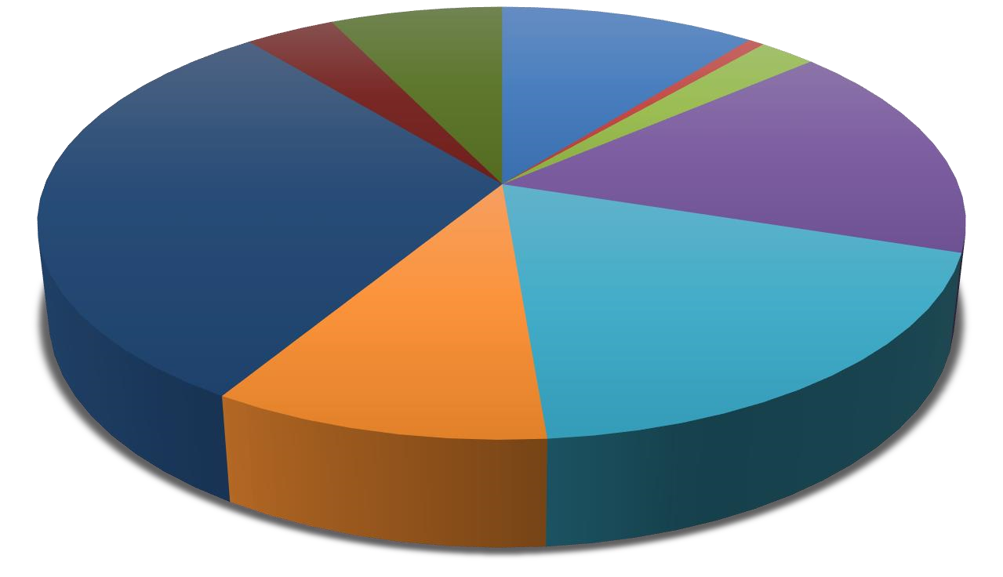
Adult Social Care
%
10.6
Children’s Social Care
0.7
%
Communities
2.4
%
Corporate Resources
16.4
%
Economic Growth &
Housing
18.7
%
Education Excellence
10.0
%
Highways & Public
Protection
30.5
%
Operational In House
Services
3.7
%
Capitalisation and DFC
7.1
%

Financing of Sefton’s 2022/2023 Capital Expenditure
Source of Finance |  | £m | %
Grants and Contributions |  | 29.652 | 76.6
Prudential Borrowing |  | 6.440 | 16.6
Capital Receipts |  | 1.517 | 3.9
Revenue |  | 1.096 | 2.8
 |  | 38.705 | 100
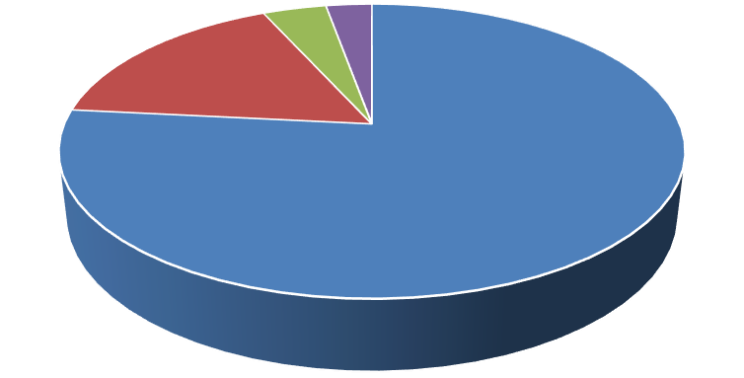
Grants and Other
Contributions
76.6
%
Prudential
Borrowing
16.6
%
Capital Receipts
3.9
%
Revenue
Contribution
2.8
%

Total capital expenditure consists of the following additions:

Type of Asset | £m
Fixed Assets:
- Property, Plant & Equipment | 9.152
- Infrastructure | 14.213
- Investment Properties | 0.158
- Assets Under Construction | 4.395
Intangible Assets (e.g., software licences) | 1.518
Revenue Expenditure Funded from Capital Under Statue | 9.269
 | 38.705

An explanation of the Financial Statements

The Statement of Accounts is intended to give clear information about the Authority's finances. It is intended to answer:

- What did the Authority's services cost in the year of account?
- Where did the money come from to pay for these services?
- What were the Authority’s assets and liabilities at the year-end?

Wherever possible the contents have been written in plain English and technical terms have been used sparingly. Where the use of technical terms has been unavoidable, a simple explanation has been included in the Glossary (see pages 147 to 154).

The Authority is required by law to follow proper accounting practices and this Statement of Accounts attempts to present fairly the financial position and transactions of the Authority.

The Statement was certified by the Executive Director of Corporate Services and Commercial on 9 December 2024.

In accordance with recommended practice, the Authority's Accounts present:

(a) Comprehensive Income and Expenditure Statement (page 27)

This statement shows the accounting cost in the year of providing services in accordance with generally accepted accounting practices, rather than the amount to be funded from taxation. Authorities raise taxation to cover expenditure in accordance with statutory requirements; this may be different from the accounting cost. The taxation position is shown in both the Expenditure and Funding Analysis and the Movement in Reserves Statement.

(b) Movement in Reserves Statement (page 29)

This statement shows the movement from the start of the year to the end on the different reserves held by the authority, analysed into ‘usable reserves’ (i.e., those that can be applied to fund expenditure or reduce local taxation) and other ‘unusable reserves’. The Statement shows how the movements in year of the authority’s reserves are broken down between gains and losses incurred in accordance with generally accepted accounting practices and the statutory adjustments required to return to the amounts chargeable to council tax (or rents) for the year. The Net Increase/Decrease line shows the statutory General Fund Balance movements in the year following those adjustments.

(c) Balance Sheet (pages 31 - 32)

The Balance Sheet shows the value as at 31 March 2023 of the assets and liabilities recognised by the Authority. The net assets of the Authority (assets less liabilities) are matched by the reserves held by the Authority. Reserves are reported in two categories. The first category of reserves are usable reserves, i.e., those reserves that the authority may use to provide services, subject to the need to maintain a prudent level of reserves, and any statutory limitations on their use. The second category of reserves are those that the Authority is not able to use to provide services.

(d) Cash Flow Statement (page 33)
The Cash Flow Statement shows the changes in cash and cash equivalents of the Authority during the reporting period. The statement shows how the Authority generates and uses cash and cash equivalents by classifying cash flows as operating, investing and financing activities.

(e) Notes to the Financial Statements - Expenditure and Funding Analysis (page 35 - 36)

This analysis shows how annual expenditure is used and funded from resources (government grants, rents, council tax and business rates) by local authorities in comparison with those resources consumed or earned by authorities in accordance with generally accepted accounting practices. It also shows how this expenditure is allocated for decision making purposes between the council’s directorates/services/departments. Income and expenditure accounted for under generally accepted accounting practices is presented more fully in the Comprehensive Income and Expenditure Statement.

(f) Other Notes to the Financial Statements (pages 37 - 110)

The notes to the Movement in Reserves Statement, Comprehensive Income and Expenditure Statement, Balance Sheet and Cash Flow Statement. It also includes the accounting policies employed by Sefton to comply with the CIPFA Code of Practice of Local Authority Accounting subject to any exceptions detailed in the note.

(g) Collection Fund (pages 111 - 114)

This statement that reflects the statutory obligation for billing authorities to maintain a separate Collection Fund in accordance with section 89 of the Local Government Finance Act 1988 (as amended by the Local Government Finance Act 1992).

The Collection Fund shows the transactions of the Billing Authority in relation to the collection of Council Tax and Non-Domestic rates and provides details of how this income has been distributed to Sefton MBC (including Parish Precepts), Merseyside Police and Crime Commissioner, Merseyside Fire and Rescue Authority, and Liverpool City Region Combined Authority.

(h) Group Accounts (pages 115 – 128)

This section incorporates the accounts of both Sefton and its wholly owned subsidiaries, Sefton New Directions Limited, Sefton (ACS) Development Company Limited (Sandway Homes) and Sefton Hospitality Operations Limited, to provide details of the Council’s financial activities as a Group.

(i) Annual Governance Statement (pages 129 - 142)
The Annual Governance Statement is the formal statement that recognises, records and publishes an authority’s governance arrangements as defined in the CIPFA / SOLACE Governance Framework. It is required to be published with the accounting statements but does not form part of the accounting statement and is therefore not covered by the Auditors’ opinion.

- Independent Auditors’ Report to the Members of Sefton Metropolitan Borough Council (pages 143 - 146)

- Glossary (pages 147 - 154)

- Abbreviations (pages 155 – 156)

- Useful Addresses (page 157)

Changes to Accounting Policy during the Year

This Statement of Accounts is prepared in accordance with the Code of Practice on Local Authority Accounting in the United Kingdom 2022/2023 (the Code).

There have been no material changes to the accounting policies in 2022/23.

Analysis of the Income and Expenditure Account

The tables and charts below summarise the Authority's gross revenue expenditure within the General Fund for 2022/2023 and highlights the main sources of General Fund Financing for 2022/2023.

Gross Expenditure on Services (including Levies) (by Expenditure Type)

Expenditure Type £m %
Employees 277.614 36
Running Expenses 466.052 60
Capital Charges 34.187 4
777.853 100
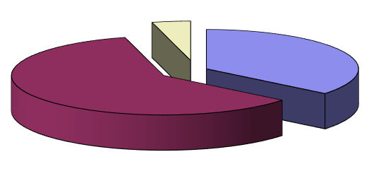
Employees
Running Expenses
Capital Charges

Gross General Fund Expenditure on Services (including Levies)

Service | £m | %
Adult Social Care | 159.898 | 21
Children’s Social Care | 77.236 | 10
Corporate Resources | 113.544 | 15
Communities / Health & Wellbeing | 57.789 | 7
Highways and Public Protection / Operational In-House Services | 62.999 | 8
Education Excellence - Non-School | 19.335 | 2
- Schools | 216.515 | 28
Other Services | 35.220 | 4
Levies | 35.317 | 5
 | 777.853 | 100
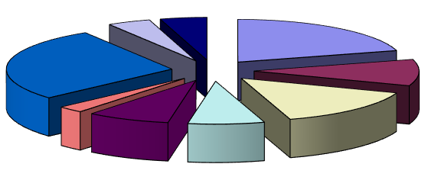
Adult Social Care
Children's Social Care
Corporate Resources
Communities / Health
& Wellbeing
Highways & Public
Protection /
Education Excellence
Education Excellence
-
Schools
Other Services
Operational In-House
Services

Main Sources of General Fund Financing for 2022/2023

Source of Income £m %
General Government Grants 94.188 21
Non-Domestic Rates Income 38.149 8
Council Tax Payers 151.707 34
Dedicated Schools Grant 168.631 37
452.675 100
Non-Domestic Rates
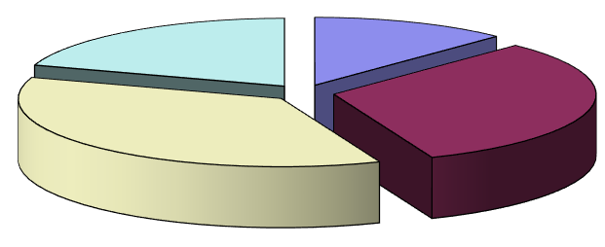
Income
Council Tax Payers
Dedicated Schools
General Government
Grants
Grant

The Gross expenditure is financed by the major grants shown above, other smaller revenue grants and contributions received by the Council (Note 17 on page 55) and fees and charges.

Other Financial Commitments

The Council’s most significant other financial commitments are the long-term contracts it has entered into with Agilisys, Formby Pool Trust, Sefton New Directions Limited and Waterfront Leisure (Crosby) Limited.

Borrowing / Investments

The Council’s arrangements for long-term borrowing and investments correspond to the Council’s Treasury Management Policy and Strategy documents. These were drawn up to comply with the Chartered Institute of Public Finance and Accountancy’s Code of Practice for Treasury Management in Local Authorities.

Under Section 3(1) of the Local Government Act 2003, the Council must approve an overall borrowing limit before the beginning of each financial year. For 2022/2023 this limit was set at £220m; the Council stayed within this figure during the year.

As at 31 March 2023, the Council had outstanding borrowing of £134.793m (£168.433m as at 31 March 2022). This includes local authority bonds, stocks, mortgages and loans from the Public Works Loans Board (PWLB). At 31 March 2023, accrued interest of £1.079m, was due to be repaid within 12 months.

During 2022/2023, no new long-term borrowing from the PWLB was required to fund capital expenditure. Principal of £33.51m was repaid during the year of which £14.520m related to Equal Instalments of Principal (EIP) loans and £1.088m related to Annuity loans.

Interest on long-term borrowing from the PWLB totalled £6.036m during the year (£6.526m in 2021/2022).

In line with its Treasury Management Policy and Strategy the Council makes daily investment decisions. At 31 March 2023, the Council had short-term investments of £26.110m (£93.690m at 31 March 2022). The Council had no short-term deposits with banks and building societies (£0.000m at 31 March 2022). The Council had long term investments with the Church and Charities Local Authority (CCLA) Property Fund (£5.278m).

Pension Liability

As at 31 March 2023 the Pensions Liability figure in the Balance Sheet includes a net deficit on the Local Government Pension Scheme Fund attributable to Sefton of £27.936m (£421.163 as at 31 March
2022). The deficit is reviewed periodically (normally every three years) by the Fund’s actuary and steps are taken to address the deficit via increased contributions over the remaining working life of employees. However, it should be noted that the notional figure included in the Statement of Accounts is calculated using a different set of assumptions (in line with accounting practice) than those used to calculate the deficit repayments required.

The latest valuation was completed during 2022/2023 and has set the contribution rates for 2023/2024 to 2025/2026. There has been a significant improvement in the Council’s funding position resulting in the Council’s overall position now being in surplus. However, it should be noted that the value of the surplus / deficit is highly dependent on market conditions at the time of the valuation and can vary significantly between valuations.

As at 31 March 2023 there was a net deficit relating to unfunded Teachers’ Pensions attributable to Sefton of £4.598m (£5.699m as at 31 March 2022). The Council has budgeted to make these payments until there is no longer a liability.

Provisions, Contingencies, Write-Offs and Material Charges or Credits

The 2022/2023 accounts include a provision for the cost of NNDR checks, challenges and appeals.
The total value of the Provision as at 31 March 2023 is £6.239m (£21.354m as at 31 March 2022). Sefton’s share of the Provision as at 31 March 2023 is £6.177m (£21.140m as at 31 March 2022).

The only material write-offs in 2022/2023 relate to revaluation losses on the Authority’s assets. These total £2.2m (£0.6m in 2022/2023).

General Balances and Reserves

The Financial Overview on pages 12 to 15 show the General Balances of the Council split between Delegated Schools’ and Non-Delegated Services. The Council’s Non-Delegated Services’ General Balances are £11.991m. This level of Balances is considered the least necessary given the financial risks faced by the Council, including the impact of current levels of inflation, Children’s Social Care and other pressures on the Council’s financial position in 2023/2024 and future years.

The Council has £45.639m of capital resources available as at 31 March 2023 (£30.122m as at 31
March 2022). These are amounts already received that will be used to fund the Council’s Capital Investment Plan in 2022/2023 and future years (see pages 15 to 17). This Plan will be vital in assisting the Borough’s recovery from the pandemic.

The Council also has £51.790m of Earmarked Reserves as at 31 March 2023 (£81.253m as at 31 March 2022). These are described in Note 35. Earmarked Reserves are held by the Council to fund anticipated future expenditure of a non-recurring nature. If these resources were not available, then the expenditure would need to be funded from the Council’s in-year Revenue Budget which would require additional savings to be made in order to make funding available.

The Council also has negative £308.160m of Unusable Reserves as at 31 March 2023 (negative £98.669 as at 31 March 2022). These are accounts required under accounting regulations and are not available to support, or a call against, Council expenditure.

Material Events after the Reporting Date

There are no material events after the reporting date.

Conclusion

During the 2022/2023 financial year, the Council has continued to experience significant additional spending pressures but has been able to contain such costs within the overall budget. The overall outturn position is an overspend which has reduced General Balances.

Decisions taken for the agreed 2023/2024 budget will increase General Fund balances from the 31 March 2023 position by £4.4m. However, the challenges presented by the significant impact of inflation mean that the Council will need to utilise some of these balances in order to stabilise local authority finances in the short term whilst the economy recovers. We will be looking to the Government to provide additional financial support beyond the amounts already announced. Maintaining financial sustainability will be a key part of the Council’s recovery plan in order to continue to provide support to its residents, service users, council tax payers and the business community.

The Statement of Accounts is a complex document and is prepared within the guidelines set by the Chartered Institute of Public Finance and Accountancy. However, I would be interested to receive any suggestions as to how the Accounts, or the Executive Summary, could be improved. Please contact me at the address on page 157 of this document.

Stephan Van Arendsen

Executive Director of Corporate Services and Commercial

Responsibilities

2 STATEMENT OF RESPONSIBILITIES FOR THE STATEMENT OF ACCOUNTS

The Authority's Responsibilities

The Authority is required to:

- Make arrangements for the proper administration of its financial affairs and to secure that one of its officers has the responsibility for the administration of those affairs. In Sefton that officer is the Executive Director of Corporate Resources and Customer Services.

- Manage its affairs to secure economic, efficient and effective use of resources and safeguard its assets.

- Approve the Statement of Accounts.

The Executive Director of Corporate Resources and Customer Services Responsibilities

The Executive Director of Corporate Resources and Customer Services is responsible for the preparation of the Authority's Statement of Accounts in accordance with proper practices as set out in the CIPFA/LASAAC Code of Practice on Local Authority Accounting in the United Kingdom (the Code).

In preparing this Statement of Accounts, the Executive Director of Corporate Resources and Customer Services has:

- selected suitable accounting policies and then applied them consistently;

- made judgements and estimates that were reasonable and prudent;

- complied with the local authority Code.

The Executive Director of Corporate Resources and Customer Services has also:

- kept proper accounting records which were up to date;

- taken reasonable steps for the prevention and detection of fraud and other irregularities.

Executive Director of Corporate Resources and Customer Services Statement

I certify that this Statement of Accounts gives a true and fair view of the financial position of Sefton Metropolitan Borough Council at 31 March 2023, and its income and expenditure for the financial year ended 31 March 2023.

Stephan Van Arendsen
Executive Director of Corporate Services and Commercial
Date: 9th December 2024

Sefton MBC Statement of Accounts 2019/20
Responsibilities

Statement by the Chair of the Audit and Governance Committee

I confirm on behalf of the Council that these accounts were approved by me under delegated authority as resolved by the Audit and Governance Committee at its meeting held on 28th November 2024.

Councillor Dave Robinson

Chair, Audit and Governance Committee
Date: 9th December 2024

Sefton MBC Statement of Accounts 2019/20
Income and Expenditure Statement

3 COMPREHENSIVE INCOME AND EXPENDITURE STATEMENT

This statement shows the accounting cost in the year of providing services in accordance with generally accepted accounting practices, rather than the amount to be funded from taxation. Authorities raise taxation to cover expenditure in accordance with statutory requirements; this may be different from the accounting cost. The taxation position is shown in both the Expenditure and Funding Analysis and the Movement in Reserves Statement.

2021/2022 |  |  | Note | 2022/2023
Gross | Gross | Net |  | Gross | Gross | Net
Expenditure | Income | Expenditure / Income (-) |  | Expenditure | Income | Expenditure / Income (-)
£000s | £000s | £000s | Continuing Operations | £000s | £000s | £000s
1,232 | -8 | 1,224 | Strategic Management | 1,348 | -11 | 1,337
150,016 | -59,773 | 90,243 | Adult Social Care | 159,898 | -57,231 | 102,667
56,406 | -2,094 | 54,312 | Children’s Social Care | 77,236 | -4109 | 73,127
31,283 | -11,896 | 19,387 | Communities | 38,779 | -19,467 | 19,312
110,508 | -78,126 | 32,382 | Corporate Resources | 113,544 | -73,925 | 39,619
11,313 | -11,433 | -120 | Economic Growth and Housing | 25,528 | -17,802 | 7,726
16,730 | -2,243 | 14,487 | Education Excellence | 19,335 | -2,504 | 16,831
204,436 | -196,789 | 7,647 | Education Excellence - Schools | 216,515 | -204,578 | 11,937
21,483 | -27,988 | -6,505 | Health and Wellbeing | 19,010 | -23,848 | -4,838
28,682 | -8,724 | 19,958 | Highways and Public Protection | 24,650 | -9,172 | 15,478
29,798 | -10,453 | 19,345 | Operational In-House Services | 38,349 | -14,124 | 24,225
18,991 | -13,200 | 5,791 | Corporate Unallocated Costs | 8,344 | -11,180 | -2,836
680,878 | -422,737 | 258,151 | Net Cost of Services | 742,536 | -437,951 | 304,585
 |  |  | Other Operating Income and Expenditure
 |  | 1,208 | Precepts paid to Parish Councils |  |  | 1,381
 |  | 34,662 | Levies |  |  | 35,317
 |  | -10 | Loss / Gain (-) on the disposal of non-current assets |  |  | 5,299
 |  | -973 | 8 Other Operating Income  Financing and Investment Income & Expenditure |  |  | -1,037
 |  | 34,887 |  |  |  | 40,960
 |  | 7,268 | 9 Interest payable and similar charges |  |  | 7,036
 |  | 9,158 | 51 Net Interest on the Net Pension Defined Benefit Liability |  |  | 11,453
 |  | -326 | Interest Receivable |  |  | -2,093
 |  | -2,459 | 20 Income and Expenditure on Investment Properties |  |  | -2,531
 |  | -3,076 | 20 Changes in the Fair Value of Investment Properties |  |  | 4,890
 |  | -944 | Changes in the Fair Value of Financial Instruments  Taxation and Non-specific Grant Income |  |  | 1,042
 |  | 9,621 |  |  |  | 19,797
 |  | -146,265 | Income from Council Tax |  |  | -152,958
 |  | -56,227 | Non-Domestic Rates Income |  |  | -79,197
 |  | -76,078 | 17 Non-Ringfenced Government Grants |  |  | -71,563
 |  | -19,043 | 17 Capital Grants and Contributions |  |  | -31,530
 |  | -297,613 |  |  |  | -335,248
 |  | 5,046 | 5 Surplus (-) / Deficit on Provision of Services |  |  | 30,094
 |  | -24,591 | 38 Surplus (-) / Deficit on Revaluation of non-current assets |  |  | -2,259
 |  | -58,455 | 40 Re-measurement of the Net Defined Benefit Liability |  |  | -433,417
 |  | -83,046 | Other Comprehensive Income and Expenditure |  |  | -435,676
 |  | -78,000 | Total Comprehensive Income and Expenditure |  |  | -405,582

Sefton MBC Statement of Accounts 2022/23 Page 27

Income and Expenditure Statement

Sefton MBC Statement of Accounts 2022/23 Page 28

Movement in Reserves

4 MOVEMENT IN RESERVES STATEMENT

This statement shows the movement from the start of the year to the end on the different reserves held by the authority, analysed into ‘usable reserves’ (i.e. those that can be applied to fund expenditure or reduce local taxation) and other ‘unusable reserves’. The Statement shows how the movements in year of the authority’s reserves are broken down between gains and losses incurred in accordance with generally accepted accounting practices and the statutory adjustments required to return to the amounts chargeable to council tax (or rents) for the year. The Net Increase/Decrease line shows the statutory General Fund Balance movements in the year following those adjustments.

Movements in Reserves in 2022/2023 | General Fund  Balance  £000 | Earmarked  Reserves Account  £000 | Capital  Receipts Reserve  £000 | Capital  Grants  Unapplied  £000 | Total  Usable  Reserves  £000 | Unusable  Reserves  (Notes 38 to 43)  £000 | Total  Authority  Reserves  £000
Balance at 1 April 2022 | -33,087 | -81,253 | -6,260 | -23,862 | -144,462 | 134,585 | -9,877
Movements in Year  Total Comprehensive Income and  Expenditure | 30,094 | 0 | 0 | 0 | 30,094 | -435,676 | -405,582
Adjustments between accounting basis and funding basis under regulations (Note 7)  Net Increase before Transfers to  Earmarked Reserves | 2,471 | 0 | -4,707 | -10,473 | -12,709 | 12,709 | 0
 | 32,565 | 0 | -4,707 | -10,473 | 17,385 | -422,937 | -405,582
Transfers to / from Earmarked Reserves (Note 35) | -29,463 | 29,463 | 0 | 0 | 0 | 0 | 0
Decrease / Increase (-) in Year | 3,102 | 29,463 | -4,707 | -10,473 | 17,385 | -422,967 | -405,582
Balance at 31 March 2023 | -29,985 | -51,790 | -10,967 | -34,335 | -127,077 | --288,382 | -415,459

Movements in Reserves in 2021/2022 | General Fund  Balance  £000 | Earmarked  Reserves Account  £000 | Capital  Receipts Reserve  £000 | Capital  Grants  Unapplied  £000 | Total  Usable  Reserves  £000 | Unusable  Reserves  (Notes 38 to 43)  £000 | Total  Authority  Reserves  £000
Balance at 1 April 2021 | -26,954 | -98,313 | -6,464 | -22,742 | -154,473 | 222,596 | 68,123
Movements in Year  Total Comprehensive Income and  Expenditure | 5,046 | 0 | 0 | 0 | 5,046 | -83,046 | -78,000
Adjustments between accounting basis and funding basis under regulations (Note 7)  Net Increase before Transfers to  Earmarked Reserves | 5,881 | 0 | 204 | -1,120 | 4,965 | -4,965 | 0
 | 10,927 | 0 | 204 | -1,120 | 10,011 | -88,011 | -78,000
Transfers to / from Earmarked Reserves (Note 35) | -17,060 | 17,060 | 0 | 0 | 0 | 0 | 0
Decrease / Increase (-) in Year | -6,133 | 17,060 | 204 | -1,120 | 10,011 | -88,011 | -78,000
Balance at 31 March 2022 | -33,087 | -81,253 | -6,260 | -23,862 | -144,462 | 134,585 | -9,877

Sefton MBC Statement of Accounts 20
Movement in Reserves

Sefton MBC Statement of Accounts 20

Balance Sheet

5 BALANCE SHEET

The Balance Sheet shows the value as at the Balance Sheet date of the assets and liabilities recognised by the Authority. The net assets of the Authority (assets less liabilities) are matched by the reserves held by the Authority. Reserves are reported in two categories. The first category of reserves are usable reserves, i.e. those reserves that the authority may use to provide services, subject to the need to maintain a prudent level of reserves and any statutory limitations on their use (for example the Capital Receipts Reserve that may only be used to fund capital expenditure or repay debt). The second category of reserves is those that the Authority is not able to use to provide services. This category of reserves includes reserves that hold unrealised gains and losses (for example the Revaluation Reserve), where amounts would only become available to provide services if the assets are sold; and reserves that hold timing differences shown in the Movement in Reserves Statement line ‘Adjustments between accounting basis and funding basis under regulations’.

31 March 2022 |  | Note | 31 March 2023
£000s |  |  | £000s
501,885 | Property, Plant and Equipment | 18 | 500,950
11,532 | Heritage Assets | 19 | 13,149
32,338 | Investment Property | 20 | 27,315
896 | Intangible Assets | 21 | 1,471
13,064 | Long Term Investments | 23 | 12,032
8,072 | Long Term Debtors  Long-Term Assets  Assets Held for Sale | 24  25 | 8,621
567,787 |  |  | 563,538
12,004 |  |  | 4,881
623 | Inventories |  | 693
43,560 | Short Term Debtors | 26 | 77,085
19,156 | Prepayments | 26 | 5,086
98,328 | Cash and Cash Equivalents  Current Assets  Current Portion of Long-Term Borrowing | 27  53 | 26,305
173,671 |  |  | 114,050
-34,719 |  |  | -12,995
-63,567 | Short Term Creditors | 28 | -63,526
-40,319 | Receipts in Advance | 29 | -15,195
-934 | Deferred Liabilities  Current Liabilities  Provisions | 31  30 | -983
-139,519 |  |  | -92,699
-24,985 |  |  | -9,600
-133,714 | Long Term Borrowing | 53 | -121,798
-6,481 | Deferred Liabilities | 31 | -5,498
-426,862 | Pensions Liability  Long Term Liabilities | 50 | -32,534
-592,042 |  |  | -169,430
9,877 | Net Assets / Liabilities (-) |  | 415,459

Sefton MBC Statement of Accounts 20
Balance Sheet
31 March 2022 | Balance Sheet (Continued) | Note | 31 March 2023
£000s |  |  | £000s
Reserves

Usable Reserves
-18,288 | General Fund - Delegated Schools | 33 | -17,994
-14,799 | General Fund - Non Delegated Services | 33 | -11,991
-81,253 | Earmarked Reserves | 34 | -51,790
-6,260 | Capital Receipts Reserve | 35 | -10,967
-23,862 | Capital Grants and Contributions Unapplied  Unusable Reserves | 36 | -34,335
-144,462 |  |  | -127,077
-91,720 | Revaluation Reserve | 37 | -91,116
-233,805 | Capital Adjustment Account | 38 | -225,341
251 | Financial Instruments Adjustment Account |  | 192
-1,319 | Pooled Investment Funds Adjustment Account |  | -278
0 | Deferred Capital Receipts |  | -2,232
426,862 | Pensions Reserve | 39 | 32,534
17,646 | Collection Fund Adjustment Account | 40 | -24,653
5,573 | Accumulated Absences Account | 41 | 5,452
11,097 | Dedicated Schools Grant Adjustment Account | 42 | 17,060
134,585 |  |  | -288,382
-9,877 | Total Reserves |  | -415,459

The Notes on pages 35 to 110 form part of the financial statements.

The unaudited accounts were issued on 19th September 2023 and the audited accounts were authorised for issue on 9th December 2024.

Stephan Van Arendsen
Executive Director of Corporate Services and Commercial
Date: 9th December 2024

Sefton MBC Statement of Accounts 20

Cash Flow

6 CASH FLOW STATEMENT

The Cash Flow Statement shows the changes in cash and cash equivalents of the Authority during the reporting year. The statement shows how the Authority generates and uses cash and cash equivalents by classifying cash flows as operating, investing and financing activities. The amount of net cash flows arising from operating activities is a key indicator of the extent to which the operations of the Authority are funded by way of taxation and grant income or from the recipients of services provided by the Authority. Investing activities represent the extent to which cash outflows have been made for resources which are intended to contribute to the Authority’s future service delivery. Cash flows arising from financing activities are useful in predicting claims on future cash flows by providers of capital (i.e. borrowing) to the Authority.

2021/2022 |  | Note | 2022/2023
£000s |  |  | £000s
 | Operating Activities
5,046 | Net deficit on the provision of services |  | 30,094
-90,534 | Adjustments to net surplus or deficit on the provision of services for non-cash movements | 45 | -11,800
20,939 | Adjustments for items included in the net surplus or deficit on the provision of services that are investing and financing activities  Net cash flows from Operating Activities  Investing Activities | 45 | 26,221
-64,549 |  |  | 44,515
28,408 | Purchase of property, plant and equipment, investment property and intangible assets |  | 30,701
5,618 | Purchase of short-term and long-term investments |  | 10
-885 | Proceeds from the sale of property, plant and equipment, investment property and intangible assets |  | -8,456
-18,862 | Other receipts from investing activities  Net cash flows from Investing Activities  Financing Activities |  | -28,732
14,279 |  |  | -6,477
0 | Cash receipts of short- and long-term borrowing |  | 0
-1,143 | Other receipts from financing activities |  | -460
504 | Cash payments for the reduction of the outstanding liabilities relating to finance leases and on-balance sheet PFI contracts |  | 496
20,667 | Repayments of short- and long-term borrowing |  | 33,949
0 | Other payments for financing activities  Net cash flows from Financing Activities | 45 | 0
20,028 |  |  | 33,985
-30,242 | Net decrease / (increase) in cash and cash equivalents |  | 72,023
-68,086 | Cash and cash equivalents at the beginning of the reporting period |  | -98,328
-98,328 | Cash and cash equivalents at the end of the reporting period | 27 | -26,305

Sefton MBC Statement of Accounts 20
Cash Flow

Sefton MBC Statement of Accounts 20
Expenditure and Funding Analysis

7 NOTES TO THE FINANCIAL STATEMENTS - EXPENDITURE AND FUNDING
ANALYSIS

The Expenditure and Funding Analysis shows how annual expenditure is used and funded from resources (government grants, rents, council tax and business rates) by local authorities in comparison with those resources consumed or earned by authorities in accordance with generally accepted accounting practices. It also shows how this expenditure is allocated for decision making purposes between the council’s directorates/services/departments. Income and expenditure accounted for under generally accepted accounting practices is presented more fully in the Comprehensive Income and Expenditure Statement.

2022/2023 | Net Expenditure  Chargeable to  General Fund Balances | Adjustments between the  Funding and  Accounting  Basis  (Note 6) | Net Expenditure in the  Comprehensive  Income and  Expenditure Statement
Strategic Management | 1,160 | 177 | 1,337
Adult Social Care | 98,971 | 3,696 | 102,667
Children’s Social Care | 70,684 | 2,443 | 73,127
Communities | 14,077 | 5,235 | 19,312
Corporate Resources | 31,661 | 7,958 | 39,619
Economic Growth and Housing | 4,723 | 3,003 | 7,726
Education Excellence | 12,718 | 4,113 | 16,831
Education Excellence - Schools | -2,044 | 13,981 | 11,937
Health and Wellbeing | 17,570 | -22,408 | -4,838
Highways and Public Protection | 8,425 | 7,053 | 15,478
Operational In-House Services | 17,322 | 6,903 | 24,224
Corporate Unallocated Costs | -3,938 | 1,102 | -2,836
Net Cost of Services | 271,329 | 33,256 | 304,585
Other Operating Income and Expenditure | 36,604 | 4,356 | 40,960
Financing and Investment Income & Expenditure | 8,675 | 11,122 | 19,797
Taxation and Non-specific Grant Income | -284,043 | -51,205 | -335,248
Other Income and Expenditure | -238,764 | -35,727 | -274,491
Deficit/(Surplus) on Provision of Services | 32,565 | -2,471 | 30,094

Opening General Fund Balance | -114,340
Plus: Surplus in the Year | 32,565
Closing General Fund Balance | -81,775
Analysis of Closing General Fund Balance:  General Fund - Delegated Schools | -17,994
General Fund - Non-Delegated Services | -11,991
Earmarked Reserves | -51,790
Closing General Fund Balance | -81,775

Sefton MBC Statement of Accounts 2022/23 Page 35

Expenditure and Funding Analysis The following table shows the comparative information for 2021/2022:

2021/2022 | Net Expenditure  Chargeable to  General Fund Balances | Adjustments between the  Funding and  Accounting  Basis  (Note 6) | Net Expenditure in the  Comprehensive  Income and  Expenditure Statement
Strategic Management | 1,120 | 104 | 1,224
Adult Social Care | 92,715 | -2,472 | 90,243
Children’s Social Care | 52,883 | 1,429 | 54,312
Communities | 16,126 | 3,261 | 19,387
Corporate Resources | 26,051 | 6,331 | 32,382
Economic Growth and Housing | 3,120 | -3,240 | -120
Education Excellence | 10,811 | 3,676 | 14,487
Education Excellence - Schools | -5,143 | 12,790 | 7,647
Health and Wellbeing | 17,216 | -23,721 | -6,505
Highways and Public Protection | 7,442 | 12,516 | 19,958
Operational In-House Services | 13,814 | 5,531 | 19,345
Corporate Unallocated Costs | 13,956 | -8,165 | 5,791
Net Cost of Services | 250,111 | 8,040 | 258,151
Other Operating Income and Expenditure | 35,776 | -889 | 34,887
Financing and Investment Income & Expenditure | 9,727 | -106 | 9,621
Taxation and Non-specific Grant Income | -284,687 | -12,926 | -297,613
Other Income and Expenditure | -239,184 | -13,921 | -253,105
Deficit/(Surplus) on Provision of Services | 10,927 | -5,881 | 5,046

Opening General Fund Balance | -125,267
Plus: Surplus in the Year | 10,927
Closing General Fund Balance | -114,340
Analysis of Closing General Fund Balance:  General Fund - Delegated Schools | -18,288
General Fund - Non-Delegated Services | -14,799
Earmarked Reserves | -81,253
Closing General Fund Balance | -114,340

Sefton MBC Statement of Accounts 2022/23 Page 36

8 OTHER NOTES TO THE FINANCIAL STATEMENTS

1 PRIOR PERIOD COMPARATORS / ADJUSTMENTS

There are no prior period adjustments in 2022/23.

2 ACCOUNTING STANDARDS ISSUED BUT HAVE NOT YET BEEN ADOPTED

At the balance sheet date, the following new standards and amendments to existing standards have been published but not yet adopted by the Code of Practice of Local Authority Accounting in the United Kingdom:

- Amendments to IAS 8 Definition of Accounting Estimates (issued in February 2021)
- Amendments to IAS 1 Disclosure of Accounting Policies and IFRS Practice Statement 2 (issued in February 2021)
- Amendments to IAS 12 Deferred Tax related to Assets and Liabilities arising from a Single Transaction (issued in May 2021)
- Amendments to IFRS 3 Updating a Reference to the Conceptual Framework (issued in May 2020)

None of these changes are expected to have a material impact on the Council’s single entity statements or group statements.

IFRS16 Leases has been introduced by the 2022/23 code, but only for those authorities that have decided to adopt IFRS 16 in the 2022/23 year. The mandatory introduction of the standard will be from 1 April 2024, and therefore included in the 2024/25 Statement of Accounts.

3 CRITICAL JUDGEMENTS IN APPLYING ACCOUNTING POLICIES

In applying the accounting policies set out in Note 54, the Authority has had to make certain judgements about complex transactions or those involving uncertainty about future events. The critical judgements made in the Statement of Accounts are:

- There is a high degree of uncertainty about future levels of funding for local government (see Narrative Report). However, the Authority has determined that this uncertainty is not yet sufficient to provide an indication that the assets of the Authority might be impaired as a result of a need to close facilities and reduce levels of service provision.

- The Council has a material interest in Sefton New Directions Limited, an entity which conducts some of the Council’s adult and social care activities. It has been deemed that Sefton New Directions Limited is a subsidiary of the Council and group accounts are required to be prepared.

- The Council has a material interest in Sandway Homes Limited, an entity which engages in housebuilding activity. It has been deemed that Sandway Homes Limited is a subsidiary of the Council and group accounts are required to be prepared.

- The Council has a material interest in Sefton Hospitality Operations Limited, an entity which engages in hospitality activity. It has been deemed that Sefton Hospitality Operations Limited is a subsidiary of the Council and group accounts are required to be prepared.

- The Council has joint working arrangements with Cheshire & Merseyside ICB in Sefton for the provision of intensive care packages for service users with a learning disability and the provision of an Integrated Community Equipment Service. In total £4.386m has been expended on both services in 2022/23. The Council does not consolidate both elements into its financial statements but only accounts for its own expenditure (see Note 10).

- The Council has given a number of warranties for up to 17 years (One Vision Housing Limited) and 35 years (Prudential Trustee Company Limited) in respect of statements, title, encumbrances, planning matters, statutory obligations, adverse orders, tenancies, information and statistics supplied, sales off, disputes and litigation, rights of entry to maintain and repair, absence of adverse replies, electricity sub-stations and shop leases, leasehold property, way leaves, telecommunications and works undertaken. In addition, warranties for 20 years have been given to both parties in respect of claims for asbestos and a warranty not exceeding £100,500,000 for up to 20 years in respect of environmental pollution has been given to One Vision Housing Limited. There is currently no liability. However, the Council has set aside resources in an earmarked reserve in case it is required to pay out under these warranties.

- Investment properties have been estimated using the identifiable criteria under IFRS of being held for rental income or for capital appreciation. These properties have been assessed using these criteria, which is subject to interpretation.

- The Council has examined its leases and classified them as either operational or finance leases. In some cases, the lease transaction is not always conclusive, and the Council uses judgement in determining whether the lease is a finance lease arrangement that transfers substantially all the risks and rewards incidental to ownership. In reassessing the lease, the Council has estimated the implied interest rate within the lease to calculate interest and principal payments.

- The Council does not recognise Voluntary Aided, Academies or Free schools on its Balance Sheet. All other types of school are recognised on the Council’s Balance Sheet.

4 ASSUMPTIONS MADE ABOUT THE FUTURE AND OTHER MAJOR SOURCES OF ESTIMATION UNCERTAINTY

The preparation of financial statements requires management to make judgements, estimates and assumptions that amounts reported for assets and liabilities as at the balance sheet date and the amounts reported for the revenues and during the year. However, the nature of estimation means that actual outcomes could differ from those estimates.

The key judgements and estimation uncertainty that have a significant risk of causing material adjustment to the carrying of assets and liabilities within the next financial year are as follows (note that the percentages quoted are for illustrative purposes only and are not an indication of the potential impact):

Item | Uncertainties | Effect if Actual Results Differ from  Assumptions
Property, Plant and Equipment | Asset valuations are based on market prices and are periodically reviewed to ensure that the Council does not materially misstate its non-current assets.  Assets are depreciated over useful lives that are dependent on assumptions about the level of repairs and maintenance that will be incurred in relation to individual assets. The current economic climate makes it uncertain that the Authority will be able to sustain its current spending on repairs and maintenance, bringing into doubt the useful lives assigned to assets.  The total value of PP&E as at 31 March 2023 is £500.950m. | A reduction in the estimated valuations would result in reductions to the Revaluation Reserve and / or a loss recorded as appropriate in the  Comprehensive Income and Expenditure Statement.  A 10% reduction in Net Book Value would equate to £50.1m.  If the useful life of assets is reduced, depreciation increases and the carrying amount of the assets falls.  It is estimated that the annual depreciation charge for assets would increase by £1.005m for every year that useful lives had to be reduced.
Investment Properties | The Council’s valuers use valuation techniques to determine the fair value of investment property.  The total value of Investment Properties as at 31 March 2023 is £27.315m. | Estimated fair values may differ from the actual prices that could be achieved in an arm’s length transaction at the reporting date.  A 10% reduction in Net Book Value would equate to £2.7m.

Provision for  NNDR Checks,  Challenges &  Appeals | A provision has been made in respect of checks, challenges, and appeals against the rateable value of business properties. The provision represents the best estimate of the amount that would be repaid to businesses in respect of business rates charged up to 31 March 2023. The total provision recorded on the Collection Fund is £6.239m (Sefton’s share is £6.177m).  This estimate has been calculated using the Valuation Office Agency (VOA) list of checks, challenges, and appeals outstanding on the 2010 and 2017 Rating Lists at 31 March 2023.  The actual value of refunds due as a result of successful checks, challenges, and appeals may be materially different from those on previous rating lists or those already settled on the current rating list. | An increase of 1% in the reduction in Rateable Value on appeals outstanding against the 2010 Rating List would require an increase of £0.006m in the total provision (Sefton’s share would be £0.006m).  An increase of 1% in the reduction in Rateable Value on check, challenge, or appeal against the 2017 Rating List would require an increase of £3.636m in the total provision (Sefton’s share would be £3.600m).
Pensions  Liability | Estimation of the net liability to pay pensions  depends on a number of complex judgements relating to the discount rate used, the rate at which salaries are projected to increase, changes in retirement ages, mortality rates and expected returns on pension fund assets. A firm of consulting actuaries is engaged to provide the Authority with expert advice about the assumptions to be applied.  As at 31 March 2023 the value of assets was  £1,099.963m and liabilities was  £1,132.497m. The net liability is therefore £32.534m. | The effects on the net pension liability of changes in individual assumptions can be measured.  The impact of changes in individual assumptions are shown in Note 50, as required by the Code of Practice.
Arrears | At 31 March 2023, Sefton had a net balance of sundry debtor accounts issued by the Authority but not yet paid of £51.387m. A review of significant balances suggested that an impairment of doubtful debts of approximately 10% (£4.880m) was appropriate for these accounts.  At 31 March 2023, Sefton had a balance of Council Tax arrears (including Court Costs) of £36.378m (Sefton’s share only). A review of significant balances suggested that an impairment of doubtful debts of approximately 78% (£28.345m) was appropriate for these accounts.  At 31 March 2023, Sefton had a balance of NNDR arrears (including Court Costs) of  £8.089m (Sefton’s share only). A review of significant balances suggested that an impairment of doubtful debts of approximately 72% (£5.818m) was appropriate for these accounts.  At 31 March 2023, Sefton had a balance of Housing Benefit arrears of £5.474m. A review of significant balances suggested that an impairment of doubtful debts of approximately 42% (£2.315m) was appropriate for these accounts.  However, in the current economic climate it is possible that such allowances would not be sufficient. | If collection rates were to deteriorate, an increase of 10% in the amount of the impairment of doubtful debts would require an additional £9.873m to be set aside as an allowance.

5 EXPENDITURE AND INCOME ANALYSED BY NATURE

2021/2022 |  | 2022/2023
£000s |  | £000s
 | Expenditure
258,634 | Employee benefit expenses | 277,614
398,244 | Other service expenses | 430,910
25,427 | Depreciation, amortisation and impairment | 34,187
7,270 | Interest Payments | 7,039
34,663 | Precepts and Levies | 36,698
-4,030 | Gain / Loss on Disposal of Non-Current Assets and Changes in Fair Value of Investment Properties and Financial Instruments | 11,231
9,158 | Net Interest on the Net Pension Defined Benefit Liability | 11,453
729,366 | Total Expenditure | 809,132
 | Income
-64,227 | Fees, charges and other service income | -78,124
-335 | Interest and Investment Income | -2,420
-202,493 | Income from council tax and non-domestic rate income | -232,155
-457,265 | Government Grants and Contributions | -466,339
-724,320 | Total Income | -779,038
5,046 | Deficit on the Provision of Services | 30,094

6 NOTE TO THE EXPENDITURE AND FUNDING ANALYSIS

Adjustments between Funding and Accounting Basis in 2022/2023

Adjustments from General Fund to Arrive at the Comprehensive Income and Expenditure Statement amounts. | Adjustments for Capital  Purposes | Net change for the  Pensions  Adjustment | Other Differences | Total Adjustments
 | £000 | £000 | £000 | £000
Strategic Management | 0 | 176 | 1 | 177
Adult Social Care | 923 | 2,756 | 17 | 3,696
Children’s Social Care | 42 | 2,386 | 15 | 2,443
Communities | 2,957 | 2,369 | -91 | 5,235
Corporate Resources | 4,028 | 3,905 | 25 | 7,958
Economic Growth and Housing | 1,803 | 1,427 | -227 | 3,003
Education Excellence | 3,319 | 790 | 4 | 4,113
Education Excellence - Schools | 143 | 8,147 | 5,691 | 13,981
Health and Wellbeing | 0 | 214 | -22,622 | -22,408
Highways and Public Protection | 6,344 | 1,023 | -314 | 7,053
Operational In-House Services | 4,223 | 4,225 | -1,545 | 6,903
Corporate Unallocated Costs | 2,450 | 219 | -1,567 | 1,102
Net Cost of Services | 26,232 | 27,637 | -20,613 | 33,256
Other Income and Expenditure | -31,275 | 11,453 | -15,905 | -35,727
Surplus (-) or Deficit | -5,043 | 39,090 | -36,518 | -2,471

Adjustments between Funding and Accounting Basis in 2021/2022

Adjustments from General Fund to Arrive at the Comprehensive Income and Expenditure Statement amounts. | Adjustments for Capital  Purposes | Net change for the  Pensions  Adjustment | Other Differences | Total Adjustments
 | £000 | £000 | £000 | £000
Strategic Management | 0 | 104 | 0 | 104
Adult Social Care | 605 | 1,626 | -4,703 | -2,472
Children’s Social Care | 67 | 1,359 | 3 | 1,429
Communities | 1,803 | 1,561 | -103 | 3,261
Corporate Resources | 3,847 | 2,478 | 6 | 6,331
Economic Growth and Housing | -3,864 | 859 | -235 | -3,240
Education Excellence | 3,264 | 411 | 1 | 3,676
Education Excellence - Schools | 158 | 7,995 | 4,637 | 12,790
Health and Wellbeing | 0 | 365 | -24,086 | -23,721
Highways and Public Protection | 12,068 | 669 | -221 | 12,516
Operational In-House Services | 3,808 | 2,600 | -877 | 5,531
Corporate Unallocated Costs | 1,376 | 1,219 | -10,760 | -8,165
Net Cost of Services | 23,132 | 21,246 | -36,338 | 8,040
Other Income and Expenditure | -32,198 | 9,158 | 9,119 | -13,921
Surplus (-) or Deficit | -9,066 | 30,404 | -27,219 | -5,881

Adjustments for Capital Purposes

Adjustments for capital purposes – this column adds in depreciation and impairment and revaluation gains and losses in the services line, and for:

- Other operating expenditure – adjusts for capital disposals with a transfer of income on disposal of assets and the amounts written off for those assets.
- Financing and investment income and expenditure – the statutory charges for capital financing i.e. Minimum Revenue Provision and other revenue contributions are deducted from other income and expenditure as these are not chargeable under generally accepted accounting practices.
- Taxation and non-specific grant income and expenditure – capital grants are adjusted for income not chargeable under generally accepted accounting practices. Revenue grants are adjusted from those receivable in the year to those receivable without conditions or for which conditions were satisfied throughout the year. The Taxation and Non-Specific Grant Income and Expenditure line is credited with capital grants receivable in the year without conditions or for which conditions were satisfied in the year.

Change for the Pensions Adjustments

Net change for the removal of pension contributions and the addition of IAS 19 Employee Benefits pension related expenditure and income:

- For services this represents the removal of the employer pension contributions made by the authority as allowed by statute and the replacement with current service costs and past service costs.
- For Financing and investment income and expenditure –- the net interest on the defined benefit liability is charged to the CIES.

Other Differences

Other differences between amounts debited/credited to the Comprehensive Income and Expenditure Statement and amounts payable/receivable to be recognised under statute:

- For Financing and investment income and expenditure the other differences column recognises adjustments to the General Fund for the timing differences for premiums and discounts.

- The charge under Taxation and non-specific grant income and expenditure represents the difference between what is chargeable under statutory regulations for council tax and NDR that was projected to be received at the start of the year and the income recognised under generally accepted accounting practices in the Code. This is a timing difference as any difference will be brought forward in future Surpluses or Deficits on the Collection Fund.

In addition, this includes differences between how expenditure and income is reported to management and how it needs to be shown in the Income and Expenditure Account, e.g. Public Health Grant and Prudential Borrowing costs charged to Services.

Segmental Analysis of Revenues from External Customers

2021/2022 |  | 2022/2023
£000s |  | £000s
-8 | Strategic Management | -11
-20,173 | Adult Social Care | -22,140
-241 | Children’s Social Care | -246
-5,544 | Communities | -7,910
-5,928 | Corporate Resources | -6,147
-3,763 | Economic Growth and Housing | -4,162
-1,304 | Education Excellence | -1,733
-4,175 | Education Excellence - Schools | -4,809
0 | Health and Wellbeing | -17
-8,624 | Highways and Public Protection | -8,634
-9,938 | Operational In-House Services | -13,537
-3,556 | Corporate Unallocated Costs | -7,741
-63,254 | Net Cost of Services | -77,087
-973 | Other Income and Expenditure | -1,037
-64,227 | Surplus on the Provision of Services | -78,124

7 ADJUSTMENTS BETWEEN ACCOUNTING BASIS AND FUNDING BASIS UNDER REGULATIONS

This note details the adjustments that are made to the total comprehensive income and expenditure recognised by the Authority in the year in accordance with proper accounting practice to the resources that are specified by statutory provisions as being available to the Authority to meet future capital and revenue expenditure.

Descriptions of the reserves that the adjustments are made against can be found in the relevant notes for each reserve.

Adjustments in 2022/2023 | General Fund  Balance  £000 | Capital  Receipts  Reserve  £000 | Capital  Grants  Unapplied  £000 | Unusable  Reserves  £000
Adjustments primarily involving the Capital Adjustment Account:  Reversal of items debited or credited to the  Comprehensive Income and Expenditure Statement:  Charges for depreciation of non-current assets | -20,633 |  |  | 20,633
Revaluation losses on non-current assets | -3,341 |  |  | 3,341
Movements in the market value of Investment Properties | -4,890 |  |  | 4,890
Amortisation of intangible assets | -944 |  |  | 944
Capital grants and contributions applied | 13,081 |  |  | -13,081
Revenue expenditure funded from capital under statute - Gross | -9,269 |  |  | 9,269
Revenue expenditure funded from capital under statute – Related Capital Grants and Contributions | 9,269 |  |  | -9,269
Amounts of non-current assets written off on disposal or sale as part of the gain/loss on disposal to the Comprehensive Income and Expenditure Statement | -12,852 |  |  | 12,852
Amortisation of Deferred Income re. Crosby PFI Scheme | 107 |  |  | -107
Insertion of items not debited or credited to the Comprehensive Income and Expenditure Statement:  Statutory provision for the financing of capital investment | 7,479 |  |  | -7,479
Capital expenditure charged against the General Fund | 1,172 |  |  | -1,172
Adjustments primarily involving the Capital Grants Unapplied Account:  Capital grants and contributions unapplied credited to the Comprehensive Income and Expenditure Statement | 22,392 |  | -22,392
Reversal of capital grants and contributions unapplied previously credited to the Comprehensive Income and Expenditure Statement | -3,943 |  | 3,943
Application of grants to capital financing transferred to the Capital Adjustment Account |  |  | 7,976 | -7,976
Adjustments primarily involving the Capital Receipts Reserve:  Transfer of cash sale proceeds credited as part of the gain/loss on disposal to the Comprehensive Income and Expenditure Statement | 7,553 | -7,553
Transfers to Usable Capital Receipts not relating to the disposal of assets | 903 | -903
Use of the Capital Receipts Reserve to finance new capital expenditure |  | 1,517 |  | -1,517
Reclassification of Deferred Capital Receipts |  | 2,232 |  | -2,232

Adjustments in 2022/2023 Continued | General Fund  Balance  £000 | Capital  Receipts  Reserve  £000 | Capital  Grants  Unapplied  £000 | Unusable  Reserves  £000
Adjustment primarily involving the  Financial Instruments Adjustment Account:  Amount by which finance costs charged to the Comprehensive Income and Expenditure Statement are different from finance costs chargeable in the year in accordance with statutory requirements | 59 |  |  | -59
Adjustment primarily involving the  Pooled Investment Funds Adjustment Account:  Amount by which Financial Instruments held under Fair Value through Profit & Loss are subject to MHCLG statutory over-ride. | -1,042 |  |  | 1,042
Adjustments primarily involving the Pensions Reserve:  Reversal of items relating to retirement benefits debited or credited to the Comprehensive Income and Expenditure Statement | -61,162 |  |  | 61,162
Employer’s pensions contributions and direct payments to pensioners payable in the year | 22,073 |  |  | -22,073
Adjustments primarily involving the Collection Fund Adjustment Account:  Amount by which council tax income credited to the Comprehensive Income and Expenditure Statement is different from council tax income and non-domestic rates income calculated for the year in accordance with statutory requirements | 42,300 |  |  | -42,300
Adjustment primarily involving the Accumulated Absences Account:  Amount by which officer remuneration charged to the  Comprehensive Income and Expenditure Statement on an accruals basis is different from remuneration chargeable in the year in accordance with statutory requirements | 121 |  |  | -121
Adjustment primarily involving the  Dedicated Schools Grant Adjustment Account:  Transfer of Dedicated Schools Grant (DSG) over/(underspend) to the DSG Adjustment Account | -5,962 |  |  | 5,962
Total Adjustments | 2,471 | -4,707 | -10,473 | 12,709

The table below provides comparative figures for 2021/2022:

Adjustments in 2021/2022 | General Fund  Balance  £000 | Capital  Receipts  Reserve  £000 | Capital  Grants  Unapplied  £000 | Unusable  Reserves  £000
Adjustments primarily involving the Capital Adjustment Account:  Reversal of items debited or credited to the  Comprehensive Income and Expenditure Statement:  Charges for depreciation of non-current assets | -20,634 |  |  | 20,634
Revaluation losses on non-current assets | -636 |  |  | 636
Movements in the market value of Investment Properties | 3,076 |  |  | -3,076
Amortisation of intangible assets | -448 |  |  | 448
Capital grants and contributions applied | 8,679 |  |  | -8,679
Revenue expenditure funded from capital under statute - Gross | -3,708 |  |  | 3,708
Revenue expenditure funded from capital under statute – Related Capital Grants and Contributions | 3,579 |  |  | -3,579

Adjustments in 2021/2022 Continued | General Fund  Balance  £000 | Capital  Receipts  Reserve  £000 | Capital  Grants  Unapplied  £000 | Unusable  Reserves  £000
Amounts of non-current assets written off on disposal or sale as part of the gain/loss on disposal to the Comprehensive Income and Expenditure Statement | 0 |  |  | 0
Amortisation of Deferred Income re. Crosby PFI Scheme | 107 |  |  | -107
Insertion of items not debited or credited to the Comprehensive Income and Expenditure Statement:  Statutory provision for the financing of capital investment | 6,557 |  |  | -6,557
Capital expenditure charged against the General Fund | 302 |  |  | -302
Adjustments primarily involving the Capital Grants Unapplied Account:  Capital grants and contributions unapplied credited to the Comprehensive Income and Expenditure Statement | 13,079 |  | -13,079
Reversal of capital grants and contributions unapplied previously credited to the Comprehensive Income and Expenditure Statement | -2,716 |  | 2,716
Application of grants to capital financing transferred to the Capital Adjustment Account |  |  | 9,243 | -9,243
Adjustments primarily involving the Capital Receipts Reserve:  Transfer of cash sale proceeds credited as part of the gain/loss on disposal to the Comprehensive Income and Expenditure Statement | 10 | -10
Transfers to Usable Capital Receipts not relating to the disposal of assets | 875 | -875
Use of the Capital Receipts Reserve to finance new capital expenditure |  | 1,089 |  | -1,089
Adjustment primarily involving the  Financial Instruments Adjustment Account:  Amount by which finance costs charged to the Comprehensive Income and Expenditure Statement are different from finance costs chargeable in the year in accordance with statutory requirements | 59 |  |  | -59
Adjustment primarily involving the  Pooled Investment Funds Adjustment Account:  Amount by which Financial Instruments held under Fair Value through Profit & Loss are subject to MHCLG statutory over-ride. | 944 |  |  | -944
Adjustments primarily involving the Pensions Reserve:  Reversal of items relating to retirement benefits debited or credited to the Comprehensive Income and Expenditure Statement | -52,582 |  |  | 52,582
Employer’s pensions contributions and direct payments to pensioners payable in the year | 22,178 |  |  | -22,178
Adjustments primarily involving the Collection Fund Adjustment Account:  Amount by which council tax income credited to the Comprehensive Income and Expenditure Statement is different from council tax income and non-domestic rates income calculated for the year in accordance with statutory requirements | 31,834 |  |  | -31,834
Adjustment primarily involving the Accumulated Absences Account:  Amount by which officer remuneration charged to the  Comprehensive Income and Expenditure Statement on an accruals basis is different from remuneration chargeable in the year in accordance with statutory requirements | -192 |  |  | 192

Adjustments in 2021/2022 Continued | General Fund  Balance  £000 | Capital  Receipts  Reserve  £000 | Capital  Grants  Unapplied  £000 | Unusable  Reserves  £000
Adjustment primarily involving the  Dedicated Schools Grant Adjustment Account:  Transfer of Dedicated Schools Grant (DSG) over/(underspend) to the DSG Adjustment Account | -4,482 |  |  | 4,482
Total Adjustments | 5,881 | 204 | -1,120 | -4,965

8 OTHER OPERATING INCOME

An analysis of amounts of Other Income not included in the Net Cost of Services but credited to the Comprehensive Income and Expenditure Statement is shown below:

2021/2022 | Other Income | 2022/2023
£000s |  | £000s
-775 | Capital Receipts re. Former Council Dwellings | -809
-100 | Other Capital Receipts not relating to the Disposal of Council Assets | -94
-98 | Sefton’s share of a VAT Shelter Agreement with One Vision Housing | -134
-973 |  | -1,037

9 INTEREST PAYABLE AND SIMILAR CHARGES

Charges to the Comprehensive Income and Expenditure Account during the year were as follows:

2021/2022 |  | 2022/2023
£000s |  | £000s
6,597 | External Interest Charges | 6,392
317 | Finance Charge re. Leasing Agreements | 298
354 | Finance Charge re. PFI Schemes | 346
7,268 | Total | 7,036

10 POOLED BUDGETS

Under section 75 of the National Health Service Act 2006, local authority and NHS bodies are able to enter into joint working arrangements with the NHS. Pooled funds, with resources provided by local and health authorities, offer the opportunity for the provision of seamless health and social services. Partners remain accountable for their services that are part of the pooled budget. A key feature of the pool is that the use of resources will be dictated by the needs of clients, rather than respective contributions.

Provision of intensive care packages for service users with a learning disability

Sefton Council has a joint working arrangement with Cheshire & Merseyside ICB (which replaced the CCG’s part year 2022/2023) in Sefton for the provision of intensive care packages for service users with a learning disability. Contributions of £1.385m from CCG’s/Cheshire & Merseyside ICB (£1.271m in 2021/2022 from CCG's) and £1.305m from Sefton Council (£1.204m in 2021/2022), £2.690m in total (£2.475m in 2021/2022), have been fully expended on purchasing of care packages to meet the health and social care needs of this client group. Sefton's contribution has been financed from within the Adult Social Care budget and is included in the Comprehensive Income and Expenditure Statement under this heading.

Provision of an Integrated Community Equipment Service

Sefton has a joint working arrangement with Cheshire & Merseyside ICB (which replaced CCG’s part year 2022/2023) for the provision of an Integrated Community Equipment Service, providing an appropriate range of equipment to meet assessed needs and to support intermediate care, hospital discharge, rehabilitation and independent living in the community. Contributions of £0.877m from Cheshire & Merseyside ICB/ South Sefton CCG (£0.783m in 2021/2022 South Sefton CCG) and £0.819m from Sefton Council (£0.766m in 2021/2022); £1.696m in total (£1.549m in 2021/22), have been fully expended on the provision of this service. Sefton's contribution has been financed from within the Adult Social Care budget and is included in the Comprehensive Income and Expenditure Statement under this heading.

Better Care Fund

The Council operates a pooled fund in partnership with Cheshire & Merseyside ICB, which replaced South Sefton Clinical Commissioning Group (CCG) and Southport and Formby CCG part year 2022/2023. The fund is hosted by the Council.

The Better Care Fund creates a local single pooled budget to incentivise the integration of health and social care and encourage the NHS and Local Government to work more closely together around people, placing their well-being as the focus of health and care services. The key themes underpinning the agreement are:

- Integrated Community Care - building on the existing Virtual Ward and Care Closer to Home initiatives to have a comprehensive, fully integrated model of care built around the communities in localities.
- Long Term Adult Social Care –supporting packages of care and personal budgets and providing additional capacity in social work.
- Intermediate Care and Reablement – seeking to reduce hospital admissions and re-admissions, reduce the need for ongoing care and support by assisting with regaining of independence and to reduce the number of long term residential and nursing care placements.
- Early Years.
- Early Intervention and Prevention.

The Improved Better Care Fund (iBCF) has also been used to Protect Social Care Fees and used to fund Rapid Response Reablement Service which has now become a permanent service following a pilot.

In 2022/2023 additions to the pool were NHS funding for Ageing Well of £1.684m along with Hospital Discharge Government Grant of £3.386m (allocated as £2.115m ICB & £1.271m LA)

Financial performance in the year was as follows:

2021/2022 £’000 |  | 2022/2023 £’000
 | Contributions
-16,782 | South Sefton CCG | -4,196
-12,072 | Southport & Formby CCG | -3,018
0 | Cheshire and Merseyside ICB | -22,967
-20,339 | Sefton Council | -20,801
0 | Discharge Grant | -3,386
-49,193 | Total Contributions | -54,368
48,227 | Total Expenditure | 53,805
-966 | Variance | -563

The variance of £0.563m relates capital expenditure in the pooled fund arrangement. The 2022/2023 Disabled Facilities grant allocation of £4.823m was utilised to fund expenditure of £4.260m in 2022/2023, the balance will be carried forward to be used in future years as part of 3-year Capital programming.

11 EXTERNAL AUDIT COSTS

The following fees relating to external audit and inspection were charged to the Comprehensive Income and Expenditure Account.

2021/2022 |  | 2022/2023
£000 |  | £000
153 | Fees for external audit services carried out by the appointed auditors | 98
18 | Fees payable for the certification of grant returns | 32
0 | Fees payable in respect of any other services | 0
171 | Total | 130

12 MEMBERS’ ALLOWANCES

The Council has a Cabinet style management structure with a scheme for Members’ Allowances. The Council is made up of 66 Members. There were 72 Members who were paid allowances in 2022/23 as some were only for part of the year (74 members in 2021/22) as shown below:

2021/2022 |  | 2022/2023
£000s |  | £000s
636 | Basic Allowances | 723
244 | Special Responsibility Allowances | 236
0 | Expenses | 7
880 | Total | 966

No Members were paid a salary in either year.

13 EXIT PACKAGES / TERMINATION BENEFITS

The number of exit packages with total cost per band and the total cost of the compulsory and other redundancies are set out in the tables below:

Exit Packages in 2022/2023

Exit Package Cost Band | Number of  Compulsory  Redundancies | Number of Other  Departures Agreed | Total Number  of Exit  Packages by Cost Band | Total Cost of  Exit Packages in each Band
£0 - £20,000 | 0 | 49 | 49 | £0.255m
£20,001 - £40,000 | 0 | 6 | 6 | £0.166m
£40,001 - £60,000  £60,001 - £80,000 | 0  0 | 0  1 | 0  1 | £0.000m  £0.065m
Total | 0 | 56 | 56 | £0.486m

Exit Packages in 2021/2022

Exit Package Cost Band | Number of  Compulsory  Redundancies | Number of Other  Departures Agreed | Total Number  of Exit  Packages by Cost Band | Total Cost of  Exit Packages in each Band
£0 - £20,000 | 1 | 61 | 62 | £0.490m
£20,001 - £40,000 | 0 | 13 | 13 | £0.359m
£40,001 - £60,000 | 0 | 1 | 1 | £0.047m
Total | 1 | 75 | 76 | £0.896m

14 EMPLOYEES' EMOLUMENTS IN EXCESS OF £50,000

The Accounts and Audit (England) Regulations require the Authority to disclose the number of employees (including teaching staff) whose remuneration in the year was £50,000 or more in bands of £5,000. The definition of remuneration excludes employer pension contributions but includes:

- all taxable amounts paid to, or receivable by, employees, including sums due by way of expenses allowances;
- the estimated money value of all other benefits received by employees, otherwise than in cash; and,
- redundancy payments paid to employees who have left the employment of the Authority during the year.

Readers should note that the tables below include Senior Officers’ remuneration, which is also disclosed separately in Note 18.

Teaching Staff (including Voluntary Aided Schools)
2021/2022 |  | Remuneration Band | 2022/2023
Employed on 31/03/22 | Left during the year |  | Employed on 31/03/23 | Left during the year
74 | 1 | £50,000 - £54,999 | 75 | 8
40 | 2 | £55,000 - £59,999 | 32 | 0
22 | 1 | £60,000 - £64,999 | 23 | 0
23 | 1 | £65,000 - £69,999 | 21 | 5
33 | 0 | £70,000 - £74,999 | 30 | 0
9 | 1 | £75,000 - £79,999 | 12 | 3
6 | 0 | £80,000 - £84,999 | 9 | 0
7 | 0 | £85,000 - £89,999 | 4 | 0
1 | 0 | £90,000 - £94,999 | 0 | 1
1 | 0 | £95,000 - £99,999 | 2 | 0
1 | 0 | £100,000 - £104,999 | 0 | 0
2 | 0 | £105,000 - £109,999 | 1 | 0
1 | 0 | £120,000 - £124,999 | 0 | 0
1 | 0 | £130,000 - £134,999 | 0 | 0

 |  | Non-Teaching Staff (including schools)
2021/2022 |  | Remuneration Band | 2022/2023
Employed on 31/03/22 | Left during the year |  | Employed on 31/03/23 | Left during the year
28 | 0 | £50,000 - £54,999 | 44 | 0
33 | 1 | £55,000 - £59,999 | 21 | 0
7 | 0 | £60,000 - £64,999 | 32 | 0
7 | 1 | £65,000 - £69,999 | 6 | 1
4 | 0 | £70,000 - £74,999 | 7 | 0
2 | 1 | £75,000 - £79,999 | 3 | 0
1 | 0 | £80,000 - £84,999 | 4 | 0
7  0 | 0  0 | £85,000 - £89,999  £90,000 - £94,999 | 3  9 | 0  0
4 | 0 | £115,000 - £119,999 | 0 | 0
1  0  0 | 0  0  0 | £120,000 - £124,999  £125,000 - £129,999  £130,000 - £134,999 | 3  2  1 | 1  0  0
0 | 0 | £150,000 - £154,999 | 0 | 0
1 | 0 | £155,000 - £159,999 | 0 | 0

15 SENIOR OFFICERS’ REMUNERATION

The following tables provide details of the remuneration paid to senior officers as defined in the Accounts and Audit Regulations. The pension contribution shown in the tables is the employer’s contribution to the local government pension scheme.

Senior Officers remuneration in 2022/2023:

Post holder Information | Notes | Salary  (Including fees and  allowances)  £ | Expense  Allowances  £ | Compensation for loss of office  £ | Total  Remuneration excluding pension  contributions  £ | Pension  Contributions  £ | Total  Remuneration including  pension  contributions  £
Chief Executive |  | 166,571 | 0 | 0 | 166,571 | 30,273 | 196,844
Executive Director - People |  | 123,552 | 0 | 0 | 123,552 | 22,375 | 145,927
Executive Director - Place |  | 123,552 | 0 | 0 | 123,552 | 22,268 | 145,820
Executive Director of Adult Social Care and Health |  | 130,997 | 0 | 0 | 130,997 | 23,751 | 154,748
Executive Director of Children’s Social Care and  Education | (a) | 129,901 | 0 | 0 | 129,901 | 22,621 | 152,522
Executive Director of  Corporate Resources and  Customer Services |  | 123,552 | 0 | 0 | 123,552 | 22,354 | 145,906
Assistant Director Corporate  Resources and Customer  Services | (b) | 90,736 | 0 | 0 | 90,736 | 16,473 | 107,209
Assistant Director of Adult Social Care |  | 89,832 | 0 | 0 | 89,832 | 16,255 | 106,087
Assistant Director of Children's  Social Care – Cared for Children  Assistant Director of Help & Protection  Assistant Director of Children’s  Social Care – Safeguarding &  Quality Assurance  Assistant Director of  Restorative Transformation | (c)  (d) | 90,736  0  81,989  0 | 0  0  0  0 | 0  0  0  0 | 90,736  0  81,989  0 | 16,324  0  14,822  0 | 107,060  0  96,811  0
Assistant Director of People -  Communities |  | 90,089 | 0 | 0 | 90,089 | 16,316 | 106,405
Assistant Director of Place - Economic Growth and  Housing |  | 90,736 | 0 | 0 | 90,736 | 16,417 | 107,153
Assistant Director of Children’s Services - Education |  | 87,040 | 0 | 0 | 87,040 | 16,514 | 103,554
Head of Health and Wellbeing (Director of Public Health) |  | 94,380 | 0 | 0 | 94,380 | 16,710 | 111,090
Assistant Director of Place - Highways and Public  Protection |  | 90,736 | 0 | 0 | 90,736 | 16,464 | 107,200
Assistant Director of People -  Operational In-House Services |  | 90,326 | 0 | 0 | 90,326 | 16,359 | 106,685
Assistant Director or People - Commercial Development  Assistant Director of Life  Course Commissioning  Chief Legal and Democratic  Officer | (e) | 90,736  14,907  90,685 | 0  0  0 | 0  0  0 | 90,736  14,907  90,685 | 16,456  2,685  16,497 | 107,192  17,592  107,182

- Post holder left the Local Authority on 31/03/2023.
- This post was previously known as Head of Strategic Support.
- This role was temporarily occupied via agency staff during 22/23.The salary for this role is £90,836 and the pension contributions are £16,078.
- This role was temporarily occupied via agency staff during 22/23. The salary for this role is £90,836 and the pension contributions are £16,078.
- Post holder started the role in February 2023.
- Roles with a ‘Head of’ designation in 21/22 have been re-designated to ‘Assistant Director’.

Senior Officers remuneration in 2021/2022:

Post holder Information | Notes | Salary  (Including fees and  allowances)  £ | Expense  Allowances  £ | Compensation for loss of office  £ | Total  Remuneration excluding pension  contributions  £ | Pension  Contributions  £ | Total  Remuneration including  pension  contributions  £
Chief Executive |  | 158,552 | 0 | 0 | 158,552 | 28,375 | 186,927
Executive Director - People |  | 119,884 | 0 | 0 | 119,884 | 21,381 | 141,265
Executive Director - Place |  | 119,884 | 0 | 0 | 119,884 | 21,282 | 141,166
Executive Director of Adult Social Care and Health |  | 119,884 | 0 | 0 | 119,884 | 21,456 | 141,340
Executive Director of Children’s Social Care and  Education | (a) | 31,747 | 0 | 0 | 31,747 | 5,536 | 37,283
Executive Director of  Corporate Resources and  Customer Services |  | 119,884 | 0 | 0 | 119,884 | 21,362 | 141,246
Head of Strategic Support |  | 87,547 | 0 | 0 | 87,547 | 15,652 | 103,199
Head of Adult Social Care | (b) | 99,314 | 0 | 0 | 99,314 | 17,707 | 117,021
Head of Children's Social Care |  | 87,547 | 0 | 0 | 87,547 | 15,514 | 103,061
Head of Communities | (c) | 91,993 | 0 | 0 | 91,993 | 16,237 | 108,230
Head of Economic Growth and Housing |  | 87,547 | 0 | 0 | 87,547 | 15,600 | 103,147
Head of Education Excellence | (d) | 58,364 | 0 | 0 | 58,364 | 10,500 | 68,864
Head of Health and Wellbeing (Director of Public Health) |  | 89,913 | 0 | 0 | 89,913 | 12,830 | 102,743
Head of Highways and Public Protection |  | 87,547 | 0 | 0 | 87,547 | 15,873 | 103,420
Head of Operational In-House Services | (e) | 59,776 | 0 | 0 | 59,776 | 10,901 | 70,677
Head of Commercial Development |  | 87,547 | 0 | 0 | 87,547 | 15,636 | 103,183

- The Executive Director of Children’s Social Care and Education left on 4th July 2021. It was then covered on an interim basis by an external contractor for the remainder of the year. The substantive pay for the post is £119,884.
- The Head of Adult Social Care post was appointed to on 13th December 2021. It had been covered on an interim basis since the beginning of the year. The substantive pay for the post is £87,547.
- The Head of Communities post was appointed to on 1st October 2021. It had been covered on an interim basis since the beginning of the year. The substantive pay for the post is £87,547.
- The Head of Education Excellence post was appointed to on 1st August 2021. It had been covered on an interim basis by an external contractor since the beginning of the year. The substantive pay for the post is £87,547.
- The Head of Operational In-House Services post was appointed to on 26th July 2021. It had previously been vacant since the beginning of the year. The substantive pay for the post is £87,547.

16 DEDICATED SCHOOLS’ GRANT

The council’s expenditure on schools is funded primarily by grant monies provided by the Education Funding Agency, the Dedicated Schools Grant (DSG). DSG is ring-fenced and can only be applied to meet expenditure properly included in the Schools’ Budget, as defined in the School Finance and Early Years (England) Regulations 2015. The Schools’ Budget includes elements for a range of educational services provided on an authority-wide basis and for the Individual Schools Budget, which is divided into a budget share for each maintained school.

Details of the deployment of DSG receivable for 2022/2023 are as follows:

 | Central  Expenditure | Individual  Schools  Budget | Total
 | £000s | £000s | £000s
Final DSG for 2022/23 before academy and high needs recoupment |  |  | -246,520
Academy and high needs figure recouped for 2022/23  Total DSG after Academy and high needs recoupment for 2022/23 |  |  | 76,955
 |  |  | -169,565
Plus: Brought forward from 2021/22 |  |  | 0
Less: Carry forward to 2023/24 agreed in advance  Agreed initial budgeted distribution in 2022/23 |  |  | 0
 | -32,096 | -137,469 | -169,565
In year adjustments  Final budgeted distribution for 2022/23  Actual central expenditure  Actual ISB deployed to schools  Local authority contributions in 2022/23 | -45 | -136 | -181
 | -32,141 38,103 | -137,605 | -169,746  38,103  137,605 0
 |  | 137,605 0
 | 0
In Year Carry forward to 2023/24 | 5,962 | 0 | 5,962
Carry forward to 2023/24 agreed in advance |  |  | 0
DSG unusable reserve at end of 2021/22 |  |  | -11,097
Addition to DSG unusable reserve at end of 2022/23 |  |  | -5,962
Total of DSG unusable reserve at end of 2022/23 |  |  | -17,059
Net DSG position at the end of 2022/23 |  |  | -17,059

17 GRANT INCOME

Grants and contributions credited to the Comprehensive Income and Expenditure Statement

The Authority credited the following grants, contributions and donations to the Comprehensive Income and Expenditure Statement:

2021/2022 | Credited to Taxation and Non-specific Grant Income | 2022/2023
£000s |  | £000s
 | Non-Ringfenced Government Grants
-21,315 | Non-Domestic Rates Top-Up Grant | -22,151
-155 | New Homes Bonus | -794
-26,408 | Business Rates Relief - S31 Grant | -20,354
-2,107 | Independent Living Fund - Transition Funding | -2,107
-11,820 | Additional Social Care Funding | -16,085
-3,473 | Council Tax Support Grant | 0
-430 | Lower Tier Services Grant | -462
-8,063 | COVID-19 Emergency Funding | 0
-1,544 | Other Specific COVID Funding | -1,170
0 | Services Grant | -4,477
0 | Market Sustainability and Improvement Fund | -1,029
-763 | Other Non-Ringfenced Government Grants | -2,934
-76,078 |  | -71,563

2021/2022 | Credited to Taxation and Non-specific Grant Income | 2022/2023
£000s |  | £000s
 | Capital Grants and Contributions
-5,681 | Liverpool City Region Combined Authority – Transport Grants | -6,753
-4,823 | Better Care Fund | -4,823
-3,358 | Liverpool City Region Combined Authority – Growth Projects Grants | -4,502
-3,239 | Department for Education Capital Grants | -9,307
-1,875 | DLUHC - Towns Fund | -6,882
-851 | Environment Agency - Northwest Regional Coastal Monitoring Grant | -595
-1,932 | Other Capital Grants and Contributions | -2,611
2,716 | Reversal of capital grants and contributions unapplied previously credited to the Comprehensive Income and Expenditure Statement | 3,943
-19,043 |  | -31,530

2021/2022 | Grants Credited to Services | 2022/2023
£000s |  | £000s
 | Revenue Grants
-166,617 | Dedicated Schools Grant | -168,631
-64,672 | Housing Benefit Subsidy | -63,657
-22,006 | Public Health Grant | -22,624
-9,153  -2,435  0  0  0  -2,428  0  0  -81  0  0  -448  -427  -843  0  0  0  0  -238  -727  0  -606  -643  -561  0  -509 | Pupil Premium  Household Support Fund  Homes for Ukraine  School Supplementary Grant  Post 16 6th Form Grant  Universal Infant Free School Meals  Discharge Grant  Recovery Premium  Syrian Refugees (Home Office)  PE and Sport Funding  Pupil Premium Plus  DFE Leeds Family Valued Model  Holiday Activity Fund  Supporting Families Programme (previously Troubled Families)  Supplemental Substance Misuse Treatment and Recovery  LCRCA – Adult Education and Community Learning  Digital Transition Fund  School Led Tutoring  Unaccompanied Asylum-Seeking Children  Arts Council  Homelessness Prevention  Domestic Abuse – New Burdens  Ways to Work  PFI Grant  Additional Discharge Funding  Police and Crime Commissioner | -8,301  -4,870  -3,285  -3,278  -2,690  -2,333  -2,209  -1,543  -1,488  -1,274  -1,147  -1,143  -1,035  -1,017  -1,002  -967  -716  -706  -696  -668  -618  -607  -579  -561  -545  -540
-699 | Discretionary Housing Payments | -495
-501 | Homelessness Reduction – New Burdens Grant | -490
-426 | Local Council Tax Support Administration | -418
-399 | Teacher’s Employer Pension Grant | -413
-580 | Rough Sleeper Initiative | -402
-302 | NNDR Administration Grant | -299
0 | Social Worker Academy | -264
0 | Resettlement | -147
-10,638 | Adult Social Care Covid Funding | 0
-5,968 | Additional Restrictions Grant to support businesses | 0
-3,471 | Education Funding Agency | 0
-2,604 | SMART Testing | 0
-2,081 | Contain Outbreak Management Fund | 0
-1,998 | Omicron Hospitality and Leisure Grant | 0
-1,418 | COVID Pupil Premium Catch-up | 0
-1,302 | PE and Sport Funding | 0
-1,191 | Test & Trace Support Payments | 0
-1,153 | COVID Local Support Grant | 0
-1,084 | Skills Funding Agency | 0
-1,066 | Retrofit Grant | 0
-916 | Housing Benefit Administration | 0
-840 | Green Homes Grant | 0
-525 | Work Programmes | 0
-494 | School Led Tutoring Grant | 0
-489 | Drug Treatment Grant | 0
-376 | Youth Justice Board | 0
-346 | Adult Weight Management | 0
-340 | Community Connectors | 0
-293 | School Improvement Grant | 0
-141 | Teachers Pay Grant | 0
-108 | COVID Winter Grant | 0
-3,951 | Other Revenue Grants | -6,525
-318,094 |  | -308,183

2021/2022 | Grants Credited to Services | 2022/2023
£000s |  | £000s
Capital Grants
Capital Grants utilised to fund Revenue Expenditure Funded from Capital Under Statute

Contributions
-3,579 |  | -9,269
-27,943 | Health Contributions | -31,466
-5,521 | School Contributions and Donations | -6,051
-1,806 | Other Local Authorities | -1,861
-5,201 | Other Contributions  Total Revenue and Capital Grants | -5,815
-40,471 |  | -45,192
-457,265 |  | -465,737

18 PROPERTY PLANT AND EQUIPMENT

Movements in 2022/2023 | Other Land  and Buildings  (  )  OL&B | Vehicles Plant  and Equipment | Infrastructure  Assets | Community  Assets | Surplus Assets | Assets Under  Construction | Total
 | £000s | £000s | £000s | £000s | £000s | £000s | £000s
Cost or Valuation  At 1 April 2022 | 324,894 | 20,444 | 255,383 | 23,133 | 10,306 | 945 | 635,105
Additions | 7,435 | 1,544 | 14,213 | 115 | 134 | 4,395 | 27,836
Revaluations - recognised in the Revaluation Reserve | 463 | 0 | 0 | 0 | 179 | 0 | 642
Revaluations – recognised in the Surplus/Deficit on the Provision of Services | -4,439 | 0 | 0 | 0 | -211 | 0 | -4,650
Derecognition - Other | -9,998 | -2,546 | 0 | 0 | -523 | 0 | -13,067
Reclassifications:  To Assets Held for Sale | -2,896 | 0 | 0 | 0 | -9 | 0 | -2,905
From Assets Held for Sale | 0 | 0 | 0 | 0 | 5,087 | 0 | 5,087
From Investment Properties | 0 | 0 | 0 | 0 | 0 | 0 | 0
At 31 March 2023 | 315,459 | 19,442 | 269,596 | 23,248 | 14,963 | 5,340 | 648,048
Accumulated Depreciation and Impairment  At 1 April 2022 | -38,164 | -10,950 | -84,106 | 0 | 0 | 0 | -133,220
Depreciation Charge | -9,457 | -3,864 | -7,311 | 0 | 0 | 0 | -20,632
Revaluations - recognised in the Revaluation Reserve | 0 | 0 | 0 | 0 | 0 | 0 | 0
Accumulated Depreciation written out upon impairment | 1,309 | 0 | 0 | 0 | 0 | 0 | 1,309
Derecognition - Other | 2,111 | 2,546 | 0 | 0 | 0 | 0 | 4,657
Reclassifications:  To Assets Held for Sale | 788 | 0 | 0 | 0 | 0 | 0 | 788
At 31 March 2023 | -43,413 | -12,268 | -91,417 | 0 | 0 | 0 | -147,098
Net Book Value  At 1 April 2022 | 286,730 | 9,494 | 171,277 | 23,133 | 10,306 | 945 | 501,885
At 31 March 2023 | 272,046 | 7,174 | 178,179 | 23,248 | 14,963 | 5,340 | 500,950

Movements in 2021/2022 | Other Land  and Buildings  (  )  OL&B | Vehicles Plant  and  Equipment | Infrastructure  Assets | Community  Assets | Surplus Assets | Assets Under  Construction | Total
 | £000s | £000s | £000s | £000s | £000s | £000s | £000s
Cost or Valuation  At 1 April 2021 | 308,776 | 19,555 | 246,233 | 23,098 | 4,379 | 0 | 602,041
Additions | 9,020 | 6,845 | 9,150 | 410 | 62 | 945 | 26,432
Revaluations - recognised in the Revaluation Reserve | 24,379 | 0 | 0 | 0 | -1,155 | 0 | 23,224
Revaluations – recognised in the Surplus/Deficit on the Provision of Services | -11,200 | 0 | 0 | 0 | -738 | 0 | -11,938
Derecognition - Other | -23 | -5,596 | 0 | 35 | 0 | 0 | -5,944
Reclassifications:  To Assets Held for Sale | -200 | 0 | 0 | 0 | -291 | 0 | -491
To Surplus Assets | -5,858 | 0 | 0 | -410 | 6,268 | 0 | 0
From Investment Properties | 0 | 0 | 0 | 0 | 1,781 | 0 | 1,781
At 31 March 2022 | 324,894 | 20,444 | 255,383 | 23,133 | 10,306 | 945 | 635,105
Accumulated Depreciation and Impairment  At 1 April 2021 | -41,547 | -15,878 | -76,795 | 0 | 0 | 0 | -134,220
Depreciation Charge | -9,309 | -4,014 | -7,311 | 0 | 0 | 0 | -20,634
Revaluations - recognised in the Revaluation Reserve | 1,367 | 0 | 0 | 0 | 0 | 0 | 1,367
Accumulated Depreciation written out upon impairment | 11,302 | 0 | 0 | 0 | 0 | 0 | 11,302
Derecognition - Other | 23 | 7,048 | 0 | 0 | 0 | 0 | 7,071
Reclassifications | 0 | 0 | 0 | 0 | 0 | 0 | 0
At 31 March 2022 | -38,164 | -10,950 | -84,106 | 0 | 0 | 0 | -133,220
Net Book Value At 1 April 2021 | 267,229 | 5,671 | 169,438 | 23,098 | 4,379 | 0 | 469,715
At 31 March 2022 | 286,730 | 9,494 | 171,277 | 23,133 | 10,306 | 945 | 501,885

Depreciation

Depreciation is provided for on the straight-line basis over an asset’s estimated useful life as detailed below:

Asset Type | Basis | Estimated Life
Other Land and Buildings | Straight-line | 10 to 75 Years
Vehicles, Plant and Equipment (Computers) | Straight-line | 5 Years
Vehicles, Plant and Equipment (Other) | Straight-line | 5 to 10 Years
Infrastructure Assets (Capitalised Highways Maintenance) | Straight-line | 10 Years
Infrastructure Assets (Other) | Straight-line | 40 Years
Community Assets | Not Depreciated | -
Surplus Assets | Not Depreciated | -
Assets Under Construction | Not Depreciated | -

The usual estimated useful life of different categories of Other Land and Buildings assets are detailed below. For individual assets the valuer may determine that a lower estimated useful life is more appropriate for that asset:

Asset Type | Estimated Life
Southport Cultural Centre (The Atkinson) | 75 Years
Schools and Educational Establishments | 50 Years
Civic Buildings | 50 Years
Social Care Establishments | 40 to 50 Years
Libraries | 40 Years
Leisure Facilities | 30 Years
Garages / Depots | 10 Years

Capital Commitments

At 31 March 2023, the Authority has entered into a number of contracts for the construction or enhancement of Property, Plant and Equipment in 2023/2024 and future years which are budgeted to cost £14.130m. Similar commitments at 31 March 2022 were £18.418m. The major commitments are:

Scheme | Expenditure approved and contracted at  31 March 2023  £000s
LED Street Lighting Upgrade | 7,737
Marine Lake Events Centre | 4,281
Crosby Lakeside Redevelopment | 707
Grange - Rewiring | 392
Kings Meadow Primary - Replace Wiring Systems | 218
Crosby Library | 102

Revaluations

Valuations are carried out as part of a rolling programme over a five-year cycle.

All freehold and leasehold land and properties which comprise the Authority's property portfolio have been valued by Ms S Rimmer (MRICS). Ms Rimmer is part of the Council’s own qualified in-house valuers. The only exception is for the Strand Shopping Centre which was valued by Andrew Watson (MRICS) who works for an external valuation company, Avison Young.

Valuations of land and buildings were carried out in accordance with the methodologies and bases for estimation set out in the professional standards of the Royal Institution of Chartered Surveyors.

The Council’s own in-house valuers have considered valuation uncertainty and market instability insofar as those properties valued this year are concerned and reflected any changes in the valuations supplied.

The table below will show the dates and amounts of valuations for each class of Property, Plant and equipment included in the balance sheet:

 | Other Land  and Buildings | Vehicles Plant  and Equipment | Infrastructure  Assets | Community  Assets | Surplus Assets | Assets Under  Construction | Total
 | £000s | £000s | £000s | £000s | £000s | £000s | £000s
Cost or Valuation  Valued at Current Value in:  2022/2023 | 12,545 | 0 | 0 | 0 | 5,465 | 0 | 18,010
2021/2022 | 149,327 | 0 | 0 | 0 | 6,997 | 0 | 156,324
2020/2021 | 30,174 | 0 | 0 | 0 | 1,202 | 0 | 31,376
2019/2020 | 13,974 | 0 | 0 | 0 | 908 | 0 | 14,882
2018/2019 | 106,087 | 0 | 0 | 0 | 185 | 0 | 106,272
2017/2018 | 33 | 0 | 0 | 0 | 0 | 0 | 33
Assets valued at Historic Cost | 0 | 19,442 | 269,596 | 23,248 | 206 | 5,340 | 317,832
Assets not subject to Revaluation | 3,319 | 0 | 0 | 0 | 0 | 0 | 3,319
At 31 March 2023 | 315,459 | 19,442 | 269,596 | 23,248 | 14,963 | 5,340 | 648,048

Notes:
- Surplus Assets shown as valued at Historic Cost relates to land valued at historic cost upon purchase.
- Other Land and Buildings not subject to revaluation mainly relates to office refurbishments being depreciated.

19 HERITAGE ASSETS

A heritage asset is an asset that is held due to its historical, artistic, scientific, technological, or environmental qualities, and is maintained principally for its contribution to knowledge and culture.

Movements in Heritage Assets during the year were as follows:

2021/2022 |  |  |  | 2022/2023
Art Collection | Other | Total |  | Art Collection | Other | Total
£000s | £000s | £000s |  | £000s | £000s | £000s
9,704 | 1,828 | 11,532 | Balance at the start of the year | 10,675 | 857 | 11,532
0 | 0 | 0 | Additions (Expenditure) | 0 | 0 | 0
0 | 0 | 0 | Disposals | 0 | 0 | 0
0 | 0 | 0 | Revaluations | 1,617 | 0 | 1,617
0 | 0 | 0 | Depreciation | 0 | 0 | 0
10,675 | 857 | 11,532 | Balance at the end of the year | 12,292 | 857 | 13,149

The Art Collection consists principally of a ceramic collection, a silver collection, works of art and an Egyptology collection and is described in more detail below. Other Heritage Assets consists of several war memorials and the art installation “Another Place”.

CERAMICS
The Authority owns a large collection of ceramics and china. The collection consists of 163 pieces of Crown Derby “Imari”, and 757 pieces of Tuscan Ware, and is mainly held at Bootle Town Hall with further collections at the Atkinson. Due to the age of the collection no accurate records are maintained of how the collection was acquired. An inventory of the collection is made at both Bootle and Town Hall and the Atkinson.

A Collection Development Policy is in place which defines the scope of future collecting activity. When assets are bequeathed to the Authority appropriate documentation is completed to transfer the right of ownership to the Authority. It is not the Authority’s policy to dispose of these assets although appropriate procedures and documentation are available for completion should an asset be disposed of. Loans of heritage assets are made to other registered museums and galleries.

Certain items are on public display within Bootle and Southport Town Halls and the Atkinson. Requests to view those items not on public display would require written request to be submitted.

The Authority has a conservation management policy and plan for heritage assets.

SILVER
The Authority owns a collection of silverware, consisting of an eclectic mix of cups, salvers, and civic regalia. The collection was principally acquired by donation. An inventory of the collection is held at both Bootle and Southport Town Halls.

The policy for acquisition, disposal, management, and public access of the silver collection is the same as for the ceramic collection. However, those assets in use, such as maces, are regularly reviewed for wear and tear that requires repair.

ARTWORKS
The Authority holds approximately 3,500 artworks at the Atkinson with a further 30,000 items of social and natural history. The gallery collection consists of paintings, prints, and sculpture. The museum collection consists of paintings, photographs, postcards, furniture, costume, natural history, archaeology, and Egyptology. The majority of assets were donated to the Authority, although some items were purchased, whilst others were transferred from other museums.

Some records of assets are held on various systems, but an ongoing project is in place to document all items on the Authority’s collection management database. This process is documented within the Authority’s Documentation Procedural Manual, a copy of which is available from the Authority.

The policy for acquisitions and disposals are contained within the Collection Development Policy for the Atkinson, copies of which are available from the Authority.

The Authority does loan such items to other galleries and museums. In addition, it may receive loans of artworks from other galleries and museums which are insured by the Council.

The Authority has a conservation management policy and plan for heritage assets. An Emergency Plan is in place in case of an incident of fire or flood.

The Art Collection is reported in the Balance Sheet at insurance valuation which is based on market values. The insurance valuation for the collection of oil paintings was last updated in 2005. The Authority considers that obtaining updated valuations for the collection would involve disproportionate cost. This is because of the diverse nature of the assets and the lack of comparable market values makes valuation expensive. As the valuations are for insurance purposes only, there is an inherent limitation on the precise valuation of Heritage Assets.

20 INVESTMENT PROPERTY

The following items of income and expense have been accounted for in the Financing and Investment Income and Expenditure line in the Comprehensive Income and Expenditure Statement:

2021/2022 |  | 2022/2023
£000s |  | £000s
-2,680 | Rental Income from Investment Property | -2,709
221 | Direct operating expenses arising from Investment Property | 178
-2,459 | Net gain | -2,531

There are no restrictions on the Authority’s ability to realise the value inherent in its investment property or on the Authority’s right to the remittance of income and the proceeds of disposal.

At 31 March 2023, the Authority had no contractual obligations for the construction or enhancement of investment property in 2023/2024 and future years. There were also no similar commitments at 31 March 2022.

The following table summarises the movement in fair value of investment properties over the year:

2021/2022 |  | 2022/2023
£000s |  | £000s
29,991 | Balance at the start of the year | 32,338
1,052 | Additions – Subsequent expenditure | 157
0 | Disposals | -290
3,076 | Net gains / losses (-) from fair value adjustments  Reclassifications: | -4,890
0 | - To Other Land and Buildings | 0
-1,781 | - To Surplus Assets | 0
0 | - To Assets Held for Sale | 0
32,338 | Balance at the end of the year | 27,315

Fair Value Hierarchy
All the Council’s investment properties have been value assessed as Level 2 on the fair value hierarchy for valuation purposes (see Note 63 Statement of Accounting Policies (i) for an explanation of the fair value levels).

Valuation Techniques Used to Determine Level 2 Fair Values for Investment Property
The fair value of investment property has been measured using inputs other than quoted prices that are observable for the asset, either directly or indirectly, assets being valued using applicable comparative evidence.

In estimating the fair value of the Council's properties, the highest and best use has been considered as part of the valuation process.

21 INTANGIBLE ASSETS

Intangible assets held by the Authority relate entirely to purchased software licences. Expenditure on purchased software licences is amortised to the relevant service revenue accounts on a straight-line basis over an estimated economic life of three years.

The amortisation of £0.944m charged to revenue in 2022/2023 (£0.448m in 2021/2022) was charged to the ICT Administration, Adult Social Care and Green Sefton cost centres and then absorbed as an overhead across all the service headings in the Net Expenditure of Services. It is not possible to quantify exactly how much of the amortisation is attributable to each service heading.

At 31 March 2023, the Authority had no contractual obligations for the construction or enhancement of intangible assets in 2023/2024 and future years (£0.376m at 31 March 2022).

Movements in purchased software licences during the year were as follows:

2021/2022 | Purchased Software Licences | 2022/2023
£000s |  | £000s
0 | Gross Carrying Amount | 1,599
0 | Accumulated Amortisation | -702
0 | Net carrying amount at start of the year | 897
1,345 | Purchases in the year | 1,518
-448 | Amortisation in the year | -944
0 | Revaluations | 0
897 | Net carrying amount at the year end | 1,471
 | Comprising:
1,599 | Gross Carrying Amount | 3,117
-702 | Accumulated Amortisation | -1,646
897 |  | 1,471

22 CAPITAL EXPENDITURE AND CAPITAL FINANCING

The total amount of capital expenditure incurred in the year is shown in the table below together with the resources that have been used to finance it. Where capital expenditure is to be financed in future years by charges to revenue as assets are used by the Authority, the expenditure results in an increase in the Capital Financing Requirement (CFR), a measure of the capital expenditure incurred historically by the Authority that has yet to be financed. The movement in CFR is analysed in the second part of this note.

2021/2022 | Capital Financing Requirement | 2022/2023
£000s |  | £000s
230,150 | Opening Capital Financing Requirement  Capital Expenditure | 233,130
26,432 | Property, Plant and Equipment | 27,836
1,051 | Investment Properties | 158
1,345 | Intangible Assets | 1,518
3,708 | Revenue expenditure funded from capital under statute  Sources of Finance | 9,269
-1,089 | Capital Receipts | -1,517
-21,501 | Grants and Contributions | -32,221
-302 | Direct Revenue Contributions  Provision for Repayment of Debt | -1,173
-6,557 | Statutory Provision for financing capital investment | -7,479
-107 | Amortisation of Deferred Income re. Crosby PFI | -107
233,130 | Closing Capital Financing Requirement | 229,414

2021/2022 | Explanation of movements in the year | 2022/2023
£000s |  | £000s
 | Decrease (-) / Increase in underlying need to borrow:
9,644 | Increase in underlying need to borrow | 3,870
-6,664 | Provision for Repayment of Debt | -7,586
2,980 | Increase (+) / Decrease (-) in Capital Financing Requirement | -3,716

23 LONG TERM INVESTMENTS

31 March |  | 31 March
2022 |  | 2023
£000s |  | £000s
6,320 | Churches & Charities Local Authority LAMIT Property Fund | 5,278
1 | Sefton New Directions (see Note 54 for more details) | 1
6,743 | Sandway Homes (see Note 54 for more details) | 6,743
0 | Sefton Hospitality Operations Limited | 10
13,064 | Total | 12,032

The Long-Term Investment in Sandway Homes relates to loans made to the Company to cover its working capital requirements (as approved by the Council’s Cabinet). The Company pays interest on these loans at an agreed commercial rate and the loans will be repaid across the period of its Business Plan covering Phase 1 of its development programme.

In addition to the shares in Sefton New Directions, the Council is the sole shareholder in Sandway Homes (£100), and Sefton Hospitality Operation Limited (£1). The investments in all three subsidiaries is shown at amortised cost.

24 LONG TERM DEBTORS

31 March |  | 31 March
2022 |  | 2023
£000s |  | £000s
 | Transferred Services
80 | Merseyside Residuary Body  Other | 71
80 |  | 71
7,927 | Long Term Sundry Debtor Accounts | 8,550
65 | Loan to Plaza Community Cinema | 0
7,992 |  | 8,550
8,072 | Total | 8,621

25 ASSETS HELD FOR SALE

2021/2022 | Movements in the year | 2022/2023
£000s |  | £000s
11,513 | Balance Outstanding at start of the year | 12,004
0 | Disposals  Assets newly classified as held for sale: | -4,153
200 | - Other Land and Buildings | 2,108
2,185 | - Surplus Assets  Assets declassified as held for sale: | 9
-1,894 | - Surplus Assets | -5,087
12,004 | Balance Outstanding at the year-end | 4,881

Fair Value Hierarchy
The Council’s Assets Held for Sale are valued using the fair value hierarchy for valuation purposes (see Note 63 Statement of Accounting Policies (i) for an explanation of the fair value levels).

Valuation Techniques Used to Determine Level 2 Fair Values for Assets Held for Sale
The fair value of Assets Held for Sale has been measured at level 2 using inputs other than quoted prices that are observable for the asset, either directly or indirectly, assets being valued using applicable comparative evidence.

In estimating the fair value of the Council's properties, the highest and best use has been considered as part of the valuation process.

26 SHORT TERM DEBTORS AND PREPAYMENTS

31 March | Short Term Debtors | 31 March
2022 |  | 2023
£000s |  | £000s
 | Amounts Falling Due Within One Year
3,292 | Central Government Bodies | 4,074
3,920 | HM Revenue and Customs | 4,197
289 | Academies | 377
8,267 | Other Local Authorities | 11,404
11,413 | NHS Bodies | 28,603
31,963 | Council Tax Payers | 36,378
9,069 | NNDR Payers | 8,089
101 | Accrued Interest on Investments | 57
14,821 | Other Entities and Individuals  Less Impairment | 25,263
83,135 |  | 118,442
-24,749 | Council Tax Payers | -28,345
-8,402 | NNDR Payers | -5,818
-6,424 | Other Entities and Individuals  Net Debtors | -7,195
-39,575 |  | -41,358
43,560 |  | 77,084

31 March | Prepayments | 31 March
2022 |  | 2023
£000s |  | £000s
2,204 | Early Years Providers | 2,212
1,453 | ICT Contracts | 1,583
611 | Direct Payments | 0
14,023 | Payment of Pension Contributions to Merseyside Pension Fund | 0
865 | Other  Net Debtors | 1,291
19,156 |  | 5,086

27 CASH AND CASH EQUIVALENTS

The balance of Cash and Cash Equivalents is made up of the following elements:

31 March |  | 31 March
2022 |  | 2023
£000s |  | £000s
64 | Cash in hand of officers | 63
4,539 | Bank current accounts | -27
93,725 | Short-term deposits with banks and building societies  Total Cash and Cash Equivalents | 26,269
98,328 |  | 26,305

28 SHORT TERM CREDITORS

31 March |  | 31 March
2022 |  | 2023
£000s |  | £000s
-4,682 | HM Revenue and Customs | -5,052
-14,787 | Government Departments | -9,492
-2,661 | Other Local Authorities | -4,479
-2,873 | NHS Bodies | -2,789
-1,937 | Council Tax Payers | -2,590
-3,573 | NNDR Payers | -4,401
-27,481 | Other entities and individuals | -29,271
-5,573 | Accumulated Absences  Total | -5,452
-63,567 |  | -63,526

The Bank Current Accounts balance includes funds held by a third party on the Council’s behalf relating to the operation of the Strand Shopping Centre.

29 RECEIPTS IN ADVANCE

31 March |  | 31 March
2022 |  | 2023
£000s |  | £000s
-5,524 | Planning Section 106 Agreements | -6,353
-4,144 | Rechargeable Works | -3,597
-4,478 | COVID Additional Relief Fund | 0
-17,140 | Council Tax Energy Rebate Scheme | 0
-9,033 | Other entities and individuals  Total | -5,245
-40,319 |  | -15,195

30 PROVISIONS

Movements in provisions during 2022/2023 were as follows:

 |  | 1 April | Additions | Applied | Released | 31 March
 |  | 2022 | in Year | In Year | In Year | 2023
 |  | £000s | £000s | £000s | £000s | £000s
 | Long-term
(a) | Internal Insurance Cover | -3,845 | -1,012 | 1,434 | 0 | -3,423
(b) | Provision for NDR Appeals | -21,140 | 0 | 4,790 | 10,173 | -6,177
 |  | -24,985 | -1,012 | 6,224 | 10,173 | -9,600

Movements in provisions during 2021/2022 were as follows:

 |  | 1 April | Additions | Applied | Released | 31 March
 |  | 2021 | in Year | In Year | In Year | 2022
 |  | £000s | £000s | £000s | £000s | £000s
 | Long-term
(a) | Internal Insurance Cover | -4,613 | -743 | 524 | 987 | -3,845
(b) | Provision for NDR Appeals | -23,647 | -789 | 3,296 | 0 | -21,140
 |  | -28,260 | -1,532 | 3,820 | 987 | -24,985

(a) Internal Insurance Cover - The purpose of the insurance provision is to enable certain known uninsured losses to be met centrally, i.e., losses arising from the excesses that apply to the Authority’s main insurance policies (Public Liability, Property, Employers Liability and Motor Insurance). The amount required to cover these uninsured losses is based on claims actually reported as outstanding. The timing of settlement of these claims is uncertain but is likely to be over a number of years. Based on an assessment by Sefton’s insurance advisors (Arthur J. Gallagher Insurance Brokers), the resources available in the Authority’s Insurance Fund are in excess of known liabilities.

Included within this balance is an amount to cover potential liabilities following the announcement on the 13 November 2012 that the Municipal Mutual Insurance Limited (MMI) Scheme of Arrangement has now been triggered.

MMI was formed as a limited company by guarantee in 1903 and by 1974 some 90% of local authorities were insured by the company. Due to dramatic increases in claims, coincidental with a fall in the property market and poor investment environment, along with its inability to raise capital because of its mutual status, MMI’s net assets fell below the minimum regulatory solvency requirement and the company went into run-off in September 1992.

The amount paid to the Council plus the amount outstanding under this arrangement is £3.856m, and under the Scheme or Arrangement a levy is chargeable on this amount. After the imposition of the levy, the Council is also liable to contribute to each and every subsequent claim paid by MMI on the Council’s behalf, thereby creating an on-going financial obligation. The initial levy requested by the scheme administrator from the Council is a percentage of the total sum paid on behalf of the Council by MMI since 30 September 1992, less the first £50,000 of such payments. As a result, and following assessment by a scheme actuary, a levy rate of 25% is being applied creating a liability to the Council of £0.901m (£0.541m of which was paid in January 2014 with £0.360m paid in May 2016). There is a possibility that the ultimate levy rate could eventually be higher than this and as such the Council has made a specific provision of an additional £0.478m million in the accounts to cover this potential liability, based on an assessment by Sefton’s insurance advisors.

The liability upon the Council as a scheme creditor cannot be fully estimated at this stage for unknown claims incurred but not reported between 1974 and 1992. Whilst the Council has considered the financial impact in producing its Statement of Accounts, by including resources in its Insurance Provision, there is a risk that the Council’s financial liability could increase from this level.

(b) Provision for NDR Appeals – Following the introduction of business rates retention on 1 April 2013, the Council assumed the liability for refunding ratepayers who have successfully appealed against the rateable value of their properties. The timing of these refunds is uncertain but is expected to be made over several years (which is the reason why the whole provision is treated as long-term). The provision covers the Council’s locally retained share of the liability which increased from 49% in 2016/17 to 99% in 2017/18 as a result of the Council’s participation in the Liverpool City Region
Business Rates Pilot Scheme from 1 April 2017. The Council’s share of potential repayments has been estimated at £6.177m based on the rateable value of properties still subject to appeal on the 2010 Rating List and an estimate of future rateable value reductions arising from checks, challenges, and appeals against the rateable value of properties on the 2017 Rating List at 31 March 2023 (£21.140m on 31 March 2022).

The provision made is the Council’s best estimate of the actual liability as at the 31 March 2023. There is a potential risk that the value of refunds due as a result of checks, challenges and appeals lodged with the Valuation Office Agency will exceed the provision made in the accounts.

31 DEFERRED LIABILITIES

31 March |  | 31 March
2022 |  | 2023
£000s |  | £000s
 | Short Term
-438 | Merseyside Residuary Body | -438
-187 | Finance Lease Liability – Crosby Baths PFI | -215
-202 | Finance Lease Liability – Property, Plant and Equipment | -223
-107 | PFI Deferred Income  Total Short Term  Long Term | -107
-934 |  | -983
-1,313 | Merseyside Residuary Body | -875
-1,671 | Finance Lease Liability – Crosby Baths PFI | -1,456
-2,960 | Finance Lease Liability – Property, Plant and Equipment | -2,737
-537 | PFI Deferred Income Total Long Term | -430
-6,481 |  | -5,498

Wirral MBC manages debt on behalf of the former Merseyside Residuary Body. Sefton MBC (along with the other Merseyside Districts, Precepting and Levying Bodies), as a successor body, inherited debt relating to services transferred to its control. The amount outstanding in respect of Sefton MBC was £1.313m at 31 March 2023 (£1.751m at 31 March 2022).

32 TRUST FUNDS

The Council acts as Sole Trustee of a number of legacies and bequests. Details of the transactions and the Committees controlling the funds are shown below. In compliance with the Code, Trust Funds have been excluded from the Council’s Balance Sheet.

Portfolio and Name of Trust | Balance at | Income | Expenditure | Balance at
 | 1 April |  |  | 31 March
 | 2022 |  |  | 2023
 | £ | £ | £ | £
Children’s Services  Bootle Holiday Camp - Children | 23,764 | 545 | 0 | 24,309
Wignall Scholarship | 12,743 | 292 | 0 | 13,035
Corporate Services  Netherton Green Trust | 14,046 | 316 | 0 | 14,362
Other  Mayor of Sefton’s Charity Fund  Total | 7,122 | 0 | 0 | 7,122
 | 57,675 | 1,153 | 0 | 58,828
The balances are invested as follows:  Government Securities | 300 |  |  | 300
Sefton Cash Balances  Total | 57,375 |  |  | 58,528
 | 57,675 |  |  | 58,828

Children’s Services Trust Funds
The Educational Trust Funds aim to help in the advancement of education and training of young people within the Sefton area by providing financial assistance to those who have difficulty in paying fees and by the award of prizes as rewards to deserving students.

Netherton Green Trust
The Netherton Green Trust Fund was set up prior to 1974 as a bequest, converted into shares with the former Mersey Docks and Harbour Company. These were subsequently redeemed in 2005/2006. The original sum was applied towards the upkeep of an area within the Borough called Netherton Green.

Mayor of Sefton’s Charity Fund
This fund has a year-end of 30 June. The opening balance included in the Trust Fund Statement above is therefore as at 1 July 2022. The movements in the year were not available at the time these accounts were approved in September 2023. The opening balance in this note has been adjusted to reflect the Charity Fund’s final audited accounts for 2021/2022.

33 GENERAL FUND BALANCE

The General Fund is the statutory fund into which all the receipts of an authority are required to be paid and out of which all liabilities of the authority are to be met, except to the extent that statutory rules might provide otherwise. These rules can also specify the financial year in which liabilities and payments should impact on the General Fund Balance, which is not necessarily in accordance with proper accounting practice. The General Fund Balance therefore summarises the resources that the Council is statutorily empowered to spend on its services or on capital investment (or the deficit of resources that the Council is required to recover) at the end of the financial year.

General Fund Balances arise due to planned contributions or underspends in previous years. Amounts held by schools are to fund expenditure in future years and as a prudent measure against future uncertainty. General Fund Balances attributable to the Council are held as a prudent measure against future uncertainty.

2021/2022 £000s | Non-School General Fund Balances |  | 2022/2023
 |  |  | £000s
-11,278 | Balance at 1 April | -14,799
-3,521 | Increase (-) / Decrease in Balances  Balance at 31 March | 2,808
-14,799 |  | -11,991

2021/2022 £000s | School General Fund Balances |  | 2022/2023
 |  |  | £000s
-15,676 | Balance at 1 April | -18,288
-2,612 | Increase (-) / Decrease in Balances  Balance at 31 March | 294
-18,288 |  | -17,994

34 EARMARKED RESERVES

The movements in earmarked reserves during the last two years are shown below:

 | Movements in 2022/2023 | 1 April | Transfers | Transfers | 31 March
 |  | 2022 | in | Out | 2023
 |  | £000s | £000s | £000s | £000s
(a) | Environmental Warranty | -9,000 | 0 | 0 | -9,000
(b) | Insurance Fund | -1,948 | 0 | 315 | -1,633
(c) | Transforming Sefton | -2,233 | -299 | 671 | -1,861
(d) | Redundancy Reserve | -1,326 | 0 | 380 | -946
(e) | Community Transition Fund | -385 | 0 | 58 | -327
(f) | Contamination Clearance | -1,379 | 0 | 0 | -1,379
(g) | Rating Appeals / Reduction in NDR Income Reserve | -18,305 | 0 | 18,305 | 0
(h) | Secondary School Deficit Reserve | -1,000 | -750 | 237 | -1,513
(i) | Council Tax - spreading of 2020/2021 Deficit Reserve | -2,872 | 0 | 2,373 | -499
(j) | Business Rates - spreading of 2020/2021 Deficit | -3,265 | 0 | 3,265 | 0
(k) | Regeneration Scheme Reserve | 0 | -2,500 | 0 | -2,500
(l) | Revenue Grants and  Contributions Unapplied | -28,471 | -11,581 | 17,576 | -22,476
(m) | Other Earmarked Reserves  Total | -11,069 | -1,879 | 3,292 | -9,656
 |  | -81,253 | -17,009 | 46,472 | -51,790

 | Movements in 2021/2022 | 1 April | Transfers | Transfers | 31 March
 |  | 2021 | in | Out | 2022
 |  | £000s | £000s | £000s | £000s
(a) | Environmental Warranty | -9,000 | 0 | 0 | -9,000
(b) | Insurance Fund | -961 | -987 | 0 | -1,948
(c) | Transforming Sefton | -3,503 | -691 | 1,961 | -2,233
(d) | Redundancy Reserve | -1,326 | 0 | 0 | -1,326
(e) | Community Transition Fund | -481 | 0 | 96 | -385
(f) | Contamination Clearance | -1,438 | 0 | 59 | -1,379
(g) | Rating Appeals / Reduction in NDR Income Reserve | -38,784 | -17,981 | 38,460 | -18,305
(h) | Secondary School Deficit Reserve | -750 | -250 | 0 | -1,000
(i) | Council Tax - spreading of 2020/2021 Deficit Reserve | 0 | -2,872 | 0 | -2,872
(j) | Business Rates - spreading of 2020/2021 Deficit | 0 | -3,265 | 0 | -3,265
(l) | Revenue Grants and  Contributions Unapplied | -30,754 | -15,852 | 18,135 | -28,471
(m) | Other Earmarked Reserves  Total | -11,316 | -1,886 | 2,133 | -11,069
 |  | -98,313 | -43,783 | 60,844 | -81,253

- Environmental Warranty - The Council has provided a 35-year environmental warranty for the land / property that has been transferred to One Vision Housing Limited. This warranty requires the Council to remediate any environmental contamination found on these sites during the life of the warranty. Resources are being set-aside over the coming years as a prudent measure against a potential cost.

- Insurance Fund – Any resources available in the Authority’s Insurance Fund in excess of known liabilities are included in an Earmarked Reserve.

- Transforming Sefton – The Council is currently undertaking a Transformation Programme to deliver customer focussed services through a high-performance culture whilst achieving significant ongoing savings. A reserve has been created to enable Sefton to progress the Programme over the next few years. In addition, it will be used to fund initiatives to support economic development in the Borough.

- Redundancy Reserve – The Council may be required to make significant savings in future years in order to meet the demands of reducing external resources and increased spending pressures which may result in redundancy costs associated with making these savings. In addition, the Council is required to pay contributions to Merseyside Pension Fund for the additional costs arising from employees taking early retirement. Resources have been set aside to fund these costs over the coming years.

- Community Transition Fund - Council on 28 February 2013 agreed to the establishment of a new one-off Community Transition Fund. The aim of this resource was to facilitate, where possible, the transfer of certain services to become community run and self-sustaining. Cabinet on 3 September 2015 agreed to increase the reserve by £1.000m as a result of the underspend achieved in 2015/2016. Cabinet on 6 December 2018 agreed to increase the reserve by a further £0.500m from a review of uncommitted Earmarked Reserves.

- Contamination Clearance Reserve - During 2011/2012 it was identified there was a site in the Borough that was contaminated and there could be significant costs associated with clearing the contamination. It was therefore considered prudent to set resources aside to cover these potential costs.

- Rating Appeals / Reduction in NDR Income Reserve - In response to COVID19, the Government introduced an expanded Business Rates retail relief scheme in 2021/2022. This resulted in a significant deficit on the Collection Fund which was be recovered in 2022/23. However, the Council received S31 grants to offset the reliefs granted which were received in 2021/22. These were therefore reserved so they could be used to offset the deficit in 2022/23.

- Secondary School Deficit Reserve – Budget Council in February 2020 approved the creation of a reserve to fund the potential deficits of Secondary Schools should they transfer to academy status. A contribution of £0.750m was included in the 2022/23 budget.

- Council Tax - spreading of 2020/2021 Deficit Reserve– Due to the impact of COVID19 on collection rates and the number of claimants of Council Tax Reduction Scheme support, the Government amended regulations so that the resulting deficit could be spread across future years rather than all in the following year. The 2021/2022 budget included a contribution to a reserve which will be utilised to offset the impact of the deficit on the 2022/2023 and 2023/2024 budgets.

- Business Rates - spreading of 2020/2021 Deficit Reserve– Due to the impact of COVID19 on collection rates, the Government amended regulations so that the resulting deficit could be spread across future years rather than all in the following year. The 2021/2022 budget included a contribution to a reserve which will be utilised to offset the impact of the deficit on the 2022/2023 and 2023/2024 budgets.

- Regeneration Scheme Reserve – The Council received an amount during 2022/23 relating to the surrender of a lease at the Strand Shopping Centre. Council approved the creation of a reserve from the receipt of £2.500m to be utilised in future years to offset the loss of income from the lease surrender.

- Revenue Grants and Contributions Unapplied – In line with proper accounting practice, the Council credits the Income and Expenditure Account with grants and contributions as and when conditions for claiming the grant or contribution have been met. However, these amounts are required to fund expenditure on specific schemes in future years. They are therefore reserved to offset this future expenditure.

- Other Earmarked Reserves – There are a number of other earmarked reserves held by the Council. These include reserves for Adult Social Care Pressures (£1.136m), Economic Recovery (£1.402m), the Formby Pool Sinking Fund (£1.549m) and the Investment Strategy Reserve (£0.858m).

35 CAPITAL RECEIPTS RESERVE

The Capital Receipts Reserve holds the proceeds from the disposal of land or other assets, which are restricted by statute from being used other than to fund new capital expenditure or to be set aside to finance historical capital expenditure. The balance on the reserve shows the resources that have yet to be applied for these purposes at the year-end.

2021/2022 £000s |  |  | 2022/2023
 |  |  | £000s
-6,464 | Balance at 1 April  Receipts in the Year | -6,260
-10 | Sale proceeds credited to the Comprehensive Income and Expenditure Account as part of the gain/loss on disposal of non-current assets | -7,553
-775 | Capital Receipts from Former Council House Sales | -809
-100 | Other Capital Receipts not relating to the Disposal of Council Assets  Applied in the Year | -94
1,089 | Applied to finance new capital expenditure  Reclassification | 1,517
0 | Transfer to Deferred Capital Receipts  Balance at 31 March | 2,232
-6,260 |  | -10,967

36 CAPITAL GRANTS AND CONTRIBUTIONS UNAPPLIED

The Capital Grants and Contributions Unapplied Account (Reserve) holds the grants and contributions received towards capital projects for which the Council has met the conditions that would otherwise require repayment of the monies, but which have yet to be applied to meet expenditure. The balance is restricted by grant terms as to the capital expenditure against which it can be applied and / or the financial year in which this can take place.

2021/2022 |  | 2022/2023
£000s |  | £000s
-22,742 | Balance at 1 April | -23,862
-13,079 | Capital grants and contributions unapplied credited to the Comprehensive Income and Expenditure Statement | -22,392
2,716 | Reversal of capital grants and contributions unapplied previously credited to the Comprehensive Income and Expenditure Statement | 3,943
9,243 | Transferred to the Capital Adjustment Account  Balance at 31 March | 7,976
-23,862 |  | -34,335

37 REVALUATION RESERVE

The Revaluation Reserve contains the gains made by the Authority arising from increases in the value of its Property, Plant and Equipment (and Intangible Assets). The balance is reduced when assets with accumulated gains are:

- revalued downwards or impaired and the gains are lost
- used in the provision of services and the gains are consumed through depreciation, or
- disposed of and the gains are realised.

The Reserve contains only revaluation gains accumulated since 1 April 2007, the date that the Reserve was created. Accumulated gains arising before that date are consolidated into the balance on the Capital Adjustment Account.

2021/2022 £000s |  |  | 2022/2023
 |  |  | £000s
-68,324 | Balance at 1 April | -91,720
-36,897 | Upward revaluation of assets | -3,123
12,306 | Downward revaluation of assets and impairment losses not charged to Surplus/Deficit on the Provision of Services  Surplus (-) / Deficit on revaluation of non-current assets not posted to the Surplus / Deficit on the Provision of Services  Difference between fair value depreciation and historical cost depreciation | 864
-24,591 |  | -2,259
1,195 |  | 1,521
0 | Accumulated gains on assets sold or scrapped  Amount written off to the Capital Adjustment Account | 1,342
1,195 |  | 2,863
-91,720 | Balance at 31 March | -91,116

38 CAPITAL ADJUSTMENT ACCOUNT

The Capital Adjustment Account absorbs the timing differences arising from the different arrangements for accounting for the consumption of non-current assets and for financing the acquisition, construction or enhancement of those assets under statutory provisions. The Account is debited with the cost of acquisition, construction or enhancement as depreciation, impairment losses and amortisations are charged to the Comprehensive Income and Expenditure Statement (with reconciling postings from the Revaluation Reserve to convert fair value figures to a historical cost basis). The Account is credited with the amounts set aside by the Authority as finance for the costs of acquisition, construction and enhancement.

The Account contains accumulated gains and losses on Investment Properties and gains recognised on donated assets that have yet to be consumed by the Authority.

The Account also contains revaluation gains accumulated on Property, Plant and Equipment before 1 April 2007, the date that the Revaluation Reserve was created to hold such gains.

Note 7 provides details of the source of all the transactions posted to the Account, apart from those involving the Revaluation Reserve and Deferred Capital Receipts Reserve.

2021/2020 |  | 2022/2023
£000s |  | £000s
-225,404 | Balance at 1 April  Reversal of items relating to capital expenditure debited or credited to the Comprehensive Income and Expenditure Statement | -233,805
20,634 | Depreciation of non-current assets | 20,633
636 | Revaluation of non-current assets | 3,341
448 | Amortisation of intangible assets | 944
129 | Revenue expenditure funded from capital under statute | 0
0 | Amounts of non-current assets written off on disposal or sale as part of the gain/loss on disposal to the Comprehensive Income and Expenditure Statement | 12,852
-107 | Amortisation of Deferred Income re. Crosby PFI Scheme | -107
21,740 |  | 37,663
 | Amounts written out to the Revaluation Reserve
-1,195 | Difference between fair value depreciation and historical cost depreciation | -1,521
0 | Accumulated gains on assets sold or scrapped  Capital financing applied in the year | -1,342
-1,195 |  | -2,863
-1,089 | Capital receipts applied to finance capital expenditure | -1,517
-8,679 | Capital Grants and Contributions credited to the Comprehensive Income and Expenditure Statement that have been applied to finance capital expenditure | -13,081
-9,243 | Transfer from the Capital Grants and Contributions Unapplied Account to finance capital expenditure | -7,976
-6,557 | Statutory provision for the financing of capital investment | -7,479
-302 | Capital expenditure charged to the General Fund  Other Movements | -1,173
-25,870 |  | -31,226
-3,076 | Movements in the market value of Investment Properties debited or credited to the Comprehensive Income and Expenditure Statement | 4,890
-3,076 |  | 4,890
-233,805 | Balance at 31 March | -225,341

39 PENSIONS RESERVE

The Pensions Reserve absorbs the timing differences arising from the different arrangements for accounting for post-employment benefits and for funding benefits in accordance with statutory provisions. The Authority accounts for post-employment benefits in the Comprehensive Income and Expenditure Statement as the benefits are earned by employees accruing years of service, updating the liabilities recognised to reflect inflation, changing assumptions and investment returns on any resources set aside to meet the costs. However, statutory arrangements require benefits earned to be financed as the Authority makes employer’s contributions to pension funds or eventually pays any pensions for which it is directly responsible. The debit balance on the Pensions Reserve therefore shows a substantial shortfall in the benefits earned by past and current employees and the resources the Authority has set aside to meet them. The statutory arrangements will ensure that funding will have been set aside by the time the benefits come to be paid.

2021/2021 £000s |  |  | 2022/2023
 |  |  | £000s
454,913 | Balance at 1 April | 426,862
-58,455 | Re-measurements (Liabilities and Assets) | -433,417
52,582 | Reversal of items relating to retirement benefits debited or credited to the Surplus or Deficit on the Provision of Services in the Comprehensive Income and Expenditure Statement | 61,162
-22,178 | Employer’s pensions contributions and direct payments to pensioners payable in the year  Balance at 31 March | -22,073
426,862 |  | 32,534

40 COLLECTION FUND ADJUSTMENT ACCOUNT

The Collection Fund Adjustment Account manages the differences arising from the recognition of council tax and non-domestic rates income in the Comprehensive Income and Expenditure Statement as it falls due from council tax payers and business rate payers compared with the statutory arrangements for paying across amounts to the General Fund from the Collection Fund.

2021/2022 £000s |  |  | 2022/2023
 |  |  | £000s
49,481 | Balance at 1 April | 17,646
-31,835 | Amount by which council tax income credited to the Comprehensive Income and Expenditure Statement is different from council tax and non-domestic rates income calculated for the year in accordance with statutory requirements  Balance at 31 March | -42,299
17,646 |  | -24,653

41 ACCUMULATED ABSENCES ACCOUNT

The Accumulated Absences Account absorbs the differences that would otherwise arise on the General Fund Balance from accruing for compensated absences earned but not taken in the year, e.g. annual leave entitlement carried forward at 31 March. Statutory arrangements require that the impact on the General Fund Balance is neutralised by transfers to or from the Account.

2021/2022 £000s |  |  | 2022/2023
 |  |  | £000s
5,381 | Balance at 1 April  Transactions in Year | 5,573
-5,381 | Settlement or cancellation of accrual made at the end of the preceding year | -5,573
5,573 | Amounts accrued at the end of the current year  Amount by which officer remuneration charged to the Comprehensive Income and Expenditure Statement on an accruals basis is different from remuneration chargeable in the year in accordance with statutory requirements  Balance at 31 March | 5,452
192 |  | -121
5,573 |  | 5,452

42 DEDICATED SCHOOLS GRANT ADJUSTMENT ACCOUNT

Regulations effective from 1 April 2020 require that a Schools Budget deficit must be carried forward to be funded from future Dedicated Schools Grant (DSG) income, unless permission is sought from the Secretary of State for Education to fund the deficit from the General Fund. They also require that where a local authority has a deficit on its Schools Budget relating to its accounts for a financial year beginning on 1 April 2020, 1 April 2021 or 1 April 2022, it must not charge the amount of that deficit to a revenue account, but instead record any such deficit in a separate account. The Dedicated Schools Grant Adjustment Account has been created for that purpose and the in-year deficit for 2020/21 and cumulative deficit brought forward as at 1 April 2020 have been transferred into that account.

Further details on the deployment of DSG are provided in Note 16.

2021/2022 £000s |  |  | 2022/2023
 |  |  | £000s
6,615 | Balance at 1 April | 11,097
4,482 | Reversal of the deficit on the Dedicated Schools Grant within the  Surplus or Deficit on the Provision of Services in the Comprehensive Income and Expenditure Statement  Balance at 31 March | 5,963
11,097 |  | 17,060

43 EVENTS AFTER THE BALANCE SHEET DATE

The Statement of Accounts was authorised for issue by the Executive Director of Corporate Services and Commercial on 12 November 2024. Events taking place after this date are not reflected in the financial statements or notes. Where events taking place before this date provided information about conditions existing at 31 March 2023, the figures in the financial statements and notes have been adjusted in all material respects to reflect the impact of this information.

44 RELATED PARTY TRANSACTIONS

The Council is required to disclose material transactions with related parties - bodies or individuals that have the potential to control or influence the council or to be controlled or influenced by the Council. Disclosure of these transactions allows an assessment of the extent to which the Council might have been constrained in its ability to operate independently or might have secured the ability to limit another party’s ability to bargain freely with the Council.

Central Government
The Government has effective control over the general operations of the Council – it is responsible for providing the statutory framework within which the Council operates, provides the majority of its funding in the form of grants and prescribes the terms of many of the transactions that the Council has with other parties (e.g., Housing Benefits). Grants received from government departments are set out in the analysis in Note 17. In addition, Sefton paid £18.568m to HM Revenue and Customs for Employers’ National Insurance Contributions. Amounts owed from and to Central Government at 31 March 2023 are shown in Notes 26 and 28.

Members’ Interests
Members of the Council have direct control over the Council’s financial and operating policies. During 2022/2023, works and services to the value of £0.130m were commissioned from companies in which one or more Members have declared an interest. These are shown in the table below. Contracts were entered into in full compliance with the Council’s standing orders. In addition, grants and payments for goods and services totalling £1.033m were made to voluntary organisations in which one or more Members have declared an interest. The most significant of these are shown in the table below. The grants were awarded by the Cabinet Member – Regulatory, Compliance and Corporate Services and were made with proper consideration of declarations of interest. The relevant Members did not take part in any discussion or decision relating to the grants.

2022/2023 | Income | Expenditure | Debtors | Creditors
 | £000s | £000s | £000s | £000s
One Vision Housing | -97 | 130 | 38 | -27
Bosco Society | -1 | 1,033 | 0 | 0

2021/2022 | Income | Expenditure | Debtors | Creditors
 | £000s | £000s | £000s | £000s
One Vision Housing | -1,161 | 337 | 1 | -30
Bosco Society | -1 | 478 | 0 | 0

Other Public Bodies
A number of Councillors are nominated to serve as representatives on other public bodies. These include, for example, Aintree University Hospital NHS Foundation Trust, British Destinations, Formby Pool Trust, Merseyside Fire and Rescue Authority, Liverpool City Region Combined Authority, Merseyside Pension Fund, Merseyside Police Authority, Merseyside Recycling and Waste Authority, Sandway Homes, Sefton Council for Voluntary Service and Sefton New Directions.

Significant transactions during the year and balances at year-end with related public bodies included:

2022/2023 | Income | Expenditure | Debtors | Creditors
 | £000s | £000s | £000s | £000s
Merseyside Police and Crime Commissioner | -259 | 19,921 | 571 | 0
Merseyside Fire and Rescue Authority | -187 | 7,752 | 138 | -313
Parish Councils | 0 | 1,382 | 0 | 0
Liverpool City Region Combined Authority | -65 | 19,111 | 45 | 0
Merseyside Recycling and Waste Authority | -1,217 | 15,877 | 356 | 0
Merseyside Pensions Authority - Employers’ Contributions | 0 | 4,972 | 0 | -2,551
Merseycare NHS Foundation | -134 | 7,326 | 113 | -14
Sefton New Directions Limited | -195 | 8,069 | 19 | -92
Sandway Homes | -469 | 18 | 0 | 0
Sefton CVS  Sefton Carers Centre | -1  -11 | 1,935 851 | 0  0 | 0  0

2021/2022 | Income | Expenditure | Debtors | Creditors
 | £000s | £000s | £000s | £000s
Merseyside Police and Crime Commissioner | -331 | 19,105 | 596 | -12
Merseyside Fire and Rescue Authority | -471 | 7,516 | 190 | -57
Parish Councils | 0 | 1,208 | 0 | 0
Liverpool City Region Combined Authority | -74 | 18,828 | 1 | 0
Merseyside Recycling and Waste Authority | -1,689 | 15,511 | 355 | 0
Merseyside Pensions Authority - Employers’ Contributions | 0 | 4,392 | 0 | -930
Merseycare NHS Foundation | -676 | 10,244 | 401 | -966
Sefton New Directions Limited | -46 | 9,970 | 29 | -103
Sandway Homes | -108 | 1,200 | 0 | 0
Sefton CVS  Sefton Carers Centre | -6  -21 | 2,161 801 | 0  13 | 0  0

The amounts owed by the Merseyside Police Authority and Merseyside Fire and Rescue Authority are the net amounts of Council Tax outstanding (after allowing for the Provision for Bad and Doubtful Debts) that relates to these bodies. There is no Provision for Bad and Doubtful Debts for amounts due from other bodies as all amounts have been assessed as being fully collectable.

Officers’ Interests

The current Assistant Director of People (Operational In-House Services) (formerly the Head of Operational In-House Services) is a Council appointed representative on the Formby Pool Trust Board. There are no other senior officer relationships. Any significant financial transactions for any relevant organisations would be disclosed in the table above under Other Public Bodies.

There are no senior officer car loans outstanding at the end of 2022/2023.

Subsidiary and associated companies

Details of the Council’s interest in companies is set out in Note 46.

Note: If organisations are no longer related parties in 2022/2023, they are not shown in 2021/2022.

45 CASH FLOW STATEMENT

OPERATING ACTIVITIES

The surplus or deficit on the provision of services has been adjusted for the following items:

2021/2022 |  | 2022/2023
£000s |  | £000s
 | Adjustments to net surplus or deficit on the provision of services for noncash movements
-20,634 | Depreciation charged to CIES | -20,633
-636 | Revaluation Losses charged to CIES | -3,341
3,076 | Movements in the Market Value of Investment Properties | -4,890
-448 | Amortisation of Intangible Assets | -944
-30,404 | Reversal of non-cash items relating to retirement benefits debited to the CIES | -39,089
2,879 | Movement in Long-Term Debtors | 623
-87 | Movement in Inventories | 70
-5,267 | Movement in Short-term Debtors | 30,858
-13,998 | Movement in Prepayments | -14,070
-6,139 | Movement in Short-term Creditors | -893
-22,151 | Movement in Receipts in Advance | 25,124
3,275 | Movement in Provisions (Long-Term)  Adjustments for items included in the net surplus or deficit on the provision of services that are investing and financing activities | 15,385
-90,534 |  | -11,800
10 | Gain (+) / Loss (-) on Sale of Fixed Assets | -5,299
19,042 | Capital Grants and Contributions credited to the CIES | 31,530
875 | Capital receipts not related to disposals | 903
1,012 | Other Adjustments | -913
20,939 |  | 34,108

The cash flows for operating activities include the following items:

2021/2022 £000s | The cash flows for operating activities include the following items: |  | 2022/2023
 |  |  | £000s
-388 | Interest received | -2,137
7,398 | Interest Paid | 7,165

FINANCING ACTIVITIES

The following table provides a reconciliation between the movements on the Balance Sheet during the year and net cash flows from financing activities in the Cash Flow Statement:

2022/2023 | 31 March 2022 | Financing Cash Flows | Acquisitions | Other non- financing  Cash Flows | 31 March 2023
 | £000s | £000s | £000s | £000s | £000s
Current Portion of Long-term Borrowing | -34,719 | 21,595 | 0 | 129 | -12,995
Long-term Borrowing | -133,714 | 11,916 | 0 | 0 | -121,798
Short-term Deferred Liabilities | -934 | -49 | 0 | 0 | -983
Long-term Deferred Liabilities | -6,481 | 983 | 0 | 0 | -5,498
Short-Term Debtors | 43,560 | -205 | 0 | 33,730 | 77,085
Short-Term Creditors | -63,567 | -255 | 0 | 296 | -63,526
Total | -195,855 | 33,985 | 0 | 34,155 | -127,715

The movements in short-term debtors and short-term creditors shown under Financing Cash Flows relate to the net amounts owed to or from the Government and Major Preceptors in respect of their share of council tax and business rates balances which are accounted for on an agency basis. The movements recorded under Other Cash Flows relate to operating and investing activities.

2021/2022 | 31 March 2021 | Financing Cash Flows | Acquisitions | Other non- financing  Cash Flows | 31 March 2022
 | £000s | £000s | £000s | £000s | £000s
Current Portion of Long-term Borrowing | -21,567 | -13,282 | 0 | 130 | -34,719
Long-term Borrowing | -167,225 | 33,511 | 0 | 0 | -133,714
Short-term Deferred Liabilities | -942 | 8 | 0 | 0 | -934
Long-term Deferred Liabilities | -7,415 | 934 | 0 | 0 | -6,481
Short-Term Debtors | 49,618 | -1,086 | 0 | 4,972 | 43,560
Short-Term Creditors | -60,980 | -57 | 0 | -2,530 | -66,567
Total | -208,511 | 20,028 | 0 | -7,372 | -195,855

46 INTEREST IN COMPANIES

As the three companies below don’t have to file their accounts until 31 December 2023, they have not yet been incorporated into the Council’s Group accounts. Once all accounts have been completed and audited, they will be incorporated.

Sefton New Directions Limited
Sefton New Directions Limited was incorporated on 15 January 2007 and began trading on 1 April 2007. It is a wholly owned subsidiary of the Council. Its principal activity is providing Social Care Services for Adults and those with Learning and / or Physical Disabilities. The filing of accounts for the company is required by Companies House by 31 December 2023.

Sandway Homes

On 19 July 2018 Sefton (ACS) Development Company Limited, a company limited by shares and wholly owned by Sefton MBC, was incorporated. On 29 October 2018 Sandway Homes Limited, a company limited by share and wholly owned by Sefton (ACS) Developments Limited, was incorporated. The nature of business of Sandway Homes Limited is registered as development of building projects. The filing of accounts of both companies is required by Companies House by 31 December 2023.

Sefton Hospitality Operations Ltd
In May 2021 Sefton Hospitality Operations Limited, a company limited by shares and wholly owned by Sefton MBC, was incorporated. The Company is registered as providing hospitality services. The filing of accounts for the company is required by Companies House by 31 December 2023.

47 OPERATING LEASES

Authority as a Lessee

The Council employs operating leases to obtain the use of certain vehicles and equipment. During 2022/2023 operating lease payments totalled £0.011m (£0.015m in 2021/2022).

In addition, the Council leases a number of properties from third parties under operating lease agreements. During 2022/2023 lease rentals paid for properties under these lease agreements totalled £0.118m (£0.093m in 2021/2022).

The future lease payments due under non-cancellable leases in future years are:

31 March 2022 |  | 31 March 2023
£000s |  | £000s
68 | Not later than one year | 51
237 | Later than one year and not later than five years | 188
2,321 | Later than five years | 2,207
2,626 |  | 2,446

Authority as a Lessor

The Council leases a number of properties to third parties under operating lease agreements. The assets leased include shops, offices, land and other commercial properties. These property leases are for economic development purposes to provide suitable affordable accommodation for local businesses. During 2022/2023 lease rentals received from these operating lease agreements totalled £5.630m (£5.417m in 2021/2022).

The future lease payments receivable under non-cancellable leases in future years are:

31 March 2022 |  | 31 March 2023
£000s |  | £000s
4,975 | Not later than one year | 3,982
15,225 | Later than one year and not later than five years | 11,075
287,324 | Later than five years | 262,544
307,524 |  | 277,601

48 FINANCE LEASES

Authority as Lessee

The Council has acquired a number of administrative buildings under finance leases.

The assets acquired under these leases are carried as Property, Plant and Equipment in the Balance Sheet at the following net amounts:

31 March 2022 |  | 31 March 2023
£000s |  | £000s
1,830 | Other Land and Buildings | 1,643
1,830 |  | 1,643

The Authority is committed to making minimum payments under these leases comprising settlement of the long-term liability for the interest in the property acquired by the Authority and finance costs that will be payable by the Authority in future years while the liability remains outstanding. The minimum lease payments are made up of the following amounts:

31 March 2022 |  | 31 March 2023
£000s |  | £000s
 | Finance lease liabilities (net present value of minimum lease payments):
202 | • Current | 222
2,960 | • Non-current | 2,737
1,536 | Finance costs payable in future years | 1,257
4,698 | Minimum lease payments | 4,216

The minimum lease payments will be payable over the following periods:

 | Minimum Lease Payments |  | Finance Lease Liabilities
 | 31 March 2022 | 31 March 2023 | 31 March 2022 | 31 March 2023
 | £000s | £000s | £000s | £000s
Not later than one year | 480 | 480 | 202 | 223
Later than one year and not later than five years | 1,920 | 1,920 | 1,040 | 1,148
Later than five years | 2,297 | 1,817 | 1,920 | 1,590
 | 4,697 | 4,217 | 3,162 | 2,961

The minimum lease payments do not include rents that are contingent on events taking place after the lease was entered into, such as adjustments following rent reviews. In 2022/2023 £0.020m contingent rents were payable by the Authority (£0.020m were paid in 2021/2022).

Authority as Lessor

The Authority did not lease out any properties on finance leases in 2022/2023 (none in 2021/22).

49 PFI AGREEMENT / SERVICE CONCESSION

Crosby Leisure Centre

On 18 September 2001, the Council entered into an agreement under a Private Finance Initiative with Waterfront Leisure (Crosby) Limited for the provision and operation of a leisure centre in Crosby. Under the terms of the agreement Waterfront Leisure constructed the centre and will operate it for a period of 25 years in accordance with the Council’s specification. The contractor has the obligation to maintain the building to a minimum acceptable condition and to procure and maintain the plant and equipment needed to operate the leisure centre. The building and any plant and equipment installed will be transferred to the Council at the end of the 25-year contract for nil consideration. The Council only has the right to terminate the contract if it pays within three months:

- the senior cost;
- any redundancy payments of the contractor that have been reasonably incurred;
- all amounts shown in the base financial model as payable by the contractor from the termination date.

Payments

The Council will pay an annual unitary charge for the serviced facility. At the start of the contract it was estimated this would total £23.860m over the life of the concession period (25 years). The figure is subject to inflationary increases with potential reductions should the service provided fall below specified standards. The charge is also eligible for government grant. The centre was opened on 17 February 2003. Payments to the contractor in 2022/2023 were £1.410m (£1.297m in 2021/2022) with government grants of £0.561m received in the year (£0.561m in 2021/2022).

The outstanding commitments (Unitary Payments) due to be made to Waterfront Leisure (Crosby) Limited each year until the end of the contract in 2028 are required to be brought into the Comprehensive Income and Expenditure Statement. In addition to this unitary payment, Waterfront Leisure generates income through the provision of goods and services, which has enabled a lower unitary payment charge.

The table below shows the outstanding commitment for the PFI contract and has been split between the key elements. It should be noted that the outstanding commitment has been inflated using the inflationary factors included within the original contract.

Commitments under PFI Contract | Reimbursement of Capital  Expenditure | Interest | Service Charge
 | £000s | £000s | £000s
Contract Payments in 2023/2024 | 216 | 327 | 891
Contract Payments between 2024/2025 and 2027/2028 | 1,455 | 1,129 | 3,393

Liabilities

Although the payments made to the contractor are described as unitary payments, they have been calculated to compensate the contractor for the fair value of the services they provide, the capital expenditure incurred and interest payable whilst the capital expenditure remains to be reimbursed. The liability outstanding to pay the liability to the contractor for capital expenditure incurred is as follows:

2021/2022 |  | 2022/2023
£000s |  | £000s
-2,072 | Balance outstanding at start of year | -1,859
213 | Payments during the year  Balance outstanding at the year-end | 187
-1,859 |  | -1,672

Property Plant and Equipment

The assets used to provide services at Crosby Leisure Centre are recognised on the Council’s Balance Sheet. The following table shows the value of assets held under Crosby Leisure Centre PFI scheme at each Balance Sheet date and an analysis of the movement in those values:

2021/2022 | Other Land & Buildings: PFI Assets | 2022/2023
£000s |  | £000s
 | Cost or Valuation
9,680 | Opening Balance at 1 April | 11,356
0 | Additions | 77
1,676 | Revaluations | 0
11,356 | Closing Balance at 31 March | 11,433
 | Depreciation and Impairments
-1,090 | Opening Balance at 1 April | 0
-277 | Depreciation Charge | -211
1,367 | Revaluations | 0
0 | Closing Balance at 31 March | -211

2021/2022 | Other Land & Buildings: PFI Assets | 2022/2023
£000s |  | £000s
 | Balance Sheet Amount
8,590 | Opening Balance at 1 April | 11,356
11,356 | Closing Balance at 31 March | 11,222

50 PARTICIPATION IN PENSION SCHEMES

As part of the terms and conditions of employment of its officers and other employees, the Authority offers retirement benefits. Although retirement benefits will not actually be payable until employees retire, the Authority has a commitment to make the payments that needs to be disclosed at the time that employees earn their future entitlement.

The Authority participates in three pension schemes:

Pension Schemes Accounted for as Defined Contribution Schemes

Teachers' Pension Scheme (TPS)
Teachers employed by the Authority are members of the Teachers’ Pension Scheme, administered by Capita Teachers’ Pensions on behalf of the Department for Education. It provides teachers with specified benefits upon their retirement, and the Authority contributes towards the costs of making contributions based on a percentage of members’ pensionable salaries.

The Scheme is a multi-employer defined benefit scheme. The scheme is unfunded, and the Department for Education uses a notional fund as the basis for calculating the employers’ contribution rate paid by local authorities. Valuations of the notional fund are undertaken every four years.

The scheme has approximately 12,200 participating employers and consequently the Authority is not able to identify its share of the underlying financial position and performance of the scheme with sufficient reliability for accounting purposes. For the purpose of this Statement of Accounts, it is therefore accounted for on the same basis as a defined contribution scheme. As a proportion of the total contributions into the Teachers’ Pension Scheme during the year ending 31 March 2023, the Authority’s own contributions equate to approximately 0.22%.

In 2022/2023, the Council paid £14.181m to Teachers' Pensions in respect of teachers' retirement benefits, representing 23.68% of teachers' pensionable pay. The figures for 2021/2022 were £14.394m and 23.68%. Contributions of £1.166m remained payable at the year-end. The contributions due to be paid in 2023/2024 are estimated to be £12.974m.

In cases of redundancy or early retirement in the interests of the efficiency of the service, the Authority is responsible for the cost of any additional benefits awarded that are outside the terms of the teachers’ scheme. In 2022/2023 these contributions amounted to £0.774m, representing 1.29% of teachers’ pensionable pay. The figures for 2021/2022 were £0.744m and 1.22%.

NHS Pension Scheme
As a result of the transfer of responsibility for Public Health to local authorities in April 2013, a number of staff also transferred who are members of the NHS Pension Scheme, administered by NHS Pensions on behalf of the Department of Health. It provides staff with specified benefits upon their retirement, and the Authority contributes towards the costs of making contributions based on a percentage of members’ pensionable salaries.

The Scheme is a multi-employer defined benefit scheme. The scheme is unfunded, and the Department of Health uses a notional fund as the basis for calculating the employers’ contribution rate paid by local authorities. Valuations of the notional fund are undertaken every four years.

The scheme has approximately 8,000 participating employers and consequently the Authority is not able to identify its share of the underlying financial position and performance of the scheme with sufficient reliability for accounting purposes. For the purpose of this Statement of Accounts, it is therefore accounted for on the same basis as a defined contribution scheme. As a proportion of the total contributions into the NHS Pension Scheme during 2022/2023, the Authority’s own contributions equate to less than 0.001% (0.001% in 2021/2022).

In 2022/2023, the Council paid £0.034m to NHS Pensions in respect of retirement benefits, representing 20.11% of the employees’ pensionable pay. The figures for 2021/2022 were £0.026m and 16.3%. Contributions of £0.004m remained payable at 31 March 2023 (£0.002m at 31 March 2022). The contributions due to be paid in 2023/2024 are estimated to be £0.032m.

Defined Benefit Schemes

Local Government Pension Scheme (LGPS)

All employees not eligible to join the Teachers’ Pension Scheme or the NHS Pension Scheme are, subject to certain qualifying criteria, eligible to join the Local Government Pension Scheme. Wirral Metropolitan Borough Council acts as the administering authority of the LGPS as lead authority for the Merseyside councils’ scheme, the Merseyside Pension Fund (MPF). This is a funded defined benefit final salary scheme (career average revalued earnings scheme from 1 April 2014), meaning that the Authority and employees pay contributions into the fund, calculated at a level intended to balance the pension liabilities with investment assets.

In 2022/2023, the Council paid £19.934m to the MPF in respect of retirement benefits, representing 15.88% of employees’ pensionable pay. The figures for 2021/2022 were £19.006m and 17.13%. Contributions of £2.551m remained payable at 31 March 2023 (£0.930m at 31 March 2022).

In cases of redundancy or early retirement in the interests of the efficiency of the service, the cost of any added years awarded is borne by the Council and not the Local Government Pension Scheme. In 2022/2023 these contributions amounted to £1.250m representing 1.00% of pensionable pay. The figures for 2021/2022 were £1.290m and 1.16%.

The principal risks of the scheme to the Authority are the longevity assumptions, statutory changes to the scheme, structural changes to the scheme (i.e., large-scale withdrawals from the scheme), changes to inflation, bond yields and the performance of the equity investments held by the scheme. These are mitigated to a certain extent by the statutory requirements to charge the General Fund the amounts required by statute, as described in the accounting policies note.

Transactions Relating to Post-Employment Benefits

The cost of retirement benefits is recognised in the Cost of Services when they are earned by employees, rather than when the benefits are eventually paid as pensions. However, the charge we are required to make against Council Tax is based on the cash payable in the year, so the real cost of retirement benefits are reversed out of the General Fund via the Movement in Reserves Statement.

The following transactions have been made in the Comprehensive Income and Expenditure Statement and the General Fund Balance via the Movement in Reserves Statement during the year:

2021/2022 |  | Comprehensive Income and Expenditure Statement | 2022/2023
LGPS | TPS  Unfunded  Liabilities |  | LGPS | TPS  Unfunded  Liabilities
£000s | £000s |  | £000s | £000s
 |  | Cost of Services:
42,719 | 0 | Current Service Cost | 48,958 | 0
154 | 0 | Curtailment Cost | 123 | 0
551 | 0 | Administration Expenses | 628 | 0
0 | 0 | Effect of Settlements | 0 | 0
0 | 0 | Past Service Cost  Financing and Investment Income and Expenditure: | 0 | 0
9,033 | 125 | Net Interest Cost | 11,304 | 149
52,457 | 125 | Total Post Employment Benefit Charged to the Surplus or Deficit on the Provision of Services | 61,013 | 149
-58,457 | 2 | Re-measurement of the Net Defined Benefit Liability | -432,941 | -476
-6,000 | 127 | Total Post Employment Benefit Charged to the  Comprehensive Income and Expenditure Statement | -371,928 | -327

2021/2022 |  | Movement in Reserves Statement | 2022/2023
LGPS | TPS  Unfunded  Liabilities |  | LGPS | TPS  Unfunded  Liabilities
£000s | £000s |  | £000s | £000s
-52,457 | -125 | Reversal of net charges made to the Deficit for the Provision of Services for post-employment benefits in accordance with the Code  Actual amount charged against the General Fund for pensions in the year:  - employers’ contributions payable to the scheme  - retirement benefits payable direct to pensioners | -61,013 | -149
21,434 | 744 |  | 21,299 | 774

Assets and Liabilities in Relation to Retirement Benefits

Pensions Assets and Liabilities Recognised in the Balance Sheet

The amount included in the Balance Sheet arising from the Authority’s obligation in respect of its defined benefit plans is as follows:

2021/2022 |  |  | 2022/2023
LGPS | TPS  Unfunded  Liabilities |  | LGPS | TPS  Unfunded  Liabilities
£000s | £000s |  | £000s | £000s
-1,566,809 | -5,699 | Present Value of the Defined Benefit  Obligation | -1,127,899 | -4,598
1,145,646 | 0 | Fair Value of Plan Assets  Net Liability arising from defined benefit obligation | 1,099,963 | 0
-421,163 | -5,699 |  | -27,936 | -4,598

Reconciliation of Present Value of the Scheme Liabilities (Defined Benefit Obligation)

2021/2022 |  |  | 2022/2023
LGPS | TPS  Unfunded  Liabilities |  | LGPS | TPS  Unfunded  Liabilities
£000s | £000s |  | £000s | £000s
1,513,855 | 6,316 | Opening Balance at 1 April | 1,566,809 | 5,699
42,719 | 0 | Current Service Cost | 48,958 | 0
31,454 | 125 | Interest Cost on Pension Liabilities | 43,431 | 149
7,033 |  | Contributions from scheme participants Remeasurement Gains (-) and Losses: | 8,115 | 0
-19,573 | -47 | - Actuarial Gains / Losses arising from changes in demographic assumptions | 0 | -71
-23,772 | 32 | - Actuarial Gains / Losses arising from changes in financial assumptions | -601,995 | -727
54,101 | 17 | - Experience Gains / Losses | 101,962 | 322
-39,162 | -744 | Benefits paid | -39,504 | -774
154 | 0 | Curtailment Cost | 123 | 0
0 | 0 | Settlements | 0 | 0
0 | 0 | Past Service Cost  Closing Balance at 31 March | 0 | 0
1,566,809 | 5,699 |  | 1,127,899 | 4,598

Reconciliation of the Movements in the Fair Value of the Scheme (Plan) Assets

2021/2022 |  |  | 2022/2023
LGPS | TPS  Unfunded  Liabilities |  | LGPS | TPS  Unfunded  Liabilities
£000s | £000s |  | £000s | £000s
1,065,258 | 0 | Opening Balance at 1 April | 1,145,646 | 0
22,421 | 0 | Interest Income  Remeasurement Gains / Losses (-): | 32,127 | 0
69,213 | 0 | - The return on plan assets, excluding the amount included in the net operating expense | -67,092 | 0
21,434 | 744 | Contributions from Employer | 21,299 | 774
7,033 | 0 | Contributions from Employees into the Scheme | 8,115 | 0
-39,162 | -744 | Benefits paid | -39,504 | -774
-551 | 0 | Administration Expenses  Closing Balance at 31 March | -628 | 0
1,145,646 | 0 |  | 1,099,963 | 0

Local Government Pension Scheme Assets Comprised:

2021/2022 |  |  | 2022/2023
Quoted | Unquoted |  | Quoted | Unquoted
£000s | £000s |  | £000s | £000s
Cash and Cash Equivalents

Equities:
24,578 | 0 |  | 19,020 | 0
168,272 | 19,036 | - UK | 147,541 | 12,376
255,700 | 125,500 | - Global  Bonds: | 245,142 | 127,348
423,972 | 144,536 |  | 392,683 | 139,724
0 | 0 | - Overseas Government | 651 | 0
0 | 0 | - Collateralised Bonds | 713 | 0
12,339 | 0 | - UK Government | 13,789 | 0
33,507 | 0 | - UK Corporate | 24,131 | 0
95,805 | 0 | - UK Index Linked | 100,922 | 0
5,618 | 0 | - Overseas Corporate | 6,419 | 0
-3,760 | 0 | - Derivative Contracts  Property: | -5,103 | 0
143,509 | 0 |  | 141,522 | 0
0 | 62,045 | - UK Direct Property | 0 | 49,180
1,410 | 17,626 | - Property Managed (UK) | 977 | 35,284
0 | 28,672 | - Property Managed (Global)  Alternatives: | 0 | 34,090
1,410 | 108,343 |  | 977 | 118,554
0 | 32,550 | - Private Equity (UK) | 109 | 41,038
118 | 71,446 | - Private Equity (Global) | 0 | 62,860
1,763 | 4,700 | - Other Alternatives (UK) | 0 | 217
0 | 40,188 | - Other Alternatives (Global) | 0 | 26,599
0 | 51,352 | - Infrastructure (UK) | 0 | 59,494
0 | 34,313 | - Infrastructure (Global) | 0 | 33,547
0 | 21,152 | - Opportunities (UK) | 0 | 16,285
1,880 | 39,836 | - Opportunities (Global) | 1,737 | 37,021
0 | 0 | - Multi Asset | 0 | 3,908
0 | 0 | - Goodhart  Total Assets (Quoted / Unquoted)  Total Assets | 0 | 4,668
3,761 | 295,537 |  | 1,846 | 285,637
597,230 | 548,416 |  | 556,048 | 543,915
 | 1,145,646 |  |  | 1,099,963

Basis for Estimating Assets and Liabilities

Liabilities have been assessed on an actuarial basis using the projected unit credit method, an estimate of the pensions that will be payable in future years dependent upon assumptions about mortality rates, salary levels etc. Both the Local Government Pension Scheme and Teachers’ Pension Scheme Unfunded Liabilities have been estimated by Mercer Human Resource Consulting, an independent firm of actuaries, estimates being based on the latest full actuarial valuation of the scheme as at 31 March 2022.

The principal assumptions used by the actuary have been:

2021/2022 |  | 2022/2023
Mortality assumptions (years):

Local Government Pension Scheme:
21.2 | Longevity at 65 for current pensioners: Men | 21.2
23.6 | Longevity at 65 for current pensioners: Women | 23.7
22.5 | Longevity at 65 for future pensioners: Men | 22.6
25.4 | Longevity at 65 for future pensioners: Women  Teachers’ Pension Scheme Unfunded Liabilities: | 25.5
20.9 | Longevity at 65 for current pensioners – aged 65: Men | 21.2
24.0 | Longevity at 65 for current pensioners – aged 65: Women | 23.7
12.5 | Longevity at 65 for current pensioners – aged 75: Men | 12.8
15.0 | Longevity at 65 for current pensioners – aged 75: Women  Other assumptions | 14.8
3.3% | Rate of Inflation - CPI | 2.7%
4.8% | Rate of increase in salaries | 4.2%
3.4% | Rate of increase in pensions | 2.8%
2.8% | Rate for discounting scheme liabilities (LGPS) | 4.8%
2.8% | Rate for discounting scheme liabilities (TPS Unfunded Liabilities) | 4.9%

The estimation of the defined benefit obligations is sensitive to the actuarial assumptions set out in the table above. The sensitivity analyses below have been determined based on reasonably possible changes of the assumptions occurring at the end of the reporting period and assumes for each change that the assumption analysed changes while all the other assumptions remain constant. The assumptions for longevity, for example, assume that life expectancy increases for men and women. In practice, this is unlikely to occur, and changes in some of the assumptions are interrelated. The estimations in the sensitivity analysis have followed the accounting policies of the scheme, i.e., on an actuarial basis using the projected unit cost method. The methods and types of assumptions used in preparing the sensitivity analysis below did not change from those used in the previous period.

Impact on the Defined
Benefit Obligation in the
Scheme
 | Increase in Assumption | Decrease in Assumption
 | £000s | £000s
Local Government Pension Scheme  Longevity (increase or decrease in 1 year) | 23,337 | -23,337
Rate of Inflation (increase or decrease by 0.25%) | 45,945 | -45,945
Rate of Increase in Salaries (increase or decrease by 0.25%) | 7,024 | -7,024
Rate of Increase in Pensions (increase or decrease by 0.25%) | 45,945 | -45,945
Rate for Discounting Scheme Liabilities (increase or decrease by 0.5%) | -85,237 | 85,237
Investment Returns (increase or decrease by 1%) | -11,017 | 11,017
Teachers’ Additional Unfunded Pensions  Longevity (increase or decrease in 1 year) | 285 | -285
Rate of Inflation (increase or decrease by 0.25%) | 52 | -52
Rate for Discounting Scheme Liabilities (increase or decrease by 0.5%) | -104 | 104

Impact on the Authority’s Cash Flows

The objectives of the Local Government Pension Scheme are to keep employers’ contributions at as constant a rate as possible. The Council has agreed a strategy with the scheme’s actuary to achieve a funding level of 100% over the next 13 years. Funding levels are monitored on an annual basis. The most recent triennial valuation took place on 31 March 2022 and has set contributions levels for 2023/2024 to 2026/2027.

The total payments expected to be made to the local government pension scheme by the Council in the year to 31 March 2024 is £21.624m.

The total payments expected to be made by the Council to former teachers receiving additional unfunded pensions in the year to 31 March 2024 is £0.824m.

The weighted average duration of the defined benefit obligation for Local Government Pension Scheme members is 17 years in 2022/2023 (16 years in 2021/2022). The weighted average duration for former teachers receiving additional unfunded pensions is 5 years in 2022/2023 (6 years in 2021/2022).

51 CONTINGENT LIABILITIES

Collateral warranty by the Council in favour of the Security Trustee (Prudential Trustee Company Limited)

The Council has given a number of warranties for up to 35 years in respect of environmental pollution, statements, title, encumbrances, planning matters, statutory obligations, adverse orders, tenancies, information and statistics supplied, sales off, disputes and litigation, rights of entry to maintain and repair, absence of adverse replies, electricity sub-stations and shop leases, leasehold property, wayleaves, telecommunications and works undertaken.

In addition, the following specific warranties have been given from the date of transfer (30 October 2006):

- Unlimited warranty for up to 35 years in respect of vires claims
- Warranty for up to 20 years in respect of claims in relation to asbestos, except that this shall not apply in respect of the first £10,685,780 of costs and expenses incurred in aggregate on asbestos works.

In aggregate, the value of these warranties is limited to £100,500,000 plus any costs associated with interest and loan breakage costs due under the One Vision Loan Agreement.

Collateral warranty by the Council in favour of One Vision Housing Limited

The Council has given a number of warranties for up to 17 years in respect of statements, title, encumbrances, planning matters, statutory obligations, adverse orders, tenancies, information and statistics supplied, sales off, disputes and litigation, rights of entry to maintain and repair, absence of adverse replies, electricity sub-stations and shop leases, leasehold property, wayleaves, telecommunications and works undertaken.

In addition, the following specific warranties have been given from the date of transfer (30 October 2006):

- Warranty not exceeding £100,500,000 for up to 20 years in respect of environmental pollution.
- Warranty for up to 20 years in respect of claims in relation to asbestos, except that this shall not apply in respect of the first £8,439,750 of costs and expenses incurred in aggregate on asbestos works.
- Unlimited warranty for up to 17 years in respect of vires claims.

Contamination Costs: During 2011/2012, it was identified there was a site in the Borough that was contaminated and there would be significant costs associated with clearing the contamination. Sefton has an Earmarked Reserve of £1.380m to cover potential costs associated with clearing the contamination. There is a potential further liability if the costs of clearing the contamination are greater than currently envisaged.

Merseyside Pension Fund - Contractor Admission Bodies: The Council provides guarantees for any potential unfunded liabilities on the Merseyside Pension Fund for Sefton New Directions Limited and Agilisys Limited. The most recently notified value of the guarantees was nil for Sefton New Directions Limited and £1.077m for Agilisys Limited. The values are highly dependent on market conditions at the time of the valuation and can vary significantly between valuations.

52 CONTINGENT ASSETS

Receipts from Former Council House Sales: The Council agreed to share any proceeds of former council house sales if they were subsequently sold by One Vision Housing Limited. The arrangement lasts until 31 March 2037 and the amount received will depend on the number of sales each year.

VAT Sharing Arrangement: As part of the voluntary stock transfer an agreement was reached with One Vision Housing Limited to share their VAT that they can claim from HM Revenue and Customs. This arrangement is unique to councils and registered social landlords upon transfer. This arrangement was due to end on 30 October 2016 but has now been extended until 2027. Sefton’s share of reclaimable VAT is estimated to be in the region of £0.4m until the end of the arrangement.

53 FINANCIAL INSTRUMENTS

A financial instrument is any contract that gives rise to a financial asset of one entity and a financial liability of another. Typical financial instruments include trade creditors and borrowings (liabilities) and investments and trade debtors (assets).

Financial Instruments in so far as the Authority is concerned relate to investments, cash and cash equivalents, loans receivable, borrowings, trade creditors and debtors.

The following categories of financial instrument are carried in the Balance Sheet:

FINANCIAL ASSETS | Long Term |  | Current
 | 31/03/2022 | 31/03/2023 | 31/03/2022 | 31/03/2023
 | £000s | £000s | £000s | £000s
Fair Value through Profit or Loss  Investments | 13,064 | 0 | 101 | 0
Amortised Cost  Debtors | 5,825 | 8,621 | 44,960 | 66,780
Cash and cash equivalents  Total Financial Assets  Non-financial assets - Debtors  Total | 0 | 0 | 98,328 | 26,305
 | 18,889 | 0 | 143,389 | 93,085
 | 0 | 0 | 8,609 | 10,304
 | 18,889 | 0 | 151,998 | 103,389

FINANCIAL LIABILITIES | Long Term |  | Current
 | 31/03/2022 | 31/03/2023 | 31/03/2022 | 31/03/2023
 | £000s | £000s | £000s | £000s
Amortised Cost  Borrowing | 133,714 | 121,798 | 34,719 | 12,995
Creditors | 0 | 0 | 62,534 | 63,526
Service Concessions and Finance Lease  Liabilities  Total Financial Liabilities | 6,481 | 5,498 | 934 | 983
 | 140,195 | 127,296 | 98,187 | 77,504

Designated to fair value through profit and loss and statutory override
The Council holds a £5m pooled investment in a property fund. As a result of the change in accounting standards for 2018/2019, under IFRS 9, this investment had been reclassified as Fair Value through Profit and Loss. To avoid any impact on the General Fund balance, the Ministry of Housing, Communities and Local Government have agreed a temporary override to allow English Local Authorities time to adjust their portfolio of all pooled investments. This override commences on the 1st April 2018 and lasts for five years. The Council will use the statutory override to account for any changes in the fair value on its pooled investments.

Items of income, expense, gains or losses
The gains and losses recognised in the Comprehensive Income and Expenditure Statement in relation to the above financial instruments are made up as follows:

 |  | 31 March 2023
 | Surplus or  Deficit on the  Provision of Services | Other  Comprehensive  Income and  Expenditure | Total
 | £000s | £000s | £000s
Net Gains/ Losses on:  Financial assets measured at fair value through profit or loss Total net gains/ losses (-) | -1,042 | 0 | 0
 | 0 | 0 | 0
Interest Revenue  Financial assets measured at fair value through profit or loss  Total Interest Revenue | -2,093 | 0 | -2,093
 | -2,093 | 0 | -2,093
Interest Expense | 7,036 | 0 | 7,036

Comparative figures for the previous financial year are made up as follows:

 |  | 31 March 2022
 | Surplus or  Deficit on the  Provision of Services | Other  Comprehensive  Income and  Expenditure | Total
 | £000s | £000s | £000s
Net Gains/ Losses on:  Financial assets measured at fair value through profit or loss Total net gains/ losses (-) | 944 | 0 | 944
 | 944 | 0 | 944
Interest Revenue  Financial assets measured at fair value through profit or loss  Total Interest Revenue | 326 | 0 | 326
 | 326 | 0 | 326
Interest Expense | 7,268 | 0 | 7,268

Fair Value of Assets and Liabilities.

The Churches and Charities Local Authority LAMIT Property Fund asset is measured in the balance sheet (Long Term Investments) at fair value on a recurring basis.

Recurring Fair Value Measurements | Input level in  Fair Value  Hierarchy | Valuation technique used to measure Fair Value | 31 March  2022  £000s | 31 March  2023  £000s
Financial Instruments - CCLA | Level 1 | Unadjusted quoted prices in active markets for identical shares | 6,319 | 5,278

The Fair Values of Financial Assets and Liabilities that are not measured at Fair Value but require a Fair Value disclosure.

Financial liabilities and financial assets represented by loans and debtors are carried in the Balance Sheet at amortised cost. Their fair value can be assessed by calculating the present value of the cash flows that will take place over the remaining term of the instruments (Level 2 Input – inputs other than quoted prices that are observable for the financial asset/ liability). We have used the following assumptions:

- The discount rate used in the net present value calculation is equal to the current rate in relation to the same instrument from a comparable lender. This rate will be the rate applicable in the market on the date of valuation (31st March 2023), for an instrument of the same duration.
- For PWLB debt the new borrowing rate has been used, as opposed to the premature repayment rate.

The fair value calculation has been based on the comparable new borrowing / deposit rate for the same financial instruments from a comparable lender. A consistent approach has been applied to assets and liabilities.

The purpose of the fair value valuation is to allow evaluation quantitatively of the Authority’s financial position and performance with regard to each class of financial instrument, and also to indicate the extent of the Authority’s risk exposure arising as a result of these transactions. The fair value also indicates the cost / benefits to the Council of retaining fixed interest borrowings and investments to maturity.

The fair values calculated are as follows:

FINANCIAL LIABILITIES | 31 March 2022 |  | 31 March 2023
 | Carrying amount | Fair value | Carrying amount | Fair value
 | £000s | £000s | £000s | £000s
Financial Liabilities held at amortised cost  Borrowing-PWLB | 168,413 | 182,714 | 134,773 | 118,561
Borrowing-Other | 20 | 20 | 20 | 20
Short-term Creditors | 59,355 | 59,355 | 63,526 | 63,526
PFI and finance lease  liabilities  Total | 7,415 | 7,415 | 6,683 | 6,481
 | 235,203 | 249,504 | 205,002 | 188,588

The fair value is more than the carrying amount because the Authority’s portfolio of loans includes a number of fixed rate loans where the interest rate payable is higher than the rates available for similar loans at the Balance Sheet date. This commitment to pay interest above the current market rate increases the amount that the Authority would have to pay if the lender requested or agreed to early repayment of the loan.

FINANCIAL ASSETS | 31 March 2022 |  | 31 March 2023
 | Carrying amount | Fair value | Carrying amount | Fair value
 | £000s | £000s | £000s | £000s
Cash and Cash  Equivalents | 98,328 | 98,328 | 26,305 | 26,305
Short-term Debtors | 44,960 | 44,960 | 66,780 | 66,780
Long-term Debtors  Total | 5,825 | 5,825 | 8,621 | 8,621
 | 149,214 | 149,214 | 101,706 | 101,706

No fixed rate investments were held at the Balance Sheet date therefore, the fair value is the same as the carrying amount as all investments are at current market rates.

Short term debtors and creditors are carried at cost as this is a fair approximation of the value.

54 NATURE AND EXTENT OF RISKS ARISING FROM FINANCIAL INSTRUMENTS

The Authority is required to disclose information, which enables the user of these statements of accounts to evaluate the nature and extent of any risk arising from Financial Instruments.

The Authority’s activities expose it to a variety of financial risks:

i) Credit risk – the possibility that other parties may fail to pay amounts due to the Authority; ii) Liquidity risk – the possibility that the Authority may not have funds available to meet its commitments to make payments; iii) Market risk – the possibility that financial loss may arise for the Authority as a result of changes in such measures as interest rates or stock market movements.

The Treasury Management Policy and Strategy documents approved by Council annually seek to limit the risk of potential adverse effects on resources available to fund services arising due to the impact of unpredictable movements in the financial markets on treasury management activity undertaken by the in-house team.

Credit Risk

The main element of credit risk the Authority is exposed to arises from deposits with banks, building societies and money market funds, as well as credit exposures to the Authority’s customers.

This risk is managed through the Authority’s Treasury Management Policy and Strategy documents approved by Council annually. These documents set out the limits in terms of value and duration over which investment can be made with the various Banks and Building Societies included on the Authority’s Counter Party lending list. This counter party list is made up of the institutions that have been rated using the Fitch scoring methodologies and any changes to the institutions rating that result in a non-compliance with the minimum criteria will see the institution taken off the counter party list.

Credit rating agencies such as Fitch rate institutions depending upon:

- Long term ability to meet all of their most senior financial obligations on a timely basis
- Short term ability to meet financial obligations within a relatively short time period
- Viability rating attempts to assess how a bank would be viewed if it was entirely independent of any external support
- Sovereign rating reflects the strength of a country’s economy, and hence the ability of a
country’s Government to support its financial institutions.

The credit criteria in respect of Financial Assets held by the Authority is as detailed below:

Financial Asset Category | Criteria | Maximum Investment
Deposits with banks | Sovereign rating: AA+  Short Term: F1  Long Term: A-  Viability rating: A  Active in sterling markets | £25m (the Authority currently operates an  operational limit of £10m)
Deposits with building societies  Deposits with money market funds | Short Term: F1 (Fitch) / P-1 (Moody)  Active in sterling markets  Minimum total assets: £2,000m  Sovereign rating: AAA | £25m (the Authority currently operates an  operational limit of £10m)  £15m

The above table demonstrates that the Authority will only invest in institutions that have the highest credit rating scores. For Banks, a risk score of F1+ (exceptionally strong credit quality), A- (High credit quality - low credit risk and very strong capacity to pay financial commitments), Building Societies that have a risk score of F1 (highest credit quality), P-1 (low risk) and Money Market Funds rating of AAA (highest credit quality).

The following analysis summarises the Authority’s potential maximum exposure to credit risk at the balance sheet date. The figures represent the actual investment made and, based on experience of default and uncollectability over the last 15 financial years, adjusted to reflect current market conditions:

Estimated maximum exposure |  | Amount | Historical experience | Historical experience  adjusted for market conditions | Estimated maximum  exposure to default & uncollectability
at 31/03/22 |  | at 31/03/23 | of default | at 31/03/23 | at 31/03/23
£000s |  | £000s  A |  | C | £000s  (A x C)
0 | Deposits with Banks | 0 | 0 | 0 | 0
0 | Deposits with Money Market | 26,110 | 0 | 0 | 0
0 | Deposits Other | 0 | 0 | 0 | 0
907 | Customers | 51,387 | 3.29% | 3.29% | 1,691
907 |  |  |  |  | 1,691

The Authority has no history of non-repayment of investments. There were no instances of counterparties failing to meet contractual obligations in relation to deposits during the financial year, and whilst no guarantee can be given against default, the Authority does not expect any losses from non-performance by any of its counterparties in relation to deposits.

The Authority also reduces its exposure of credit risk by limiting the number of investments with a maturity period of between 1 and 5 years to a maximum of 40% of our total investments. This ensures that the Authority does not tie up all its funds for a long period of time, increasing the risk of a bank running into financial problems.

As mentioned previously, the Authority has changed its investment policy with banks and when investing in banks it now only invests with extremely highly rated ones (with a Sovereign rating: AA+) that are backed by the Government in which the bank is situated. The Authority currently has no investments with banks. The Council does have an investment with the Churches & Charities Local
Authority LAMIT Property Fund (CCLA) – this investment is an accordance with the Council’s Treasury Management Policy.

The profile of investments by country is shown below:

 | Total Investments at 31 March 2022 | Total Investments at 31 March 2023
 | £000s | £000s
United Kingdom Banks | 9,000 | 0
Other: CCLA | 6,319 | 5,278
 | 15,319 | 5,278

Although the Authority does not generally allow credit for customers, £24.020m of the £53,387m balance is past its due date for payment. The total debt amount can be analysed by age as follows:

 |  | 31 March 2022 |  |  | 31 March 2023
 |  | £000s |  |  | £000s
Less than three months | 15,415 |  |  | 33,563
Three months to one year | 4,676 |  |  | 8,010
More than one year | 7,478 |  |  | 9,789
 | 27,569 |  |  | 51,387

A provision for bad debts relating to customers exists which totals £4.878m at 31 March 2023 (£4.029m at 31 March 2022). This provision relates to a wide variety of assets of which none are individually significant. The provision was increased by £0.849m in 2022/2023 (£1.075m in 2021/2022) and £0.000m was written-off during the year (£0.001m in 2021/2022).

Of this debt £6.140m is secured against properties at 31 March 2023 (£5.680m as at 31 March 2022). These properties are held as collateral but cannot be pledged or resold unless the owner defaults.

Liquidity Risk

The Authority has a comprehensive cash flow management system that seeks to ensure that cash is available as needed. If unexpected movements happen, the Authority has ready access to borrowings from the Public Works Loans Board (PWLB) and Money Markets as a result of the annual Treasury Management Policy and Strategy documents approved by Council. The authority has set an affordable borrowing limit that reflects its underlying need to borrow for a capital purpose, and this includes an allowance for exceptional cash flow movements. There is thus no significant risk that the Authority will be unable to raise finance to meet its commitments.

The risk for the Authority is that it will need to replace its borrowings at a time when interest rates are unfavourable, leading to additional ongoing financing costs. The strategy for the Council is to ensure that by careful planning of the repayment date for new and replacement loans, and (when economic to do so) the restructuring of debt, the maturity profile of its fixed rate loans do not exceed or fall below the limits for the periods set out below. These limits also ensure that the Authority does not have significant amounts of variable borrowing in the long term, exposing itself to major movements in interest rates. Analyses of the Council’s debt by type and maturity are shown in the following tables.

Without  Interest  31 March | With  Interest Due  31 March | Analysis of Loans by Type: | Range of | Without Interest  31 March | With  Interest Due  31 March
2022 | 2022 |  | Interest Rates | 2023 | 2023
£000s | £000s |  | Payable (%) | £000s | £000s
168,413 | 248,506 | Public Works Loan Board | 1.91 – 6.25 | 134,773 | 208,701
0 | 0 | Money Market |  | 0 | 0
16 | 16 | Individuals | 0.00 | 16 | 16
0 | 0 | Other Local Authorities |  | 0 | 0
4 | 4 | Other Total | 0.00 – 6.50 | 4 | 4
168,433 | 248,526 |  |  | 134,793 | 208,721

Without  Interest  31 March | With  Interest Due  31 March | Analysis of Loans by Maturity: | Without Interest  31 March | With  Interest Due  31 March
2022 | 2022 |  | 2023 | 2023
£000s | £000s |  | £000s | £000s
34,738 | 40,904 | Maturing within one year | 13,015 | 17,789
11,916 | 16,690 | Maturing in 1-2 years | 8,012 | 12,484
15,599 | 28,144 | Maturing in 2-5 years | 10,917 | 22,852
24,333 | 42,111 | Maturing in 5-10 years | 25,532 | 42,328
18,728 | 31,505 | Maturing in 10-15 years | 23,713 | 35,820
15,920 | 25,174 | Maturing in 15-20 years | 7,246 | 15,963
20,841 | 28,079 | Maturing in 20-25 years | 20,000 | 26,688
0 | 5,608 | Maturing in 25-30 years | 0 | 5,608
23,000 | 26,727 | Maturing in 30-35 years | 23,000 | 25,755
3,358 | 3,584 | Maturing in 35-40 years | 3,358 | 3,433
0 | 0 | Maturing in 40-45 years | 0 | 0
0 | 0 | Maturing in more than 45 years  Total | 0 | 0
168,433 | 248,526 |  | 134,793 | 208,720

The Analysis of Loans by Maturity shows the total of loans that are due to be repaid within one year (shown as Current Portion of Long-term Borrowing on the Balance Sheet) and those due to be repaid in more than one year (shown as Long-Term Borrowing on the Balance Sheet).

The maturity profile of the Council’s PWLB debt only is shown in the following chart.

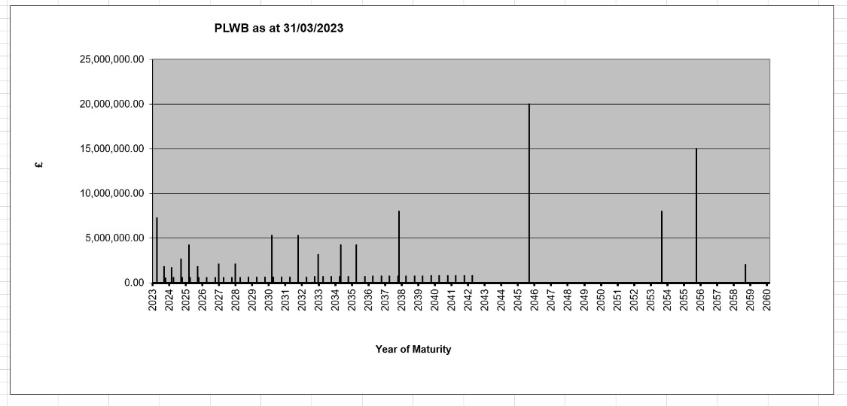

All trade and other creditors are due to be repaid within one year.

Market Risk

a) Foreign Exchange Risk
The Authority has no financial assets or liabilities denominated in foreign currencies, and thus has no exposure to loss arising from movements in exchange rates.

b) Price Risk
Price risk arises on financial assets because of changes in commodity prices or equity prices.
The Authority’s holdings in the CCLA Local Authority Property Fund are held on the Balance Sheet at bid price. This is the expected return if the Authority decided to sell its holdings. The asset value will reflect fluctuations in Property Values and rents and are therefore exposed to risk arising from movements in the price of such assets due to changes in general economic conditions. The property fund is classified at fair value through profit or loss, meaning that all movements in price will impact on gains and losses recognised in the surplus or deficit on the provision of services. However, for a five-year period commencing the 1st April 2018, there is a statutory override to avoid such an impact.

c) Interest Rate Risk
The Authority is exposed to significant risk in terms of its exposure to interest rate movements on its borrowings and investments. As an example of this, a rise in interest rate has the following effects:

- Borrowings at variable rates – the interest expense charged to the surplus or deficit on the provision of services will rise;
- Borrowings at fixed rates – the fair value of the loan will fall;
- Investments at variable rates – the interest income credited to the surplus or deficit on the provision of services will rise;
- Investments at fixed rates – the fair value of the investment will fall.

Borrowings are carried at amortised cost on the Balance Sheet not fair value, and so nominal gains and losses on fixed rate borrowings would not impact on the Surplus or Deficit on the Provision of Services or Other Comprehensive Income and Expenditure. However, changes in variable rates on borrowings and investments will be posted to the Surplus or Deficit on the Provision of Services and affect the General Fund Balance.

The annual Treasury Management Policy and Strategy documents approved by Council contain a number of strategies for managing interest rate risk. To guard against the impact of adverse changes in interest rates, the maximum proportion of borrowing subject to variable interest rates is limited to 33% along with a maximum proportion of investments subject to variable rates limited to 40%.

During periods of falling interest rates, and where economic circumstances make it favourable, the Authority will look to reschedule its loans in order to limit its exposure to losses and so reduce its capital financing costs.

The in-house Treasury Management team receives professional advice and has an active strategy for assessing interest rate exposure via the use of indicators. This is used to establish and monitor the budget for capital financing costs, allowing any adverse changes to be accommodated. The monitoring of interest rate exposure assists with the decision as to whether new borrowing or investment undertaken is fixed or variable.

Based on the assessment strategy for interest rate risk if interest rates had been 1% higher with all other variables held constant on 31 March, the financial effect would be (note that the percentages quoted are for illustrative purposes only and are not an indication of the likely change):

31 March  2022  £000s |  | 31 March  2023  £000s
1,029 | Increase in interest receivable on variable rate investments (and resultant impact on the Surplus or Deficit on the Provision of Services) | 852
16,024 | Decrease in fair value of fixed rate loans (no impact on Other  Comprehensive Income and Expenditure) | 9,861
0 | Increase in fair value of fixed rate investments (impact on Other  Comprehensive Income and Expenditure) | 0
0 | Increase in fair value of financial liabilities (no impact on Other  Comprehensive Income and Expenditure) | 0

The impact of a 1% fall in interest rates would be as above but with the movements being reversed. The 1% variation chosen for sensitivity analysis can be treated as a flat line change, so a 5% variation will result in amounts totalling five times the amount included in the table above.

The Authority held no loans at variable rate at the Balance Sheet date so any movement in interest rates will have no effect on the Surplus or Deficit on the Provision of Services.

55 STATEMENT OF SINGLE ENTITIY AND GROUP ACCOUNTING POLICIES

(a) GOING CONCERN

The provisions in the Code in respect of going concern reporting requirements reflect the economic and statutory environment in which local authorities operate. These provisions confirm that, as authorities cannot be created or dissolved without statutory prescription, they must prepare their financial statements on a going concern basis of accounting.

Local authorities carry out functions essential to the local community and are themselves revenue raising bodies (with limits on their revenue raising powers, arising only at the discretion of central government). If an authority were in financial difficulty, the prospects are thus that alternative arrangements might be made by central government either for the continuation of the services it provides or for assistance with the recovery of a deficit over more than one financial year. As a result of this, it would not therefore be appropriate for local authority financial statements to be provided on anything other than a going concern basis.

The accounts are prepared on the expectation that the services and functions of the Council are expected to continue in operational existence for the foreseeable future. Therefore, these financial statements are produced on a going concern basis.

Additionally, management have assessed cash flow modelling through to March 2025 which demonstrates the Council’s ability to work within its Capital Financing Requirement and Cash management framework, with appropriate headroom (at least £10m), and identified no significant risks to liquidity within the next twelve months from the date of issue of these financial statements.

The Narrative Report sets out the significant impacts of the current high levels of inflation, and the ongoing impact of the pandemic, on the local economy and on Council finances, as well as the response structures and steps taken to manage the risks and impacts. The Council is still experiencing a reduction in income in the current year, with losses of fees and charges and Council Tax and Business Rates. The current high levels of inflation and the pandemic is also still resulting in the Council bearing significant extra costs, particularly in social care.

The Council received additional grant support from Government in 2021/22 to fund a proportion of these costs, including emergency funding, and compensation for an element of losses on sales, fees and charges and council tax. It is estimated that this funding will offset a significant proportion of costs and income losses, with no residual losses currently included in the Council’s budget monitoring position for the year.

Current cash and cash-equivalents of £26m at the balance sheet date have been modelled, using reasonable assumptions regarding service costs, staff costs and income, for 12 months from the final certification of these statements to March 2025, including downside scenarios for cash collection and the ongoing impact of reduction on fees and charges. The low point in liquidity is in March 2024 due to the cumulative impacts of the downside scenarios modelled and the usual cycle of taxation collection resulting in lower cash income in February and March. The Council remains in a positive cash position for the duration of the forecast.

The Council do not plan for any borrowing to support cashflow until March 2024, and only then in the downside scenario. In line with the treasury management strategy of the Council, planned borrowing is limited to the refinancing of a loan due for repayment. The Council remains within its prudential borrowing limits with sufficient headroom should further need arise.

The Council budget and medium-term financial strategy identify savings requirements over the next three years. The Council plan to move towards the General Fund Balance being maintained above the minimum 6.5% of Council net budget as recommended by the Section 151 officer in the Robustness report to Budget Council. There was no planned use of the Council’s General Fund Balances to support the short- or medium-term budgets. However, given the current high levels of inflation and service pressures in areas such as Children’s Social Care, the Council may need to agree to utilise some General Fund Balances to meet these pressures in 2023/24 – however, they will remain above the absolute minimum level required. The use of these balances will necessitate their replenishment, and plans will be developed to do this in line with the Council’s track record of achieving savings required by difficult financial decisions.

The Council recognise that Collection Fund losses from 2020/2021 can be carried forward and funded over three years in line with Government guidance.

As the cash flow modelling demonstrates that the Council will continue to have liquidity for the next 12 months, to support the continuation of service assumption, management are satisfied that there is no material uncertainty relating to going concern.

(b) GENERAL PRINCIPLES

The Statement of Accounts summarises the Council’s transactions for the financial year and its position at the year end. The Council is required to prepare an Annual Statement of Accounts by the Accounts and Audit (England) Regulations 2015 in accordance with proper accounting practices. These practices are set out primarily the Code of Practice on Local Authority Accounting in the United Kingdom 2022/2023.

The accounting convention adopted in the Statement of Accounts is primarily historical cost, modified by the revaluation of certain categories of non-current assets and financial instruments.

(c) ACCRUALS OF INCOME AND EXPENDITURE

Activity is accounted for in the year that it takes place, not simply when cash payments are made or received, in particular:

- Revenue from contracts with service recipients, whether for services or the provision of goods, is recognised when (or as) the goods or services are transferred to the service recipient in accordance with the performance obligations in the contract.
- Supplies are recorded as expenditure when they are consumed - where there is a gap between the date supplies are received and their consumption, they are carried as inventories on the Balance Sheet.
- Expenses in relation to services received (including services provided by employees) are recorded as expenditure when the services are received rather than when payments are made.
- Interest receivable on investments and payable on borrowings is accounted for respectively as income and expenditure on the basis of the effective interest rate for the relevant financial instrument rather than the cash flows fixed or determined by the contract.
- Where revenue and expenditure have been recognised but cash has not been received or paid, a debtor or creditor for the relevant amount is recorded in the Balance Sheet. Where debts may not be settled, the balance of debtors is written down and a charge made to revenue for the income that might not be collected.

(d) BUSINESS IMPROVEMENT DISTRICTS

A Business Improvement District (BID) scheme applies to an area in Southport Town Centre. The scheme is funded by a BID levy paid by non-domestic ratepayers. The Authority acts as principal under the scheme, and accounts for income received and expenditure incurred (including contributions to the BID project) within the relevant services within the Comprehensive Income and Expenditure Statement.

(e) CASH AND CASH EQUIVALENTS

Cash is represented by cash in hand and deposits with financial institutions repayable without penalty on notice of not more than 24 hours. Cash equivalents are investments that mature in three months or less from the date of acquisition and that are readily convertible to known amounts of cash with insignificant risk of change in value.

In the Balance Sheet and Cash Flow Statement, cash and cash equivalents are shown net of bank overdrafts that are repayable on demand and form an integral part of the Council’s cash management. (f) CHARGES TO REVENUE FOR NON-CURRENT ASSETS

Services, support services and trading accounts are debited with the following amounts to record the cost of holding Property, Plant and Equipment and Intangible Assets during the year:

- Depreciation attributable to the assets used by the relevant service;
- Revaluation and impairment losses on assets used by the service where there are no accumulated gains in the Revaluation Reserve against which the losses can be written off; and
- Amortisation of intangible assets attributable to the service.
The Council is not required to raise council tax to fund depreciation, revaluation and impairment losses or amortisation. However, it is required to make an annual contribution from revenue towards the reduction in its overall borrowing requirement equal to an amount calculated on a prudent basis determined by the Council in accordance with statutory guidance. Depreciation, revaluation and impairment losses are therefore replaced by the contribution in the General Fund Balance (Statutory Provision for the Financing of Capital Investment) by way of an adjusting transaction with the Capital Adjustment Account in the Movement of Reserves Statement for the difference between the two.

(g) COUNCIL TAX AND NON-DOMESTIC RATES

Sefton Council as a billing authority acts as an agent, collecting council tax and non-domestic rates (NDR) on behalf of the major preceptors (Merseyside Police and Crime Commissioner, Merseyside Fire and Rescue Service, and Liverpool City Region Combined Authority) and, as principal, collecting council tax and NDR for the Council. Billing authorities are required by statute to maintain a separate fund (i.e. the Collection Fund) for the collection and distribution of amounts due in respect of council tax and NDR. Under the legislative framework for the Collection Fund, billing authorities, major preceptors and central government share proportionately the risks and rewards that the amount of council tax and NDR collected could be less or more than predicted. Sefton is part of the Liverpool City Region Business Rate Retention Pilot scheme currently retains 99% of NDR rates, which includes the 50% that would otherwise be due to central government.

Accounting for Council Tax and NDR

The council tax and NDR income included in the Comprehensive Income and Expenditure Statement
(CIES) is the authority’s share of accrued income for the year. However, regulations determine the amount of council tax and NDR that must be included in the authority’s General Fund. Therefore, the difference between the income included in the CIES and the amount required by regulation to be credited to the General Fund is taken to the Collection Fund Adjustment Account and included as a reconciling item in the Movement in Reserves Statement.

The Balance Sheet includes the authority’s share of the end of year balances in respect of council tax and NDR relating to arrears, impairment allowances for doubtful debts, overpayments and prepayments and appeals.

(h) EMPLOYEE BENEFITS

Benefits payable during employment
Short term employee benefits are those due to be settled within 12 months of the year end. They include such benefits as wages, salaries, paid annual leave and paid sick leave, bonuses and nonmonetary benefits (e.g., cars) for current employees and are recognised as an expense for services in the year in which the employees render service for the Council. An accrual is made for the cost of holiday entitlements (or any form of leave e.g., time off in lieu), earned by employees but not taken before the year-end which employees can carry forward into the next financial year. The accrual is made at the wage and salary rates applicable in the following financial year, being the period in which the employee takes the benefit. The accrual is charged to Surplus or Deficit on the Provision of Services, but then reversed out through the Movement in Reserves Statement so that holiday entitlements are charged to revenue in the financial year to which the holiday absence occurs.

Termination Benefits
Termination benefits are amounts payable as a result of a decision by the authority to terminate an officer’s appointment before the normal retirement date or an officer’s decision to accept voluntary redundancy in exchange for those benefits and are charged on an accruals basis to the appropriate service or, where applicable, to the Corporate Unallocated Costs line in the Comprehensive Income and Expenditure Statement at the earlier of when the Authority can no longer withdraw the offer of those benefits or when the Authority recognises costs for a restructuring.

Where termination benefits involve the enhancement of pensions, statutory provisions require the General Fund balance to be charged with the amount payable by the Authority to the pension fund or pensioner in the year, not the amount calculated according to the relevant accounting standards. In the Movement in Reserves Statement, appropriations are required to and from the Pensions Reserve to remove the notional debits and credits for pension enhancement termination benefits and replace them with debits for the cash paid to the pension fund and pensioners and any such amounts payable but unpaid at the year end.

Post-Employment Benefits
Employees of the Council are members of three separate pension schemes:

- The Teachers’ Pension Scheme administered by Capita Teachers’ Pensions on behalf of the Department for Education.

- The NHS Pension Scheme administered by NHS Pensions on behalf of the Department of Health.

- Local Government Pension Scheme (Merseyside Pension Fund) administered by Wirral Metropolitan Borough Council.

These Schemes are defined benefits schemes in that they provide defined benefits to members (retirement lump sums and pensions) earned as employees working for the Council.

However, the arrangements for the Teachers’ Pension Scheme and NHS Pension Scheme mean that liabilities for these benefits cannot ordinarily be identified specifically to the Council. The scheme is therefore accounted for as if it were a defined contribution scheme and no liability for future payments of benefits is recognised in the Balance Sheet. The Schools and Families - Schools line in the Comprehensive Income and Expenditure Statement is charged with the employer’s contributions payable to Teachers’ Pensions. The Health and Wellbeing line in the Comprehensive Income and Expenditure Statement is charged with the employer’s contributions payable to NHS Pensions in the year.

The Local Government Pension Scheme
The Local Government Scheme is accounted for as a defined benefits scheme:

- The liabilities of the Merseyside Pension Fund attributable to the Council are included in the Balance Sheet on an actuarial basis using the projected unit method – i.e. an assessment of the future payments that will be made in relation to retirement benefits earned to date by employees, based on assumptions about mortality rates, employee turnover rates etc. and projections of current earnings for current employees.
- Liabilities are discounted to their present value at current prices using a discount rate based on the indicative rate of return on high quality corporate bonds (based on a weighted average of ‘spot yields’ on AA rated corporate bonds). The discount rate used for the year is disclosed in the Participation in Pension Schemes note.
- The assets of Merseyside Pension Fund attributable to the Council are included in the Balance Sheet at their fair value:
  - Quoted Securities – current bid price,
  - Unquoted securities – professional estimate,
  - Unitised securities- current bid price, – Property – market value.
- The change in the net pensions’ liability is analysed into the following components:

Service cost comprising:
- Current Service Cost – the increase in liabilities as a result of years of service earned this year - allocated in the Comprehensive Income and Expenditure Statement to the services for which the employee worked.
- Past Service Cost - the increase in liabilities as a result of scheme amendment or curtailment whose effect relates to years of service earned in earlier years - debited to the Surplus or Deficit on the Provision of Services in the Comprehensive Income and Expenditure Statement as part of Corporate Unallocated Costs,
- Net Interest on the Net Defined Benefit Liability (Asset), i.e. net interest expense of the Authority - the change during the period in the net defined benefit liability (asset) that arises from the passage of time charged to the Financing and Investment Income and Expenditure line in the Comprehensive Income and Expenditure Statement – this is calculated by applying the discount rate used to measure the defined benefit obligation at the beginning of the period to the net defined benefit liability (asset) at the beginning of the period – taking into account any changes in the net defined benefit liability (asset) during the year as a result of contribution and benefit payments.
Remeasurements comprising:
- The Return on Plan Assets – excluding amounts included in net interest on the net defined benefit liability (asset) – charged to the Pensions Reserve as Other Comprehensive Income and Expenditure.
- Actuarial Gains and Losses - changes in the net pensions liability that arise because events have not coincided with assumptions made at the last actuarial valuation or because the actuaries have updated their assumptions - charged to the Pensions Reserve as Other Comprehensive Income and Expenditure.

Contributions paid to the Merseyside Pension Fund
– Cash paid as employer’s contributions to the pension fund in settlement of liabilities; not accounted for as an expense.

In relation to retirement benefits, statutory provisions require the General Fund balance to be charged with the amount payable by the Authority to the pension fund or directly to pensioners in the year, not the amount calculated according to the relevant accounting standards. In the Movement in Reserves Statement, this means that there are transfers to and from the Pensions Reserve to remove the notional debits and credits for retirement benefits and replace them with debits for the cash paid to the pension fund and pensioners and any such amounts payable but unpaid at the year end. The negative balance that arises on the Pensions Reserve therefore measures the beneficial impact on the General Fund of being required to account for retirement benefits on the basis of cash flows rather than benefits which are earned by employees.

Discretionary Benefits
The Council also has restricted powers to make discretionary awards of retirement benefits in the event of early retirements. Any liabilities estimated to arise as a result of an award to any member of staff (including teachers) are accrued in the year of the decision to make the award and accounted for using the same policies as are applied to the Local Government Pension Scheme.

(i) EVENTS AFTER THE BALANCE SHEET DATE

Events after the Balance Sheet date are those events, both favourable and unfavourable that occur between the end of the reporting period and the date when the Statement of Accounts is authorised for issue. Two types of events can be identified:

- Those that provide evidence of conditions that existed at the end of the reporting period - the Statement of Accounts is adjusted to reflect such events.

- Those that are indicative of conditions that arose after the reporting period – the Statement of Accounts is not adjusted to reflect such events, but where a category of events would have a material effect, disclosure is made in the notes of the nature of the events and their estimated financial effect.

Events taking place after the authorisation to issue are not reflected in the Statement of Accounts.

(j) FAIR VALUE MEASUREMENT

The Council measures some of its assets and liabilities at fair value at the end of the reporting period. Fair value is the price that would be received to sell an asset or paid to transfer a liability at the measurement date. The fair value measurement assumes that the transaction to sell the asset or transfer the liability takes place either:

- in the principal market for the asset or liability, or

- in the absence of a principal market, in the most advantageous market for the asset or liability.

The Council uses external valuers to provide a valuation of its assets and liabilities in line with the highest and best use definition within the accounting standard. The highest and best use of the asset or liability being valued is considered from the perspective of a market participant.

Inputs to the valuation techniques in respect of the Council’s fair value measurement of its assets and liabilities are categorised within the fair value hierarchy as follows:

Level 1 – quoted prices (unadjusted) in active markets for identical assets or liabilities that the authority can access at the measurement date.
Level 2 – inputs other than quoted prices included within Level 1 that are observable for the asset or liability, either directly or indirectly.
Level 3 – unobservable inputs for the asset or liability.

(k) FINANCIAL INSTRUMENTS

General Comment

A financial instrument is any contract that gives rise to a financial asset in one entity, and a financial liability in another. Most straight forward financial assets (debtors, bank deposits, investments etc.) and liabilities (creditors, borrowings etc) are covered by this policy.

Financial Liabilities

Financial liabilities are recognised on the Balance Sheet when the authority becomes a party to the contractual provisions of a financial instrument and are initially measured at fair value and are subsequently carried at their amortised cost. Annual charges to the Financing and Investment Income and Expenditure line in the Comprehensive Income and Expenditure Statement for interest payable are based on the carrying amount of the liability, multiplied by the effective rate of interest for the investment. The effective interest rate is the rate that exactly discounts estimated future cash payments over the life of the instrument to the amount at which it was originally recognised.

For most of the borrowings that the Council has, this means that the amount presented in the Balance Sheet is the outstanding principal repayable (plus accrued interest); and interest charged to the Comprehensive Income and Expenditure Statement is the amount payable for the year according to the loan agreement.

Gains and losses on the repurchase or early settlement of borrowing are credited and debited to the Financing and Investment Income and Expenditure line in the Comprehensive Income and Expenditure in the year of repurchases/settlement. However, where repurchase has taken place as part of a restructuring of the loan portfolio that involves the modification or exchange of existing instruments, the premium or discount is respectively deducted from or added to the amortised cost of the new or modified loan and the write down is spread over the life of the loan by an adjustment to the effective interest rate. This is managed by a transfer to or from the Financial Instruments Adjustment Account in Movement in Reserves Statement.

Where premiums and discounts have been charged to CIES, regulations allow the impact on the General Fund Balance to be spread over future years. The Council has a policy of spreading the gain or loss over the term that was remaining on the loan against which the premium payable or discount receivable when it was repaid.

Financial Assets

Financial assets are classified based upon a classification and measurement approach that reflects the business model for holding financial assets and their cash flow characteristics. There are three main classes of financial assets measured at
- Amortised costs
- Fair value through profit and loss (FVPL), and
- Fair value through other comprehensive income (FVOCI)

The Council does not hold investments that are measured fair value through FVOCI.

Financial assets measured at amortised cost
Financial assets measured at amortised cost are recognised on the Balance Sheet when the Council becomes a party to the contractual provision of a financial instrument and are initially valued at fair value. They are subsequently measured at their amortised costs. Annual credits to the Financing and Investment Income and Expenditure line in the Comprehensive Income and Expenditure Statement (CIES) for interest receivable are based on the carrying amount of the asset multiplied by the effective rate of interest for the instrument. For most of the financial instrument held by the Council, this means that the amount presented in the Balance Sheet is the outstanding principal receivable (plus accrued interest) and interest credited to CIES is the amount receivable for the year in the loan agreement.

Financial assets measured at fair value through profit and loss
Financial assets that are measured at FVPL are recognised on the Balance Sheet when the Council becomes a party to the contractual provision of a financial instrument and are initially measured and carried at fair value. Fair value gains and losses are recognised as they arise in the Surplus or Deficit on the Provision of Services.

The fair value measurement is based on the following techniques:
- Instruments with quoted market prices – the market price
- Other instruments with fixed determinable payments – discounted cash flow analysis

The inputs to the measurement techniques are categorised in accordance with the accounting policy set out in section (i) Fair Value Measurement.

Churches & Charities Local Authority LAMIT Property Fund:
The Ministry for Housing, Communities and Local Government introduced a mandatory statutory override requiring local authorities to reverse out all unrealised fair value movements resulting from pooled investment funds to protect the General Fund. This will be effective for 5 years from the financial year commencing 1 April 2018, and upon expiry all fair value movements will then impact on the General Fund Balance.

Credit loss model

The credit risk model allows the authority to measure the loss allowance for a financial instrument at an amount equal to the lifetime expected credit losses if the credit risk on that instrument has increased significantly since initial recognition. To make the assessment the authority compares the risk of a default occurring on the financial instrument. This is carried out with market intelligence supplied by external treasury consultants.

Warranties and Guarantees
The Council has entered into a number of Guarantees that are not required to be accounted for as Financial Instruments. These guarantees are reflected in the Statement of Accounts to the extent that at some future date a provision or earmarked reserve may have to be set up. These guarantees relate to:

- Housing stock transfer warranties,
- Pension guarantees related to contractor admissions bodies, such as New Directions.

(l) FOREIGN CURRENCY TRANSLATION

Where the Council has entered into a transaction denominated in a foreign currency, the transaction is converted into sterling at the exchange rate applicable on the date the transaction was effective.

(m) GOVERNMENT GRANTS AND CONTRIBUTIONS

Whether paid on account, by instalments or in arrears government grants and third-party contributions and donations are recognised as due to the authority where there is reasonable assurance that:

- The Authority will comply with the conditions attached to the payments, and
- The grants or contributions will be received.

Amounts recognised as due to the Council are recognised immediately in the CIES, except to the extent that the grant or contribution has a condition(s) relating to initial recognition that the Authority has not satisfied. Conditions are stipulations that specify that the future economic benefits or service potential embodied in the asset received in the form of the grant or contribution are required to be consumed by the recipient as specified, or future economic benefits or service potential must be returned to the transferor.

Monies advanced as grants and contributions for which conditions have not been satisfied are carried in the Balance Sheet as receipts in advance. When conditions are satisfied, the grant or contribution is credited to the relevant services line (attributable revenue grants and contributions) or Taxation and Non-Specific Grant Income (Non-Ringfenced Government Grants and Capital Grants and Government Grants) in the Comprehensive Income and Expenditure Statement.

Where capital grants are credited to the Comprehensive Income and Expenditure Statement, they are reversed out of the General Fund Balance in the Movement in Reserves Statement. Where the grant has yet to be used to finance capital expenditure, it is posted to the Capital Grants Unapplied Reserve. Where it has been applied, it is posted to the Capital Adjustments Account. Amounts in the Capital Grants Unapplied Reserve are transferred to the Capital Adjustments Account once they have been applied to fund capital expenditure.

(n) HERITAGE ASSETS

A heritage asset is an asset that is held due to its historical, artistic, scientific, technological, or environmental qualities, and is maintained principally for its contribution to knowledge and culture. The
Authority’s heritage assets are held in a number of locations, such as Town Halls and the Atkinson Centre.

The collection consists principally of a ceramic collection, a silver collection, works of art, an Egyptology collection, several war memorials, and the art installation “Another Place”. The collection is mainly valued on an insurance valuation basis. However, a number of war memorials are held that are valued at a nominal £1.

The assets are felt to have indeterminate lives and a high residual value; hence the Authority does not consider it appropriate to charge depreciation.

The Authority considers that obtaining valuations for the collection would involve disproportionate cost. This is because of the diverse nature of the assets and the lack of comparable market values.

Heritage Assets are recognised and measured (including the treatment of revaluation gains and losses) in accordance with the Authority’s accounting policies on property, plant and equipment (note (q). The carrying amounts of Heritage Assets would be reviewed where there was evidence of impairment, e.g. where an item has suffered physical deterioration or breakage or where doubts arise about its authenticity. Any impairment would be recognised and measured in accordance with the Authority’s general policies on impairment (see Impairment section of note (v)). If any items were disposed of, the proceeds would be accounted for in accordance with the Authority’s general provisions relating to the disposal of property, plant and equipment. Disposal proceeds are disclosed separately in the notes to the financial statements and are accounted for in accordance with statutory accounting requirements relating to capital expenditure and capital receipts.

(o) INTANGIBLE ASSETS

Expenditure on non-monetary assets that do not have physical substance but are controlled by the Council as a result of past events (e.g. software licenses) is capitalised when it is expected that the future economic benefits or service potential will flow from the intangible asset to the Council.

Expenditure on the development of websites is not capitalised if the website is solely or primarily intended to promote or advertise the Councils goods or services.

Intangible assets are carried at amortised cost. An intangible asset is amortised over its useful life to the relevant service lines in the Comprehensive Income and Expenditure Statement. An asset is tested for impairment whenever there is an indication that the asset might be impaired - any losses recognised are posted to the relevant service line(s) in the Comprehensive Income and Expenditure Statement. Any gain or loss arising on the disposal or abandonment of an intangible asset is posted to the Other Operating Expenditure line in the Comprehensive Income and Expenditure Statement.

Where expenditure on intangible assets qualifies as capital expenditure for statutory purposes, amortisation, impairment losses and disposal gains and losses are not permitted to have an impact on the General Fund Balance. The gains and losses are therefore reversed out of the General Fund Balance in the Movement of Reserves Statement and posted to the Capital Adjustments Account and (if sales proceeds exceed £10,000) the Capital Receipts Reserve.

(p) INTERESTS IN COMPANIES AND OTHER ENTITIES

The Council has a material interest in companies that are subsidiaries and is required to prepare group accounts. In the Council’s own single entity accounts the interest in the companies is recorded as a long-term investment at cost.

In the group accounts transactions and balances between the Council and subsidiary are netted out on consolidation.

(q) INVENTORIES AND LONG-TERM CONTRACTS

Inventories are included in the Balance Sheet at the lower of cost or net realisable value. The cost of inventories is assigned using the First-In-First-Out costing formula.

Long term contracts are accounted for on the basis of charging the Surplus or Deficit on the Provision of Services with the value of works and services received under the contract during the financial year.

(r) INVESTMENT PROPERTY

Investment properties are those that are used solely to earn rentals and/or for capital appreciation. The definition is not met if the property is used in any way to facilitate the delivery of services or the production of goods or is held for sale.

Investment Properties are measured initially at cost. This is the amount of cash or cash equivalents paid or the fair value of other consideration given to acquire an asset at the time of its acquisition. They are subsequently measured at fair value, based on the market price that would be received to sell an asset in an orderly transaction between market participants at the measurement date. Properties are not depreciated but are revalued. An annual revaluation of all investment properties is undertaken. Gains and losses on revaluation are posted to the Financing and Investment Income and Expenditure line in the Comprehensive Income and Expenditure Statement. The same treatment is applied to gains and losses on disposal.

Rentals received in relation to investment properties are credited to the Financing and Investment Income line and result in a gain for the General Fund Balance. However, revaluation and disposal gains and losses are not permitted by statutory arrangements to have an impact on the General Fund Balance. The gains and losses are therefore reversed out of the general fund balance in the movement in reserves statement and posted to the capital adjustment account and (for any sale proceeds greater than £10,000) the capital receipts reserve.

(s) JOINT OPERATIONS

Joint operations are arrangements where the parties that have joint control of the arrangement have rights to the assets and obligations for the liabilities relating to the arrangement. The activities undertaken by the authority in conjunction with other joint operators involve the use of the assets and resources of those joint operators. In relation to its interest in a joint operation, the authority as a joint operator recognises:

- its assets, including its share of any assets held jointly
- its liabilities, including its share of any liabilities incurred jointly
- its revenue from the sale of its share of the output arising from the joint operation - its share of the revenue from the sale of the output by the joint operation - its expenses, including its share of any expenses incurred jointly.

(t) LEASES

Leases have been classified as finance leases where the terms of the lease transfer substantially all the risks and rewards incidental to the ownership of property from the lessor to the lessee. All other leases are to be classified as operating leases.

Where a lease covers both land and buildings, the land and buildings elements are considered separately for classification.

Arrangements that do not have the legal status of a lease but convey a right to use an asset in return for a payment are accounted for under this policy where fulfilment of the arrangement is dependent on the use of specific assets.

THE COUNCIL AS A LESSEE

Finance Leases
Property, plant and equipment held under Finance leases will be recognised on the balance sheet at the commencement of the lease at its fair value measured at the leases inception (or the present value of the minimum lease payments if lower). The asset recognised will be matched by a liability for the obligation to pay the lessor. Initial direct costs of the Authority are added to the carrying amount of the asset. Premiums paid on entry into a lease are applied to writing down the lease liability. Contingent rents are charged as expenses in the periods in which they are incurred.

Lease payments will be apportioned between:

- A charge for the acquisition of the interest in the property, plant or equipment - applied to write down the lease liability,
- A finance charge (debited to the Financing and Investment Income and Expenditure line in the Comprehensive Income and Expenditure Statement).

Property, Plant and Equipment recognised under finance leases is accounted for using the policies applied generally to such assets, subject to depreciation being charged over the lease term if this is shorter than the asset’s estimated useful life (where ownership of the asset does not transfer to the Council at the end of the lease period).

The Council is not required to raise Council Tax to cover depreciation or revaluation and impairment losses arising on leased assets. Instead a prudent annual contribution is made from revenue funds towards the deemed capital investment in accordance with statutory requirements. Depreciation and revaluation and impairment losses are therefore substituted by a revenue contribution in the General Fund Balance, by way of an adjusting transaction with the Capital Adjustment Account in the Movement in Reserves Statement for the difference between the two.

Operating Leases
Rentals paid under operating leases are charged to the Comprehensive Income and Expenditure Statement as an expense of the services benefiting from the use of the leased property, plant and equipment. Charges are made on a straight-line basis over the life of the lease, even if this does not match the pattern of payments (i.e., there is a rent free period at the commencement of the lease).

THE COUNCIL AS A LESSOR

Finance Leases
Where the Council grants a finance lease over a property or an item of plant or equipment, the relevant asset is written out of the balance sheet as a disposal. At the commencement of the lease, the carrying amount of the asset in the balance Sheet (whether Property, Plant and Equipment or Assets Held for Sale) is written off to the Other Operating Expenditure line in the Comprehensive Income and Expenditure Statement as part of the gain or loss on disposal. A gain, representing the Authority’s net investment in the lease is credited to the same line in the Comprehensive Income and Expenditure Statement also as part of a gain or loss on disposal (i.e., netted off against the carrying value of the asset at the time of disposal) matched by a lease (long term debtor) asset in the balance sheet.

Lease rentals receivable will be apportioned between:

- A charge for the acquisition of the interest in the property, plant or equipment - applied to write down the lease debtor (together with any premiums received), and
- Finance income (credited to the Financing and Investment Income and Expenditure line in the Comprehensive Income and Expenditure Statement).

The gain credited to the Comprehensive Income and Expenditure Statement is not permitted by Statute to increase the General Fund Balance and is required to be treated as a capital receipt. Where a premium, this is posted out of the General Fund Balance to the Capital Receipts Reserve in the Movement in Reserves Statement. Where the amount due in relation to the lease asset is to be settled by the payment of rentals in future financial years, this is posted out of the General Fund Balance to the Deferred Capital Receipts Reserve in the Movement in Reserves Statement. When the future rentals are received, the element for the capital receipt for the disposal of the asset is used to write down the lease debtor. At this point, the deferred capital receipts are transferred to the Capital Receipts Reserve.

The written off value of disposals is not a charge against council tax, as the cost of Property, Plant and Equipment is fully provided for under separate arrangements for capital financing. Amounts are therefore appropriated to the Capital Adjustment Account from the General Fund Balance in the Movement in Reserves Statement.

Operating Leases
Where the Council grants an operating lease over a property or an item of Plant or Equipment, the asset is retained in the Balance Sheet. Rental Income is credited to the Other Operating Expenditure line in the Comprehensive Income and Expenditure Statement.

Credits are made on a straight-line basis over the life of the lease, even if this does not match the pattern of payments (i.e. there is a premium paid at the commencement of the lease).

Initial direct costs incurred in negotiating and arranging the lease are added to the carrying amount of the relevant asset and charged as an expense over the term on the same basis as rental income.

(u) OVERHEADS AND SUPPORT SERVICES

The costs of overhead and support services are charged to those services that benefit from them, in accordance with the Council’s arrangements for accountability and financial performance.

(v) PRIOR YEAR ADJUSTMENTS, CHANGES IN ACCOUNTING POLICY AND ESTIMATES AND ERRORS

Prior year adjustments may arise as a result of a change in accounting policies or to correct a material error. Changes in accounting estimates are accounted for prospectively, i.e. in the current and future years affected by the change and do not give rise to a prior year adjustment.

Changes in accounting policies are only made when required by proper accounting practices or the change provides more clear and reliable information about the effect of transactions, other events and conditions on the Council’s financial position or financial performance. Where a change is made, it is applied retrospectively (unless otherwise stated) by adjusting opening balances and comparative amounts for the prior year as if the new policy had always been applied.

(w) PRIVATE FINANCE INITIATIVE AND SIMILAR CONTRACTS

PFI and similar contracts are agreements to receive services, where the responsibility for making available the property, plant and equipment needed to provide the services passes to the PFI contractor. As the Council is deemed to control the services that are provided under its PFI schemes, and as ownership of the property, plant and equipment will pass to the Council at the end of the contracts for no additional charge, the Authority carries the assets used under the contracts on its Balance Sheet as Property Plant and Equipment.

The original recognition of these assets at fair value (based on the cost to purchase the Property, Plant and Equipment) was balanced by the recognition of a liability for amounts due to the scheme operator to pay for the capital investment.

These non-current assets recognised on the Balance Sheet are revalued and depreciated in the same way as property plant and equipment owned by the Council.

The amounts payable to the PFI operator each year are analysed into five elements:

- Fair value of the services received during the year - debited to the relevant service in the Comprehensive Income and Expenditure Statement;
- Finance Cost – An interest charge on the outstanding Balance Sheet Liability, debited to the Financing and Investment Income and Expenditure line in the Comprehensive Income and Expenditure Statement;
- Contingent Rent – increases in the amount to be paid for the property arising during the contract, debited to the Financing and Investment Income and Expenditure line in the Comprehensive Income and Expenditure Statement;
- Payment towards liability – applied to write down the balance sheet liability towards the PFI operator (the profile of write downs is calculated on the same basis as for a finance lease);
- Lifecycle replacement costs - proportion of the amounts payable is posted to the Balance Sheet as a prepayment and then recognised as additions to Property, Plant and Equipment when the relevant works are eventually carried out.

(x) PROPERTY, PLANT AND EQUIPMENT

Assets that have physical substance and are held for use in the production or supply of goods or services, for rental to others, or for administrative purposes and that are expected to be used during more than one financial year are classified as Property, Plant and Equipment (PP&E).

Recognition
Expenditure on the acquisition, creation or enhancement of Property Plant and Equipment is capitalised on an accruals basis, provided that it is probable that the future economic benefits or service potential associated with the item will flow to the authority and the cost of the item can be measured reliably. Expenditure that remains but does not add to an assets potential to deliver future economic benefits or service potential (i.e. repairs and maintenance) is charged as an expense when it is incurred.

All expenditure, regardless of value, is capitalised if it relates to an existing asset. Expenditure on new assets under £10,000 is not capitalised but treated as Revenue Expenditure Funded from Capital Under Statute (REFCUS), with expenditure over £10,000 being capitalised.

Measurement
Assets are initially measured at cost, comprising:

- The purchase price,
- Any costs attributable to bringing the asset to the location and condition necessary for it to be capable of operating in the manner intended by management,
- The initial estimate of the costs of dismantling and removing the item and restoring the site upon which it is located.

The Council does not capitalise borrowing costs incurred whilst assets are under construction.

The cost of assets acquired other than by purchase is deemed to be its current value, unless the acquisition does not have commercial substance (i.e. it will not lead to a variation in the cash flows of the authority). In the latter case, where an asset is acquired via an exchange, the cost of the acquisition is the carrying value of the asset given up by the Authority.

Assets are then carried in the Balance Sheet using the following measurement bases:

- Infrastructure, community assets and assets under construction – depreciated historical cost,
- Non HRA dwellings and rented property - current value, determined using the basis of existing use,
- Surplus assets - fair value, determined as the amount that would be paid for the asset in its existing use.
- All other assets - current value, determined as the amount that would be paid for the asset in its existing use.
Where there is no market-based evidence of fair value because of the specialist nature of an asset, depreciated replacement cost (DRC) is used as an estimate of current value.

Where non-property assets that have short useful lives or low values (or both), depreciated historical cost basis is used as a proxy for current value.

Assets included in the balance sheet at current value are revalued sufficiently regularly to ensure that their carrying amount is not materially different from their current value at the year end, but as a minimum every five years. Increases in valuations are matched by credits to the Revaluation Reserve to recognise unrealised gains. (Exceptionally gains might be credited to the Comprehensive Income and Expenditure Statement where they arise from the reversal of a loss previously charged to a service).

Where decreases in value are identified, they are accounted for by;

- Where there is a balance of revaluation gains for the asset in the Revaluation Reserve, the carrying amount of the Asset is written down against that balance (up to the amount of accumulated gains),
- Where there is no balance in the revaluation reserve or an insufficient balance, the carrying amount of the asset is written down against the relevant service line(s) in the Comprehensive Income and Expenditure Statement.

The Revaluation Reserve contains gains recognised since 1 April 2007 only, the date of its formal implementation. Gains arising before that date have been consolidated into the Capital Adjustment Account.

Impairment
Assets are assessed at each year end as to whether there is any indication that an asset may be impaired. Where indications exist and any possible differences are estimated to be material, the recoverable amount of the asset is estimated and, where this is less than the carrying amount of the asset, an impairment loss is recognised for the shortfall.

Where impairment losses are identified, they are accounted for by:

- Where there is a balance of revaluation gains for the asset in the Revaluation Reserve, the carrying amount of the Asset is written down against that balance (up to the amount of accumulated gains),
- Where there is no balance in the Revaluation Reserve or an insufficient balance, the carrying amount of the asset is written down against the relevant service line(s) in the Comprehensive Income and Expenditure Statement.

Where an impairment loss is reversed subsequently, the reversal is credited to the relevant service line(s) in the Comprehensive Income and Expenditure Statement, up to the amount of the original loss, adjusted for depreciation that would have been charged if the loss had not been recognised.

Depreciation
Depreciation is provided for on all Property, Plant and Equipment assets by the systematic allocation of their depreciable amounts over their useful lives. An exception is made for assets without a determinable finite useful life, such assets that are not yet available for use (i.e. assets under construction) and assets held for a commercial return (i.e. investment properties).

Where an item of Property Plant or Equipment asset has major components whose cost is significant in relation to the total cost of the item, then the components are depreciated separately.

For those assets that have major components the percentage of the asset that makes up each component is shown below:

Asset Type | Building | Roof | Services | Externals | Total
Primary Schools | 42% | 9% | 26% | 23% | 100%
Secondary Schools | 50% | 11% | 22% | 17% | 100%
Sports Centres | 49% | 10% | 23% | 18% | 100%
Libraries | 49% | 8% | 28% | 15% | 100%

Revaluation gains are also depreciated, with an amount equal to the difference between current value depreciation charged on assets and the depreciation that would have been chargeable based on their historical cost being transferred each year from the Revaluation Reserve to the Capital Adjustment Account.

Disposals and non-current assets held for sale
When it becomes apparent that the carrying amount of an asset will be recovered principally through a sale transaction rather than through its continuing use, it is reclassified as an Asset Held for Sale. The asset is revalued immediately before reclassification and then carried at the lower of this amount and current value less costs to sell. Where there is a subsequent decrease to current value less costs to sell, the loss is posted to the Other Operating Expenditure line in the Comprehensive Income and Expenditure Statement. Gains in current value are recognised only up to the amount of any losses previously recognised in the Surplus or Deficit on Provision of Services. Depreciation is not charged on Assets Held for Sale.

If assets no longer meet the criteria to be classified as Assets Held for Sale, they are reclassified back to non-current assets and valued at the lower of the carrying amount before they were classified as held for sale; adjusted for depreciation, amortisation or revaluations that would have been recognised had they not been classified as Held for sale, and their recoverable amount at the date of the decision not to sell.

Assets that are to be abandoned or scrapped are not reclassified as Assets Held for Sale.

When an asset is disposed of or decommissioned, the carrying amount of the asset in the Balance Sheet (whether Property Plant and Equipment or Assets Held for Sale) is written off to the Other Operating Expenditure line in the Comprehensive Income and Expenditure Statement as part of the gain or loss on disposal, Receipts from disposals (if any) are credited to the same line in the Comprehensive Income and Expenditure Statement also as part of the gain or loss on disposal (i.e. netted off against the carrying value of the asset at the time of disposal). Any revaluation gains accumulated for the asset in the Revaluation Reserve are transferred to the Capital Adjustment Account.

When an asset has been fully depreciated it is assumed, unless otherwise known, that the asset is disposed of or decommissioned in the following year. The gross value of the asset and the matching accumulated depreciation are then written out as disposals in that year.

Amounts received for a disposal in excess of £10,000 are categorised as capital receipts.

The written off value of disposals is not a charge against council tax, as the cost of Property, Plant and Equipment is fully provided for under separate arrangements for capital financing. Amounts are appropriated to the capital adjustments account from the General Fund Balance in the Movement in Reserves Statement.

Schools
When a maintained school transfers to Foundation Trust or Academy status the transfer of the school is treated as a disposal. Voluntary Aided and Voluntary Controlled schools are not recognised on the
Council’s Balance Sheet. The land and building are owned by the trustees of the school and the Council provides educational services under mere licence with no assignment of rights to the property. The trustees can terminate the arrangement at any time and as such the risks and rewards of the asset have not transferred to the school.

(y) PROVISIONS, CONTINGENT LIABILITIES AND CONTINGENT ASSETS

Provisions
Provisions are made where an event has taken place that gives the Authority a legal or constructive obligation that probably requires settlement by a transfer of economic benefits or service potential, and a reliable estimate can be made of the amount of the obligation. For instance, the authority may be involved in a court case that could eventually result in the making of a settlement or the payment of compensation.

Provisions are charged as an expense to the appropriate service line in the Comprehensive Income and Expenditure Statement in the year that the Council becomes aware of the obligation and are measured at the best estimate at the Balance Sheet date of the expenditure required to settle the obligation taking into account relevant risks and uncertainties.

When payments are eventually made, they are charged to the provision carried within the Balance Sheet. Estimated settlements are reviewed at the end of each financial year - where it becomes less than probable that a transfer of economic benefits will now be required (or a lower settlement than anticipated is made) the provision is reversed and credited back to the relevant service.

Where some or all of the payment required to settle a provision is expected to be recovered from another party (e.g. an insurance claim), this is only recognised as income for the relevant service if it is virtually certain the reimbursement will be received if the Council settles the obligation.

Amounts needed to settle any obligation are only discounted where required when included in the accounts.

Internal Insurance Cover
The Authority has established a provision to cover the potential costs of certain known uninsured losses, i.e., losses arising from excesses that apply to the Authority’s main insurance policies. This is accounted for in line with the normal policy above.

Provision for NDR Appeals
The Authority has established a provision to cover the potential costs for refunding ratepayers who have successfully appealed against the rateable value of their properties. The provision covers the Council’s locally retained share (99%) of the cost. This is accounted for in line with the normal policy above.

Contingent liabilities
A contingent liability arises where an event has taken place that gives the Council a possible obligation whose existence will only be confirmed by the occurrence or otherwise of uncertain future events not wholly within the control of the authority. Contingent liabilities also arise in circumstances where a provision would otherwise be made but either it is not probable that an outflow of resources will be required, or the amount of the obligation cannot be measured reliably.

Contingent liabilities are not recognised in the Balance Sheet but disclosed in a note to the accounts.

Contingent Assets
A contingent asset arises where an event has taken place that gives the Council a possible asset whose existence will only be confirmed by the occurrence or otherwise of uncertain future events not wholly within the control of the authority.

Contingent Assets are not recognised in the Balance Sheet but disclosed in a note to the accounts where it is probable that there will be an inflow of economic benefit or service potential.

(z) RESERVES

The Council sets aside specific amounts as reserves for future policy purposes or to cover contingencies. Reserves are created by appropriating amounts out of the General Fund Balance in the Movement in Reserves Statement. When the expenditure to be financed from a reserve is incurred, it is charged to the appropriate service in that year to score against the Surplus or Deficit on the Provision of Services in the Comprehensive Income and Expenditure Statement. The reserve is then appropriated back into the General Fund Balance in the Movement of Reserves Statement so that there is no net change against council tax for the expenditure.

Certain reserves are held to manage the accounting processes for non-current assets, financial instruments, retirement and employee benefits and do not represent usable resources for the authority- these reserves are explained in the relevant notes and policies.

(aa) REVENUE EXPENDITURE FUNDED FROM CAPITAL UNDER STATUTE (REFCUS)

Expenditure incurred during the year that may be capitalised under statutory provisions but that does not result in the creation of a non-current asset has been charged as expenditure to the relevant service in the Comprehensive Income and Expenditure Statement in the year. Where the Council has determined to meet the cost of this expenditure from existing capital resources or from borrowing, a transfer in the Movement in Reserves Statement from the General Fund Balance to the Capital Adjustment Account then reverses out the amounts charged so that there is no impact on the level of council tax.

(bb) SCHOOLS

The Code of Practice on Local Authority Accounting in the United Kingdom confirms that the balance of control for local authority-maintained schools (ie those categories of school identified in the School Standards and Framework Act 1998, as amended) lies with the local authority. The Code also stipulates that those schools’ assets, liabilities, reserves and cash flows are recognised in the local authority financial statements (and not the Group Accounts). Therefore, schools’ transactions, cash flows and balances are recognised in each of the financial statements of the authority as if they were the transactions, cash flows and balances of the authority.

(cc) VAT

VAT payable is included as an expense only to the extent that it is not recoverable from Her Majesty’s Revenue and Customs. VAT receivable is excluded from income.

9 COLLECTION FUND

The Collection Fund is an agent’s statement that reflects the statutory obligation for billing authorities to maintain a separate Collection Fund. The statement shows the transactions of the billing authority in relation to the collection from taxpayers and distribution to local authorities and the Government of council tax and non-domestic rates.

 | 2021/2022 |  | INCOME AND EXPENDITURE ACCOUNT | Note |  | 2022/2023
Business Rates | Council Tax | Total |  |  | Business Rates | Council Tax | Total
£000s | £000s | £000s |  |  | £000s | £000s | £000s
INCOME

Council Tax
 | -178,820 | -178,820 | Income from Council Tax Payers  Transfers from the General Fund |  |  | -186,326 | -186,326
 | -375 | -375 | Hardship Relief / Care leavers  Discounts  Business Rates |  |  | -252 | -252
-56,440 |  | -56,440 | Income from Business Ratepayers  Contributions |  | -63,099 |  | -63,099
-39,206 | -1,764 | -40,970 | Contributions towards previous year’s estimated deficit  TOTAL INCOME  EXPENDITURE  Distribution of Resources | 2 | -18,702 | 0 | -18,702
-95,646 | -180,959 | -276,605 |  |  | -81,801 | -186,578 | -268,379
 | 170,167 | 170,167 | Council Tax | 4 |  | 178,591 | 178,591
68,605 |  | 68,605 | Non-domestic Rates Income | 5 | 57,236 |  | 57,236
603 |  | 603 | Transitional Protection Payments  Transfers to the General Fund |  | 516 |  | 516
303 |  | 303 | Cost of Collection Allowance |  | 299 |  | 299
 | 7 | 7 | Council Tax Benefit  Impairment of Debts / Appeals |  |  | 13 | 13
1,272 | 5,179 | 6,451 | Provision for Bad and Doubtful Debts | 6 | -2,599 | 4,462 | 1,863
-2,533 |  | -2,533 | Provision for Appeals  Contributions | 7 | -15,114 |  | -15,114
0 | 0 | 0 | Contributions towards previous year’s estimated surplus  TOTAL EXPENDITURE | 2 | 0 | 2,022 | 2,022
68,250 | 175,353 | 243,603 |  |  | 40,338 | 185,088 | 225,426
-27,396 | -5,606 | -33,002 | MOVEMENT ON FUND BALANCE |  | -41,463 | -1,490 | -42,953

 | 2021/2022 |  | INCOME AND EXPENDITURE ACCOUNT (continued) | Note |  | 2022/2023
Business Rates | Council Tax | Total |  |  | Business Rates | Council Tax | Total
 |  |  | COLLECTION FUND BALANCES
46,006 | 4,678 | 50,684 | Balances Brought Forward |  | 18,610 | -928 | 17,682
-27,396 | -5,606 | -33,002 | Movement in Year |  | -41,463 | -1,490 | -42,953
18,610 | -928 | 17,682 | BALANCES AT YEAR END |  | -22,853 | -2,418 | -25,271
 |  |  | BALANCES TO BE ALLOCATED
18,424 | -778 | 17,646 | Sefton MBC |  | -22,624 | -2,029 | -24,653
0 | -110 | -110 | Police and Crime Commissioner |  | 0 | -276 | -276
186 | -33 | 153 | Fire and Rescue Authority |  | -229 | -93 | -322
0 | -7 | -7 | Combined Authority |  | 0 | -20 | -20
18,610 | -928 | 17,682 |  |  | -22,853 | -2,418 | -25,271

NOTES TO THE COLLECTION FUND

1 COUNCIL TAX BASE

The Council's tax base, i.e., the number of chargeable dwellings in each valuation band for
2022/2023 (adjusted for dwellings where discounts apply) converted to a number of band D dwellings, has been calculated as follows:

Band | Number of  Chargeable  Dwellings  After Discounts | Proportion of Band D  Charge | Band D  Equivalent  Dwellings
A* | 66.3 | 5/9 | 36.8
A | 23,335.8 | 6/9 | 15,557.2
B | 20,567.7 | 7/9 | 15,997.1
C | 25,442.6 | 8/9 | 22,615.7
D | 13,364.8 | 9/9 | 13,364.8
E | 7,699.1 | 11/9 | 9,410.0
F | 3,610.8 | 13/9 | 5,215.6
G | 2,471.4 | 15/9 | 4,119.1
H | 224.5 | 18/9 | 449.0
 | 96,783.1 |  | 86,765.3
Adjustment for estimated collection rate (97.0%) |  |  | -2,603.0
Adjustment for Ministry of Defence properties  Council Tax Base |  |  | 8.0
 |  |  | 84,170.4

* Properties subject to disabled relief

Band "D" Equivalent is the statutory method of expressing the cost of Council Tax for any given area if all properties are valued as a proportion of a band D property, e.g. band H, which is equivalent to twice the value of band D, would therefore be charged twice the band D equivalent.

2 COLLECTION FUND SURPLUS / DEFICIT (-) PAYMENTS IN THE YEAR

The following amounts were paid / recouped (-) during the year in respect of the estimated collection fund surplus / deficit:

Council Tax | 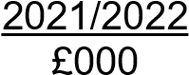 | 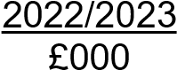
Sefton Council | -1,484 | 1,699
Merseyside Police and Crime Commissioner | -191 | 226
Merseyside Fire and Rescue Service | -72 | 79
Liverpool City region Combined Authority | -17 | 18
 | -1,764 | 2,022

Business Rates | 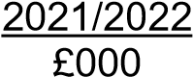 | 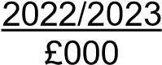
Sefton Council | -38,814 | -18,515
Merseyside Fire and Rescue Service | -392 | -187
 | -39,206 | -18,702

3 BUSINESS RATES MULTIPLIER AND RATEABLE VALUE

Under the arrangements for nationally uniform business rates, the Council collects rates for its area, which are based on local rateable values multiplied by a uniform rate. The business rate multipliers applied are shown below:

Multipliers | 2021/2022 | 2022/2023
Standard Business Rate Multiplier | 51.2p | 51.2p
Small Business Rate Multiplier | 49.9p | 49.9p

The total non-domestic rateable value on Sefton’s Rating List was £180,471,508 at 31 March 2023 (£180,991,064 at 31 March 2022).

4 PRECEPTS AND DEMANDS ON THE COLLECTION FUND

The following precepts and demands have been made on the fund during the year:

Council Tax | 2021/2022 £000 | 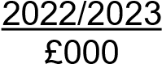
Sefton Council (Including Parish Precepts) | 143,037 | 150,008
Merseyside Police and Crime Commissioner | 18,775 | 19,946
Merseyside Fire & Rescue Authority | 6,783 | 7,037
Liverpool City Region Combined Authority | 1,572 | 1,599
 | 170,167 | 178,591

5 SHARES OF NON-DOMESTIC RATES INCOME

Business rates income is shared on the following basis:

Business Rates | Share % | 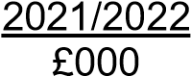 | 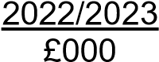
Sefton Council | 99% | 67,919 | 56,664
Merseyside Fire & Rescue Authority | 1% | 686 | 572
 | 100% | 68,605 | 57,236

6 PROVISION FOR BAD AND DOUBTFUL DEBTS

The Collection Fund provides for bad debts on Council Tax and Business Rates arrears. The following movements on the bad debt provisions were recorded in the year:

Council Tax

Balance at 1 April | -21,919 | -27,106
Write-offs in year | -8 | -3
Increase / Decrease in Year Balance at 31 March | -5,179 | -4,462
 | 27,106 | -31,571

Business Rates | 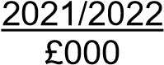 | 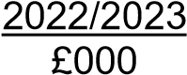
Balance at 1 April | -7,019 | -8,314
Written-off in year | -23 | -5
Increase / Decrease in Year Balance at 31 March | -1,272 | 2,600
 | -8,314 | -5,719

7 PROVISION FOR CHECKS, CHALLENGES AND APPEALS

The Collection Fund also makes a provision for checks, challenges, and appeals against rateable values set by the Valuation Office Agency (VOA). The table below shows the movements on the provision in the year:

Business Rates | 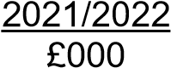 | 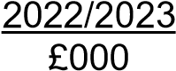
Balance at 1 April | -23,886 | -21,353
Movement in the Year Balance at 31 March | 2,533 | 15,114
 | -21,353 | -6,239

10 GROUP ACCOUNTS

The standard financial statements consider the Council only as a single entity. Sefton Council conducts some of its adult and social care services activities through a wholly owned company, Sefton New Directions Limited, which began trading on 1 April 2007. In addition, it wholly owns Sandway Homes Limited, a housing development company, and Sefton Hospitality Operations Limited, a hospitality company.

Thus, a full picture of the Council’s economic activities, financial position, service position, accountability for resources and exposure to risk is not presented in the Council’s single entity financial statements. As a result, group financial statements are used to reflect the full extent of Sefton Council’s involvement with its group undertakings in order to provide a clearer picture of the Council’s activities as a group.

The following pages include:

- Group Movement in Reserves Statement,
- Group Comprehensive Income and Expenditure Statement,
- Group Balance Sheet,
- Group Cash Flow Statement, and,
- Notes to the Group Accounts. • A summary of the financial statements for Sefton New Directions and Sandway Homes.

The financial positions of Sefton Council, Sefton New Directions, Sandway Homes and Sefton Hospitality Operations Limited have been consolidated to produce the Group Accounts with any transactions and balances between the three organisations netted out on consolidation.

All organisations have a financial year-end of 31 March.

Sefton New Directions
The main effect of consolidation has been to increase revenue reserves by £3.302m (£4.194m increase as at 31 March 2022), representing the Authority’s 100% share of accumulated net surplus in the Company.

The Group Comprehensive Income and Expenditure Statement records a deficit for Sefton New Directions Limited of £0.891m in 2022/2023 (a £4.700m surplus in 2021/2022). It should be noted that the main reason for the surplus in 2021/2022 was a change in the accounting treatment of the Company’s pension liability. As Sefton Council is the full guarantor for the Company’s pension liability, the directors have deemed the derecognition of the liability to be appropriate.

Copies of the Company’s accounts for 2022/2023 will be able to be obtained from The Company Secretary, Sefton New Directions Head Office, Third Floor, Burlington House, Crosby Road North, Waterloo, Liverpool, Merseyside, United Kingdom, L22 0PJ.

Sandway Homes
The main effect of consolidation has been to reduce revenue reserves by £0.441m in 2022/2023
(£2.234m in 2021/2022) representing the Authority’s 100% share of accumulated net deficit in the Company.

The Group Comprehensive Income and Expenditure Statement records a surplus for Sandway Homes Limited of £1.793m in 2022/2023 (a deficit of £0.396m in 2021/2022).

Sefton Hospitality Operations Limited
The main effect of consolidation has been to reduce revenue reserves by £0.813m in 2022/2023
(£0.084m in 2021/22 but not consolidated in the Group Accounts) representing the Authority’s 100% share of accumulated net deficit in the Company.

The Group Comprehensive Income and Expenditure Statement records a deficit for Sefton Hospitality Operations Limited of £0.728m in 2022/2023 (£0.084m in 2021/2022 but not consolidated in the Group Accounts).

GROUP COMPREHENSIVE INCOME AND EXPENDITURE STATEMENT
This statement shows the accounting cost in the year of providing services in accordance with generally accepted accounting practices, rather than the amount to be funded from taxation. Authorities raise taxation to cover expenditure in accordance with regulations; this may be different from the accounting cost. The taxation position is shown in the Movement in Reserves Statement.

2021/2022 |  |  | Note | 2022/2023
Gross | Gross | Net |  | Gross | Gross | Net
Expenditure | Income | Expenditure / Income (-) |  | Expenditure | Income | Expenditure / Income (-)
 |  |  | Continuing Operations
1,232 | -8 | 1,224 | Strategic Management | 1,348 | -11 | 1,337
150,016 | -59,773 | 90,243 | Adult Social Care | 159,898 | -57,231 | 102,667
56,406 | -2,094 | 54,312 | Children’s Social Care | 77,236 | -4109 | 73,127
31,283 | -11,896 | 19,387 | Communities | 38,779 | -19,467 | 19,312
110,508 | -78,126 | 32,382 | Corporate Resources | 113,544 | -73,925 | 39,619
11,313 | -11,433 | -120 | Economic Growth and Housing | 25,528 | -17,802 | 7,726
16,730 | -2,243 | 14,487 | Education Excellence | 19,335 | -2,504 | 16,831
204,436 | -196,789 | 7,647 | Education Excellence - Schools | 216,515 | -204,578 | 11,937
21,483 | -27,988 | -6,505 | Health and Wellbeing | 19,010 | -23,848 | -4,838
28,682 | -8,724 | 19,958 | Highways and Public Protection | 24,650 | -9,172 | 15,478
29,798 | -10,453 | 19,345 | Locality Services | 38,349 | -14,124 | 24,225
18,991 | -13,200 | 5,791 | Corporate Unallocated Costs | 8,344 | -11,180 | -2,836
748 | -776 | -28 | Sefton New Directions - Net | 1,585 | -598 | 987
326 | 21 | 347 | Sandway Homes - Net | 6,012 | -7,978 | -1,966
0 | 0 | 0 | Sefton Hospitality Operations - Net | 1,294 | -565 | 729
681,952 | -423,482 | 258,470 | Net Cost of Services | 751,427 | -447,092 | 304,335
 |  |  | Other Operating Income and Expenditure
 |  | 1,208 | Precepts paid to Parish Councils |  |  | 1,381
 |  | 34,662 | Levies |  |  | 35,317
 |  | -10 | Loss on the disposal of non-current assets |  |  | 5,299
 |  | -973 | Other Operating Income  Financing and Investment Income & Expenditure |  |  | -1,037
 |  | 34,887 |  |  |  | 40,960
 |  | 7,268 | Interest payable and similar charges |  |  | 7,036
 |  | 9,158 | Net Interest on the Net Pension Defined Benefit Liability |  |  | 11,453
 |  | -278 | Interest Receivable |  |  | -1,934
 |  | -2,459 | Income and Expenditure on Investment Properties |  |  | -2,531
 |  | -3,076 | Changes in the Fair Value of Investment Properties |  |  | 4,890
 |  | -944 | Changes in the Fair Value of Financial Instruments  Taxation and Non-specific Grant Income |  |  | 1,042
 |  | 9,669 |  |  |  | 19,956
 |  | -146,265 | Income from Council Tax |  |  | -152,958
 |  | -56,227 | Non-Domestic Rates Income |  |  | -79,197
 |  | -76,078 | Non-Ringfenced Government Grants |  |  | -71,563
 |  | -19,043 | Capital Grants and Contributions |  |  | -31,530
 |  | -297,613 |  |  |  | -335,248
 |  | 5,413 | Deficit on Provision of Services |  |  | 30,003
 |  | 15 | Taxation |  |  | -82
 |  | 5,428 | Group Deficit |  |  | 29,921

2021/2022 |  |  | Continued from previous page | 2022/2023
Gross | Gross | Net |  | Gross | Gross | Net
Expenditure | Income | Expenditure / Income (-) |  | Expenditure | Income | Expenditure / Income (-)
 |  | -24,591 | Surplus (-) / Deficit on Revaluation of non-current assets |  |  | -2,259
 |  | -58,455 | Re-measurement of the Net Defined Benefit Liability |  |  | -433,417
 |  | -4,687 | Movement on Transfer Out of Defined Benefit Pension  Liability |  |  | 0
 |  | -87,733 | Other Comprehensive Income and Expenditure |  |  | -435,676
 |  | -82,305 | Total Comprehensive Income and Expenditure |  |  | -405,755

GROUP MOVEMENT IN RESERVES STATEMENT

This statement shows the movement in the year on the different reserves held by the authority, analysed into
‘usable reserves’ (i.e. those that can be applied to fund expenditure or reduce local taxation) and unusable reserves. The Surplus or (Deficit) on the Provision of Services line shows the true economic cost of providing the authority’s services, more details of which are shown in the Comprehensive Income and Expenditure Statement. These are different from the statutory amounts required to be charged to the General Fund Balance for Council Tax setting purposes. The Net Increase /Decrease before Transfers to Earmarked Reserves line shows the statutory General Fund Balance before any discretionary transfers to, or from, earmarked reserves undertaken by the Council.

Movements in Reserves in 2022/2023 | Council | New  Directions | Sandway Homes | SHOL | Total  Usable  Reserves  £000 | Council | Total  Council  Reserves  £000 | Total Group  Reserves  £000
 | Usable  Reserves  £000 | Surplus  £000 | Surplus  £000s | Surplus  £000s |  | Unusable  Reserves  £000
Balance at 1 April 2022 | -144,462 | -4,194 | 2,234 | 0 | -146,422 | 134,585 | -9,877 | -11,837
Movements in Year  Total Comprehensive  Income and Expenditure | 30,094 | 892 | -1,793 | 813 | 30,006 | -435,676 | -405,582 | -405,670
Adjustments between accounting basis and funding basis under regulations  (Note 7 of single entity accounts)  Net Increase (-) / Decrease before  Transfers to Earmarked  Reserves | -12,709 | 0 | 0 | 0 | -12,709 | 12,709 | 0 | 0
 | 17,385 | 892 | -1,793 | 813 | 17,297 | -422,937 | -405,582 | -405,670
Transfers to / from  Earmarked Reserves  (Note 35 of single entity accounts) | 0 | 0 | 0 | 0 | 0 | 0 | 0 | 0
Increase in Year | 17,385 | 892 | -1,793 | 813 | 17,297 | -422,967 | -405,582 | -405,670
Balance at 31 March 2023 | -127,077 | -3,302 | 441 | 813 | -129,125 | -288,382 | -415,459 | -417,507

Movements in Reserves in 2021/2022 | Council | New  Directions | Sandway Homes | Total  Usable  Reserves  £000 | New  Directions | Council | Total  Council  Reserves  £000 | Total  Group  Reserves  £000
 | Usable  Reserves  £000 | Surplus  £000 | Surplus  £000s |  | Pensions  Reserve  £000 | Unusable  Reserves  £000
Balance at 1 April 2021 | -154,473 | 423 | 1,839 | -152,211 | 83 | 222,596 | 68,123 | 70,468
Movements in Year  Total Comprehensive  Income and Expenditure | 5,046 | -4,617 | 395 | 824 | -83 | -83,046 | -78,000 | -82,305
Adjustments between accounting basis and funding basis under regulations (Note 7 of single entity accounts)  Net Increase (-) / Decrease before Transfers to Earmarked Reserves | 4,965 | 0 | 0 | 4,965 | 0 | -4,965 | 0 | 0
 | 10,011 | -4,617 | 395 | 5,789 | -83 | -88,011 | -78,000 | -82,305
Transfers to / from Earmarked Reserves (Note 35 of single entity accounts) | 0 | 0 | 0 | 0 | 0 | 0 | 0 | 0
Increase in Year | 10,011 | -4,617 | 395 | 5,789 | 0 | -88,011 | -78,000 | -82,305
Balance at 31 March 2022 | -144,462 | -4,194 | 2,234 | -146,422 | 0 | 134,585 | -9,877 | -11,837

GROUP BALANCE SHEET

The Balance Sheet shows the value as at the Balance Sheet date of the assets and liabilities recognised by the Authority. The net assets of the Authority (assets less liabilities) are matched by the reserves held by the authority. Reserves are reported in two categories. The first category of reserves are usable reserves, i.e. those reserves that the Authority may use to provide services, subject to the need to maintain a prudent level of reserves and any statutory limitations on their use (for example the Capital Receipts Reserve that may only be used to fund capital expenditure or repay debt). The second category of reserves is those that the Authority is not able to use to provide services. This category of reserves includes reserves that hold unrealised gains and losses (for example the Revaluation Reserve), where amounts would only become available to provide services if the assets are sold; and reserves that hold timing differences shown in the Movement in Reserves Statement line ‘Adjustments between accounting basis and funding basis under regulations’.

31 March 2022 |  | Note | 31 March 2023
£000s |  |  | £000s
504,413 | Property, Plant and Equipment | 5 | 503,546
11,532 | Heritage Assets |  | 13,149
32,338 | Investment Property |  | 27,315
896 | Intangible Assets |  | 1,471
6,320 | Long Term Investments |  | 5,288
5,825 | Long Term Debtors  Long-Term Assets  Assets Held for Sale |  | 6,389
561,324 |  |  | 557,158
12,004 |  |  | 4,881
7,657 | Inventories |  | 8,467
43,831 | Short Term Debtors | 6 | 76,617
19,156 | Prepayments |  | 5,086
103,313 | Cash and Cash Equivalents  Current Assets  Short Term Borrowing | 7 | 32,008
185,962 |  |  | 127,059
-34,719 |  |  | -12,995
-63,178 | Short Term Creditors | 8 | -68,107
-44,531 | Receipts in Advance | 8 | -15,195
-45 | Provisions | 9 | 0
-934 | Deferred Liabilities  Current Liabilities  Provisions |  | -983
-143,407 |  |  | -97,280
-24,985 |  |  | -9,600
-133,714 | Long Term Borrowing |  | -121,798
-6,481 | Deferred Liabilities |  | -5,498
-426,862 | Pensions Liability  Long Term Liabilities |  | -32,534
-592,042 |  |  | -169,430
11,837 | Net Assets |  | 417,507

31 March 2022 | Balance Sheet (Continued) | Note | 31 March 2023
£000s |  |  | £000s
Reserves

Usable Reserves
-18,288 | General Fund - Delegated Schools |  | -17,994
-14,799 | General Fund - Non-Delegated Services |  | -11,991
-4,194 | New Directions - Profit and Loss Account |  | -3,302
2,234 | Sandway Homes - Profit and Loss Account |  | 441
0 | Sefton Hospitality Operations - Profit and Loss Account |  | 813
-81,253 | Earmarked Reserves |  | -51,790
-6,260 | Capital Receipts Reserve |  | -10,967
-23,862 | Capital Grants and Contributions Unapplied  Unusable Reserves |  | -34,335
-146,422 |  |  | -129,125
-91,270 | Revaluation Reserve |  | -91,116
-233,805 | Capital Adjustment Account |  | -225,341
251 | Financial Instruments Adjustment Account |  | 192
-1,319 | Pooled Investment Funds Adjustment Account |  | -278
0 | Deferred Capital Receipts |  | -2,232
426,862 | Pensions Reserve |  | 32,534
17,646 | Collection Fund Adjustment Account |  | -24,653
5,573 | Accumulated Absences Account |  | 5,452
11,097 | Dedicated Schools Grant Adjustment Account |  | 17,060
134,585 |  |  | -288,382
-11,837 | Total Group Reserves |  | -417,507

The Notes to the single entity accounts on pages 35 to 108, and to the Group Accounts on pages 121 to 125 form part of the financial statements (note that the disclosures on pages 125 to 127 are for information only and do not form part of the financial statements).

The unaudited accounts were issued on 19th September 2023 and the audited accounts were authorised for issue on 9th December 2024.

Stephan Van Arendsen
Executive Director of Corporate Services and Commercial
Date: 9th December 2024

GROUP CASH FLOW STATEMENT

The Cash Flow Statement shows the changes in cash and cash equivalents of the authority during the reporting year. The statement shows how the authority generates and uses cash and cash equivalents by classifying cash flows as operating, investing and financing activities. The amount of net cash flows arising from operating activities is a key indicator of the extent to which the operations of the authority are funded by way of taxation and grant income or from the recipients of services provided by the authority. Investing activities represent the extent to which cash outflows have been made for resources which are intended to contribute to the authority’s future service delivery. Cash flows arising from financing activities are useful in predicting claims on future cash flows by providers of capital (i.e. borrowing) to the authority.

2021/2022 |  | Note | 2022/2023
£000s |  |  | £000s
 | Operating Activities
5,428 | Net Deficit on the provision of services |  | 29,921
-85,868 | Adjustments to net surplus or deficit on the provision of services for non-cash movements |  | -12,560
20,939 | Adjustments for items included in the net surplus or deficit on the provision of services that are investing and financing activities  Net cash flows from Operating Activities  Investing Activities | 10 | 26,221
-59,501 |  |  | 43,582
28,424 | Purchase of property, plant and equipment, investment property and intangible assets |  | 30,916
0 | Purchase of short-term and long-term investments |  | 10
-885 | Proceeds from the sale of property, plant and equipment, investment property and intangible assets |  | -8,456
-18,862 | Other receipts from investing activities  Net cash flows from Investing Activities  Financing Activities |  | -28,732
8,677 |  |  | -6,262
0 | Cash receipts of short- and long-term borrowing |  | 0
-1,143 | Other receipts from financing activities |  | -460
504 | Cash payments for the reduction of the outstanding liabilities relating to finance leases and on-balance sheet PFI contracts |  | 496
20,667 | Repayments of short- and long-term borrowing |  | 33,949
0 | Other payments for financing activities  Net cash flows from Financing Activities |  | 0
20,028 |  |  | 33,985
-30,796 | Net decrease / increase (-) in cash and cash equivalents |  | 71,305
-72,517 | Cash and cash equivalents at the beginning of the reporting period |  | -103,313
-103,313 | Cash and cash equivalents at the end of the reporting period | 7 | -32,008

NOTES TO THE GROUP ACCOUNTS

1 INTRODUCTION

The notes below include details of where the inclusion of Sefton New Directions Limited and / or Sandway Homes has altered the disclosures within Sefton’s single entity accounts. All other notes to the Group Financial Statements are as shown in the Notes to the single entity accounts.

2 DISCLOSURE OF AUDIT COSTS

Sefton New Directions Limited and Sandway Homes incurred the following fees relating to external audit and inspection.

2021/2022 £000 |  | 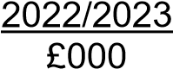
 | Sefton New Directions Limited
17  0 | Fees payable to Hazlewoods LLP for external audit services  Sandway Homes  Fees payable to Beever and Struthers for external audit services | 19  13
17 | Total | 32

Sefton Hospitality Operations Limited didn’t incur any fees relating to external audit and inspection. Sefton’s expenditure on audit costs is shown in Note 11 to the single entity accounts.

3 ASSETS ON OPERATING LEASES

Sefton New Directions Limited made operating lease payments of £0.074m in 2021/2022 relating to Land and Buildings and other assets (£0.058m in 2020/2021). Sefton New Directions has obligations to make payments for operating leases in future years as follows:

31 March 2022 |  | 31 March 2023
£000s |  | £000s
54 | Not later than one year | 54
124 | Later than one year and not later than five years | 76
503 | Later than five years | 4977
681 |  | 627

Sandway Homes and Sefton Hospitality Operations Limited had no operating leases. Sefton’s expenditure on operating leases is shown in Note 48 to the single entity accounts.

4 PARTICIPATION IN PENSION SCHEMES

Sefton New Directions Limited and Sandway Homes employees are eligible to join defined contribution pension schemes. The pension cost charge for the year relates to the contributions paid in the year by the companies.

Sefton New Directions employees were previously eligible to join the same Local Government Pension Scheme as those employees in Sefton, i.e., a defined benefit scheme. Until 2020/2021 this was accounted for as a defined benefit scheme. However, for 2021/2022, due to Sefton Council being a full guarantor for the pension liability, the directors of the Company have deemed that the derecognition of the liability is appropriate. Pension contributions in respect of the defined benefit contribution scheme are now charged when contributions are paid.

The following transactions have been made in the Group Comprehensive Income and Expenditure Statement during the year:

2021/2022 |  | Comprehensive Income and Expenditure Statement | 2022/2023
Sefton Council | Sefton  New  Directions Limited |  | Sefton Council | Sefton  New  Directions Limited
£000s | £000s |  | £000s | £000s
 |  | Cost of Services:
42,719 | 0 | Current Service Cost | 48,958 | 0
154 | 0 | Curtailment Cost | 123 | 0
551 | 0 | Administration Expenses | 628 | 0
0 | 0 | Past Service Cost  Financing and Investment Income & Expenditure: | 0 | 0
9,158 | 0 | Net Interest Cost | 11,453 | 0
52,582 | 0 | Total Post Employment Benefit Charged to the Surplus or Deficit on the Provision of Services | 61,162 | 0
-58,455 | 0 | Actuarial Losses / Gains (-) on Pension Assets and Liabilities | -433,417 | 0
0 | 0 | Deferred Tax re. Actuarial losses on pension fund assets and liabilities for Sefton New  Directions Limited | 0 | 0
 | -4,687 | Movement on Transfer Out of Defined Benefit  Pension Liability |  | 0
-5,873 | -4,687 | Total Post Employment Benefit Charged to the  Comprehensive Income and Expenditure Statement | -372,255 | 0

Pensions Assets and Liabilities Recognised in the Balance Sheet

The amount included in the Balance Sheet arising from the Authority’s obligation in respect of its defined benefit plans is as follows:

2021/2022 |  |  | 2022/2023
Sefton Council | Sefton  New  Directions Limited |  | Sefton Council | Sefton  New  Directions Limited
£000s | £000s |  | £000s | £000s
-1,572,508 | -51,292 | Present Value of the Defined Benefit Obligation | -1,132,497 | -38,832
1,145,646 | 48,687 | Fair Value of Plan Assets | 1,099,963 | 46,278
0 | 2,605 | Other amounts recognised in the statement of financial position  Net Liability arising from defined benefit obligation | 0 | -7,446
-426,862 | 0 |  | -32,534 | 0

Assets and Liabilities in Relation to Retirement Benefits
Reconciliation of present value of scheme liabilities

2021/2022 |  |  | 2022/2023
Sefton Council | Sefton  New  Directions Limited |  | Sefton Council | Sefton  New  Directions Limited
£000s | £000s |  | £000s | £000s
1,520,171 | 50,759 | 1 April | 1,572,508 | 51,292
42,719 | 971 | Current Service Cost | 48,958 | 930
31,579 | 1,055 | Interest Cost on Pension Liabilities | 43,580 | 1,419
7,033 | 154 | Contributions by scheme participants | 8,115 | 159
10,758 | -367 | Remeasurement Gains (-) and Losses | -500,438 | -13,667
-39,906 | -1,282 | Benefits paid | -40,278 | -1,302
154 | 0 | Curtailment Cost | 123 | 0
0 | 2 | Past Service Cost  31 March | 0 | 1
1,572,508 | 51,292 |  | 1,132,497 | 38,832

Reconciliation of fair value of scheme assets:

2022/2023 |  |  | 2023/2024
Sefton  Council | Sefton  New  Directions  Limited  Restated |  | Sefton  Council | Sefton  New  Directions Limited
£000s | £000s |  | £000s | £000s
1,065,258 | 44,972 | 1 April | 1,145,646 | 48,687
22,421 | 933 | Interest Income | 32,127 | 1,347
69,213 | 3,923 | Remeasurement Gains / Losses (-) | -67,092 | -2,601
22,178 | 0 | Employer contributions | 22,073 | 0
7,033 | 154 | Contributions by scheme participants | 8,115 | 159
-39,906 | -1,282 | Benefits paid | -40,278 | -1,302
-551 | -13 | Administration Expenses  31 March | -628 | -12
1,145,646 | 48,687 |  | 1,099,963 | 46,278

The deficit for Sefton New Directions Limited on the Local Government Pension Scheme will be made good by increased contributions over the remaining working life of employees, as assessed by the scheme Actuary.

Basis for Estimating Assets and Liabilities

The principal assumptions used by the actuary for Sefton New Directions have been:

2021/2022 |  | 2022/2023
Mortality assumptions (years):
Local Government Pension Scheme:
21.0 | Longevity at 65 for current pensioners: Men | 21.0
24.0 | Longevity at 65 for current pensioners: Women | 24.0
22.0 | Longevity at 65 for future pensioners: Men | 23.0
26.0 | Longevity at 65 for future pensioners: Women  Other assumptions | 26.0
3.4% | Rate of Inflation - CPI | 2.7%
4.9% | Rate of increase in salaries | 4.2%
3.5% | Rate of increase in pensions | 2.8%
2.8% | Rate for discounting scheme liabilities | 4.9%

The assumptions used by the actuary for Sefton Council are shown in Note 51 to the single entity accounts.

5 PROPERTY, PLANT AND EQUIPMENT

The Property, Plant and Equipment (PP&E) figure in the Group Balance Sheet includes £0.125m for Vehicles, Plant and Equipment of Sefton New Directions Limited at 31 March 2023 (£0.231m at 31 March 2022) and £0.046m for Land and Buildings (£0.065m at 31 March 2022). It also includes £2.232m at 31 March 2023 for Land of Sandway Homes (£2.232m at 31 March 2022) and includes £0.144m for Vehicles, Plant and Equipment of Sefton Hospitality Operations Limited at 31 March 2023 (£0.000m at 31 March 2022) and £0.050m for Land and Buildings (£0.000m at 31 March 2022). Details of Sefton’s PP&E are shown in Note 18 to the single entity accounts.

6 CURRENT ASSETS

The Current Assets figure in the Group Balance Sheet includes £0.948m for Debtors of Sefton New Directions Limited at 31 March 2023 (£0.354m at 31 March 2022), £0.263m at 31 March 2023 for Debtors of Sandway Homes (£0.518m at 31 March 2022) and £0.050m at 31 March 2023 for Debtors of Sefton Hospitality Operations Limited (£0.000m at 31 March 2022). Details of Sefton’s Debtors are shown in Note 27 to the single entity accounts.

7 CASH AND CASH EQUIVALENTS

The balance of Cash and Cash Equivalents held by Sefton MBC, Sefton New Directions Limited and Sandway Homes are shown below:

31 March |  | 31 March
2022 |  | 2023
£000s |  | £000s
98,328 | Sefton MBC - Cash and Cash Equivalents | 26,305
4,770 | Sefton New Directions Limited - Bank Deposits | 3,368
215 | Sandway Homes | 1,896
0 | Sefton Hospitality Operations Limited  Total Cash and Cash Equivalents | 439
103,313 |  | 32,008

8 CURRENT LIABILITIES

The Current Liabilities figure in the Group Balance Sheet includes £1.183m for Creditors of Sefton New Directions Limited at 31 March 2023 (£1.181m at 31 March 2022), £10.356m for Creditors (£10.001m at 31 March 2022) relating to Sandway Homes and £0.428m for Creditors of Sefton Hospitality Operations Limited at 31 March 2023 (£0.000m at 31 March 2022. Details of Sefton’s Creditors are shown in Note 29 to the single entity accounts.

9 PROVISIONS

The Current Liabilities figure in the Group Balance Sheet includes £0.000m for Short Term Provisions of Sefton New Directions Limited at 31 March 2023 (£0.045m at 31 March 2022). Details of Sefton’s provisions are shown in Note 30 to the single entity accounts. Movements in New Directions’ provisions during the year were as follows:

 | 2022/2023 | 1 April | Additions | Applied | Released | 31 March
 |  | 2022 | in Year | In Year | In Year | 2023
 |  | £000s | £000s | £000s | £000s | £000s
(a) | Deferred Tax | -45 | 0 | 45 | 0 | 0

Comparable figures for the previous year are shown below:
 | 2021/2022 | 1 April | Additions | Applied | Released | 31 March
 |  | 2021 | in Year | In Year | In Year | 2022
 |  | £000s | £000s | £000s | £000s | £000s
(a) | Deferred Tax | -54 | 0 | 9 | 0 | -45

(a) Deferred Tax – This relates to the difference between accumulated depreciation and amortisation and capital allowances.

10 CASH FLOW STATEMENT – OPERATING ACTIVITIES

The cash flows for operating activities include the following items:

2021/2022 |  | 2022/2023
£000s |  | £000s
-339 | Interest received | -,1978
7,398 | Interest paid | 7,165

11 STATEMENT OF ACCOUNTING POLICIES

The Accounting Policies for the Group are described in Note 56 to the single entity accounts.

12 OTHER INFORMATION:

The following disclosures are for information only and do not form part of the financial statements.

SEFTON NEW DIRECTIONS SUMMARY FINANCIAL INFORMATION

Profit and Loss Account

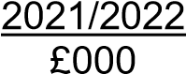 |  | 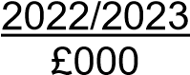
10,374 | Turnover | 10,084
-8,471 | Cost of Sales | -9,246
1,903 | Gross Profit | 838
-1,631 | Administrative Expenses | -1,596
272 | Gross Profit / Loss (-) | -758
-244 | Costs of reorganisation and restructuring / COVID19 Related Costs | -229
0 | Other interest receivable and similar income | 14
28 | Profit / Loss (-) before Tax | -973
-16 | Taxation | 82
12 | Profit / Loss (-) for the financial year | -891

Statement of Comprehensive Income

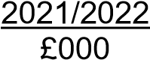 |  | 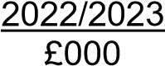
12 | Profit / Loss (-) for the financial year | -891
4,688 | Movement on Transfer Out of Defined Benefit Pension Liability | 0
4,688 |  | -891
4,700 | Comprehensive Income for the financial year | -891

Balance Sheet

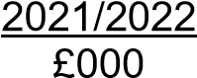 |  | 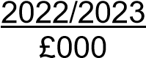
Fixed Assets
Tangible Assets

Current Assets
296 |  | 170
354 | Debtors | 948
4,771 | Cash at bank and in hand  Creditors: Amounts falling due within one year  Net Current Assets | 3,368
5,125 |  | 4,316
-1,181 |  | -1,183
3,944 |  | 3,133
4,240 | Total assets less current liabilities | 3,303
 | Long-Term Liabilities
45 | Provision for liabilities | 0
0 | Net pension liability  Capital and reserves | 0
45 |  | 0
1 | Called up share capital | 1
4,194 | Retained earnings | 3,302
4,195 |  | 3,303
4,240 | Total capital, reserves and long-term liabilities | 3,303

SANDWAY HOMES SUMMARY FINANCIAL INFORMATION

Profit and Loss Account

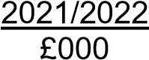 |  | 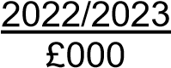
0 | Turnover | 7,998
0 | Cost of Sales | -5,493
0 | Gross Profit | 2,505
-347 | Administrative Expenses | -539
-347 | Gross Profit / Loss (-) | 1,966
-49 | Interest payable and similar charges | -173
-396 | Profit / Loss (-) for the financial year | 1,793

Balance Sheet

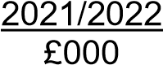 |  | 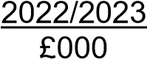
Fixed Assets
Tangible Assets

Current Assets
2,232 |  | 2,232
7,034 | Work in Progress | 7,755
518 | Debtors | 263
215 | Cash at bank and in hand  Current Liabilities | 1,896
7,767 |  | 9,914
-10,001 | Creditors: Amounts falling due within one year  Net Current Assets | -10,355
-10,001 |  | -10,355
-2,234 |  | -441
-2 | Total assets less current liabilities | 1,791
Long-Term Liabilities
Creditors: Amounts falling due after one year

Capital and reserves
Retained earnings

2,232 |  | 2,232
-2,234 |  | -441
-2 | Total capital, reserves and long-term liabilities | 1,791

SEFTON HOSPITALITY OPERATIONS LIMITED SUMMARY FINANCIAL INFORMATION

Balance Sheet

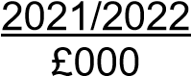 |  | 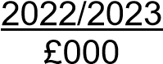
Fixed Assets
Tangible Assets

Current Assets
0 |  | 194
0 | Stocks | 18
0 | Debtors | 49
0 | Cash at bank and in hand  Current Liabilities | 441
0 |  | 508
0 | Creditors: Amounts falling due within one year  Net Current Assets | -428
0 |  | -428
0 |  | 80
0 | Total assets less current liabilities | 274
Long-Term Liabilities
Creditors: Amounts falling due after one year

Capital and reserves
Retained earnings

0 |  | 1,087
0 |  | -813
0 | Total capital, reserves and long-term liabilities | 274

11 FOREWORD TO THE ANNUAL GOVERNANCE STATEMENT
The Council is responsible for ensuring that its business is conducted in accordance with the law and proper standards and that public money is safeguarded and properly accounted for and used economically, efficiently and effectively. The Leader of the Council, Councillor Ian Maher and the Chief Executive, Dwayne Johnson both recognise the importance of having good systems of governance, risk and assurance in place to be able to manage and deliver services to its residents, businesses, partners and stakeholders. The Council has adopted a Code of Corporate Governance, which is consistent with the principles of the CIPFA/SOLACE Framework ‘Delivering Good Governance in Local Government’.
Each year, to provide an assurance on this, the Council is required to conduct an annual review of the effectiveness of its governance, risk and assurance systems to produce an Annual Governance Statement (AGS) which provides an assurance on how these systems have been working. This annual review is in respect of 2022/23 and this statement provides an assurance that good governance arrangements are in place and the Council is managing the risks to achieving its objectives. It also sets out planned actions for next year 2023/24. The AGS is also published in the Council’s Annual Accounts.

We have conducted our annual review of the effectiveness of the systems of governance, risk and assurance in place at Sefton MBC and it is our opinion that these are fit for purpose and in accordance with the governance framework. We propose over the coming year to take actions to address highlighted issues in the AGS and further improve our corporate governance arrangements. We are satisfied that these actions will address the need for improvements that were identified in our annual review of effectiveness in 2022/23 and we will monitor their implementation and operation as part of our annual review in 2023/24.
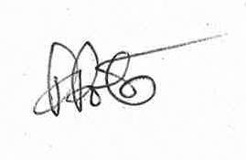
Councillor Ian Maher Phil Porter
Leader of the Council Chief Executive

Page 129

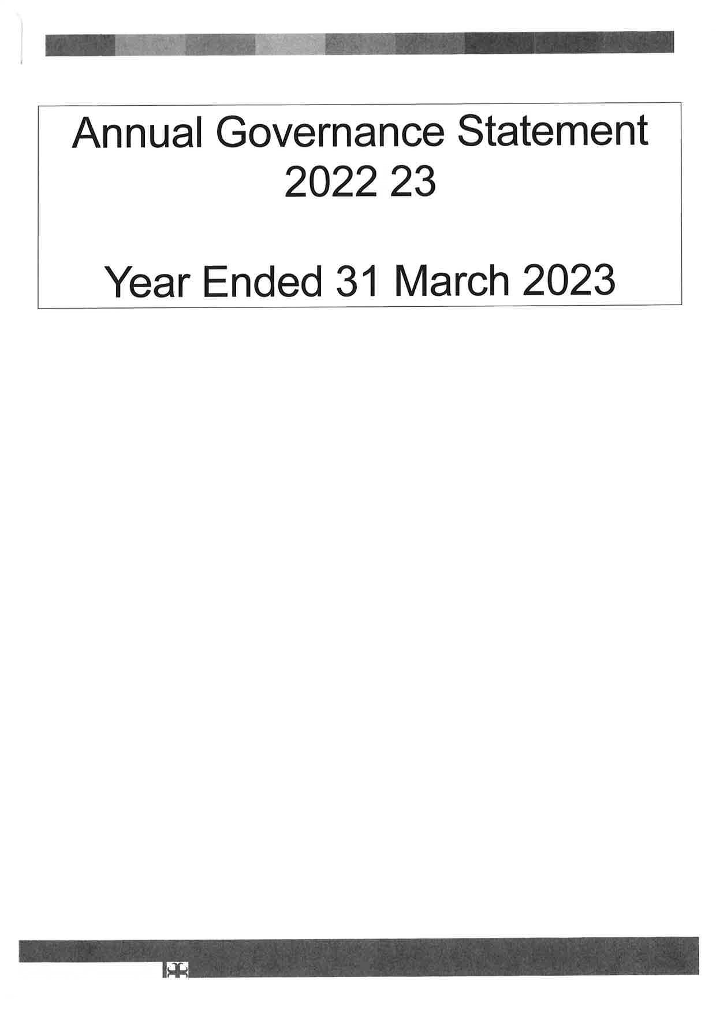




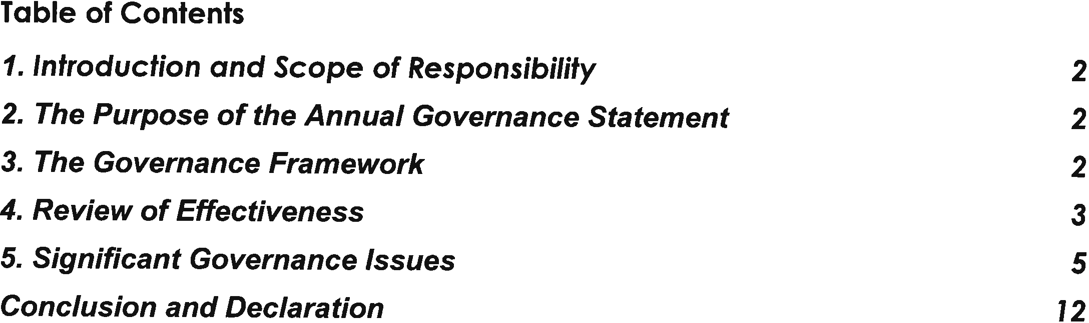



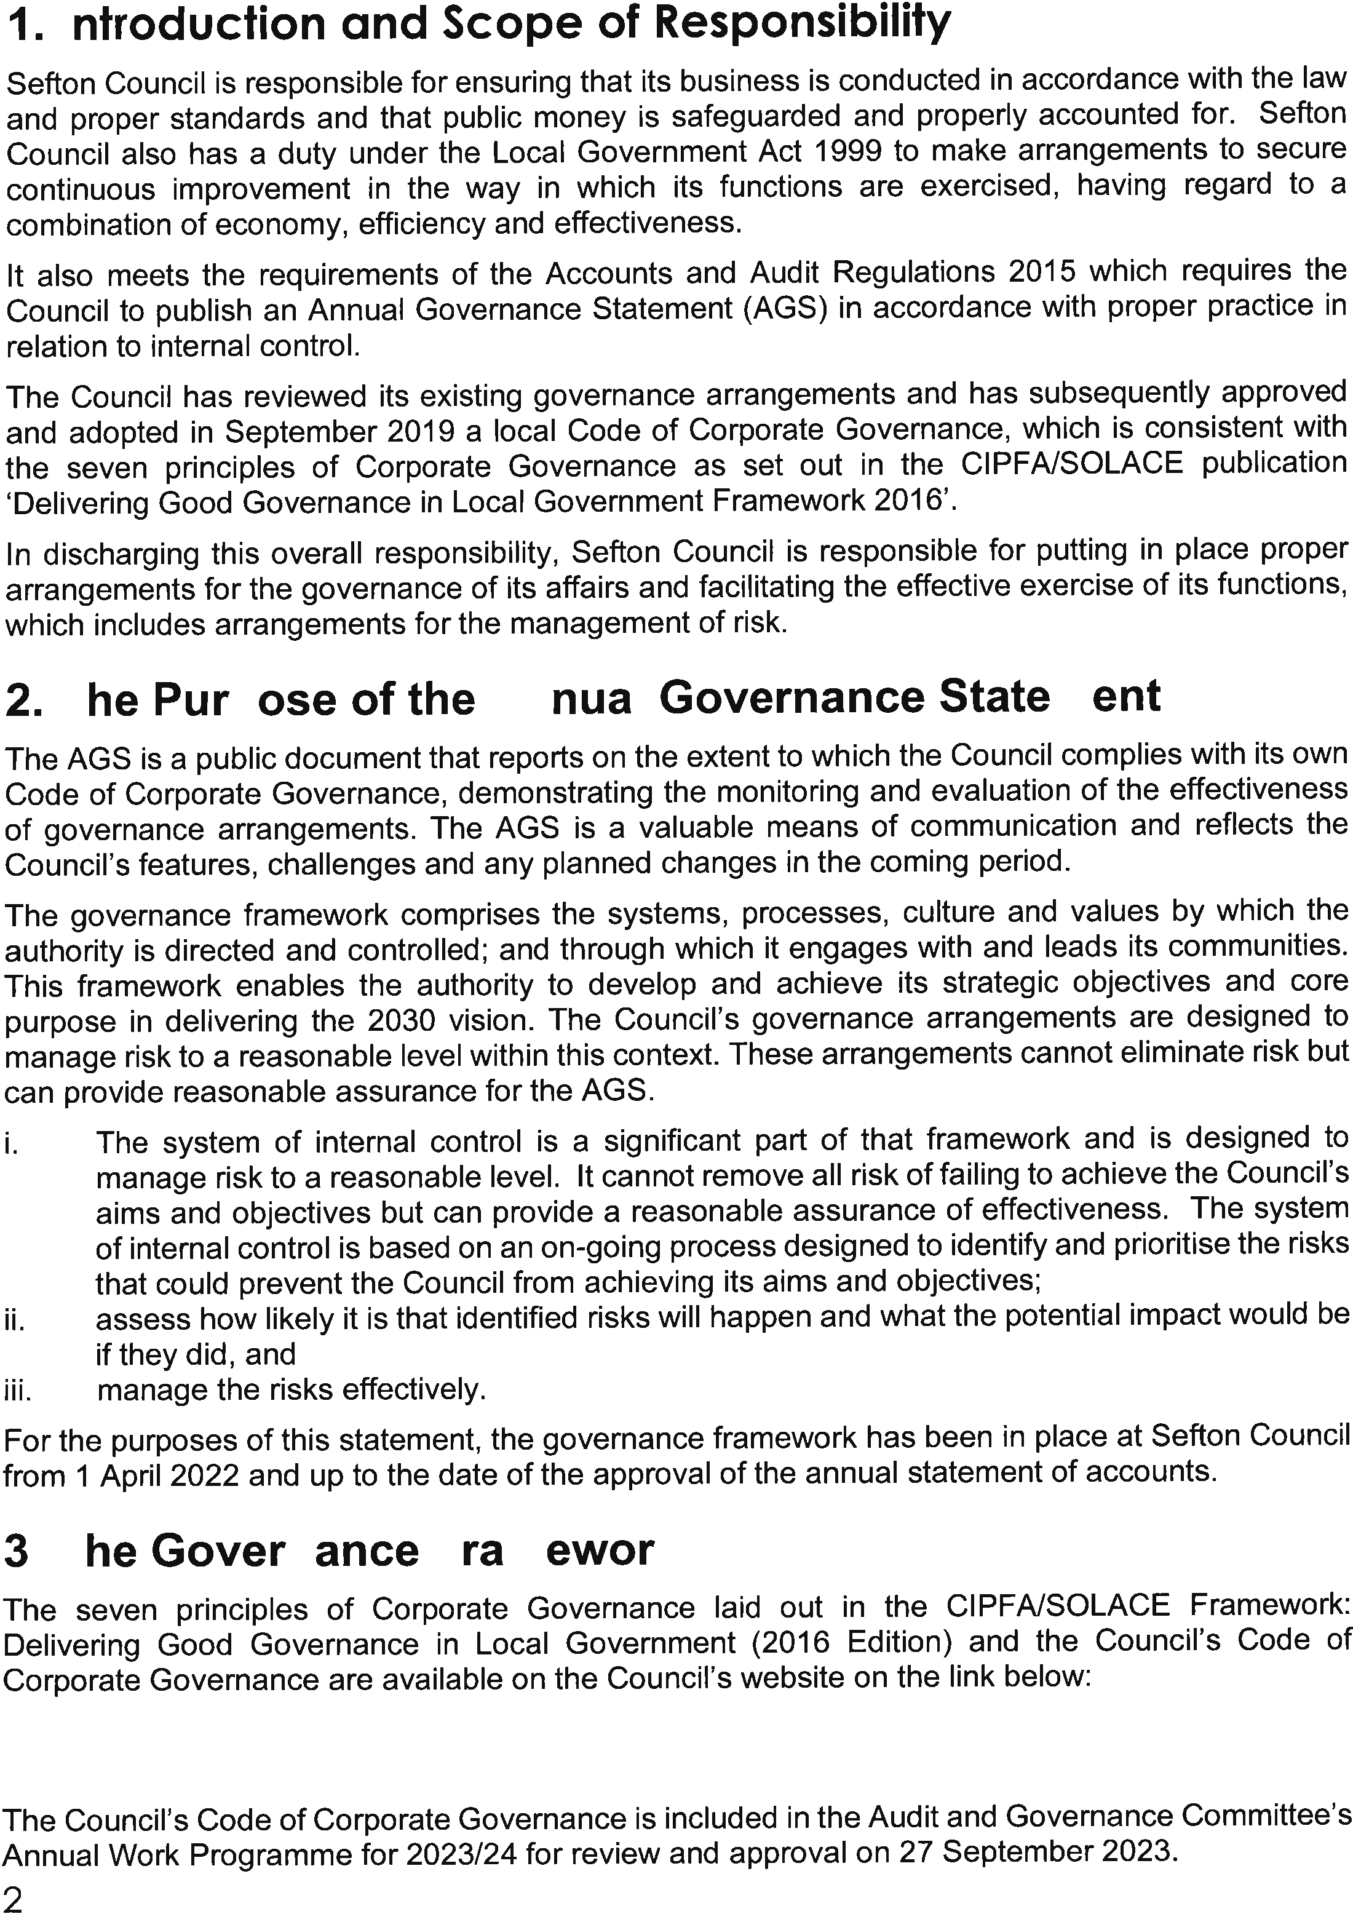



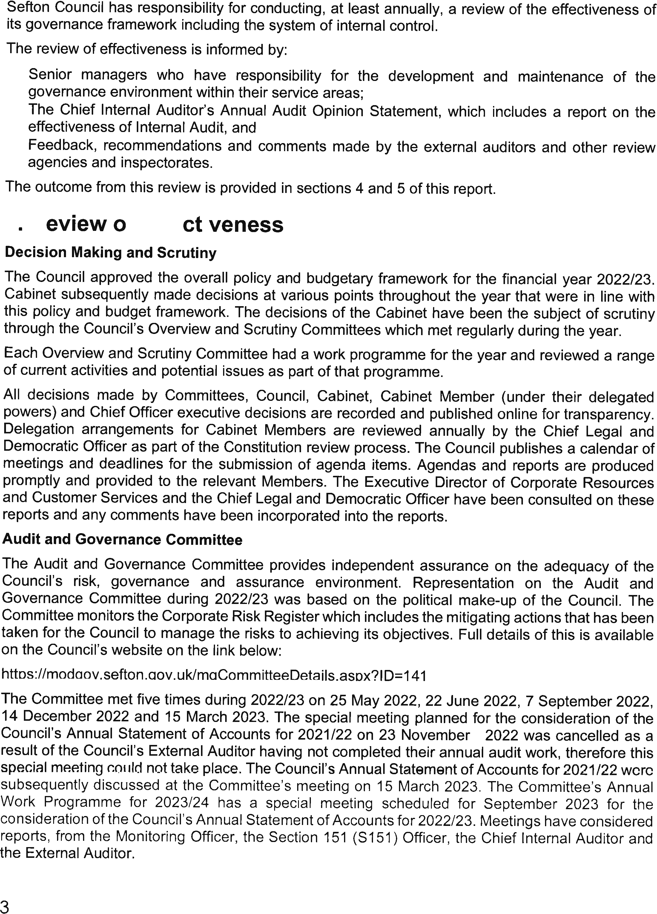

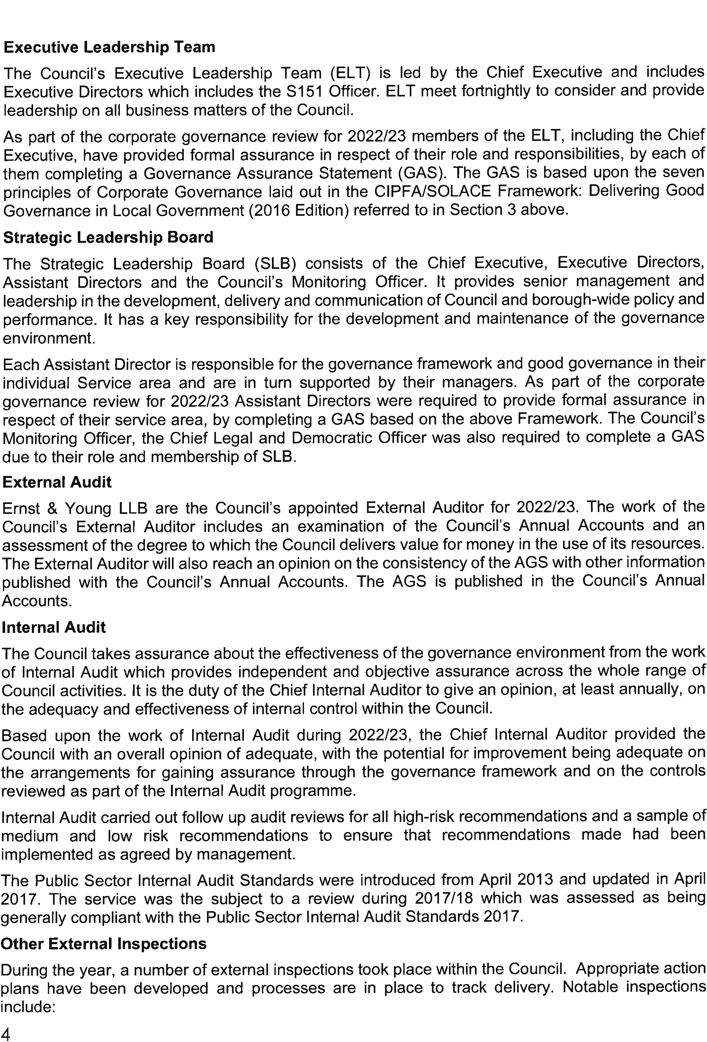


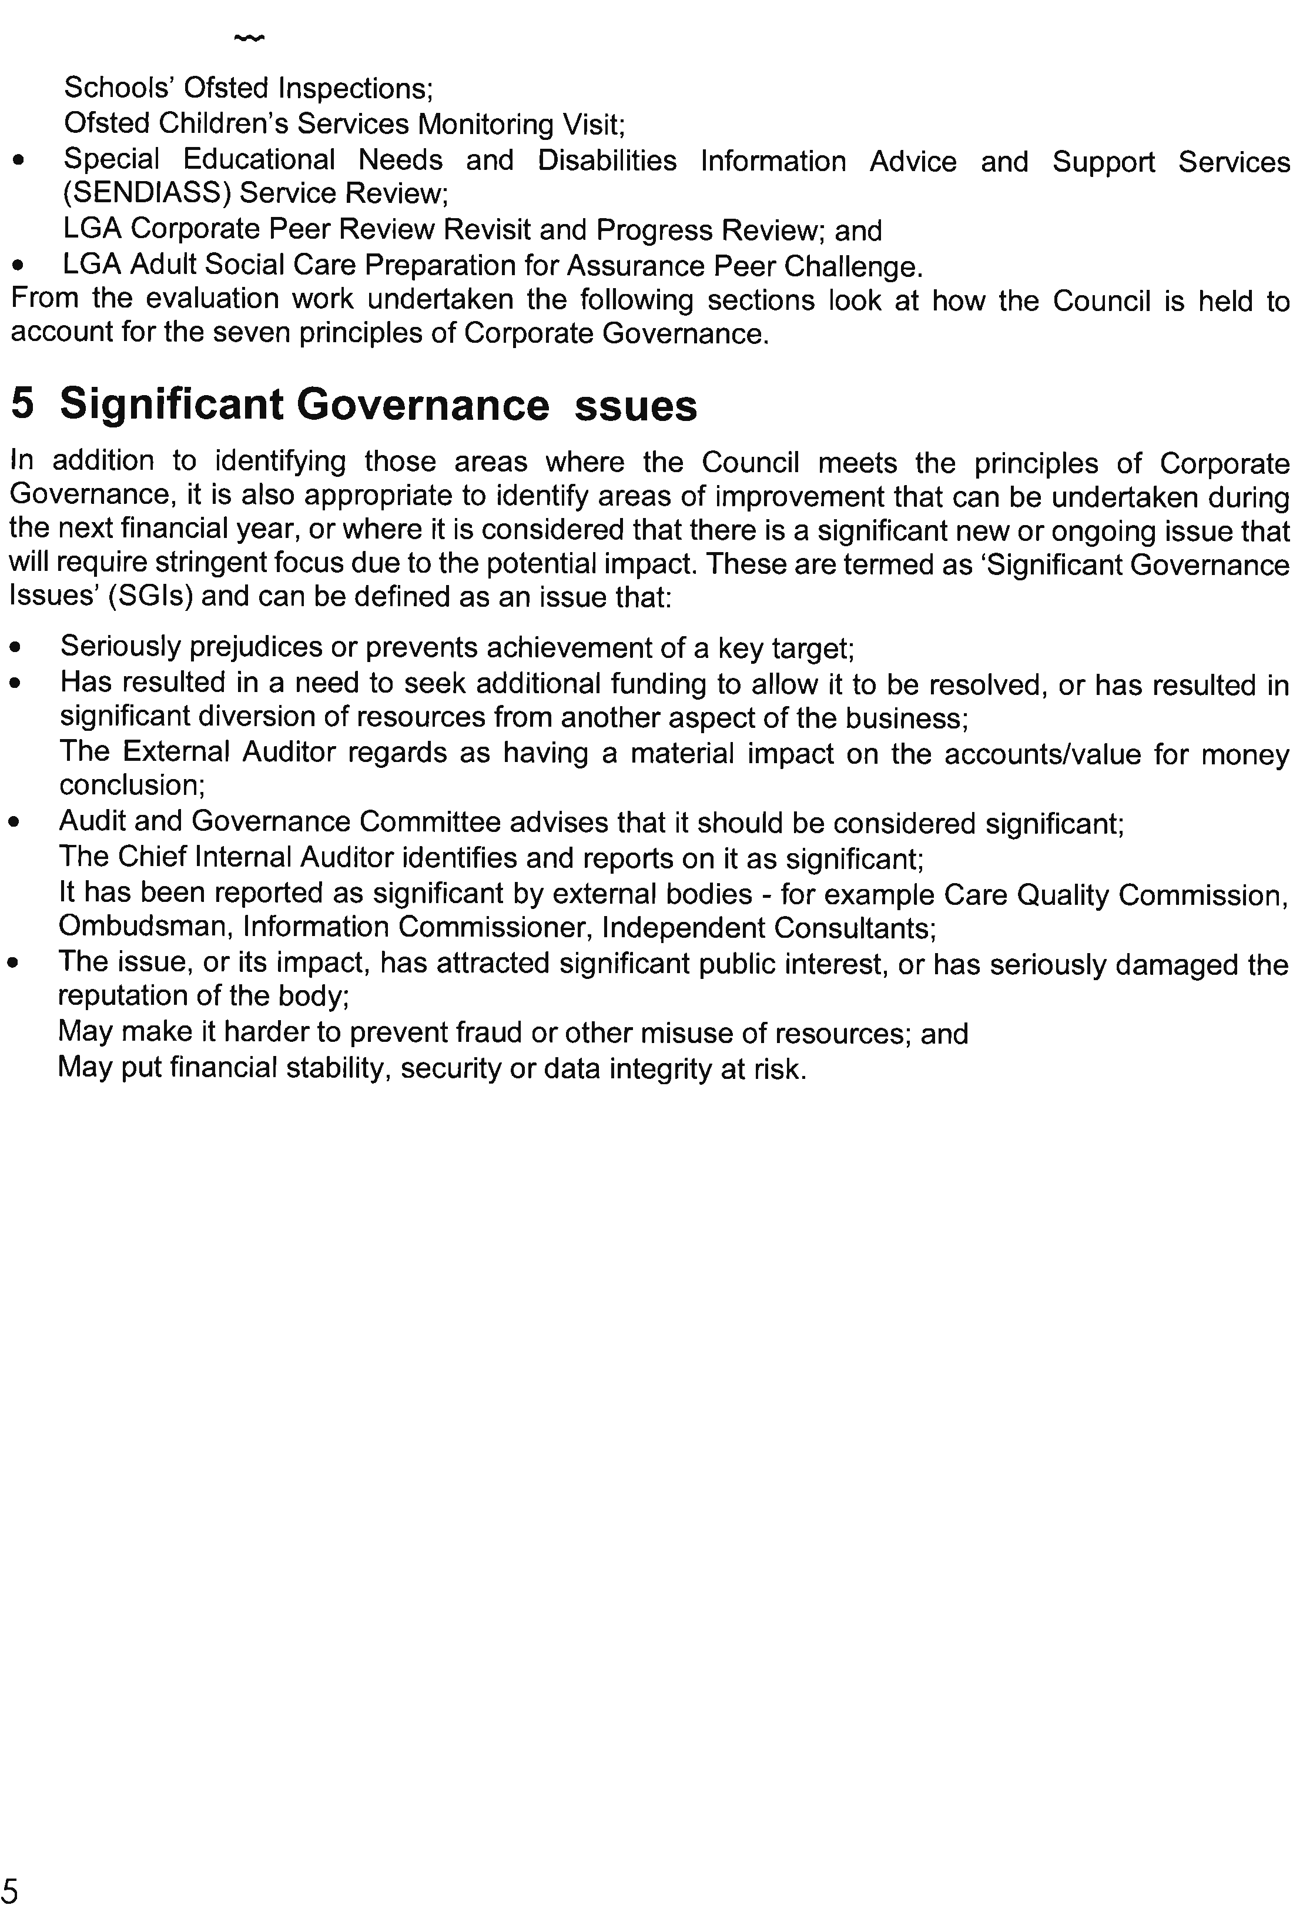


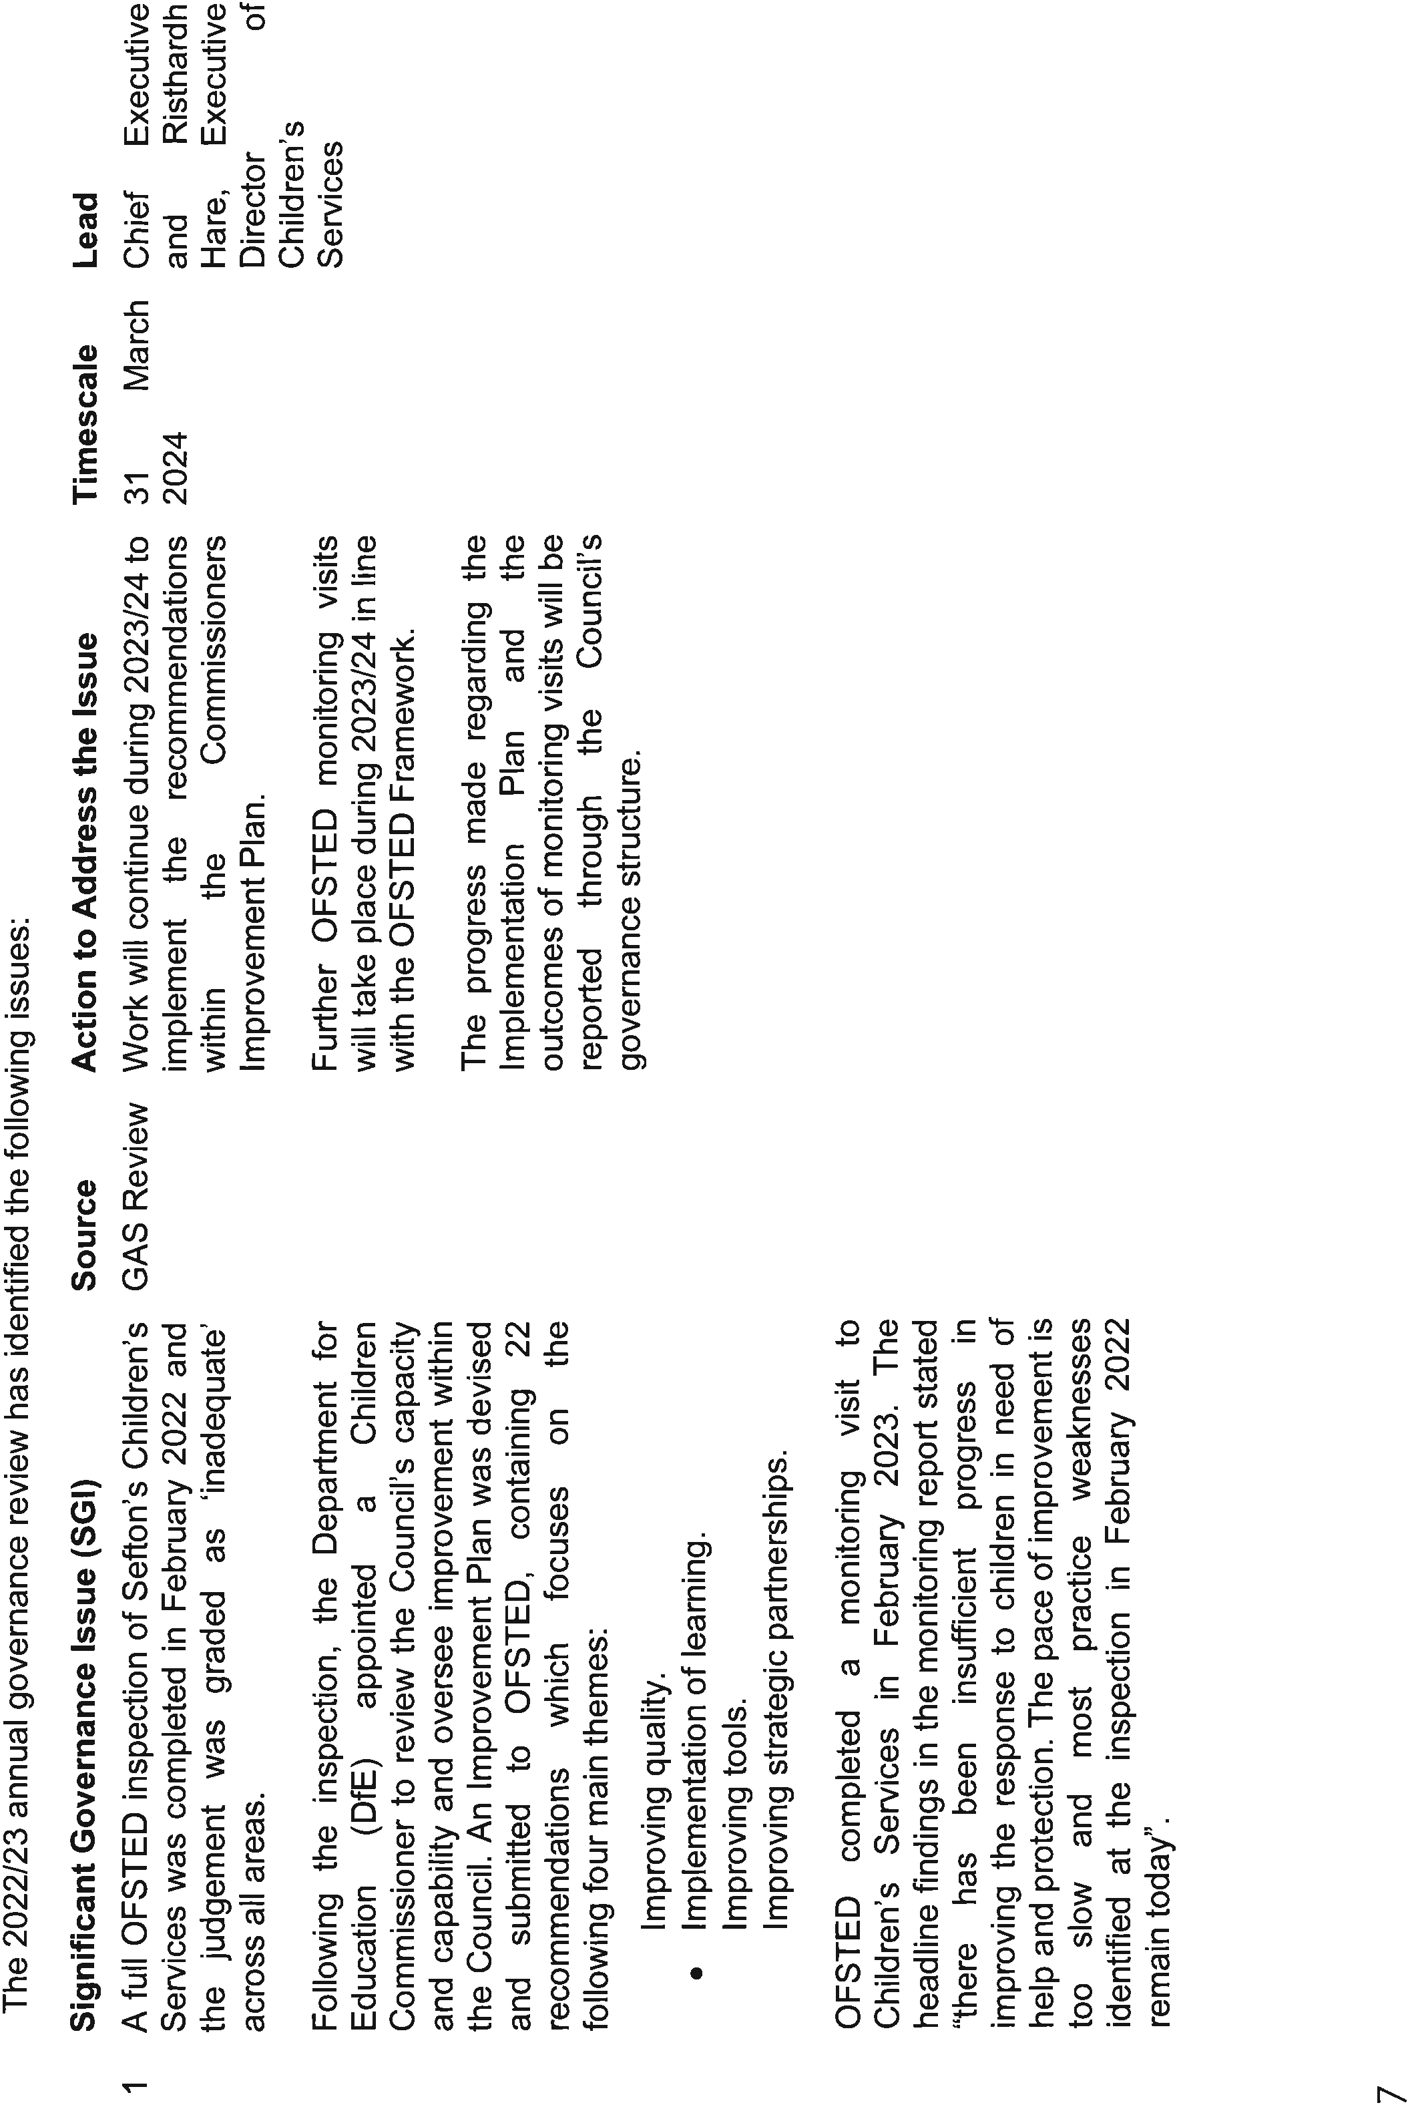



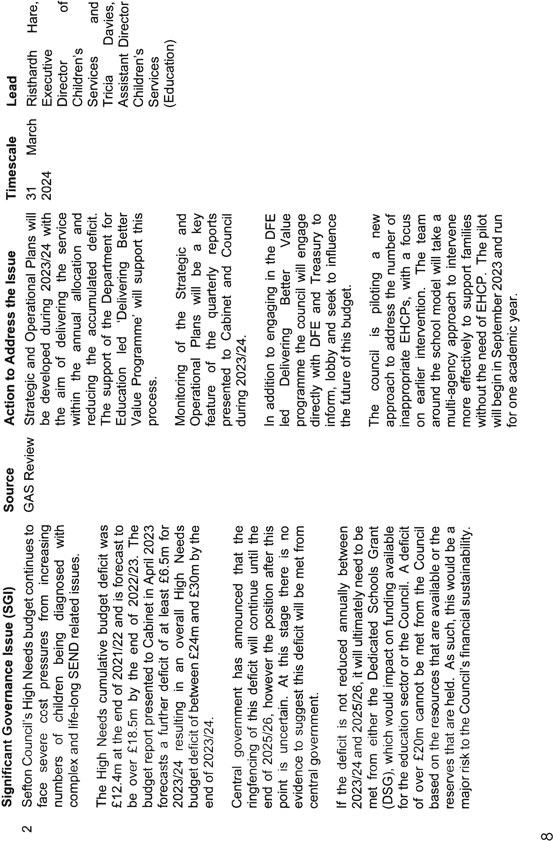



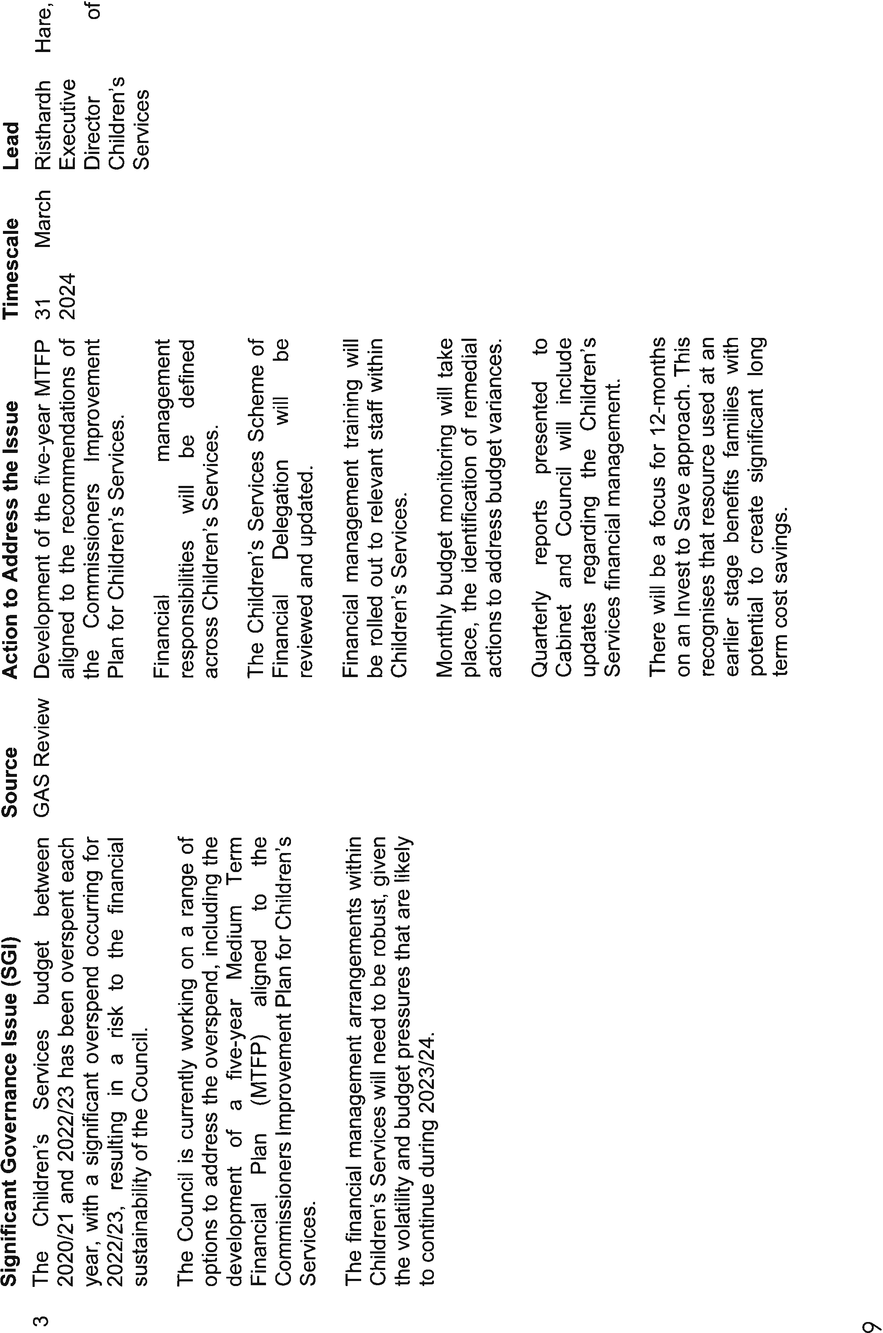



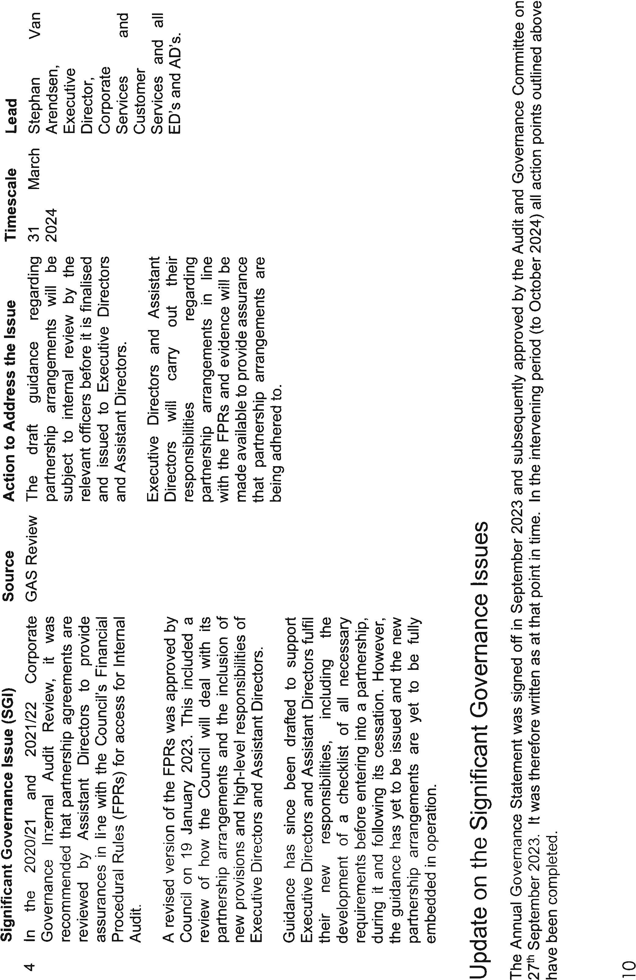






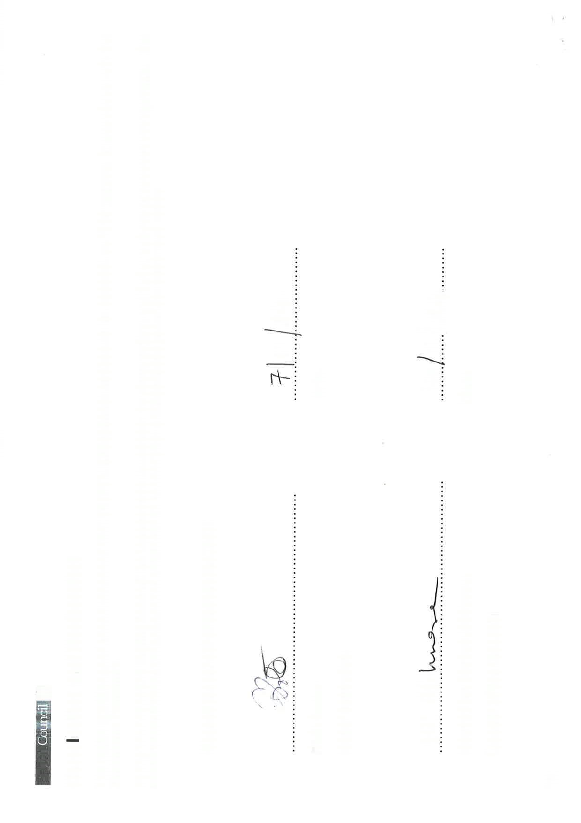
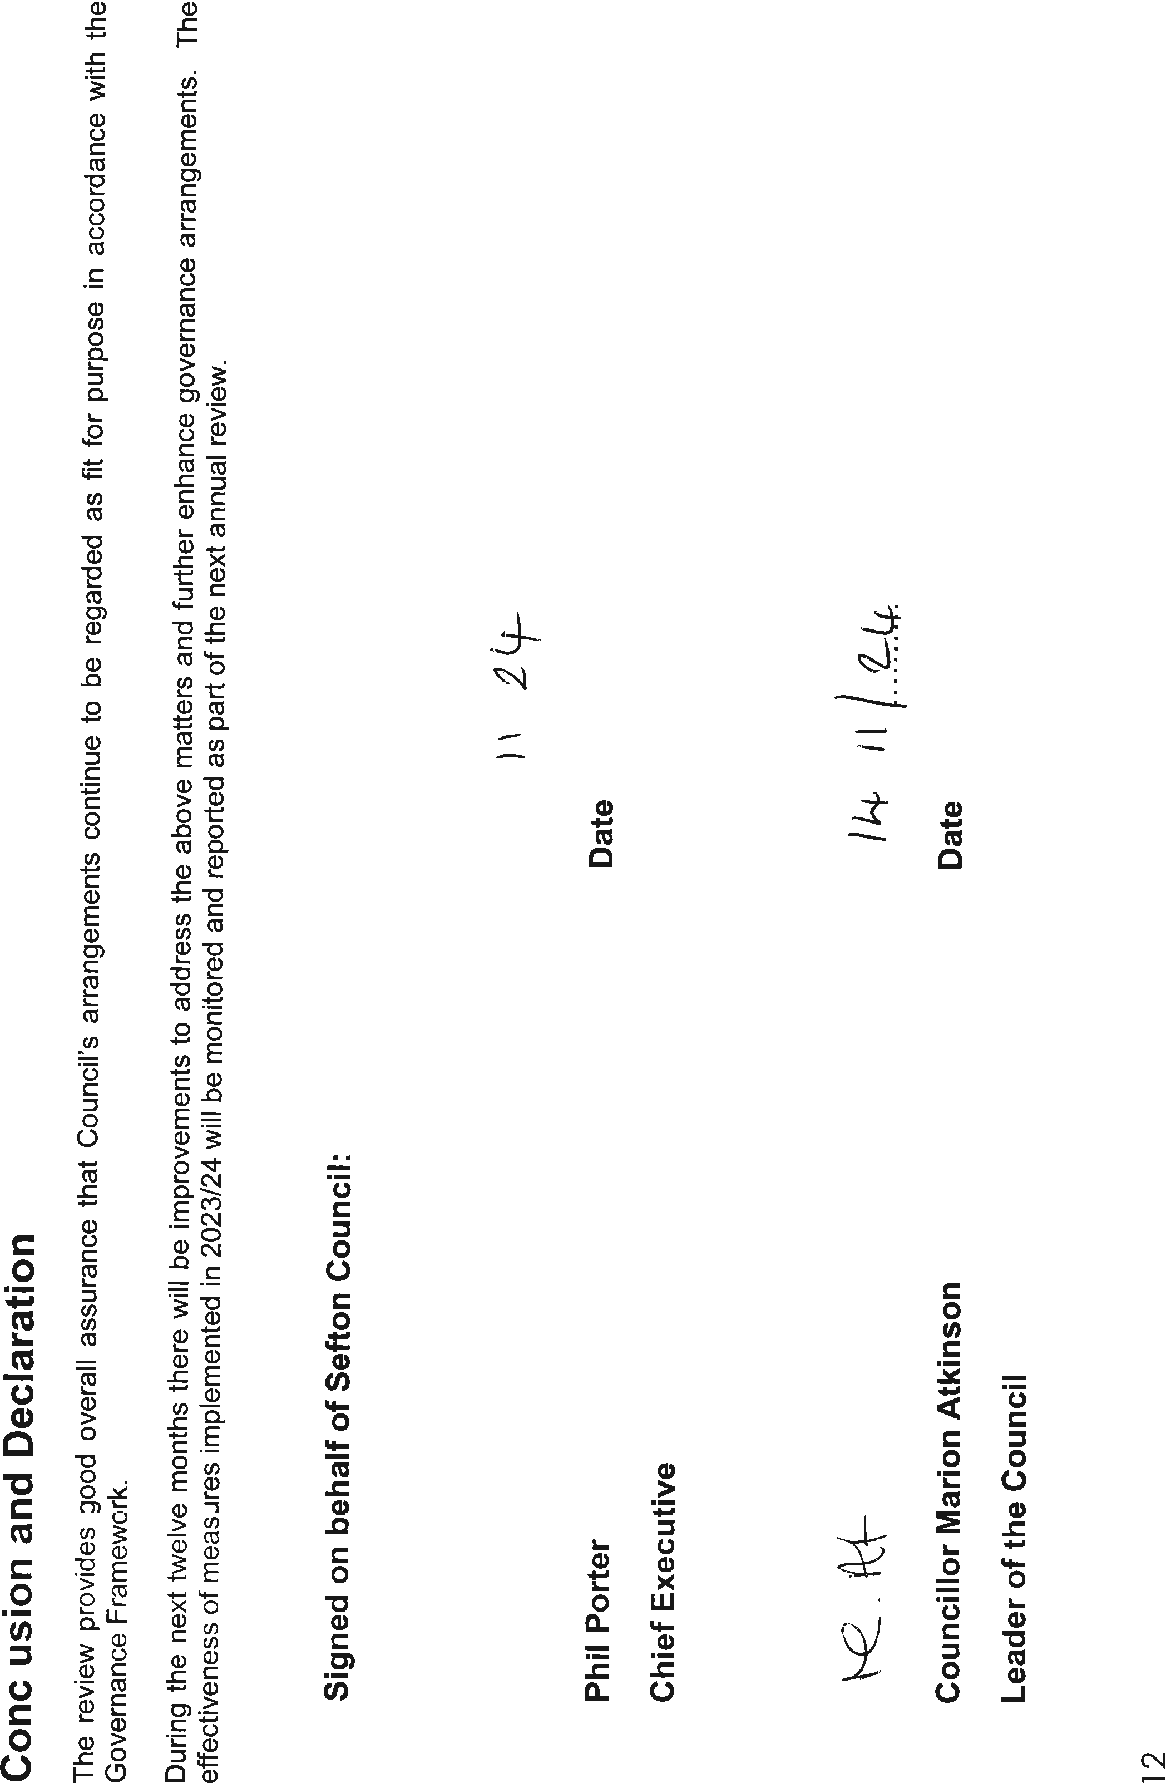








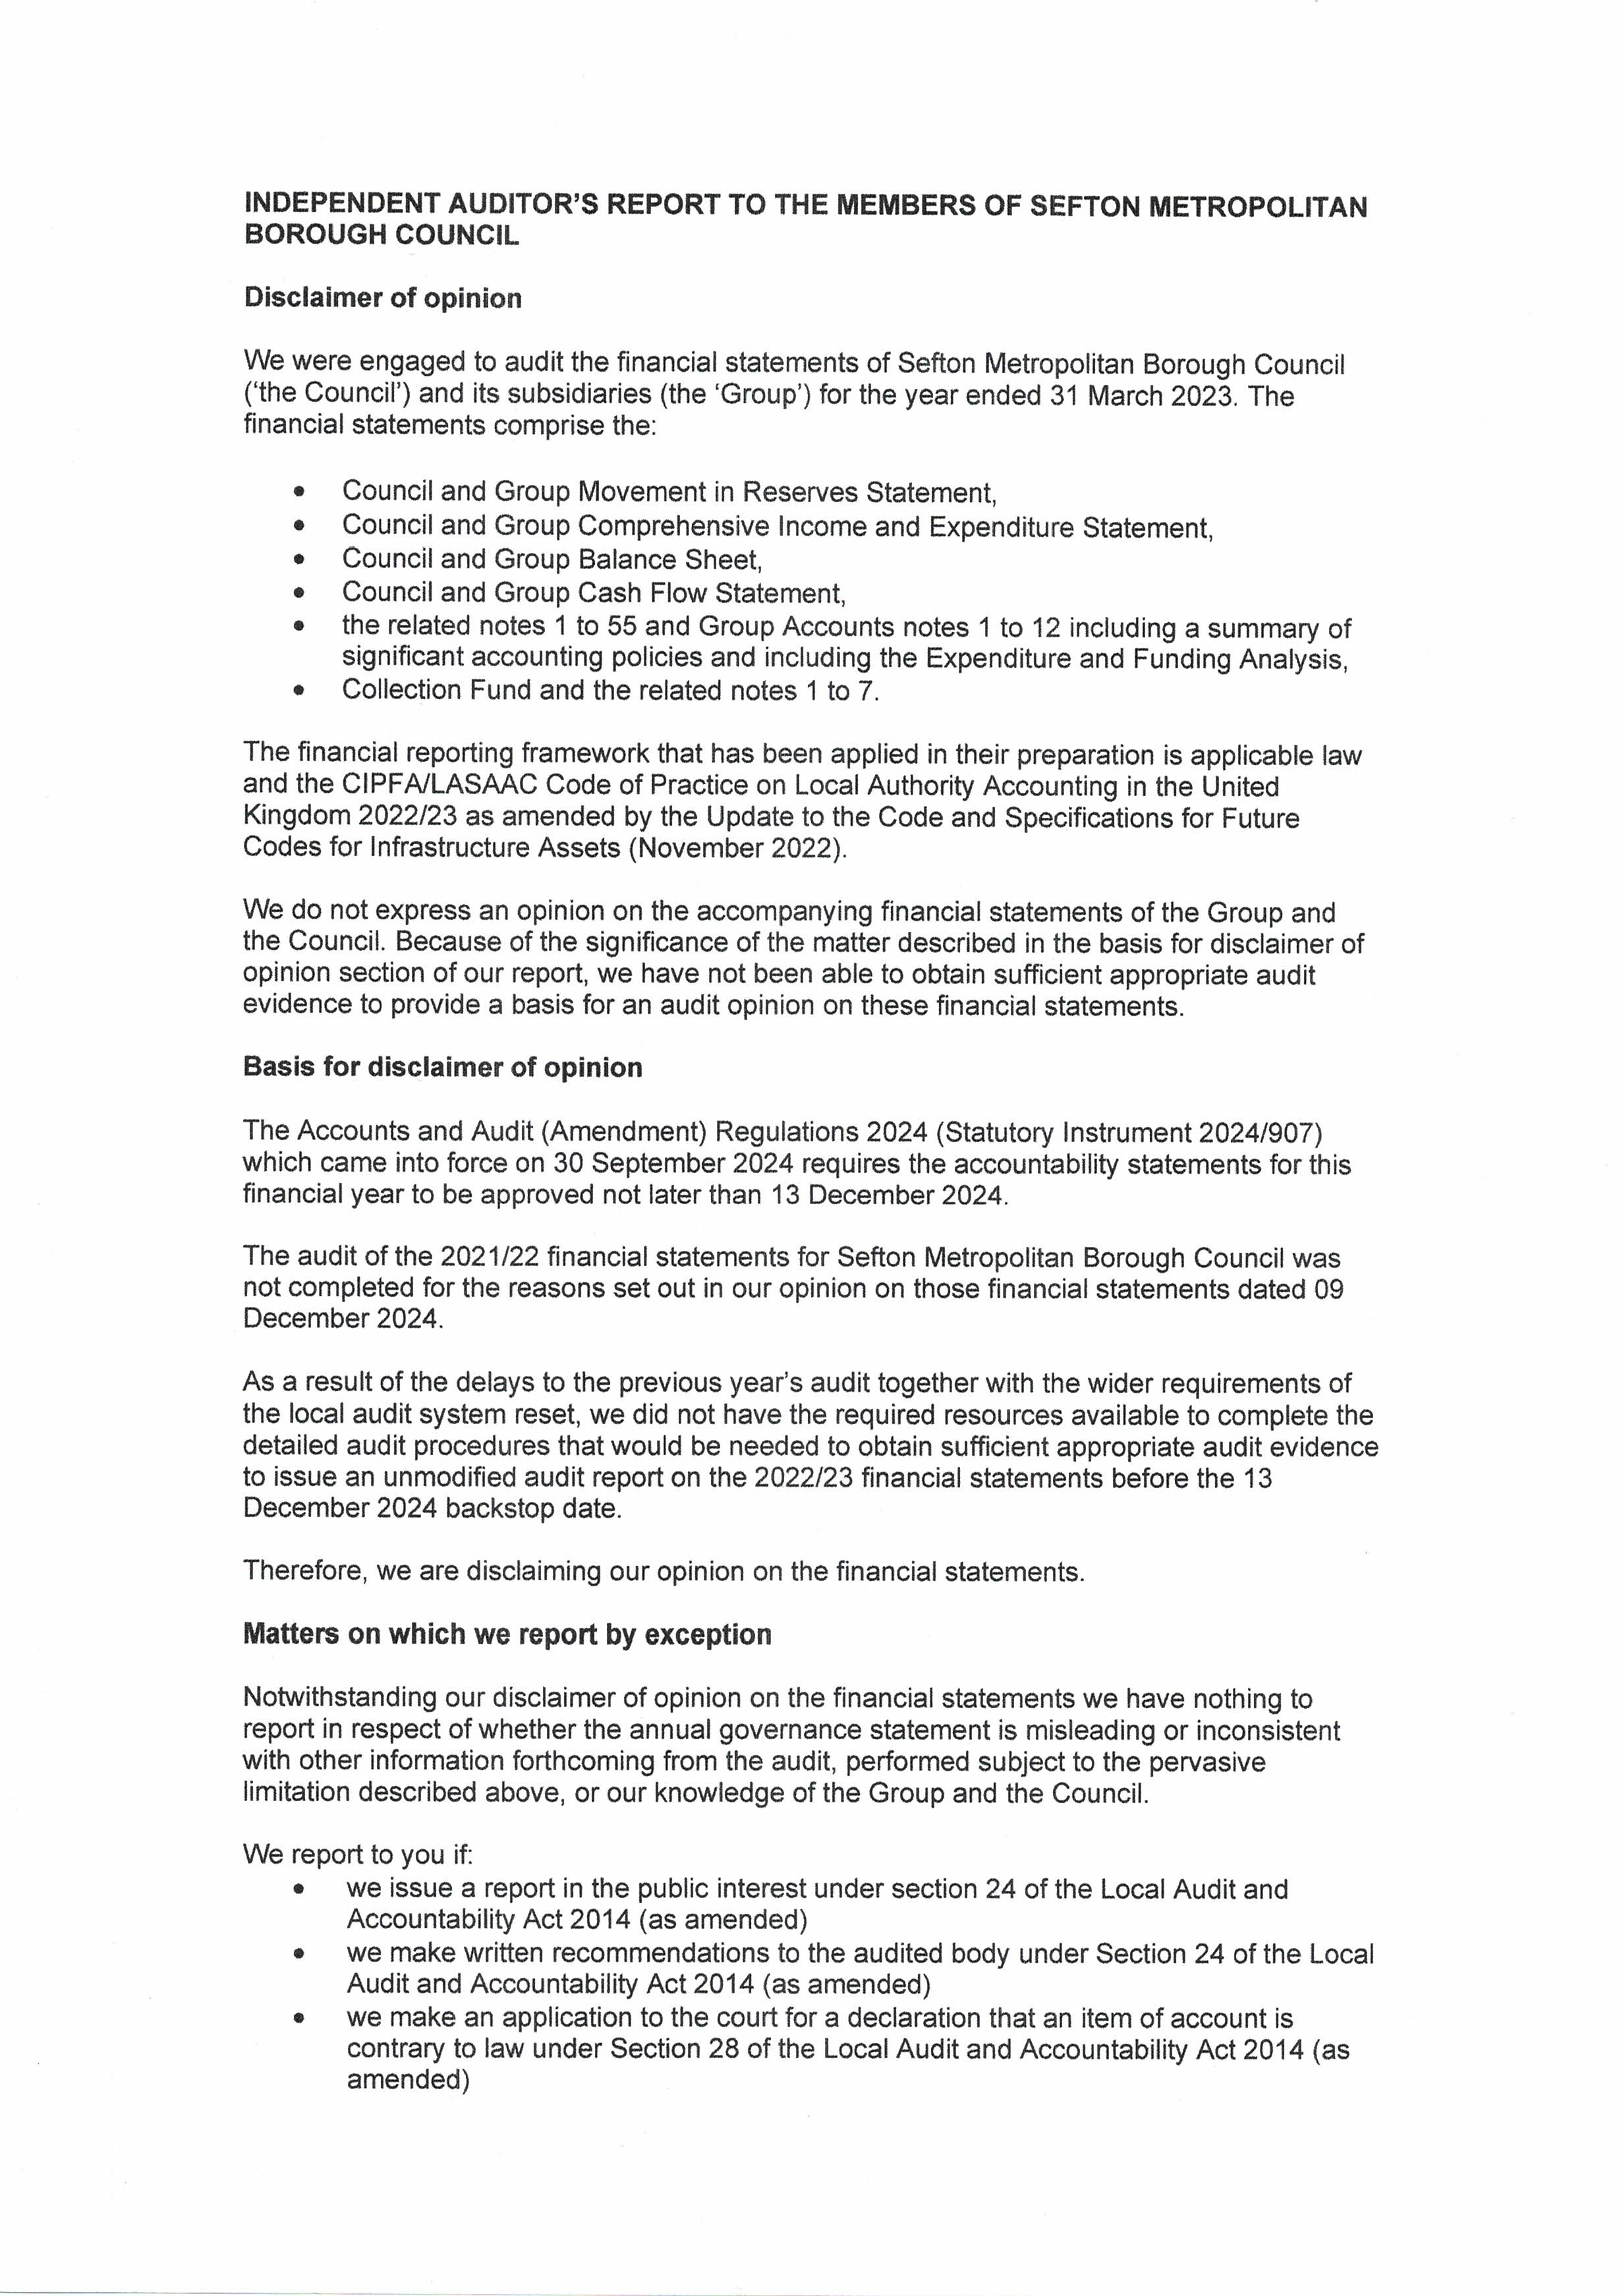
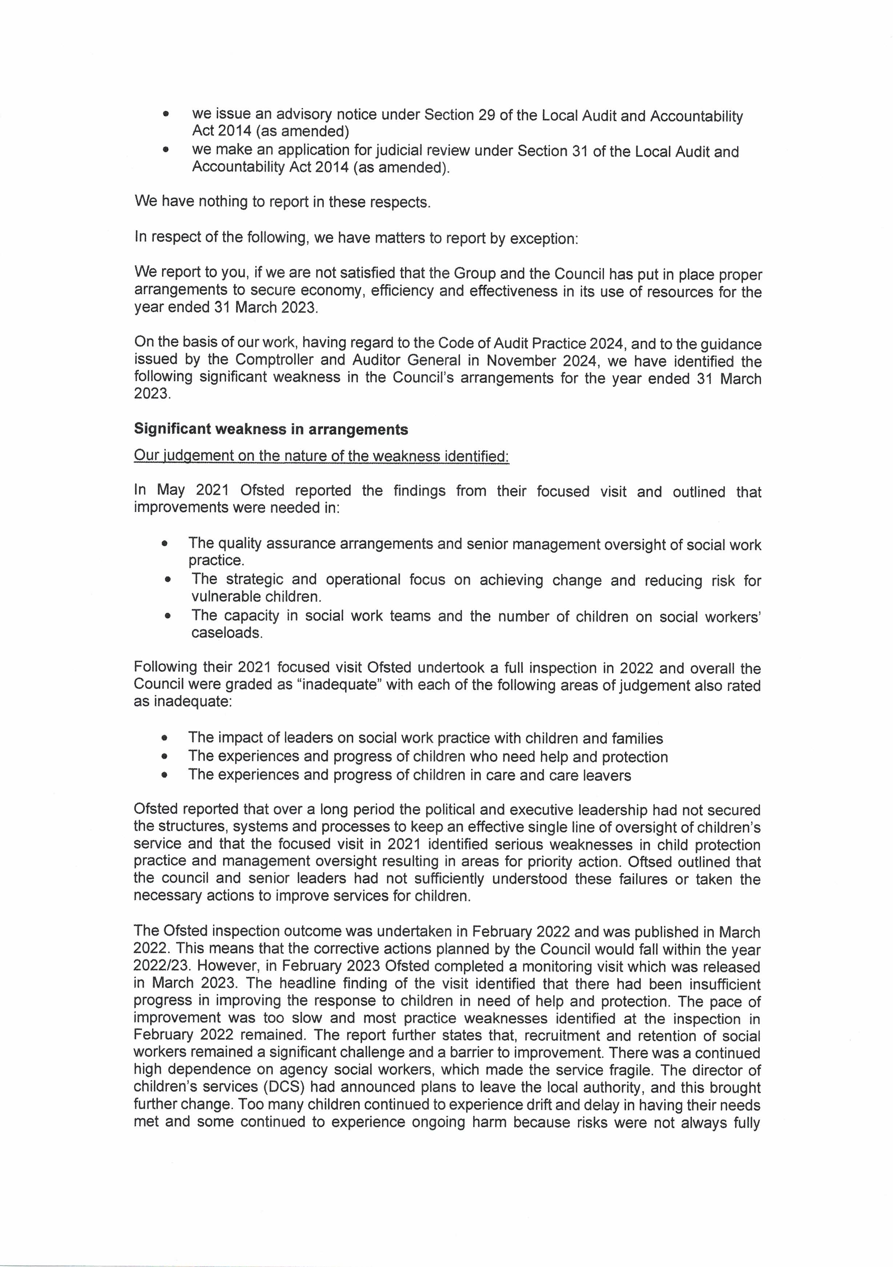
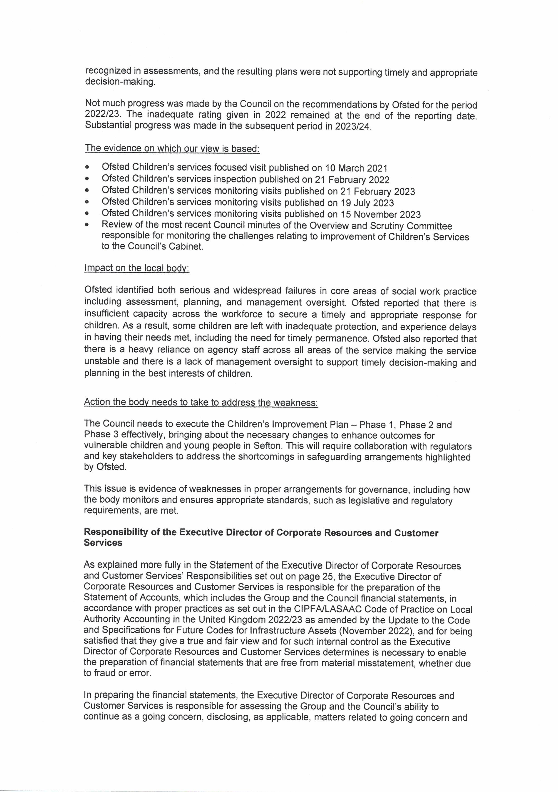
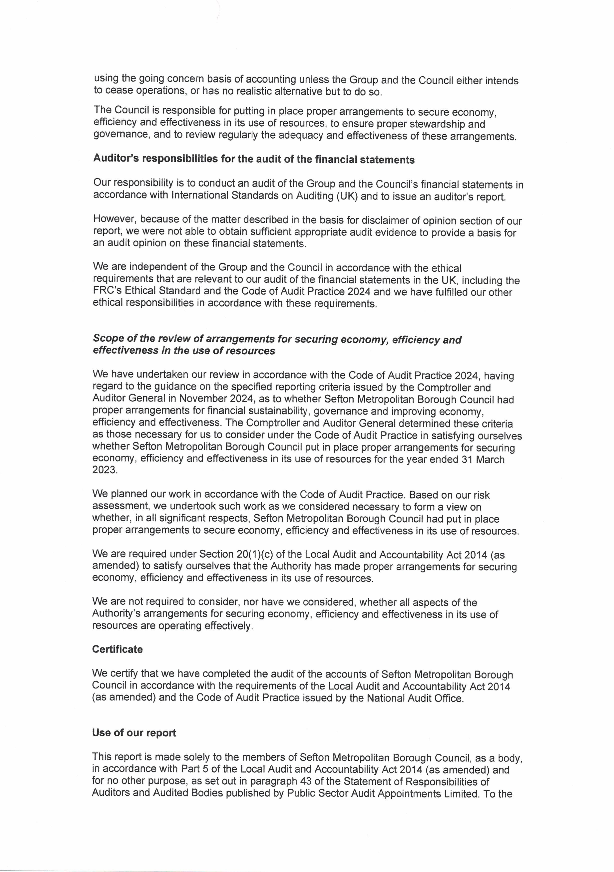
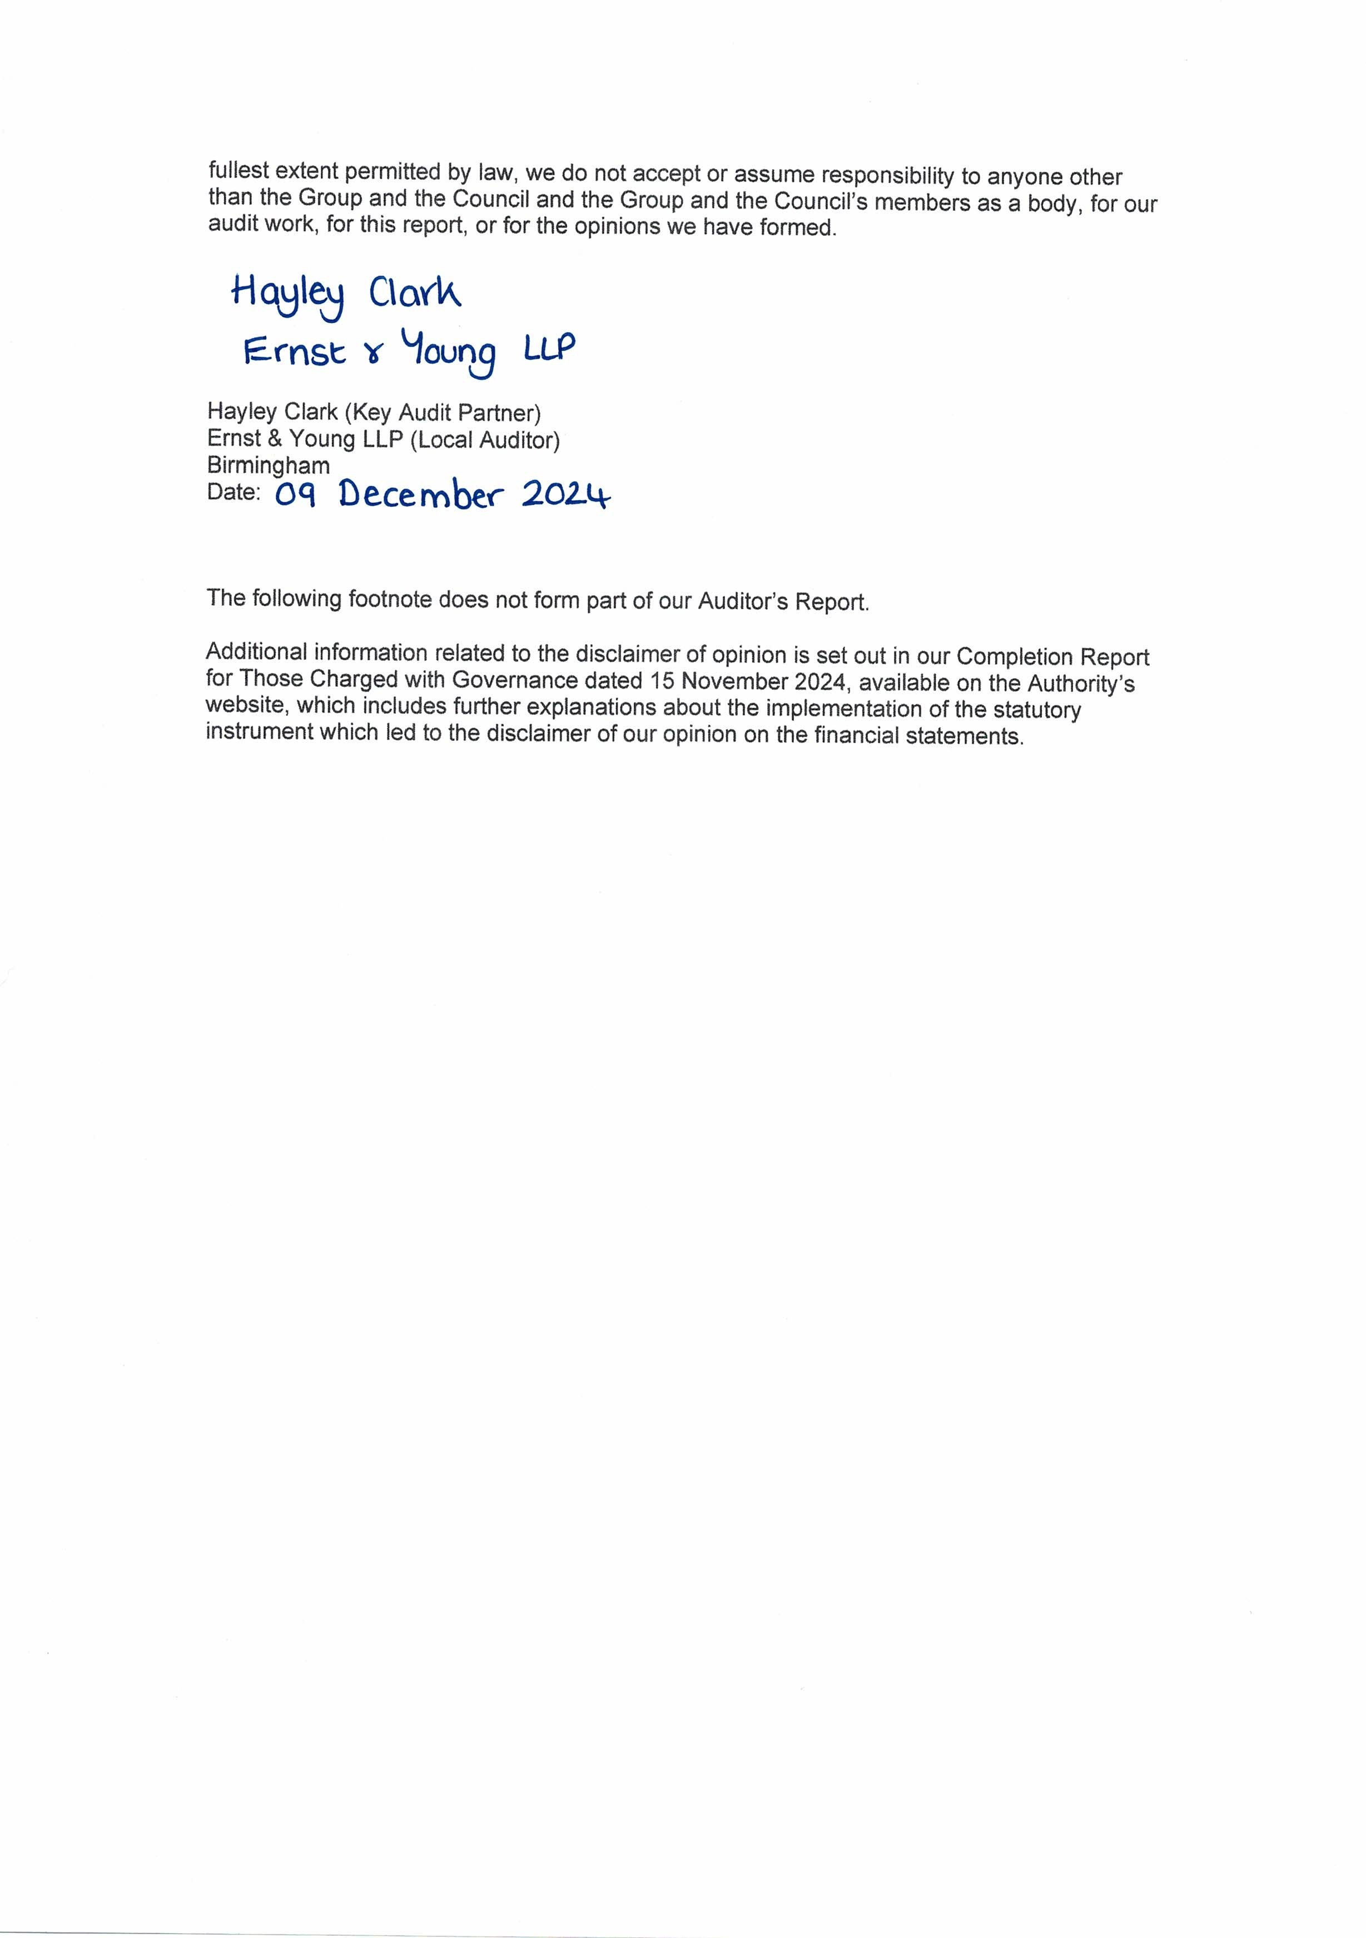

13 GLOSSARY

ACCOUNTABLE BODY

Projects financed from Government / European resources in some instances require grant claims from recognised legal entities, especially when a partnership or voluntary organisation is involved. This accountable body (usually the local authority) is held responsible for the proper completion of grant claims, ensuring that appropriate financial systems are in place and to receive and distribute the grant.

ACCRUALS

The concept that income and expenditure are recognised in the accounts as they are earned or incurred not as money is received or paid.

ACTUARIAL GAINS AND LOSSES

For a defined benefit pension scheme, the changes in actuarial deficits or surpluses that arise because:

- Events have not coincided with the actuarial assumptions made for the last valuation (Asset and Liability Gains and Losses); or
- The actuarial assumptions have changed.

AMORTISATION

The accounting technique of recognising a cost or item of income in the Income and Expenditure Account over a period of years rather than when the initial payment is made. Its purpose is to charge/credit the cost/income over the accounting periods that gain benefit for the respective item. The technique is supported by relevant accounting policies and practices.

AUTHORITY

Another term used to refer to the Council.

BALANCES
These represent accumulated monies of the Authority. Non-School General Fund balances may be utilised to reduce the amount to be met from Revenue Support Grant, NNDR and local taxpayers. School balances can be used by schools to finance future years’ expenditure.

BEST VALUE

The Local Government Act 1999 introduced the principle of Best Value and places a statutory duty on authorities to provide economy, efficiency and effectiveness in the provision of its services.

BUSINESS IMPROVEMENT DISTRICT

Business Improvement Districts are business led partnerships which are created through a ballot process to deliver additional services to local businesses.

Business Improvement Districts cover a defined area in which a levy is charged on all business rate payers in addition to the business rates bill. This levy is used to develop projects which will benefit businesses in the local area.

CAPITAL CHARGES

A charge to service revenue accounts to reflect the cost of fixed assets used in the provision of services.

CAPITAL EXPENDITURE

Capital expenditure is the acquisition of a fixed asset or expenditure which adds to the value of the existing fixed asset (e.g. building of a school). It can be spent either directly by the local authority or indirectly in the form of grants to other persons or bodies.

CAPITAL RECEIPTS

The proceeds from the sale of capital assets which, subject to various limitations, can be used to finance Capital Expenditure or to repay leasing charges or outstanding debt on assets originally
financed through loan. A proportion of capital receipts may need to be set aside to meet future liabilities.

CHARTERED INSTITUTE OF PUBLIC FINANCE AND ACCOUNTANCY (CIPFA)

CIPFA is the leading professional accountancy body for public services, which has responsibility for setting accounting standards in Local Government.

CODE OF PRACTICE ON LOCAL AUTHORITY ACCOUNTING IN GREAT BRITAIN (THE CODE)

The Statement of Accounts is produced in accordance with CIPFA's Code of Practice on Local Authority Accounting in Great Britain, which is updated annually. The Code specifies the principles and practices of accounting required to prepare a Statement of Accounts which "presents fairly" the financial position and transactions of a local authority.

COMMUNITY ASSETS

These are assets that the Authority intends to hold indefinitely, have no determinable useful life and may have restrictions on their disposal. Examples include parks and historic buildings.

CONTINGENT ASSET

A contingent asset is a possible asset arising from past events whose existence will be confirmed only by the occurrence of one or more uncertain future events not wholly within the local authority’s control.

CONTINGENT LIABILITY

A condition that exists at the balance sheet date, where the outcome will be confirmed only on the occurrence or non-occurrence of one or more uncertain future events. Where a material loss can be estimated with reasonable accuracy a contingent liability is accrued in the financial statements. If, however, a loss cannot be accurately estimated or the event is not considered sufficiently certain, it will be disclosed in a note to the balance sheet.

COVID-19

COVID-19 is an infectious disease caused by a newly discovered coronavirus.

COUNCIL TAX

A property based tax levied on all domestic properties in the Borough. The banding (and resultant sums due) is based on independent assessed property values. The Council sets levels of Council Tax on an annual basis under relevant statutory provisions.

CREDITORS

Amounts owed by the Authority for goods and services provided for which payment has not been made by the end of the financial year.

CURRENT SERVICE COSTS (PENSIONS)

The increase in the present value of a defined benefit scheme’s liabilities expected to arise from employee service in the current year.

CURTAILMENT

For a defined benefit scheme, an event that reduces the expected years of future service of present employees or reduces for a number of employees the accrual of defined benefits for some or all of their future service. Curtailments include:

- Termination of employees services earlier than expected, for example as a result of closing or discontinuing a segment of a business; and

- Termination of, or amendment to the terms of, a defined benefit scheme so that some or all of future service by current employees will no longer qualify for benefits or will qualify only for reduced benefits.

DEBTORS

Sums of money due to the Authority but not received by the end of the financial year.

DEFERRED CAPITAL RECEIPTS

Deferred Capital Receipts are derived from the sale of Assets receivable over an agreed period of time, principally mortgages relating to the sale of Council houses.

DEFERRED CREDITS

These represent capital income to be received in the future, when disposals have taken place, and deferred payments have been agreed e.g. the principal outstanding from the sale of Council houses.

DEFINED BENEFIT SCHEME

A pension or other retirement benefit scheme other than a defined contribution scheme. Usually, the scheme rules define the benefits independently of the contributions payable, and the benefits are not directly related to the investments of the scheme. The scheme may be funded or unfunded (including notionally funded).

DEFINED CONTRIBUTION SCHEME

A pension or other retirement benefit scheme into which an employer pays regular contributions fixed as an amount or as a percentage of pay and will have no legal or constructive obligation to pay further contributions if the scheme does not have sufficient assets to pay all employee benefits relating to employee service in the current or prior periods.

DEPRECIATED REPLACEMENT COST (DRC)

A method of valuation that provides a recognised proxy for the market value of specialised properties.

DEPRECIATION

The measure of the wearing out, consumption, or other reduction in the useful life of a fixed asset, whether arising from use, effluxion of time or obsolescence through technological or other changes.

DISCRETIONARY BENEFITS

Retirement benefits that the employer has no legal, contractual or constructive obligation to award and which are awarded under the Authority’s discretionary powers.

EARMARKED RESERVES

Earmarked reserves are created by setting resources aside for future events or to equalise expenditure between years. Earmarked reserves do not affect service expenditure in the year of creation.

EMOLUMENTS

Amounts paid to or receivable by an employee including expenses allowances chargeable to tax, and the estimated money value of any other benefits received by an employee other than in cash.

EVENTS AFTER THE BALANCE SHEET DATE

Events after the Balance Sheet date are those events, favourable or unfavourable, that occur between the Balance Sheet date and the date when the Statement of Accounts is authorised for issue.

EXISTING USE VALUE

The estimated amount for which a property should exchange on the date of valuation between a willing buyer and a willing seller in an arms-length transaction after proper marketing wherein the parties had each acted knowledgeably, prudently and without compulsion assuming that the buyer is granted vacant possession of all parts of the property and disregarding potential alternative uses and any other characteristics that would cause its market value to differ from that needed to replace the remaining service potential at least cost.

EXPECTED RATE OF RETURN (ON PENSIONS ASSETS)

For a funded defined benefit scheme, the average rate of return, including both income and changes in fair value but net of scheme expenses, expected over the remaining life of the related obligation on the actual assets held by the scheme.

FAIR VALUE

The fair value of an asset is the price at which it could be exchanged in an arm’s length transaction, less, where applicable, any grants receivable towards the purchase or use of the asset.

FAIR FUNDING

Under Section 48 of the School Standards Framework Act 1998, Local Education Authorities (LEAs) are required to have schemes dealing with the financing of schools. These govern the financial relationship between maintained schools and LEAs from the inception of the new funding framework on 1 April 1999

FINANCE LEASE

A lease that transfers substantially all the risks and rewards of ownership of a fixed asset to the lessee.

FIXED ASSETS

Assets that yield benefits to the Local Authority and the services it provides for a period of more than one year.

GENERAL FUND

This is the account where costs are charged for the year of the major functions for which the Authority is responsible (excluding the Collection Fund). Income to the Fund includes charges made by the Authority, specific Government and other grants and receipts from the Collection Fund.

HERITAGE ASSETS

Heritage assets are assets that are held by the Authority principally for their contribution to knowledge or culture.

IMPAIRMENT

A reduction in the value of a fixed asset below its carrying amount on the balance sheet.

INFRASTRUCTURE ASSETS

These include facilities to enable other developments to take place, including roads, street lighting and coastal defence works.

INTANGIBLE FIXED ASSET

“Non-financial” fixed assets that do not have physical substance but are identifiable and are controlled by the Authority through custody or legal rights. Purchased intangibles (e.g. software licences) are capitalised at cost, whilst internally developed intangibles are only capitalised where there is a readily ascertainable market value for them.

INTEREST COST (PENSIONS)

For a defined benefit scheme, the expected increase during the period in the present value of the scheme liabilities because the benefits are one period closer to settlement.

INTERNATIONAL FINANCIAL REPORTING STANDARDS (IFRS)

Defined Accounting Standards that must be applied by all reporting entities to all financial statements in order to provide a true and fair view of the entity’s financial position, and a standardised method of comparison with financial statements of the other entities.

INVENTORIES

Amounts of unused or unconsumed stocks held in expectation of future use. Inventories are comprised of the following categories:
- Goods or other assets purchased for resale
- Consumable stores
- Raw materials and components
- Products and services in intermediate stages of completion
- Finished goods

LIQUID RESOURCES

Current asset investments that are readily disposable by the authority without disrupting its business and are either readily convertible to known amounts of cash at or close to the carrying amount or traded in an active market.

LOCAL MANAGEMENT OF SCHOOLS (FAIR FUNDING)

The Authority is required to delegate responsibility for the management of a large proportion of its Nursery, Primary, Secondary and Special School budgets to schools. Individual schools are allocated a share of the budget through a formula mechanism, which distributes funds primarily on the basis of age weighted pupil numbers.

LONG-TERM CONTRACTS

A contract entered into for the design, manufacture or construction of a single substantial asset or the provision of a service (or a combination of assets or services which together constitute a single project), where the time taken substantially to complete the contract is such that the contract activity falls into different accounting periods. Some contracts with a shorter duration than one year should be accounted for as long-term contracts if they are sufficiently material to the activity of the period.

MARKET VALUE

The estimated amount for which a property should exchange on the date of valuation between a willing buyer and a willing seller in an arms-length transaction after proper marketing wherein the parties had each acted knowledgeably, prudently and without compulsion.

NATIONAL NON-DOMESTIC RATES (NNDR)

These are often referred to as Business Rates, and are a levy on business properties based on a national rate in the pound applied to the ‘rateable value’ of the property. The Government determines that national rate poundage. Local Authorities collect the sums due, but the proceeds are split, with 1% paid to the Merseyside Fire and Rescue Authority and 99% retained by the Council.

NET BOOK VALUE

The amount at which fixed assets are included in the balance sheet, i.e. their historical cost or current value less the cumulative amount provided for depreciation.

NET CURRENT REPLACEMENT COST

The cost of replacing or recreating the particular asset in its existing condition and in its existing use, i.e. the cost of its replacement or of the nearest equivalent asset, adjusted to reflect the current condition of the existing asset.

NET REALISEABLE VALUE

The open market value of the asset in its existing use (or open market value in the case of nonoperational assets), less the expenses to be incurred in realising the asset.

NON-OPERATIONAL ASSETS

These are assets, which are held by the authority but not directly occupied, used or consumed in the delivery of services. Examples include assets that are surplus to requirements, pending sale or redevelopment.

OPERATING LEASES

In an operating lease, the ownership of the asset remains with the leasing company and the annual rent is charged to the annual service account. Expenditure financed by operating leases does not count against capital allocations.

OPERATIONAL ASSETS

These are assets that are held and occupied, used or consumed in the direct delivery of services for which the Authority is responsible.

PAST SERVICE COST / GAIN

For a defined benefit scheme, the increase or reduction in the present value of the scheme liabilities related to employees service in prior periods arising in the current period as a result of the revision of scheme benefits.

POOLED BUDGET

Arrangement permissible under the Health Act 1999 and National Health Service Act 2006 that provides an opportunity for partners to bring money together, in a discrete fund, to pay for the services that are an agreed part of the pooled fund arrangement for the client group who are to benefit from one or all of the services. Instead of users being inconvenienced by disputes about Health and Local Authority responsibilities, organisations will agree at the outset the range of Health and Local Government services to be purchased and provided from a pooled fund.

PRECEPT

This is a charge issued by the Merseyside Police and Crime Commissioner, Merseyside Fire and Rescue Authority (and Parish Councils where appropriate), which is collected by the Council on their behalf by adding the precept to its own Council Tax.

PRIOR YEAR ADJUSTMENTS

Those material adjustments applicable to prior years arising from changes in accounting policies and from the correction of fundamental errors. They do not include normal recurring corrections and adjustments of accounting estimates made in prior years.

PROVISIONS

Provisions represent sums set aside for liabilities or losses, which are certain to arise but, owing to their inherent nature, cannot be quantified with any certainty.

PUBLIC WORKS LOANS BOARD (PWLB)

An arm of Central Government which is the major provider of loans to finance long term funding requirements for Local Authorities.

RELATED PARTY TRANSACTION

A related party transaction is the transfer of assets or liabilities or the performance of services by, to or for a related party irrespective of whether a charge is made. Related party transactions include the provision of services to a related party.

The materiality of related party transactions should be judged not only in terms of their significance to the authority, but also in relation to its related party.

REMUNERATION

All sums paid to or receivable by an employee and sums due by way of expenses allowances (as far as those sums are chargeable to UK income tax) and the money value of any other benefits received other than in cash. Pension contributions payable by the employer are excluded.

RESERVES

A reserve is an amount, which has been set aside for a specific purpose in one financial year and carried forward to meet expenditure in future years. Reserves include earmarked reserves set aside for specific policy purposes and balances that represent resources set aside for purposes such as general contingencies and cash flow management.

RETIREMENT BENEFITS

All forms of consideration given by an employer in exchange for services rendered by employees that are payable after the completion of employment. Retirement benefits do not include termination benefits payable as a result of either: -

- An employer’s decision to terminate an employee’s employment before the normal retirement date, or
- An employee’s decision to accept voluntary redundancy in exchange for those benefits, because these are not given in exchange for services rendered by employees.

REVENUE SUPPORT GRANT

This is a Government grant in aid of Local Authority services generally. It is based on the Government's assessment of how much an authority needs to spend in order to provide a standard level of service.

REVENUE EXPENDITURE

This is money spent on the day-to-day running costs of providing services (e.g. salary costs). It is usually of a constantly recurring nature and produces no permanent asset.

SCHEME LIABILITIES

The liabilities of a defined benefit scheme for outgoings due after the valuation date. Scheme liabilities measured using the projected unit method reflect the benefits that the employer is committed to provide for service up to the valuation date.

SECTION 52 / 106 AGREEMENTS

The Council is able to restrict or regulate the development or use of land by requiring that a developer deposit funds with the Authority when granting planning permission. The funds are either used directly by the Authority to undertake work, such as providing access from the existing highway to a new development, or held as a deposit which is refundable to the developer when the conditions attached to the planning permission, such as landscaping work, are complied with. The statutory basis for such agreements is currently contained within Section 106 of the 1990 Town and Country Planning Act and previously, within Section 52 of the 1971 Town and Country Planning Act.

SET ASIDE CAPITAL RECEIPTS

These are receipts that have to be reserved under the Local Government and Housing Act 1989 and can only be used to repay external debt or in substitution for new external borrowing.

SETTLEMENT

An irrevocable action that relieves the employer of the primary responsibility for a pension obligation and eliminates significant risks relating to the obligation and the assets used to effect the settlement. Settlement includes the transfer of scheme assets and liabilities relating to a group of employees leaving the Authority’s scheme.

SPECIFIC GOVERNMENT GRANTS

These are designed to aid particular services or reimburse the costs of payments made to claimants. Examples of specific grants include Dedicated Schools Grant, Standards Fund and Housing and Council Tax Benefit Subsidy. Assistance may also be given in aid of specific capital expenditure, e.g. Housing Market Renewal Grant and Stronger Safer Communities Fund.

STATUTORY PROVISION FOR THE FINANCING OF CAPITAL INVESTMENT

This is the amount required to be set aside from revenue for the repayment of external loans. It is calculated in accordance with the Local Authorities (Capital Finance and Accounting) (England) (Amendment) Regulations 2008 [SI 2008/414], in conjunction with the MHCLG guidance on the minimum revenue provision (published in February 2018).

TREASURY MANAGEMENT

This is the process by which the Authority controls its cash flow and its borrowing and lending activities.

TRUST FUNDS

These are funds administered by the Council on behalf of charitable organisations and/or specific organisations.

USABLE CAPITAL RECEIPTS

These are receipts which, after allowing for the proportion to be set aside, may be used to finance capital expenditure.

USEFUL LIFE

The period over which the Local Authority will derive benefits from the use of a fixed asset.

Abbreviations

14 ABBREVIATIONS

AGS Annual Governance Statement

ASHE Annual Survey of Hours and Earnings

BID Business Improvement District

CCG Clinical Commissioning Group

CCLA Church and Charities Local Authority

CERMS | Continuous Emission Rate Monitoring System
CFR | Capital Financing Requirement
CIES | Comprehensive Income and Expenditure Statement
CIPFA | Chartered Institute of Public Finance and Accountancy
CPI | Consumer Price Index
CVS | Council for Voluntary Service

DfE Department for Education

DRC |  | Depreciated Replacement Cost
DSG |  | Dedicated Schools Grant
EFA |  | Expenditure and Funding Analysis
HRA |  | Housing Revenue Account
IAS |  | International Accounting Standards
ICT |  | Information and Communication Technology
IBCF |  | Improved Better Care Fund
IFRS |  | International Financial Reporting Standard

LGA Local Government Association

IMD Index of Multiple Deprivation

LCHT Liverpool Community Health Trust

LCR Liverpool City Region

LEA Local Education Authority

LGPS Local Government Pension Scheme

LSOA Lower Super Output Area

MBC | Metropolitan Borough Council
MHCLG | Ministry of Housing, Communities and Local Government
MMI | Municipal Mutual Insurance Limited
MPF | Merseyside Pension Fund
Abbreviations

MRF Merseyside Local Resilience Forum

MRICS Member of the Royal Institution of Chartered Surveyors

NHS | National Health Service
NNDR | National Non-Domestic Rates
PFI | Private Finance Initiative
PP&E | Property, Plant and Equipment
PWLB | Public Works and Loans Board
REFCUS | Revenue Expenditure Funded from Capital Under Statute

SCG Strategic Coordination Group

SCIG | Strategic Capital Investment Group
SOLACE | Society of Local Authority Chief Executives
TPS | Teachers’ Pension Scheme
UK | United Kingdom
VAT | Value Added Tax
VOA | Valuation Office Agency

Useful Addresses

15 USEFUL ADDRESSES

Additional financial information on Sefton MBC and related organisations is usually available at libraries throughout the Borough and on our website (www.sefton.gov.uk). Further copies are also available upon request to the following addresses.

Sefton Council

Executive Director of Corporate Resources and Customer Services,
Magdalen House
30 Trinity Road
Bootle
L20 3NJ

Sefton New Directions

Sefton New Directions Limited Annual Financial Statements can be obtained from:

Sefton New Directions Limited Head Office,
Third Floor,
Burlington House,
Crosby Road North,
Waterloo,
Liverpool
Merseyside,
United Kingdom
L22 0PJ

Pension Fund Information

The Merseyside Pension Fund's Annual Report can be obtained from:

The Pension Manager
Merseyside Pension Fund,
PO Box 120,
7th Floor,
Castle Chambers,
43 Castle Street,
Liverpool
L69 2NW

CONTACT US

If you have any questions or comments on the Statement of Accounts, please write to the Executive Director of Corporate Resources and Customer Services at the above address. We would particularly like to hear from you if you have any suggestions on how the accounts could be improved.

Useful Addresses

